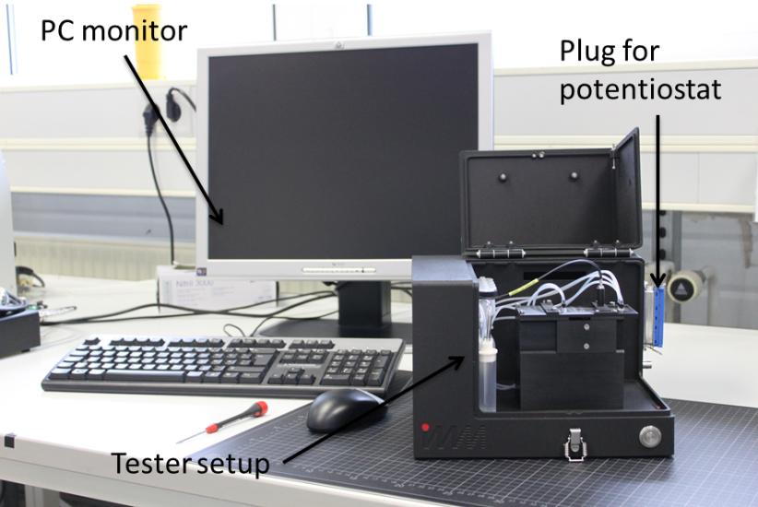

Figure 1. Picture of developed ECL prototype instrument.

Figure 2. DNA (left) and antigen (right) biorecognition surfaces and proof-of-concept of amperometric detection of celiac disease genetic and serological markers.

Figure 3. Left: Scheme for DNA ECL detection. Right: ECL signals obtained in the detection of 100 nM HLA-DQ02 allele using diazonium surface chemistry. Inset: blank signal.

Figure 4. Demonstration of nanoparticle-mediated signal amplification in the ECL detection of anti-gliadin antibodies.

