Application of chemical pesticides in agriculture represents one of the major costs of agricultural production and is a key source of environmental pollution, destruction of wildlife and introduction of known carcinogens into the human food chain. The current need for novel methods of pest control coincide with unprecedented advances in genomic analyses of crop plants. The two-spotted spider mite (Tetranychus urticae) is one of the major pests in agriculture. It feeds on over 1000 plant species and has rapid development. It represents a key pest for greenhouse crops, annual field crops and many horticultural crops. In addition, spider mites are pests of hot and dry climates. Computer modeling studies suggest that with intensifying global warming the significance of pests will dramatically increase. The whole-genome sequence of T. urticae is now available. It provides a unique resource for studies of plant-herbivore interactions. T. urticae develops successfully on Arabidopsis, allowing development of T. urticae and Arabidopsis as tractable models for a systems level studies of plant-herbivore interactions. In addition, T. urticae successfully develops on grapes, a crop species with established genomic resources.

1) Analysis of the Arabidopsis-spider mite interaction
To asses natural variation in Arabidopsis responses to spider mite feeding, we screened the set of Arabidopsis accessions for spider mite-induced damage by scoring the total surface of chlorotic spots. Among accessions tested, we identified Bla-2 as the most tolerant strain that sustained the least amount of damage and Kondara (Kon) that displayed the greatest susceptibility and damage. To characterize the Arabidopsis responses to spider mite feeding, and to potentially differentiate between responses of the tolerant Bla-2 and the susceptible Kon accessions, we determined changes in transcriptome profiles of Bla-2 and Kon plants during the first day and within 5 days of feeding. Bla-2 and Kon are Arabidopsis accessions collected from Spain and Middle East, respectively, and have pronounced differences in the basal gene expression between them in oxylipin (jasmonic acid, JA) metabolism and glucosinolate biosynthesis, processes that give rise to metabolites known to affect plant responses to herbivory. Indeed, the measurements of OPDA, JA and JA-Ile metabolites, and aliphatic glucosinolates confirmed the expectation that Bla-2 accumulates greater levels of these compounds relative to Kon. The induced responses of Arabidopsis plants to spider mite feeding are characterized by: a) transient oxidative and heat shock stress responses (Bla-2 specific), b) biosynthesis and responses to jasmonic (JA), salicylic acids (SA) and ethylene (ET), that are sustained throughout the first day, and c) synthesis of secondary metabolites and defence proteins, whose expression is sustained throughout the first day, at which point their expression declines. Comparison of Arabidopsis response to spider mite feeding to responses triggered by P. rapae (caterpillar), F. occidentalis (trips) and M. persicae (aphids) herbivory indicated that Arabidopsis plants specifically synthesize phytoalexins and induce Trp-derived glucosinolates. Analysis of mutants that disrupt JA and glucosinolate biosynthesis pointed to the importance of these processes to deter spider mite feeding on Arabidopsis. Importantly, a tolerant strain Bla-2 either has greater accumulation of these important metabolites, or synthesizes them earlier in comparison to susceptible Kon strain. We have also determined spider mite transcriptome responses to feeding on Arabidopsis plants that contained different amounts of glucosinolates and found out that same group of enzymes involved in biosynthesis of these compounds are being used for their detoxification. These data are all complete, and we are currently preparing a manuscript.

2) Analysis of the grapevine-spider mite interaction
Spider mite feeding on grapes mostly affects normal bud development that can lead to decline in photosynthesis causing a reduction in the yields, late maturity and reduction in the sugar content of grapes (loss of 1 to 3 °). Grapevine is a non-host for T. urticae. We have performed microarray analysis of grapevine responses at 1 and 12h of spider mite feeding, using the custom made GrapeGen GeneChip that has been developed by the host Dr. Jose Miguel Martinez Zapater in collaboration with Dr. Steven Lund from UBC, Canada. This chip contains a consensus of vinifera sequences where overlaps in EST data existed, or individual sequence data from five cultivars: Cabernet Sauvignon, Muscat Hamburg, Pinot Noir, Chardonnay and Shiraz. As in Arabidopsis, the response was observed within the first hour of feeding (824 genes had 2 fold ratio, p-val <0.05 BH (DEG)), and the response continued after 12h (at which point 511 genes had 2 fold ratio, p-val <0.05 BH). In comparison with the Arabidopsis response were majority of genes were up-regulated in their expression as a response to spider mite feeding, in grapevine almost half of the DEG were down-regulated (Fig.1). The majority of DEG genes were associated with the metabolism of carbone assimilation, nucleic acids, amino acids and proteins. Thus, the response to spider mite attack seems to induce metabolism-related transcripts, particularly, the protein synthesis. Changes in hormonal signaling are visible but they are difficult to decipher as for each hormone genes are both up- and down-regulated and no clear response signature can be observed. Therefore, the grapevine responses to spider mite feeding differ from responses observed for the Arabidopsis response, which may associate with differences in life-history traits.
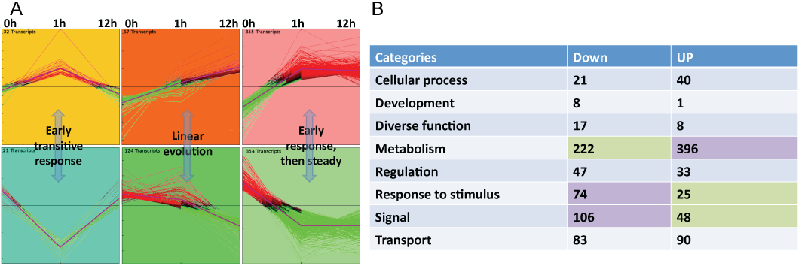
Figure 1. Analysis of the grapevine DEGs upon spider mite feeding. A. Cluster analysis of DEG. B. GO enriched categories of DEG.

3) Genetic analysis of Arabidopsis response to spider mite feeding
A population of Recombinant Inbred Lines (RILs) generated from the cross between Col and Ler is available from the Arabidopsis Stock Centre. The phenotyping of the RILs indicated that phenotypic variation has a continuous range, demonstrating that the QTL analysis is the most suitable approach for this genetic analysis. Genotype of the Col/Ler RILs has already been determined, allowing us to perform the QTL mapping that identified a QTL at the top of chromosome 4, see Figure 2.

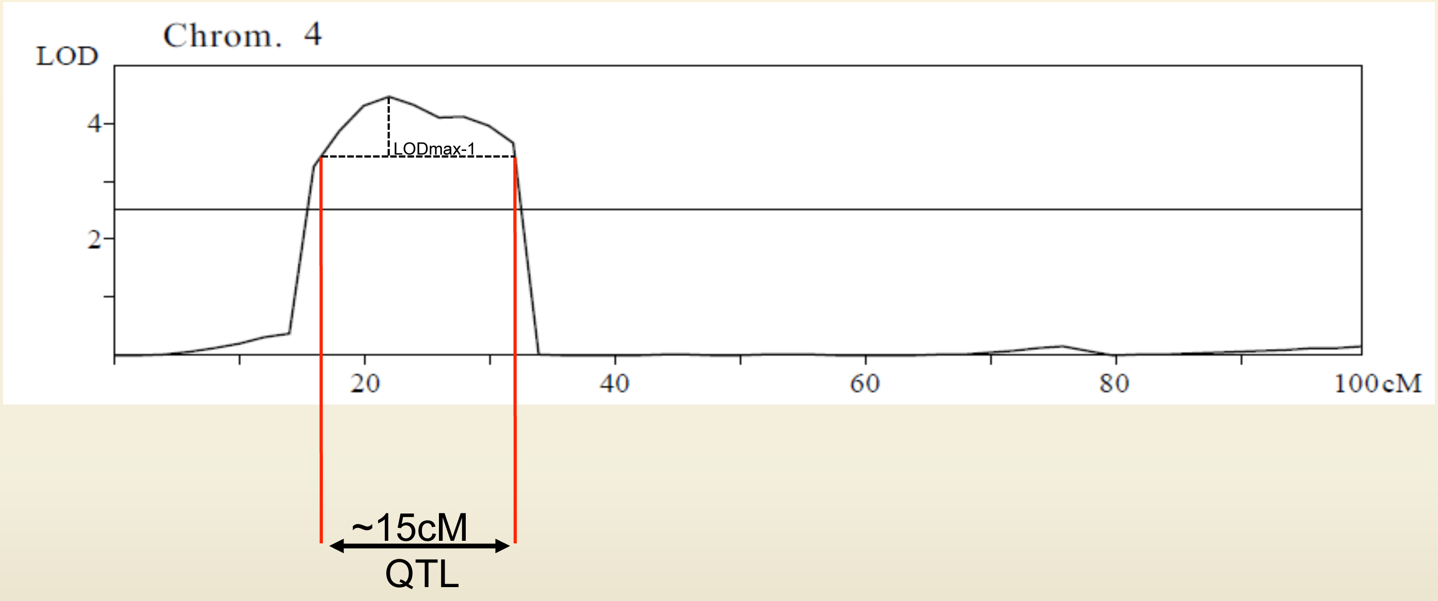
Figure 2. QTL mapping of spider mite response in Ler/Col RIL population identified a QTL at the top of chr. IV.

The ICVV provided an outstanding environment for this project. The major input for the grapevine response analysis was provided by Dr. Jose Miguel Martinez Zapater and his group. In addition, we extended existing collaborations with Spanish laboratories in the area of plant-pest interactions. The international project on plant-spider mite interaction analysis that is based on consortia of groups from Spain, France, Belgium and Canada (<http://devbiol.zoo.uwo.ca/spidermite/), is now extended with group of Drs. Aurelio Gómez Cadenas and Vicente Arbona Mengual from the Universitat Jaume I, Castelló de la Plana, and with entomology groups at ICVV headed by Drs. Vincente Marco and Ignatio Perez Moreno.

