Design and Synthesis of Responsive MR Contrast Agents Sensitive to Glutamate
237253: GluReProbes: Dr Anurag Mishra and Prof David Parker, Durham University, UK

Glutamate (Glu) is the major mediator of excitatory signals in the mammalian central nervous system, involved in most aspects of normal brain function including cognition, memory and learning. The interaction of this neurotransmitter with its receptors was selected as the model system in this project. Glutamate is abundantly distributed in the brain and plays a central role in brain metabolism.

Figure 1. Synapse at resting stage [A], active stage [B] and glutamate re-uptake cycle [C]
Most of the neurons in the mammalian brain release Glu as a neurotransmitter. When the presynaptic neuron is stimulated, synaptic vesicles containing Glu merge with the neuron’s plasma membrane and release their contents outside the cell. Glu diffuses to the postsynaptic neuron and binds to receptors there, activating the postsynaptic cell (Figure 1[A, B]). The released Glu is then cleared away by the glutamate transporters (present on astroglial and support cells) and to a later extent by transporters on postsynaptic neurons. In astroglial cells, Glu is enzymatically converted to glutamine, later it is supplied to presynaptic neurons through the neutral amino-acid-transporters and finally is recovered as glutamate to repackage into vesicles (Figure 1C).
Glutamate mediates its effect through both the G-protein coupled metabotropic receptors (mGluRs) and the ligand-gated ionotropic receptors (iGluRs). Only the mGluR subtype-5 (mGluR₅) are found to be actively involved in transducing excitatory signals between neurons through Glu. These receptors are widely localized on the postsynaptic membrane and are distributed in various brain regions, including the spinal cord, thalamic nuclei and the hippocampus. Next to neurons, mGluR₅ is also expressed on astrocytes where it is thought to be part of Glu transmission by astrocytes. In addition, a role in the Glu-mediated astrocyte-to-neuron signalling has also been discussed.

Hypothesis. We hypothesized that in the brain resting stage, a selective glutamate responsive contrast agent (GluRCA) would bind to mGluR₅ and provide a high contrast in magnetic resonance images. At the same time, the GluRCA will bind to mGluR₅ expressed on astrocytes, which are located nearby the synaptic cleft. Therefore, using mGluR₅ as the target for our GluRCA was considered to give an advantage of increasing the number of available binding sites, leading to a larger signal change.
Design, synthesis and characterisation of GluRCA. We designed, synthesised and evaluated eight GluRCAs containing various selective mGluR₅ binding moieties linked to ‘DOTA’ derived gadolinium (Gd³⁺) complexes, exploring their potential application as responsive MR imaging probes. These binding moieties have been as established specific mGluR₅ antagonists (alkynes and dipyridyl/heterobiaryl amides derivative) and have been integrated into these structures in a modular fashion, involving linkage to a macrocyclic ligand core (i.e. ‘DOTA’) to allow the targeting of mGluR₅ receptors (Figure 2A).
Probe-receptor binding studies. Primary rat astrocytes were chosen as the cellular model, as these cells are known to express mGluR₅ efficiently. However, we did not use additional differentiation of the cells with a G5-supplement, as sufficient expression of the receptor in our model was revealed by immunofluorescence staining studies.
The cytotoxicity of the gadolinium complexes [Gd.L¹⁻⁸] was examined with a proliferation assay (XTT: mitochondrial redox perturbation) in combination with a cell number assay (Hoechst 33342: stains DNA in cells). Apart from [Gd.L³], none of the complexes exhibited significant effects in each assay over the range of 50 to 200µM after 24 h.
Cellular labelling of mGluR₅-expressing primary astrocytes with [Gd.L¹⁻⁸] was assessed by measuring T₁-weighted MR images on a 3T Siemens human whole body MR scanner and calculating the cellular longitudinal relaxation rates R_{1,cell} (Figure 2B). In a first set of experiments, primary astrocytes were treated for 45 min. with 200 µM of each of the gadolinium complexes, then washed to remove unbound complex, re-suspended in fresh buffer and T₁-weighted MR images were acquired. From the structurally similar [Gd.L¹⁻⁴], [Gd.L³] showed statistically significant increases in R_{1,cell} (141% of control), comparable to [Gd.L²] (138% of control), while [Gd.L¹] and [Gd.L⁴] also exhibited significant increases but to a lesser extent (Figure 2B). Amongst the dipyridyl/heterbiaryl amide analogues [Gd.L⁵⁻⁸], only [Gd.L⁸] had cellular relaxation rate R_{1,cell} (138% of control) that was significantly different from untreated control cells. The increased R_{1,cell} is consistent with receptor binding or uptake into the cells, as each process has been shown to increase the measured proton relaxation rate of Gd³⁺ complexes. To further elucidate which of these two is responsible for the observed increase in R_{1,cell} , the following experiment was conducted. The antagonist-arm of [Gd.L¹] is structurally identical with the highly efficient, established mGluR₅-antagonist MPEP (2-methyl-6-(phenylethynyl)pyridine). Hence, in one series of experiments, primary astrocytes were pre-treated with a known antagonist (MPEP) for 15 min. and then incubated with 100µM [Gd.L¹] for another 45 min. with MPEP still present in the incubation solution. With this pre-treatment, no increase in R_{1,cell} was observed after treatment with [Gd.L¹]. This result indicates that the increases observed in R_{1,cell} are likely to be associated with receptor binding and not a non-specific cellular internalisation process.
Antagonistic activity and the reversibility of probe-receptor binding in the presence of glutamate. The antagonistic activity of [Gd.L³] and [Gd.L⁸] was assessed using a functional cellular calcium fluorescence assay. Activation of mGluR₅ by Glu leads to transient changes in intracellular calcium concentration. These calcium-transients can be measured in cells that are intracellulary labelled with the calcium-sensitive fluorescence dye. Pre-treatment of the cells with antagonists, prior to exposure to Glu, results in a diminished calcium-transient and an increase in the EC₅₀ value for Glu. Both Gd³⁺ complexes, [Gd.L³] and [Gd.L⁸] had a pronounced antagonistic activity, each significantly increasing the EC₅₀ of Glu by a factors of 3.9(±0.9) and 3.1(±0.3), respectively.
Reversibility studies in the presence of glutamate have been performed by optical method. Fortunately, out of the eight complexes [Gd.L⁸] exhibited a strong absorbance and fluorescence. The favourable absorption (λ_{max} 312 nm, ε = 20 mM⁻¹cm⁻¹) and emission characteristics (λ_{exc}/λ_{em} 340/450 nm) of [Gd.L⁸] allowed binding studies to be made at micromolar complex concentrations. Addition of human mGluR₅ membrane preparations to [Gd.L⁸], (λ_{exc} 340/λ_{em} 450), gave rise to increases in emission intensity. Up to a four-fold intensity change was observed in the emission maximum (Figure 2C), consistent with probe binding to the receptors. Subsequent additions of Glu, in the 5 to 100 nM range, restored the emission intensity to the value of the unbound complex, indicating the reversibility of probe binding to receptors that is induced by Glu addition.

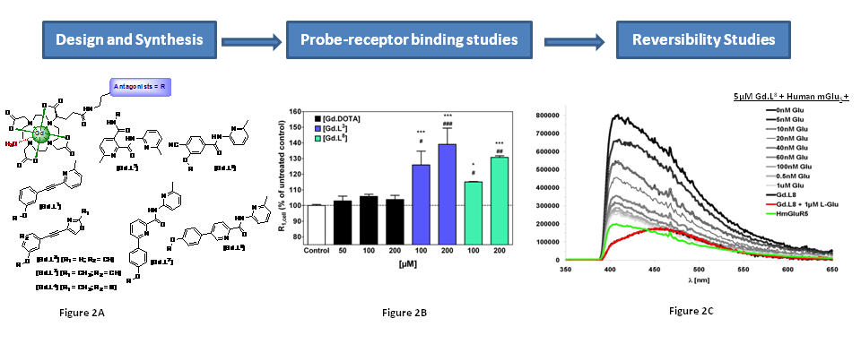
Summary. In summary GluRCAs [Gd.L³] and [Gd.L⁸] are promising candidates as imaging probes that could allow the monitoring of events induced by fluctuations in local Glu concentrations. They exhibit a significant relaxation rate increase in the presence of the mGluR₅ on primary astrocytes, and function as antagonists as revealed by functional calcium binding assays. The reversibility of binding to the receptors is further exemplified in fluorescence studies with [Gd.L⁸], demonstrating that addition of glutamate leads to release of the complex from the receptor binding site.
Dissemination. The work has been reported at scientific meetings in Turin, Santa Fe (USA) and forms the basis of two articles about to be submitted for publication. A French company has expressed an interest in the systems and is screening the scope of the probes for their own commercial assays.

Here, the EC₅₀ is the concentration of Glu that gives a response half way between bottom and top of the fitting curve, as reported by the fluo-4 indicator for calcium.

