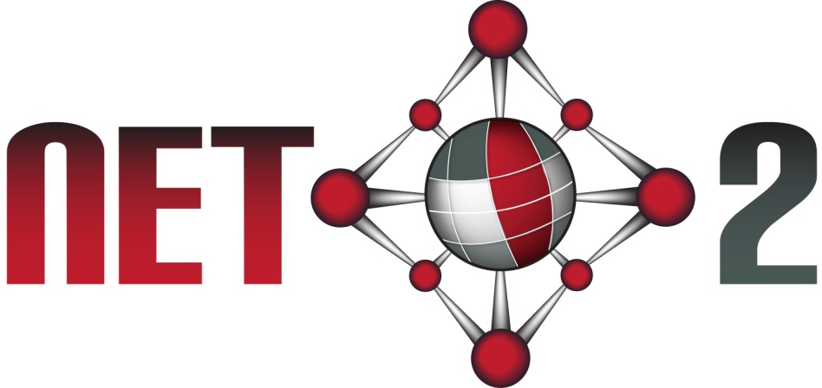

Net2: A Network for Enabling Networked Knowledge
The wealth of information and services on today’s information infrastructures like the Internet and the Web has significantly changed everyday life and has substantially transformed the way in which business, public and private interactions are performed globally. The economic and social influence of the Web is enormous, enabling new business models and social change, and creating wealth. However, we have barely scratched the surface of what information technology can do for society. The Web has enabled information creation and dissemination, but has also opened the information floodgates. The enormous amount of information available has made it increasingly difficult to find, access, present and maintain the information required. As a consequence, we are drowning in information and starving for knowledge. This project and network is aiming – as part of a global effort – to remedy this situation by contributing to the emerging next generation of the World Wide Web, continuing to build on ideas from Vannevar Bush, Doug Engelbart and Tim Berners-Lee on enabling systematic and access to explicitly represented and networked knowledge. It is our central hypothesis that collaborative production and access to networked knowledge assists humans, organisations and systems with their individual as well as collective problem solving, creating solutions to problems that were previously thought insolvable, and enabling innovation and increased productivity on individual, organisational and global levels. The Net2 research plan aims to:
- research the principles, technologies and techniques for creating, managing and exploiting networks of knowledge using the Web
- produce real-world networks of knowledge that provide maximum gains over the coming years for human, organisational and systems problem solving

Partners
- Digital Enterprise Research Institute (DERI), National University of Ireland, Galway (NUIG), Ireland
- Free University of Bozen/Bolzano (FUB), Italy
- Institute of Information Systems at the Vienna University of Technology (TUWIEN), Austria
- Institute for Web Science and Technologies at University of Koblenz-Landau (UKoblenz), Germany
- Technische Universiteit Delft (TUDelft), the Netherlands
- Universidad de Chile (UChile), Chile
- Pontificia Universidad Católica de Chile (PUC-Chile), Chile
- Pontifical Catholic University of Rio de Janeiro (PUC-Rio), Brazil
- African Advanced Institute for Information & Communication Technology (MERAKA)
- University of South Africe (UNISA), South Africa
- Shanghai Jiao Tong University (SJTU), China

Work packages
- WP1 - Networked Web and Knowledge Engineering
- WP2 - Natural Language Processing for Networked Knowledge
- WP3 – Reasoning and Querying for Networked Knowledge
- WP4 – Dissemination and Exploitation

Joint Net2 Tutorials
Lectures, seminars, and tutorials that have been presented by Net2 partners are as follows. All tutorials have been recorded and are accessible from http://net2.deri.ie/net2/Tutorials
- An Answer Set Programming Tutorial
- Answer-Set Programming: Basics, Combinations with Ontologies, and Debugging
- Data Exchange over RDF
- Evolving Web, Evolving Search & Heterogeneous Transfer Learning
- Exchanging More than Complete Data
- Exchanging more than Complete Data
- Managing Social Communities
- SPARQL1.1
- XSPARQL

Joint Net2 Publications
Net2 partners have published a number of joint publications, which are accessible from http://net2.deri.ie/net2/publications

Jointly Organized Net2 Events
- Net2 WP2 workshop on NLP and Semantic Technologies co-located with the TC37 2013 annual conference, Pretoria, South-Africa
- September 3-8 2012 - 8th Reasoning Web Summer School (RW 2012) http://reasoningweb.org/2012/
- September 10-12 2012 - 6th International Conference on Web Reasoning and Rule Systems (RR 2012) http://www.rr-conference.org/RR2012
- September 11-14 2012 - 2nd Workshop on the resurgence of Datalog in Academy and Industry (Datalog 2.0) http://www.dbai.tuwien.ac.at/event/datalog-2.0/
- October 2011 - ISWC-2011, 10th Int. Semantic Web Conference, http://iswc2011.semanticweb.org
- 26-30 September 2011 - Masters Artificial Intelligence School, held in Durban, South Africa http://cair.meraka.org.za/~mais2011/MAIS2011/Welcome.html
- 23-27 August 2011 - 7th ReasoningWeb Summer School http://reasoningweb.org/2011/
- 29-30 August 2011 - 5th International Conference on Web Reasoning and Rule Systems http://www.rr-conference.org/RR2011
- August 2011 - ESSIR-2011, European Summer School on Information Retrieval http://essir.uni-koblenz.de
- June 2011 - WebSci-11, 3rd Int Conf on Web Science, http://www.websci11.org/
- 8 February 2011 - Workshop at UNISA on Natural Language Processing, Ontologies and Linked Data for the Business Information Domain
- 19-30 July 2010 - Masters Ontology Winter School, held at Meraka http://krr.meraka.org.za/events/general-events/masters-ontology-winter-school
- SWAP/RR2010 - Attendance of several Net2 members, SPARQL1.1 Tutorial by Axel Polleres (DERI)
- ISWC2010 Net2 kickoff meeting! Several NEt2 partners involved in ISWC organisation (PC membership, papers presented at the event, DERI part of the organisers (Conference Web page including Semantic Technologies based on Drupal, jointly done by DERI and STJU)

