PROJECT FINAL REPORT
 FINAL PUBLISHABLE SUMMARY REPORT
Investigating the Mechanism of the Fe^{II}/2-Oxoglutarate-Dependent Histone Demethylases by a Combined Biochemical/Biophysical Approach
Histone lysine demethylases comprise an important family of epigenetic regulatory enzymes. They catalyse the demethylation of tri-, di- and monomethylated lysine residues of histones, thus contributing to either silencing or activation of chromatin. Most histone lysine demethylases belong to the 2-oxoglutarate (2OG) and ferrous iron dependent dioxygenase superfamily. This family utilises molecular oxygen to catalyse the hydroxylation of substrates, in a process coupled with 2OG decarboxylation. The histone demethylase KDM4E, a member of the human KDM4 (JMJD2) subfamily which acts on tri- and dimethylated H3K9 (histone H3 lysine 9), has the structural features typical of Fe(II)/2OG oxygenases. KDM4E catalysis is proposed to occur according to the consensus mechanism for (most) 2OG oxygenases (Figure 1).
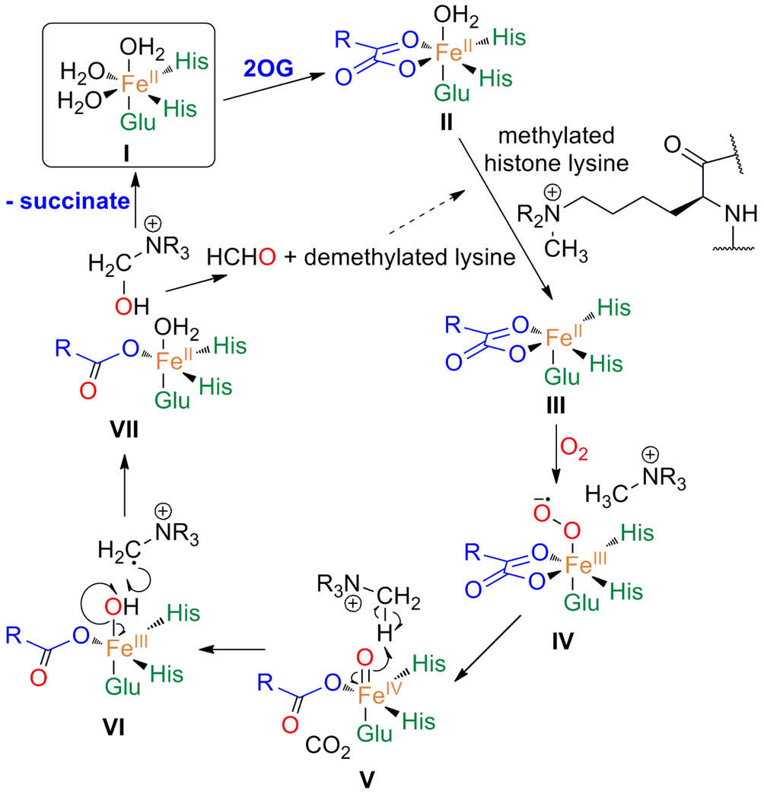
Figure 1. Proposed mechanism of KDM4E
O₂ is the final substrate to bind to the KDM4E:Fe(II):2OG:H3K9 complex (I-III) resulting in generation of a Fe(IV)-oxo species that enables hydroxylation of the unactivated C-H bond (IV-VI). The unstable hydroxymethyl product is released as HCHO (VII), to give the N-demethylated product.
Continuing with our investigations into demethylation mechanism and effects of oxygen levels on KDM4E demethylase activity, stopped-flow UV-vis spectroscopy kinetic experiments, along with rapid chemical quench and NMR spectroscopy experiments were conducted under the same conditions. The research findings obtained in the presence of KDM4E:Fe(II):2OG complex with various tri-, di-, mono- and unmethylated substrates (H3K9) after mixing with oxygen-saturated buffer show a peak at 320 nm. It is possible that the 320 nm species observed corresponds to the proposed Fe(IV)=O (ferryl) intermediate (Figure 1), and decay of this feature reflects the abstraction of hydrogen from the substrate as demonstrated for other similarly studied 2OG dependent oxygenases, such as taurine dioxygenase and prolyl-4-hydroxylase. The results reveal that the rate of reaction of the KDM4E:Fe(II):2OG:substrate complex with O₂ is slow as observed for prolyl hydroxylase 2 (PHD2), a hypoxia-inducible factor (HIF) hydroxylase with a proposed O₂-sensing role. Interestingly, they also reveal that the rate of formation of apparent intermediates (320 nm-absorbing species) is dependent on the methylation state of the substrate (H3K9 me3/me2/me1/me0) and the potential for histone demethylase activity to be regulated by oxygen availability in a biologically relevant manner. Overall the results support a mechanism for histone demethylases proceeding via sequential 2-oxoglutarate, histone, and finally oxygen binding. This work will be of significant biological interest to the wide range of scientists that are interested in the fields of epigenetics and hypoxia as this is the first kinetic study of the reaction of a histone demethylase with O_{2.}
Acknowledgments
The research leading to these results has received funding from the European Union Seventh Framework Programme (FP7/2007-2013) under grant agreement n° [252217]. Proposal Acronym: “Histone Demethylases”
Relevant contact details:
-Postdoctoral researcher: Dr. Elena M. Sanchez-Fernandez,
Email address: elena.sanchezfernandez@chem.ox.ac.uk
-Scientist in charge: Professor Christopher J. Schofield, http://www.chem.ox.ac.uk/oc/cjschofield
Email address: christopher.schofield@chem.ox.ac.uk
Chemistry Research Laboratory (CRL), 12 Mansfield Road, OX1 3TA, University of Oxford (United Kingdom).



