**Mathematical Virology: A classification of virus architecture and the structural transitions important for maturation and infection**

Scientist in charge of the supervision of the project: Prof. Reidun Twarock

Researcher: Dr. Giuliana Indelicato

University of York, UK

**Summary of project aims and context**

Understanding the mathematical and physical principles underlying virus structure and the mechanisms of formation and infection is paramount for preventing and tackling epidemics. The majority of viruses have protein shells (capsids or nucleocapsids) whose basic function is to package the viral DNA or RNA and hence provide protection from the environment. Viruses from different families exhibit similar (homologous) capsid and capsid protein structures despite a lack of significant sequence similarity, suggesting that there are fundamental design principles common to these viruses. One such principle is that of genetic economy: larger capsids are built from multiple copies of a relatively small number of identical building blocks. It is important for viruses to self-assemble quickly once the constituents are available and to guarantee a sufficient yield of intact virus particles. Evolution has solved this design problem using symmetry. A large number of viral capsids exhibit icosahedral symmetry, i.e. they share mathematical properties with a mathematical shape called icosahedron (see Fig. 1).

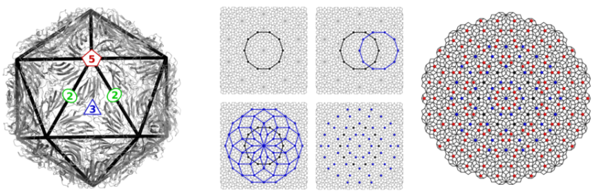   
Since symmetry plays a key role in the assembly and function of capsids, it is natural to enquire about its role in one of the most important functions of the capsid: the release of the genetic material within the cell. Understanding this fundamental step in the infection process is important to inform the design of antiviral strategies that target this phenomenon. This project was concerned with studying these release mechanism for an important class of plant viruses that cause major economic damage in agriculture. For these plant viruses, an expansion and structural rearrangement of the capsid plays a major role in the infection process, resulting in the opening of channels in the container through which genomic material is released in the host cell. Our goal was to understand the role of symmetry in this opening and rearrangement event and to study the mechanisms by which it occurs.

Fig. 1: Example of a viral capsid with an icosahedron superimposed on its surface. Examples of 5-, 3- and 2-fold symmetry axes are shown superimposed. The capsid has the same mathematical properties as the icosahedron.

**Summary of work performed**

Below we give details regarding our results concerning the project objectives listed in the proposal:

*i) Symmetry properties of transition intermediates:*

In order to better understand the transition paths from the closed to the open form of the capsid, we started by analysing the symmetry properties of the transition intermediates. For this we chose the libraries of point sets developed by Twarock’s group at YCCSA as descriptors for capsid geometry. These point sets are by construction subsets of vertex sets of aperiodic structures known as quasicrystals. We used the fact that these can be constructed via projection from the points of a suitable 6d hypercubic crystal lattice. We took inspiration from crystal physics: in this field, it is known that transformation paths between different phases of a crystal tend to keep maximal intermediate symmetry. The theory of structural transformation of crystals is a well-developed tool that can be used to study the role of symmetry in transformations of regular sets of points; however a corresponding theory for quasi-lattices had not been available. We developed such a theory in this project: by lifting the point sets with icosahedral symmetry to a six-dimensional hypercubic crystal and constructing corresponding symmetry preserving transformations in 6D, we were then able to induce corresponding transition in 3D via projection. We have applied this method to the plant virus CCMV. Our results show that only low-symmetry crystallographic transformations can occur between the initial and final stages of the capsid.

*ii) A description of virus structure via tilings and corresponding quasi-lattice transitions*

As mentioned above, the library of point arrays can be viewed as subsets of quasi-lattices or aperiodic tilings, and tilings therefore provide information on virus structure in addition to that encoded by the descriptors. An example of such a tiling is shown in Fig. 2. It is therefore possible to study structural transitions of viral capsids by analysing the structural transitions of aperiodic tilings. We have used the technique developed in i) above to tackle this problem.

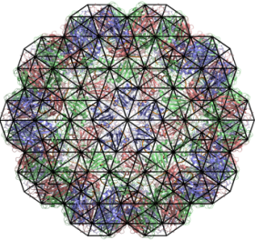 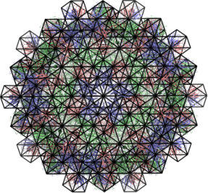

Fig. 2: Examples of 3D tilings representing viral capsids. Tilings have been obtained via the projection method from a BCC (Body centred cubic) lattice in 6D, which corresponds to one of the three Bravais lattice types with icosahedral symmetry.

In preparation for a study of 3D tilings we have focused first on the Penrose tiling of the plane, and have then applied the procedure to three dimensional icosahedral tilings. Our analysis shows that symmetry-preserving transformations of such tilings occur by well defined mechanisms, involving the nucleation of newly-shaped tiles that propagate along the original structure. As a result we have developed a theory for quasi-lattice transitions that should be of independent interest also in physics and materials science.

*iii) Introducing the concept of energy into the model – coupling biophysics with mathematics*

The above considerations were based entirely on mathematical considerations. In the final step of the project, we have coupled these insights with biophysics. For this, we have developed a coarse-grain approach in which proteins are approximated as rigid units, linked by peptidic chains, and interacting by surface cohesive forces. This approach is substantiated by the fact that conformational changes of the capsid are a result of different energetic contributions that result in a collective rigid motion of the proteins. We used state-of-the-art computational tools (via our contacts with the Micheletti group at SISSA) to decompose protein assemblies in rigid domains. Our goal was to quantify whether the capsid opens in a highly-symmetric expansive movement, or by an expansion wave propagating along the particle. We have shown that it is energetically favourable for the opening to occur through a cascade of localized detaching events that propagate as a wave along the capsid. The cascade is triggered by the weakening of a few localized bonds between the capsomeres (i.e. the main protein building blocks of the capsid), for instance, due to a change of the chemical environment of the capsid. We have shown that even though the intermediate configurations have low symmetry, the final open state is icosahedral.

**Summary of main conclusions**:

We have developed a theory of quasi-lattice transitions that allows us to quantify structural transitions in tilings with non-crystallographic symmetry. We have applied it specifically to icosahedral viral capsids, and have elucidated the role of symmetry in such transitions. We have been able to couple these results with biophysics to account for the energetic contributions. We have formulated a model for the expansion of the capsid in which proteins are represented as rigid blocks. The analysis has allowed us to show that it is more energetically favourable for the opening of channels in viral capsids to occur through a cascade of capsomere motions that propagates like a wave along the viral shell. This approach provides a basis for a predictive analysis of the release mechanism of nucleic acid in viruses, which is currently not accessible to experiment.

**Impact of results**

Our work provides new insights into transition events in viral capsids, which form a crucial part in the life-cycle of important classes of viruses, in particular plant viruses that are responsible for significant economic losses. Our results are primarily of interest to experimental biologists and biophysicists working in the area of virology. In addition, the methods devised to study structural transitions in aperiodic tilings should be of independent interest also in other areas, such as materials science. The insights concerning structural transitions in viral capsids gained here have the potential to impact also on the design of anti-viral strategies that act as inhibitors of these mechanisms.