

PROJECT FINAL REPORT

Grant Agreement number: 253096
Project acronym: BAAGS
Project title: Bacterial alginate: isolation, fine structure characterization and role in aerobic sludge formation
Funding Scheme: FP7-MC-IEF
Period covered: from 08-09-2010 to 08-09-2012
Name of the scientific representative of the project's co-ordinator, Title and Organisation:
Prof. dr.Ir, T.H.J.J. van der Hagen
Dean of the Faculty of Applied Science
TECHNISCHE UNIVERSITEIT DELFT
Tel: 0031-15-2784841
Fax:0031-15-2782655
E-mail: t.h.j.j.vanderhagen@tudelft.nl

Final publishable summary report

Executive summary

Aerobic sludge granulation is strongly connected with the property of exopolysaccharides, particularly the bacterial alginates, which have been recently shown to be more than 10% of aerobic granules’ organic carbon content. Determining their function based on clearly defined analytical methods is significant for bringing this technology into practice. The overall objective of the BAAGS project is to study the fine structure of bacterial alginate in aerobic granular sludge formation and stability, and establish analytical methods for advanced exopolysaccharides characterization in aerobic granules. Important progress has been made during the last two years: not only on the analytical methods for alginate-like exopolysaccharides characterization, but also on elucidating its role in granules formation. Secondly, the inducement effect of alginate-like exopolysaccharides on mineral accumulation in aerobic granular sludge was also discovered. In addition, a method to measure the mechanical strength of anammox granules and detect apatite accumulation inside granules was established. As a result, information obtained from BAAGS research project greatly facilitates exopolysaccharides research in aerobic granular sludge area; knowledge obtained provides insight on exopolysaccharides function both in aerobic granules and normal biofilms, and utilization the alginate-like exopolysacchairdes from aerobic granular sludge.

4.1.1 Project context and objectives

Aerobic sludge granulation is a promising innovative technology with the potential to be an alternative to the activated sludge process. It allows running a wastewater treatment plant with 30% less energy input, and requiring 75% less space combining with significant lower investment costs. Aerobic granules’ stability is the main concern of this process. It is strongly connected with the property of exopolysaccharides, particularly the bacterial alginates, which have been recently shown to be more than 10% of aerobic granules’ organic carbon content. Determining their function based on clearly defined analytical methods is significant for bringing this technology into practice.

The overall objective of the BAAGS project is to study the fine structure of bacterial alginate in aerobic granular sludge formation and stability, and establish analytical methods for advanced exopolysaccharides characterization in aerobic granules.

The specific objectives of the research are: standardize the method for bacterial alginate extraction from aerobic granular sludge and other bioflm systems; fully establish integrated methods for the extracted bacterial alginate fine structure examination combining chemical assays and physical analysis; determine the structure-function relationship of the extracted bacterial alginate; evaluate its impact on aerobic granular sludge formation and stability.

4.1.2 Main S&T results

The project was started from September, 2010. During the last two years, investigation was conducted based on the objective and methodologies described in the contract. The research objectives, as set down in the project programme are still very relevant and achievable. The methodological approach was minor changed from that described in the contract.

Important progress has been made not only on the analytical methods for alginate-like exopolysaccharides characterization, but also on elucidating its role in granules formation. Secondly, the inducement effect of alginate-like exopolysaccharides on mineral accumulation in aerobic granular sludge was also discovered. In addition, a method to measure the mechanical strength of anammox granules and detect apatite accumulation inside granules was established. Details are explained as follows:

Fine structure investigation of the alginate-like exopolysaccharides isolated from pilot plant

Alginate-like exopolysaccharides, were isolated from aerobic granular sludge treating municipal wastewater. They were chemically fractionated and examined by FT-IR spectroscopy. The chemical structure of these alginates was linked to the ionic gelation behaviour of the exopolysaccharides in aerobic granular sludge. Ca²⁺ induced ionic gelation was investigated by atomic force microscopy. Experimental results indicated that each fraction in alginates, poly(mannuronic acid) blocks, poly(guluronic acid) blocks and heteropolymeric blocks, had its specific characteristics in gelation and morphology of the gel. Ca²⁺ induced the ionic gelation of alginate-like exopolysaccharides by transforming a loose structure into an ordered and compact structure with pores and channels distributed through the matrix. Fractions enriched in poly(guluronic acid) blocks and heteropolymeric blocks were both easily cross-linked by Ca²⁺. Ionic cross-linked gel was the major form of polysaccharide gels in aerobic granules.

Understanding the difference between aerobic granular sludge and activated sludge from the chemical structure of alginate-like exopolysaccharides

The differences in the gel matrix of aerobic granular sludge and normal aerobic flocculent sludge were investigated. From both types of sludge that fed with the same municipal sewage, the functional gel-forming exopolysaccharides, alginate-like exopolysaccharides, were isolated. These two exopolysaccharides were chemically fractionated, and investigated by FT-IR spectroscopy. The isolated polymers were made into a gel by calcium addition (Figure 1) and the mechanical properties of these reconstituted gels were measured by a low load compression tester. The viscoelastic behavior of the gels was described by a generalized Maxwell model. The alginate-like exopolysaccharides derived from aerobic granules had significantly higher amount of poly(guluronic acid) blocks but lower amount of poly(guluronic acid-manuronic acid) blocks in the chemical structure, while the alginate-like exopolysaccharides derived from aerobic flocculent sludge had equal amount of poly(guluronic acid) blocks and poly(guluronic acid-manuronic acid) blocks. These differences result in a perfect gel-forming capability of alginate-like exopolysaccharides derived from aerobic granules (Figure 2) and bestowed this exopolysaccharides gel a stronger mechanical property as compared to alginate-like exopolysaccharides derived from aerobic flocculent sludge. The different chemical and mechanical properties of these two exopolysaccharides contributed to the distinguished characteristics between aerobic granular sludge and aerobic flocculent sludge.
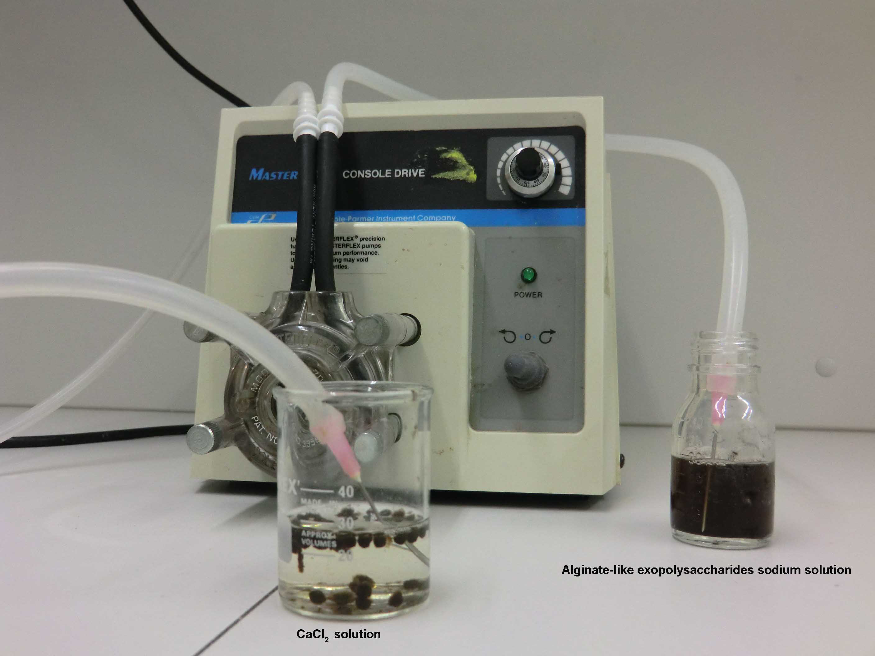

Figure 1 Making alginate-like exopolysaccharides gel by dropping 2% alginate-like exopolysacchairdes sodium solution into 2% CaCl₂ solution.

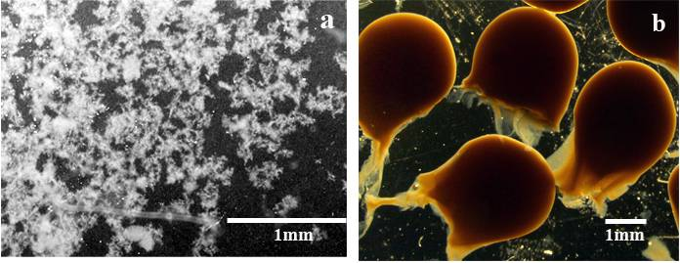

Figure 2 Morphology of alginate-like exopolysaccharides after crosslink with Ca²⁺. a: alginate-like exopolysaccharides derived from aerobic flocculent sludge in CaCl₂ solution; b: alginate-like exopolysaccharides derived from aerobic granular sludge in CaCl₂ solution.

Minerals in alginate-like exopolysaccharides

The K-struvite was found in aerobic granular sludge from a reactor performing enhanced biological phosphorus removal. The accumulation of K-struvite was attributed to the inducement of alginate-like exopolysaccharides.

The alginate-like exopolysaccharides were acidic due to the presence of uronic acids monomers. These negatively charged groups enable the exopolysaccharides to attract cations (e.g. Ca²⁺, Mg²⁺, Na⁺, K⁺) via electrostatic interactions. Alginates has higher affinity to Ca²⁺, but lower affinity to Mg²⁺, making Ca²⁺ participate in the formation of gel structure, while Mg²⁺ only use as the counter ions like Na⁺ and K⁺ in the gel. The weak binding of Mg²⁺ and K⁺ enabled them to combine with other ionic groups. Thus, the alginate exopolysaccharides matrix functions as a chelator for cations and as a template for crystal nucleation. In enhanced biological phosphorus removal process, phosphates with potassium and magnesium as counter ions are released by phosphorus accumulating organisms (PAOs) during the anaerobic feeding phase. The entrapment by alginate-like exopolysaccharides of potassium and magnesium ions produces a spatial-temporal gradient of concentration that enhances supersaturation conditions for the development of struvite-like structure. K-struvite formed in the granular sludge from lab-scale reactor, which has higher amounts of phosphate, potassium and magnesium release in the anaerobic period.

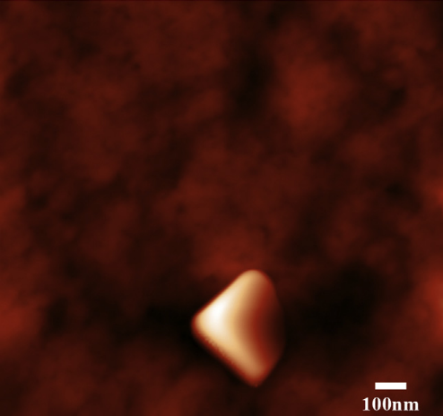
Figure 4: Pyramidal shaped crystals formed inside the dialysis bag when the alginate-like EPS dialyzed against NH₄Cl solution.

The mechanical strength measurement of anammox granules

The strength of granular sludge is essential to maintain their mechanical stability (Pereboom, 1997). Granules with low strength are easily broken by the shear force in the reactor. Broken pieces are likely to be washed out with the effluent, which significantly decrease the biomass concentration and result to unstable operation of the reactor. To an anammox system, it is significantly important to make granules maintain high strength. As the maximum specific growth rate of the anammox microorganisms is extremely low, the system is hardly recovered once biomass concentration is tremendously decreased due to biomass washout.
Various direct and indirect methods to quantify the physical characteristics of the granular sludge in terms of strength have been presented. The strength of granules was measured in several studies by examining the effects of shear force, sonication, shaking of the granules, or turbidity (Teo et al., 2000; Quarmby and Forster, 1995; Tramper et al., 1984). Microbial granules with a high physical strength could withstand compression. It could be measured as the resistance against compression forces (Van Hullebusch et al. 2007). In this method, granule samples were placed in a vertical cylinder. A piston was moved downwards at a constant speed and the resistance to compression was recorded with time using a tension and compression apparatus. The pressure at which the transition of the two resistances occurred was taken as a measurement of the granule strength. However, due to the limitation of the system, the measurement so far can only be done with large amount of granules. It is difficult to know the mechanical behavior of a single granule.

In the current research, it is possible to measure the mechanical strength of a single granule by low load compression tester (LLCT), due to its low compression force used and high sensitivity. The LLCT consists of a linear positioning stage (Intellistage M-511.5IM, physic Instrument, Karlsruhe, Germany) connected to a cylindrical, moving upper plate (10 mm diameter), a bottom stationary plate is fixed to an automated force compensating balance. Load cell and linear positioning stage are interfaced to a PC for data acquisition and control using LabVIEWTM 7.1 (Sharma et al., 2011). Movement of top plate (position, h) and force registered (Force, F) by the load cell were computer-stored for further analysis (Figure 2). The mechanical strength measurement is able to be finished within 100 seconds.
Bottom plate (fixed)
Top plate
t = t
Force = F₀
Force = F_{t}
Bottom plate (fixed)
Top plate
t = 0
h₀
h_{t}
one granule or floc
Figure 2 Viscoelasticity measurement by the low load compression tester. Both the position h and the force F are computer monitored, ht and Ft are the position and force at time t.

4.1.3 Research training activities

The researcher was trained on how to select one of the significant components from a complex environmental sample, establish appropriate methodology to isolate and examine it, by performing the project. She also learned how to conduct molecular microbiological studies of the genes for alginate production in aerobic granular sludge. By attending biofilm workshop concerning biofilm investigation by various analytical methods, and advanced courses for environmental biotechnology, her experience and understanding in microbiology was extended.

4.1.4 Project management

The project is processing smoothly; collaborations not only within the host research group, but also with research groups in Singapore, France, Spain and Denmark were setup. New analytical methodologies such as electron microprobe, micro-CT scan and prolysis-GC-MS are introduced into the research. The planned milestones and deliverables are reached.

4.1.5 Potential impact of the project
As a result, information obtained from BAAGS research project greatly facilitates exopolysaccharides research in aerobic granular sludge area; knowledge obtained provides insight on exopolysaccharides function both in aerobic granules and normal biofilms, and utilization the alginate-like exopolysacchairdes from aerobic granular sludge.

Potential utilization of the research result

Alginates can be used as viscosifiers, stabilizers, gel-formers, film-formers or water binding agents. The applications range from textile printing, welding rods, food industries to pharmaceutical uses. The estimated price of alginate is 0.75 €/kg for technical grade up to 3500€/kg for ultra pure alginate for pharmaceuticals. Currently the alginate is extracted from brown algae harvested from the sea. The season of harvesting influences the properties of the alginate, thereby the quality of the alginate can not be guaranteed. The most recent known attempt to produce alginate from bacteria was by Azotobacter vinelandii using a membrane bioreactor. Unsatisfactory results were obtained due to membrane fouling and a substandard molecular weight of the produced alginate.

In the past decade aerobic granular sludge has been developed as the next generation wastewater treatment process. The granules produced in the waste water treatment process are considered as waste so far. The costs of waste disposal are 500-600 € per ton of sludge. This represents roughly one third of the waste water treatment costs. However, recently we discovered that granules contain 10 % w/w of alginate. There is a rich resource hidden in wastewater treatment process. Production of alginate by aerobic granular sludge processes may provide alginate with a controlled quality and reduced price. The extraction of alginate from the waste granules decreases the total waste and reduces the costs of the processing of the sludge.

Section A (public)

A1: list of scientific (peer reviewed) publications, starting with the most important ones
NO. | Title | Main author | Title of the periodical or the series | Number, date or frequency | Publisher | Place of publication | Year of publication | Relevant pages | Permanent identifiers  (if available) | Is/Will open access provided to this publication?
1 | The contribution of exopolysaccharides indueced struvites accumulation to ammonium adsorption in aerobic granular sludge. | Lin Y.M., Bassin J. and van Loosdrecht M.C.M | Water research | December,2011 | Elsevier | Netherlands | 2012 (46) | pp. 986 - 992 |  | no
2 | Aerobic sludge granulation: A tale of two polysaccharides. | Seviour T., Yuan,Z.G., van Loosdrecht M.C.M and Lin Y.M. | Water research | June, 2012 | Elsevier | Netherlands | 2012 (46) | pp. 4803 - 4813 |  | no
3 | The chemical and mechanical difference between alginate-like exopolysaccharides isolated from aerobic flocculent sludge and aerobic granular sludge | Lin Y.M., Sharma P.K.. and van Loosdrecht M.C.M | Water research |  | Elsevier | Netherlands | 2012 | http://dx.doi.org/10.1016  /j.watres.2012.09.017 |  | no

A2: list of dissemination activities
NO. | Type of activities | Main leader | Title | Date | Place | Type of audience | Size of audience | Countries addressed
1 | Long platform presentation, 7th IWA World Water Congress (International) | Lin Y.M., | Fractionation of Alginate like Exopolysaccharides Isolated from Aerobic Granular Sludge | October, 2010 | Montreal, Canada | Scientific community (higher education, research) | 300 | Canada
2 | Oral presentation, IWA biofilm conference (International) | Lin Y.M. | Understanding the difference between aerobic granular sludge and activated sludge from the chemical structure of alginate-like exopolysacchairdes | October, 2011 | Shanghai, China | Scientific community (higher education, research | 200 | China
3 | Aerobic granular sludge workshop (International), Oral presentation, | Lin Y.M. | The EPS matrix in aerobic granular sludge | October, 2011 | Shanghai, China | Scientific community (higher education, research | 200 | China

Report on societal implications

Replies to the following questions will assist the Commission to obtain statistics and indicators on societal and socio-economic issues addressed by projects. The questions are arranged in a number of key themes. As well as producing certain statistics, the replies will also help identify those projects that have shown a real engagement with wider societal issues, and thereby identify interesting approaches to these issues and best practices. The replies for individual projects will not be made public.

 | A General Information (completed automatically when Grant Agreement number is entered.
 | Grant Agreement Number: |  |  |  |  |  |  |  |  |  |  |  |  |  |  |  | PIEF-GA-2009-253096
 | Title of Project: |  |  |  |  |  |  |  |  |  |  |  | Bacterial alginate: isolation, fine structure characterization and role
 |  |  |  |  |  |  |  |  |  |  |  |  | in aerobic granular sludge formation
 | Name and Title of Coordinator: |  |  |  |  |  |  |  |  |  |  |  | Prof. T.H. J.J. van der Hagen
 |  |  |  |  |  |  |  |  |  |  |  |  | Dean of the Faculty of Applied Science, Technische Universiteit Delft
 |  |  | B Ethics
 |  | 1. Did your project undergo an Ethics Review (and/or Screening)?  - If Yes: have you described the progress of compliance with the relevant Ethics Review/Screening Requirements in the frame of the periodic/final project reports?  Special Reminder: the progress of compliance with the Ethics Review/Screening Requirements should be described in the Period/Final Project Reports under the Section 3.2.2 'Work Progress and Achievements' |  |  |  |  |  |  |  |  |  |  |  |  |  |  |  |  |  |  |  |  |  |  |  |  |  |  |  |  |  |  |  |  |  | √ No
 |  | 2. Please indicate whether your project involved any of the following issues (tick box) : |  |  |  |  |  |  |  |  |  |  |  |  |  |  |  |  |  |  |  |  |  |  |  |  |  |  |  |  |  |  |  |  |  | YES
 |  | Research on Humans
 |  | - Did the project involve children?
 |  | - Did the project involve patients?
 |  | - Did the project involve persons not able to give consent?
 |  | - Did the project involve adult healthy volunteers?
 |  | - Did the project involve Human genetic material?
 |  | - Did the project involve Human biological samples?
 |  | - Did the project involve Human data collection?
 |  | Research on Human embryo/foetus
 |  | - Did the project involve Human Embryos?
 |  | - Did the project involve Human Foetal Tissue / Cells?
 |  | - Did the project involve Human Embryonic Stem Cells (hESCs)?
 |  | - Did the project on human Embryonic Stem Cells involve cells in culture?
 |  | - Did the project on human Embryonic Stem Cells involve the derivation of cells from Embryos?
 |  | Privacy
 |  | - Did the project involve processing of genetic information or personal data (eg. health, sexual lifestyle, ethnicity, political opinion, religious or philosophical conviction)?
 |  | - Did the project involve tracking the location or observation of people?
 |  | Research on Animals
 |  | - Did the project involve research on animals?
 |  | - Were those animals transgenic small laboratory animals?
 |  | - Were those animals transgenic farm animals?
 |  | - Were those animals cloned farm animals?
 |  | - Were those animals non-human primates?
 |  | Research Involving Developing Countries
 |  | - Did the project involve the use of local resources (genetic, animal, plant etc)?
 |  | - Was the project of benefit to local community (capacity building, access to healthcare, education etc)?
 |  | Dual Use
 |  | - Research having direct military use |  |  |  |  |  |  |  |  |  |  |  |  |  |  |  |  |  |  |  |  |  |  |  |  |  |  |  |  |  |  |  |  |  | 0 Yes √ No
 |  | - Research having the potential for terrorist abuse
C Workforce Statistics
3. Workforce statistics for the project: Please indicate in the table below the number of people who worked on the project (on a headcount basis).
Type of Position |  |  |  |  |  |  |  |  |  |  |  |  |  |  |  |  |  |  | Number of Women |  |  |  |  |  |  |  |  |  | Number of Men
Scientific Coordinator |  |  |  |  |  |  |  |  |  |  |  |  |  |  |  |  |  |  |  |  |  |  |  |  |  |  |  |  | 1
Work package leaders
Experienced researchers (i.e. PhD holders) |  |  |  |  |  |  |  |  |  |  |  |  |  |  |  |  |  |  | 1
PhD Students
Other
4. How many additional researchers (in companies and universities) were recruited specifically for this project?
Of which, indicate the number of men:

D Gender Aspects
5. Did you carry out specific Gender Equality Actions under the project? |  |  |  |  |  |  |  |  |  |  |  |  |  |  |  |  |  |  |  |  |  |  |  |  |  |  |  |  |  |  |  |  | ● |  |  |  | Yes
6. Which of the following actions did you carry out and how effective were they?
 |  |  |  |  |  |  |  | Not at all  effective |  |  |  |  |  |  |  |  |  |  |  |  |  |  |  |  |  |  |  |  |  | Very  effective
 |  |  |  |  |  |  | √ | Design and implement an equal opportunity policy |  |  |  |  |  |  |  |  |  |  |  |  |  |  |  | ○ | ○ | ○ |  | ○ |  | ●
 |  |  |  |  |  |  | ❑ | Set targets to achieve a gender balance in the workforce |  |  |  |  |  |  |  |  |  |  |  |  |  |  |  | ○ | ○ | ○ |  | ○ |  | ○
 |  |  |  |  |  |  | ❑ | Organise conferences and workshops on gender |  |  |  |  |  |  |  |  |  |  |  |  |  |  |  | ○ | ○ | ○ |  | ○ |  | ○
 |  |  |  |  |  |  | ❑ | Actions to improve work-life balance |  |  |  |  |  |  |  |  |  |  |  |  |  |  |  | ○ | ○ | ○ |  | ○ |  | ○
 |  |  |  |  |  |  | ○ | Other:
7. Was there a gender dimension associated with the research content – i.e. wherever people were the focus of the research as, for example, consumers, users, patients or in trials, was the issue of gender considered and addressed?
 |  |  |  |  |  |  | ○ | Yes- please specify
 |  |  |  |  |  |  | ● | No
E Synergies with Science Education
8. Did your project involve working with students and/or school pupils (e.g. open days, participation in science festivals and events, prizes/competitions or joint projects)?
 |  |  |  |  |  |  | ○ | Yes- please specify
 |  |  |  |  |  |  | ● | No
9. Did the project generate any science education material (e.g. kits, websites, explanatory booklets, DVDs)?
 |  |  |  |  |  |  | ○ | Yes- please specify
 |  |  |  |  |  |  | ● | No
F Interdisciplinarity
10. Which disciplines (see list below) are involved in your project?
 |  |  |  |  |  |  | ● | Main discipline: environmental engineering
 |  |  |  |  |  |  | ● | Associated disciplineError: Reference source not found: microbiology, analytical biochemistry |  |  |  |  |  |  |  | ○ |  |  |  | Associated disciplineError: Reference source not found:
G Engaging with Civil society and policy makers
11a Did your project engage with societal actors beyond the research community? (if 'No', go to Question 14) |  |  |  |  |  |  |  |  |  |  |  |  |  |  |  |  |  |  |  |  |  |  |  |  |  |  |  |  |  |  |  |  | ●  ○ |  |  |  | Yes  No
11b If yes, did you engage with citizens (citizens' panels / juries) or organised civil society (NGOs, patients' groups etc.)?
 |  |  |  |  |  |  | ○ | No
 |  |  |  |  |  |  | ○ | Yes- in determining what research should be performed
 |  |  |  |  |  |  | ○ | Yes - in implementing the research
 |  |  |  |  |  |  | ○ | Yes, in communicating /disseminating / using the results of the project
11c In doing so, did your project involve actors whose role is mainly to organise the dialogue with citizens and organised civil society (e.g. professional mediator; communication company, science museums)? |  |  |  |  |  |  |  |  |  |  |  |  |  |  |  |  |  |  |  |  |  |  |  |  |  |  |  |  |  |  |  |  |  | ○  ○ |  |  | Yes  No
12. Did you engage with government / public bodies or policy makers (including international organisations)
 |  |  |  |  |  |  | ○ | No
 |  |  |  |  |  |  | ○ | Yes- in framing the research agenda
 |  |  |  |  |  |  | ○ | Yes - in implementing the research agenda
 |  |  |  |  |  |  | ○ | Yes, in communicating /disseminating / using the results of the project
13a Will the project generate outputs (expertise or scientific advice) which could be used by policy makers?
 |  |  |  |  |  |  | ● | Yes – as a primary objective (please indicate areas below- multiple answers possible)
 |  |  |  |  |  |  | ○ | Yes – as a secondary objective (please indicate areas below - multiple answer possible)
 |  |  |  |  |  |  | ○ | No
13b If Yes, in which fields?
Agriculture  Audiovisual and Media  Budget  Competition  Consumers  Culture  Customs  Development Economic and Monetary Affairs  Education, Training, Youth  Employment and Social Affairs |  |  |  |  |  |  |  |  |  |  | Energy  Enlargement  Enterprise  Environment  External Relations  External Trade  Fisheries and Maritime Affairs  Food Safety  Foreign and Security Policy  Fraud  Humanitarian aid |  |  |  |  |  |  |  |  |  |  |  | Human rights  Information Society  Institutional affairs  Internal Market  Justice, freedom and security  Public Health  Regional Policy  Research and Innovation  Space  Taxation  Transport
13c If Yes, at which level?
 |  |  |  |  |  |  | ○ | Local / regional levels
 |  |  |  |  |  |  | ● | National level
 |  |  |  |  |  |  | ● | European level
 |  |  |  |  |  |  | ● | International level
H Use and dissemination
14. How many Articles were published/accepted for publication in peer-reviewed journals? |  |  |  |  |  |  |  |  |  |  |  |  |  |  |  |  |  |  |  |  |  |  |  |  |  |  | 3
To how many of these is open access provided? |  |  |  |  |  |  |  |  |  |  |  |  |  |  |  |  |  |  |  |  |  |  |  |  |  |  | 3
How many of these are published in open access journals?
How many of these are published in open repositories?
To how many of these is open access not provided? |  |  |  |  |  |  |  |  |  |  |  |  |  |  |  |  |  |  |  |  |  |  |  |  |  |  | 0
Please check all applicable reasons for not providing open access:
❑ publisher's licensing agreement would not permit publishing in a repository
❑ no suitable repository available
❑ no suitable open access journal available
❑ no funds available to publish in an open access journal
❑ lack of time and resources
❑ lack of information on open access
❑ other: ……………
15. How many new patent applications (‘priority filings’) have been made? ("Technologically unique": multiple applications for the same invention in different jurisdictions should be counted as just one application of grant). |  |  |  |  |  |  |  |  |  |  |  |  |  |  |  |  |  |  |  |  |  |  |  |  |  |  |  |  |  |  | 0
16. Indicate how many of the following Intellectual Property Rights were applied for (give number in each box). |  |  |  |  |  |  |  |  |  |  |  |  |  |  |  |  |  |  |  |  |  | Trademark
 |  |  |  |  |  |  |  |  |  |  |  |  |  |  |  |  |  |  |  |  |  | Registered design
 |  |  |  |  |  |  |  |  |  |  |  |  |  |  |  |  |  |  |  |  |  | Other
17. How many spin-off companies were created / are planned as a direct result of the project? |  |  |  |  |  |  |  |  |  |  |  |  |  |  |  |  |  |  |  |  |  |  |  |  |  |  |  |  |  |  | 0
Indicate the approximate number of additional jobs in these companies:
18. Please indicate whether your project has a potential impact on employment, in comparison with the situation before your project:
 |  |  |  | ❑ |  | Increase in employment, or |  |  |  |  |  |  |  |  | ❑ |  |  | In small & medium-sized enterprises
 |  |  |  | ❑ |  | Safeguard employment, or |  |  |  |  |  |  |  |  | ❑ |  |  | In large companies
 |  |  |  | ❑ |  | Decrease in employment, |  |  |  |  |  |  |  |  | ❑ |  |  | None of the above / not relevant to the project
 |  |  |  | ● |  | Difficult to estimate / not possible to quantify
19. For your project partnership please estimate the employment effect resulting directly from your participation in Full Time Equivalent (FTE = one person working fulltime for a year) jobs:  Difficult to estimate / not possible to quantify |  |  |  |  |  |  |  |  |  |  |  |  |  |  |  |  |  |  |  |  |  |  |  |  |  |  |  |  |  |  |  | Indicate figure:  
I Media and Communication to the general public
20. As part of the project, were any of the beneficiaries professionals in communication or media relations?
 |  |  |  |  |  |  | ○ | Yes |  |  |  | ● |  | No
21. As part of the project, have any beneficiaries received professional media / communication training / advice to improve communication with the general public?
 |  |  |  |  |  |  | ○ | Yes |  |  |  | ● |  | No
22 Which of the following have been used to communicate information about your project to the general public, or have resulted from your project?
 |  |  |  | ❑ |  | Press Release |  |  |  |  |  |  |  |  | ❑ |  |  | Coverage in specialist press
 |  |  |  | ❑ |  | Media briefing |  |  |  |  |  |  |  |  | ❑ |  |  | Coverage in general (non-specialist) press
 |  |  |  | ❑ |  | TV coverage / report |  |  |  |  |  |  |  |  | ❑ |  |  | Coverage in national press
 |  |  |  | ❑ |  | Radio coverage / report |  |  |  |  |  |  |  |  | ❑ |  |  | Coverage in international press
 |  |  |  | ❑ |  | Brochures /posters / flyers |  |  |  |  |  |  |  |  | ❑ |  |  | Website for the general public / internet
 |  |  |  | ❑ |  | DVD /Film /Multimedia |  |  |  |  |  |  |  |  | ● |  |  | Event targeting general public (festival, conference, exhibition, science café)
23 In which languages are the information products for the general public produced?
 |  |  |  | ❑ |  | Language of the coordinator |  |  |  |  |  |  |  |  | ● |  |  | English
 |  |  |  | ❑ |  | Other language(s)

Question F-10: Classification of Scientific Disciplines according to the Frascati Manual 2002 (Proposed Standard Practice for Surveys on Research and Experimental Development, OECD 2002):

Fields of science and technology

1. Natural Sciences
1.1 Mathematics and computer sciences [mathematics and other allied fields: computer sciences and other allied subjects (software development only; hardware development should be classified in the engineering fields)]
1.2 Physical sciences (astronomy and space sciences, physics and other allied subjects)
1.3 Chemical sciences (chemistry, other allied subjects)
1.4 Earth and related environmental sciences (geology, geophysics, mineralogy, physical geography and other geosciences, meteorology and other atmospheric sciences including climatic research, oceanography, vulcanology, palaeoecology, other allied sciences)
1.5 Biological sciences (biology, botany, bacteriology, microbiology, zoology, entomology, genetics, biochemistry, biophysics, other allied sciences, excluding clinical and veterinary sciences)

2 Engineering and technology
2.1 Civil engineering (architecture engineering, building science and engineering, construction engineering, municipal and structural engineering and other allied subjects)
2.2 Electrical engineering, electronics [electrical engineering, electronics, communication engineering and systems, computer engineering (hardware only) and other allied subjects]
2.3. Other engineering sciences (such as chemical, aeronautical and space, mechanical, metallurgical and materials engineering, and their specialised subdivisions; forest products; applied sciences such as geodesy, industrial chemistry, etc.; the science and technology of food production; specialised technologies of interdisciplinary fields, e.g. systems analysis, metallurgy, mining, textile technology and other applied subjects)

3. Medical Sciences
3.1 Basic medicine (anatomy, cytology, physiology, genetics, pharmacy, pharmacology, toxicology, immunology and immunohaematology, clinical chemistry, clinical microbiology, pathology)
3.2 Clinical medicine (anaesthesiology, paediatrics, obstetrics and gynaecology, internal medicine, surgery, dentistry, neurology, psychiatry, radiology, therapeutics, otorhinolaryngology, ophthalmology)
3.3 Health sciences (public health services, social medicine, hygiene, nursing, epidemiology)

4. Agricultural sciences
4.1 Agriculture, forestry, fisheries and allied sciences (agronomy, animal husbandry, fisheries, forestry, horticulture, other allied subjects)
4.2 Veterinary medicine

5. Social sciences
5.1 Psychology
5.2 Economics
5.3 Educational sciences (education and training and other allied subjects)
5.4 Other social sciences [anthropology (social and cultural) and ethnology, demography, geography (human, economic and social), town and country planning, management, law, linguistics, political sciences, sociology, organisation and methods, miscellaneous social sciences and interdisciplinary , methodological and historical S1T activities relating to subjects in this group. Physical anthropology, physical geography and psychophysiology should normally be classified with the natural sciences].

6. Humanities
6.1 History (history, prehistory and history, together with auxiliary historical disciplines such as archaeology, numismatics, palaeography, genealogy, etc.)
6.2 Languages and literature (ancient and modern)
6.3 Other humanities [philosophy (including the history of science and technology) arts, history of art, art criticism, painting, sculpture, musicology, dramatic art excluding artistic "research" of any kind, religion, theology, other fields and subjects pertaining to the humanities, methodological, historical and other S1T activities relating to the subjects in this group]

Usually the contact person of the coordinator as specified in Art. 8.1. of the Grant Agreement.
A permanent identifier should be a persistent link to the published version full text if open access or abstract if article is pay per view) or to the final manuscript accepted for publication (link to article in repository).
Open Access is defined as free of charge access for anyone via Internet. Please answer "yes" if the open access to the publication is already established and also if the embargo period for open access is not yet over but you intend to establish open access afterwards.
A drop down list allows choosing the dissemination activity: publications, conferences, workshops, web, press releases, flyers, articles published in the popular press, videos, media briefings, presentations, exhibitions, thesis, interviews, films, TV clips, posters, Other.
A drop down list allows choosing the type of public: Scientific Community (higher education, Research), Industry, Civil Society, Policy makers, Medias ('multiple choices' is possible.
Insert number from list below (Frascati Manual).
Open Access is defined as free of charge access for anyone via Internet.
For instance: classification for security project.

