**Final publishable summary report**

**EXECUTIVE SUMMARY**

Catalysts accelerate chemical reactions and are keys in the production of fuels, plastics, pharmaceuticals, and others. Most catalysts are solids incorporating metals as the active sites. To achieve optimum performance, it is necessary to understand how the structure of the sites affects their catalytic properties. The complexity of common industrial catalysts hinders this understanding, because they consist of mixtures of structures whose role cannot be resolved unambiguously.

In contrast, when the active sites are synthesized to be simple and uniform, a solid basis for designing new materials is established. We anchored metals in well-defined structures onto surfaces with variable characteristics. The structure of the metal sites was tuned at a molecular level by treatments in controlled atmospheres, with the changes being precisely determined via state-of-the-art spectroscopy and microscopy. Correlations between the structures and the catalytic performance enabled the design of improved catalysts, some with excellent potential to replace current technological catalysts.

**SUMMARY DESCRIPTION OF PROJECT CONTEXT AND OBJECTIVES**

Solid catalysts, the keys to efficient fuel conversion, chemical manufacture, and pollution abatement, typically consist of nanostructures (metals, metal oxides, or metal sulfides) on porous supports. The performance of a supported catalyst is influenced by the size, shape, and structure of the metal species; the ligands bonded to the metal; and the support, which itself acts as a ligand when the metal species are small enough to be essentially molecular. Resolution of these effects is challenging because the typical solid catalyst consists of highly nonuniform supported species, on support surfaces that themselves are intrinsically nonuniform. Besides hindering fundamental understanding, the nonuniformity often implies low catalytic selectivity.

In contrast, the typical soluble catalyst, like many metalloenzymes, incorporates a molecular metal complex or cluster with a unique structure that can be determined precisely for fundamental understanding of the catalytic function. Such understanding is similarly achievable with supported catalysts, provided that they are synthesized to incorporate uniform, isolated catalytic structures. The challenge begins with the synthesis.

Our main goal was to gain understanding of the catalytic properties of solids that incorporate uniform, essentially molecular metal species, by using spectroscopic methods to track the reactions of the sites with small ligands introduced into the sample from the gas phase, with these ligands being chosen to include those involved in catalytic reactions. Thus, we sought methods for the preparation of well-defined catalytic structures on supports, and then investigated their performance in a variety of reactive atmospheres.

A particular objective was to better understand the initial steps of metal cluster formation by investigating the reactions of small, essentially molecular metal species on supports, and to learn how to limit the growth of the metal species to extremely small clusters. Thus, we investigated the formation of the smallest metal clusters formed from single-metal-atom (mononuclear) metal complexes on supports.

We aimed at the investigation of set of catalysts that allow resolution of the roles of the support and the nuclearity of the metal species in catalysis. We focused on supported catalytic species that are essentially molecular, incorporating controlled numbers of metal atoms and well-defined structures that are (a) stable during catalysis; (b) fully accessible to reactants; (c) present on supports with markedly different reactivities; (d) bonded equivalently to each support; (e) lacking ligands other than the support and reactants; and (f) characterizable by spectroscopy in the functioning state.

Initially, the following variables were considered in the design of well-defined solid catalysts: (a) choice of the metal (Rh or Ir); (b) variation of the metal nuclearity; (c) variation of the support (chosen to be electron-donating, MgO, or electron-withdrawing, HY zeolite); and (d) variation of the ligands on the metal. This approach was proposed to be extended to catalysts that incorporate two metals on the same surface of a support (bimetallic samples). We anticipated that the investigation of these structural factors might open the opportunity for improvement of catalytic technology in reactions of industrial interest.

To determine the structures of the active species, we proposed the use of extended X-ray absorption fine structure (EXAFS) and infrared (IR) spectroscopies and high-angle annular dark-field scanning transmission electron microscopy (HAADF-STEM). To determine the performance of the various catalysts, we proposed reactions of ligand exchange, HD formation from H2/D2 mixtures, and conversion of simple alkenes. To elucidate the role of the various design variables in the catalysis, the activity, selectivity, and stability of the samples was evaluated.

In a final stage of the project, samples with a higher degree of structural complexity (small metal nanoparticles) and enhanced stability (suitable for more challenging catalytic transformations) were targeted.

**MAIN RESULTS/FOREGROUNDS**

***Catalysis by Iridium Complexes and Clusters***

A first set of catalysts investigated in this project were mononuclear iridium complexes and clusters consisting of only a few Ir atoms each, supported on solids with widely different properties—highly dehydroxylated MgO, a strong electron-donor ligand, and highly dealuminated HY zeolite (HY zeolite), an electron-withdrawing ligand.

Ir(C2H4)2(acac) (acac is acetylacetonate) was used as the precursor of supported iridium complexes with uniform structures. The reaction between Ir(C2H4)2(acac) and the surface of MgO or HY zeolite, evidenced by IR and EXAFS spectra of the resultant supported species, took place with removal of the acac group and the formation of Ir(C2H4)2 bonded to the support through two Ir–O bonds. The iridium complex was bonded to the zeolite selectively at the acidic Al–OH sites, as shown by the EXAFS data. The strong influence of the support as a ligand is demonstrated by IR spectra of iridium gem-dicarbonyls formed by the almost instantaneous exchange of the initially -bonded ethene ligands in the supported mononuclear iridium complexes with CO at 298 K. These data provide the following relevant information: a) the metal site on the zeolite is structurally identical to that on the MgO surface but, however, is more electron-rich when grafted to the latter support; b) the iridium complexes are more nearly uniform on the zeolite than on the MgO, because of the higher degree of crystallinity and uniformity of the binding sites of the former.

Interestingly, the isolated mononuclear iridium complexes could be selectively transformed into nearly uniform ligated clusters incorporating only several Ir atoms each. On both the zeolite and MgO supports, the clusters formed in high yield in the presence of H2 at 353 K, identified as tetranuclear iridium clusters by EXAFS spectroscopy and HAADF-STEM microscopy.



Figure. HAADF-STEM images characterizing tetranuclear iridium clusters formed on the surface of HY zeolite (left) and MgO (right).

The performance of each catalyst—iridium complexes and iridium clusters on each support—was evaluated by its performance in mixtures of H2 + C2H4. The catalyst performance data, the spectra of the working catalysts, and images of the supported species indicate that the catalytic activity is strongly dependent on the nuclearity of the iridium species and on the nature of the support. The iridium clusters on MgO are more active than the mononuclear iridium complexes on MgO, and the iridium clusters on the zeolite are more active than the mononuclear complexes on the zeolite. However, although the catalytic activity increased 6-fold as mononuclear iridium was converted into clusters when the support was MgO, the corresponding increase was only 1.2-fold when the support was the zeolite. Yet the activity of the iridium complexes on the zeolite was more than 20 times higher than that of the isostructural iridium complexes on MgO—and it was even 4 times that of the iridium clusters on this support. Thus, the data demonstrate a striking support effect, much greater than any yet observed for alkene hydrogenation with catalysts consisting of bigger metal particles.

Our spectra give evidence of marked support-dependent differences in the reactivities of the two supported iridium complexes with H2. The reactivity of the MgO-supported iridium complexes with H2 is low, as the ethene bonded to Ir atoms remains nearly stable. In contrast, the ethene ligands bonded to Ir that holds on the zeolite readily react in H2 to yield ethyl ligands, which are intermediates towards the final hydrogenation product, ethane.

To understand the chemistry, and expecting that breaking of H–H bonds precedes hydrogenation of the C=C bond, we investigated the dissociation of H2 on the catalysts by using the HD exchange reaction involving H2 and D2. The HD exchange reaction data measured in the absence of ethene indicate that both iridium complexes and iridium clusters on the zeolite support are responsible for fast activation of H2, readily producing HD. It is clear that the iridium was the catalyst, as the support alone was inactive. The activities of the MgO-supported catalysts for H2 activation were much less than those of the zeolites, the more so when the iridium was present in the form of mononuclear complexes. Significantly, the presence of C2H4 co-fed with H2 + D2 caused a drastic decrease in the rate of HD formation for all four catalysts, indicating competition between the alkene and hydrogen for bonding to the active sites.

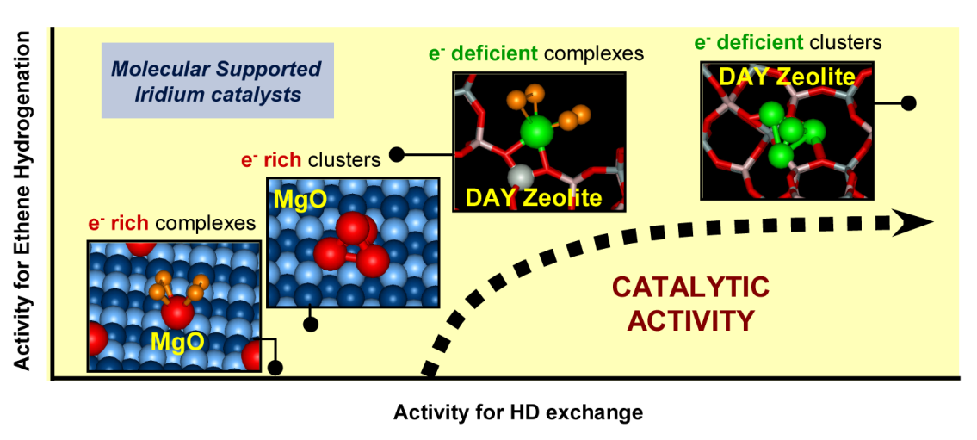

Figure. Catalytic performance of mononuclear iridium complexes and tetranuclear iridium clusters supported on zeolite HY and on MgO for reactions of isotopic H2/D2 exchange and hydrogenation of ethane.

These results demonstrate how the performance of a supported metal catalyst can be tuned by inducing changes either in the nature of the metal–support interactions (metal–ligand bonding) or the nuclearity of the metal species. Our data show that the effect of the metal nuclearity on the catalytic activity of iridium for ethene hydrogenation is strongly dependent on the nature of the metal–support interaction, being much more important when the iridium sites are electron-rich on the basic MgO than when they are electron-deficient on the acidic zeolite. The data show that electron-enrichment of the iridium is responsible for a diminution of the capacity of the iridium to react with and form ligands from H2 and C2H4 simultaneously, and in this case the adsorption of the latter hinders the activation of H2. Accordingly, high activities for ethene hydrogenation on MgO-supported catalysts require the presence of several neighboring iridium atoms that can take on separate functions in the catalytic reaction. However, as in numerous examples of metal-complex catalysis in solution, the performance of essentially molecular species is influenced not only by the characteristics of the metal-metal framework, but also by the ligands that enable the metal centers to facilely enter into the catalytic cycle and allow the turnover. Our data show that even isolated Ir atoms, only slightly active on the surface of MgO, can provide high activities for alkene hydrogenation when the ligand that is the solid support is electron-withdrawing, because then the simultaneous bonding of both hydrogen and C2H4 is allowed in a balance that facilitates rapid turnover.

***Reactions of Ligand Exchange on Mononuclear Iridium Catalysts***

The role of the support in the reactivity of iridium was further investigated with actives sites that consisted of only one metal atom each, so that the effect of the metal frame is excluded from the analysis of the results. To do this, we characterized (IR, XANES and EXAFS) mononuclear iridium complexes supported on either MgO or zeolite HY in contact with flowing CO, C2H4, H2 or D2, and mixtures of them.

As depicted above, the initial iridium diethene complexes supported on the zeolite and on MgO were facilely converted into iridium dicarbonyl complexes when exposed to pulses of CO, with IR bands that indicate the metal to be more electron-deficient when supported on the zeolite than on the MgO. The general pattern that transition metals tend to establish strong metal–CO bonds agrees well with our observation that Ir(CO)2 complexes on the surface of MgO are highly stable in a continuous flow of ethene. In contrast, the zeolite-supported Ir(CO)2 complexes under the same conditions gave evidence of an intriguing coordination chemistry of the mononuclear iridium complexes on the markedly electron-withdrawing zeolite support. Treatment of the iridium dicarbonyl on the zeolite with C2H4 led to a change in the iridium ligation characterized by the disappearance of the two IR bands assigned to Ir(CO)2 species, the appearance of new bands in the CO region of the spectra, and the concomitant formation of other bands in the CH stretching region, a clear indication of the formation of ethene ligands -bonded to the iridium sites. After performance of IR experiments at increasing temperatures and subsequent analysis of the spectra, we postulated the formation of Ir(CO)(C2H4) and Ir(CO)(C2H4)2 species that are in equilibrium with each other when the sample is in the C2H4 stream, with increasing temperatures shifting the equilibrium for desorption of the second C2H4 ligand.

Additional evidence of the new ligand chemistry of the zeolite-supported iridium complexes was provided in experiments characterizing the reactivities of these complexes in flowing mixtures of C2H4 and CO. The presence of CO impurities in hydrocarbons, even at low concentrations, often leads to deactivation or poisoning of catalysts by strong adsorption of CO on metal centers, especially at relatively low reaction temperatures. In this situation, the activation of CO by the metal center may prevail over the adsorption of other compounds, such as alkenes, as we observed for iridium complexes supported on MgO (the resulting iridium gem-dicarbonyls were shown to be highly stable, with no replacement of the CO ligands by ethene).

In contrast, contacting of the zeolite-supported iridium complexes with a mixture of ethene and CO resulted in the formation of Ir(CO)2(C2H4) and Ir(CO)(C2H4)2, highlighting the role of the zeolite in stabilizing electron-deficient iridium complexes that can accommodate an unusually large number of ligands (three labile ligands, including two CO and one C2H4, plus the support).



Figure. Structural changes occurring in HY zeolite-supported iridium complexes, initially present as Ir(C2H4)2, when exposed to various gases, as inferred from analysis of the corresponding IR spectra.

Our data demonstrate that the tendency of the iridium complexes to bond to ligands such as alkenes is markedly enhanced by the zeolite, because this support is responsible for the generation of electron-deficient iridium sites that can accommodate a relatively large number of ligands. This intriguing role of the acidic support makes possible to activate various reactive groups simultaneously, which is often a necessary (although often not sufficient) criterion for catalysis of reactions involving more than one reactant. The reactivity of the zeolite-supported iridium complexes implies that new bonds can be formed facilely with the reactants from the fluid phase, as the metal can share a larger number of electrons with those reactants than when the support is MgO; this reactivity has important implications for catalysis. As depicted hereinabove, the activity of electron-deficient iridium on the surface of the zeolite HY for the HD exchange reaction and the reactivity of ethene bonded to the metal is higher than with electron-rich species on MgO. We also evaluated the catalytic performance of the zeolite-supported iridium complexes when they initially incorporated different combinations of C2H4 and CO ligands. When the iridium complexes incorporated both CO and ethene ligands, the stability of ethene bonded to the iridium was markedly higher than in the Ir(C2H4)2 complex.

The reactivity for H2 dissociation of each of the CO-containing iridium complexes supported on the zeolite was found to be rather low relative to that of Ir(C2H4)2 on the same support, and the former complexes are characterized by catalytic performance similar to that representative of the samples initially consisting of Ir(C2H4)2 on MgO. However, the former class of catalysts appeared to be completely inactive for ethene hydrogenation, whereas the latter was active for this reaction, with an intermediate reaction rate by the standards of our samples.

Although Ir(CO)2 complexes supported on MgO did not evidence any reactivity for the dissociation of H2, the isostructural complexes on the zeolite were found to be moderately active as H2 dissociation catalysts, with an activity similar to that observed for samples initially consisting of Ir(C2H4)2 complexes on the basic MgO support. This result indicates, once more, the importance of the support as a ligand anchoring the iridium sites. Hence, the samples initially consisting of Ir(C2H4)2 and of Ir(CO)2 complexes supported on the zeolite are more reactive for H2 dissociation and more active catalytically for ethene hydrogenation, and the ligands are more reactive than those in the isostructural complexes supported on MgO.

In summary, the ethene hydrogenation and HD exchange catalysis data indicate that the activity of the mononuclear supported iridium complexes for the dissociation of H2 is reduced as (a) the zeolite support is replaced by MgO; (b) the total number of ligands on the iridium is increased; and (c) the number of CO ligands on the iridium is increased. The opportunity to tune the properties of supported catalysts by modifying the support is critical for the design of more efficient supported catalysts.

***Catalysis by Rhodium Complexes and Clusters***

In a different series of experiments, we developed routes for the preparation of rhodium complexes and rhodium clusters on the surface of MgO and zeolite HY, characterized the resultant structures and investigated their catalytic performance in several reactions.

Our spectroscopic data show success in the preparation of mononuclear rhodium complexes that incorporate ethene or carbonyl ligands supported to the two supports, and their transformation into clusters in H2 flow at temperatures that depend on the nature of the support and the other ligands bonded to rhodium. Our data provide evidences leading to a picture of the first steps of rhodium cluster formation on the zeolite and MgO supports. The temperatures required for the onset of cluster formation (< 423 K) are markedly lower than those typically applied in investigations of the mechanisms of metal nanoparticle sintering in supported metal catalysts; thus, our data characterize the first steps of cluster formation rather than sintering.

The effects of the support and the other ligands are not simply resolvable. The less electron-donating support, zeolite HY, facilitates the formation of Rh–Rh bonds provided that ethene is bonded to the rhodium in the supported complexes. The observed temperatures of onset of cluster formation show that the rhodium ethene complexes are more stable on MgO than on the zeolite. In contrast, when the ligands on the rhodium complexes are CO, the rhodium complexes are more resistant to aggregation on the zeolite than on MgO.

Beyond the differences in stability of the rhodium complexes on the different supports, the XANES data indicate a significant contrast in the chemistry leading to cluster formation. Most significant, nearly unique species—rhodium dimers—form when the support is MgO and the ligands on rhodium are ethene. Formation of larger clusters did not occur on this support under the mild conditions of dimer formation (353 K in H2). Rhodium dimers, as highly unstable, are rare species difficult to synthesize according to classical organometallic protocols (high pressures of CO and/or low temperatures must be maintained to avoid rhodium forming other more stable structures). Accordingly, little is known about the behaviour of rhodium dimers in catalysis. In contrast, the MgO-supported dimers are stable species in processes that hydrogenate C=C bonds, which opens the door for investigation of their catalytic performance. Their structural simplicity has provided the opportunity for investigations of the role of metal–metal bonds in catalysis. For example, a 58-fold increase in the catalytic activity for ethene hydrogenation resulted from the transformation of Rh(C2H4)2 species into the rhodium dimers, which are stable in reacting ethene-H2 mixtures.

The data characterizing rhodium cluster formation on the zeolite, in contrast, demonstrate a mixture of species, suggesting the occurrence of a sequence of transformations whereby a fraction of the small clusters formed initially (presumably including rhodium dimers) keep migrating and undergoing further aggregation.

On the other hand, the data also demonstrate differences in the stability of the rhodium clusters in contact with CO, depending on the nature of the support. This observation is important for catalysis of reactions involving CO (such as CO oxidation and alkene hydroformylation, which are large-scale processes), especially as some such reactions involve neighbouring metal sites for activation of multiple reactants. The oxidative fragmentation of metal clusters on acidic supports caused by CO that we observed for the zeolite-supported sample is avoided when the support is the more electron-donating MgO, enabling the preparation of rhodium carbonyl dimers on the latter support.



Figure. Stability of mononuclear rhodium complexes in H2 and CO at various temperatures as a function of the nature of the support and other ligands bonded to the metal centers.

The rhodium carbonyl dimers show excellent catalytic performance in the selective partial hydrogenation of 1,3-butadiene to give n-butenes. 1,3-Butadiene is a by-product in the manufacture of butenes by thermal cracking of petroleum fractions that must be removed from the stream because it (a) leads to side products that reduce product quality and (b) causes deactivation of the catalysts used to manufacture either polymers from 1-butene or high-octane-number gasoline components from isobutylene. Previous literature had ranked catalysts for 1,3-butadiene hydrogenation in terms of decreasing selectivity as follows: gold > palladium >> platinum ~ rhodium. Our results demonstrate striking differences in the catalytic chemistry of rhodium as a function of the structure and composition of the catalytically active species, and we interpret them in terms of differences in the interactions between the reactants (1,3-butadiene and H2) and these species. The structure of our catalysts, essentially molecular in nature, can be tuned much more precisely than with common supported bulk structures to suppress the catalytic routes yielding to undesired by-products so, in contrast to the reported catalysts, a highly active and selective material is accomplished.

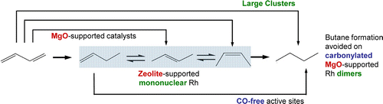

Figure. Schematic representation of the 1,3-butadiene hydrogenation by various supported molecular rhodium catalysts. Only rhodium dimmers supported on MgO and partially poisoned with CO avoid the formation of the undesired byproduct butane.

On the other hand, we found other interesting catalytic features of this family of rhodium catalysts in mixtures of ethene and H2. One of the most intriguing results is that rhodium catalyzes the formation of n-butenes, via dimerization, with approximately 75% selectivity, when it is in the form of mononuclear complexes located above Al sites of the zeolite, whereas otherwise the supported rhodium catalysts are selective for hydrogenation to form ethane. Specifically, hydrogenation occurred selectively when (a) MgO was the support, independent of the nuclearity of the rhodium species; (b) the rhodium diethene complexes were merely physisorbed on the zeolite (in the sodium form), not interacting with the Al sites; or (c) rhodium was present in the form of clusters (independent of which support was used). Our data demonstrate once more how sensitive the catalytic performance is to the groups bonded to the rhodium centers—including neighboring Rh atoms, the support, and other ligands. The demonstration that supported rhodium catalysts can be made to be highly selective for ethene dimerization, even in an excess of H2, is significant when one considers that until recently rhodium was regarded as almost inactive for alkene dimerization except when bonded to ligands such as halides. Instead, rhodium had been recognized as generally active for hydrogenation of C=C bonds.

The selectivity of the HY-zeolite-supported rhodium catalysts for n-butene vs. ethane formation can be tuned simply by regulation of the reactant composition, which controls the ratio of mononuclear rhodium complexes to clusters. Thus, the HY-zeolite-supported rhodium complexes resist aggregation into clusters in mixtures of H2 and ethene at 298 K, and then n-butenes are the major catalytic reaction products. However, when the mononuclear rhodium catalyst is exposed to pure H2 flowing at 298 K, small clusters form, resulting in stable hydrogenation catalysts when the H2:C2H4 molar ratio is high (4:1). Interestingly, these clusters broke up rapidly into mononuclear species when this ratio was low (1:4), as evidenced by the EXAFS spectra, which triggered the onset of selectivity for ethene dimerization. The cluster formation/fragmentation process was found to be reversible when the gas composition was cycled.

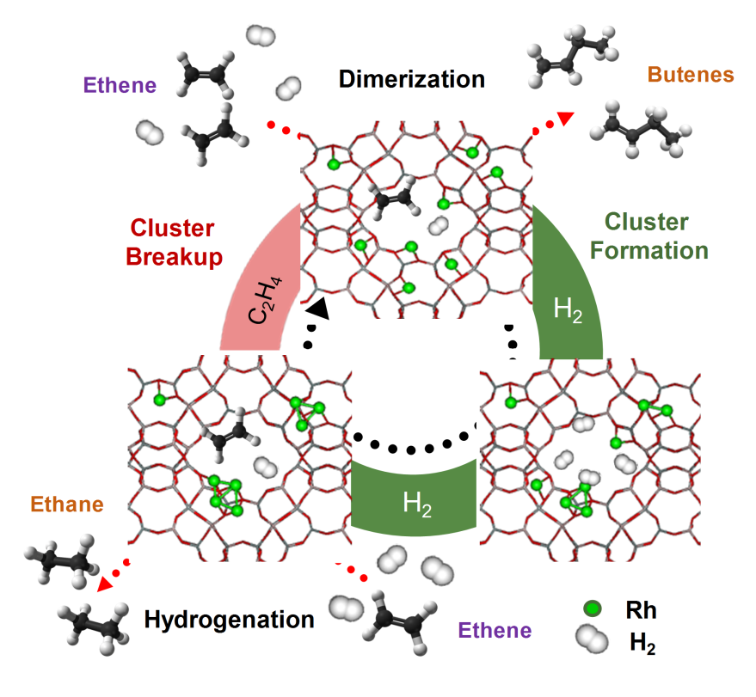

Figure. Schematic representation of the structure and catalytic performance of zeolite-supported rhodium species as a function of the composition of the reaction feed. Ethene-rich mixtures stabilize rhodium in the form of mononuclear complexes that are selective for dimerization of the alkene to *n*-butenes. H2 converts the mononuclear complexes into small clusters that are stable in a H2-rich mixture of H2 and C2H4 and then selective for hydrogenation of the alkene to ethane.

That the catalytic selectivity shuttles between dimerization and hydrogenation as rhodium is switched between mononuclear complexes and small clusters is consistent with the rather general observation that metal clusters or surfaces are more active for activation (dissociation) of H2 than single-atom complexes of the same element. This point is bolstered by our observations of the activity of rhodium complexes and clusters supported on zeolite HY for H-D exchange in the reaction of H2 with D2. We thus infer that the hydrogenation of the double bond kinetically swamps the dimerization on the rhodium clusters because these incorporate an excess of hydride species to react with the alkene. However, a key point is that the capability of rhodium to activate H2 does not alone control its catalytic selectivity. For example, the formation of HD from H2 + D2 catalyzed by MgO-supported rhodium complexes is much slower than that catalyzed by the isostructural rhodium complexes on the acidic zeolite. Nonetheless, butenes did not form from ethene on the MgO-supported catalyst. The use of a support such as the acidic zeolite is thus mandatory for the C–C bond formation catalysis. We also stress that butene dimers were not observed at 298 K, not even in trace amounts, when the HY zeolite was used in the absence of rhodium (or with a physical mixture of an MgO-supported catalyst and the bare zeolite), indicating that the simple acid-catalyzed ethene dimerization was kinetically negligible under our reaction conditions (and that the dimerization requires rhodium on the zeolite surface). Based on these results and additional characterization data, we reported a new cooperative mechanism in which rhodium on the zeolite acts in concert with neighboring acidic sites to accomplish the dimerization reaction.

***Bimetallic Rhodium/Osmium Catalysts***

Recently, we reported an investigation of a bimetallic catalyst in which the metals remained segregated upon deposition on highly dehydroxylated MgO, and even as the supported species reacted with H2, migrated on the support surface, and underwent modifications of their original structures (ligands and/or the nuclearity of the metal species). Thus, the samples reported included supported species that did not react with each other, instead remaining as separate site-isolated species that had a high degree of structural definition.

The results show that the metals in our bimetallic samples remained segregated during treatments at temperatures even up to 393 K. The rhodium species migrated on the support, as shown by the formation of rhodium clusters, and so we infer that reactive rhodium species likely came in contact with the supported osmium species. We infer that the lack of Rh–Os bond formation should be attributed to the relative lack of reactivity of the osmium species, which our data indicate to have been coordinatively saturated triosmium carbonyl clusters. The stability of the triosmium frame and the strong bonding of the CO ligands to this frame thus account for the stability of the osmium species and the lack of formation of bimetallic species.

The catalytic performance of the bimetallic sample consisting of mononuclear rhodium together with trinuclear osmium, tested in the hydrogenation of ethene, was virtually identical to that of a sample formed exclusively by mononuclear rhodium complexes without osmium. This result is consistent with our observation that the two metals remain segregated on the MgO surface, and that osmium alone is inactive for ethene hydrogenation in the selected reaction conditions. This class of segregated supported bimetallic catalyst offers new opportunities for bifunctional catalysis by tuning of the structure of one metal species without altering the structure of the second metal species. Indeed, the synthetic protocol has been successfully extended to bimetallic samples that incorporate iridium, highly selective for the hydrogenation of the alkene, and ruthenium, highly selective for dimerization of the alkene. In this catalyst, it is possible to vary the number of iridium atoms (from one to a few) while keeping the nuclearity of the ruthenium sites constant (more specifically, only one ruthenium atom per active site). Our results show that mononuclear ruthenium dimerizes ethene in the presence of H2 as iridium is in the form of mononuclear complexes, but catalyzes hydrogenation as iridium is in the form of small clusters. This result is attributed to an increase in the concentration of hydrides on the surface of the support (as the mononuclear iridium complexes are turned into clusters), with a change in selectivity of the second metal, ruthenium, that interestingly takes place without any appreciable change in its nature and structure.

***Other Results***

Some of the samples synthesized, characterized and tested in catalytic experiments for the present project were complimentarily investigated using *Density Functional Theory* (DFT)to further understand the chemistry of supported metal species bonded to ligands such as ethene, CO and hydrogen. Zeolite was chosen as the support, because complexes such as iridium and rhodium bind to its surface very selectively above the aluminium centers, which derives in particularly well-defined active sites.

The task of simulating a zeolite supported catalyst with reasonable computational methods is difficult to impossible without using a reduced size model. For example, the unit cell of faujasite zeolite Y contains more than 500 atoms, so including the entire unit cell in a DFT simulation including multiple structures, ligands, geometry optimization, and vibrational frequency calculations is beyond current computational resources. Our study uses two computational models of different sizes to investigate ligand properties and dissociation energetics for zeolite supported iridium and rhodium complex catalysts. The simple Al(OH)4- model provide reasonable geometries, vibrational frequencies and binding energies for the zeolite supported catalysts, which are in good agreement with the experimental values and the computational results. The use of the Al(OH)4- model greatly reduce the computational cost, yet still retained most of the key energetic features for the simulation of the complex catalysts in a zeolite environment.

The calculated structures and energies indicate a metal–oxygen coordination number of two for most of the supported complexes, in agreement with the experimental data. The results characterizing various isomers of supported metal complexes incorporating hydrocarbon ligands indicate that some carbene and carbyne ligands could form. A set of ligand bond dissociation energies is reported to explain reactivity trends. For example, the carbyne and carbene ligands are found to be more stable on the Ir complexes than on Rh complexes, explaining why the Ir complex catalyst is the best for C-C and H-H activation. These results are right now under evaluation for publication in a *peer*-reviewed journal.

In the last period of the project, more complex catalysts, consisting of small clusters or nanoparticles on solid supports are being investigated. More specifically, we have found unexpected catalytic performance of tiny platinum and gold nanoparticles of about 1 nm for reactions that involve the activation of aromatic compounds in the presence of hydrogen and oxygen. For example, gold nanoparticles on TiO2 have been found to catalyze alkynilation of electron-rich arenes with propiolates in O2, whereas cyclotrimerization of the propiolate occurs if no O2 is present. Other results are to be published soon.

**POTENTIAL IMPACT AND DISSEMINATION OF RESULTS.**

This project is mainly focused on fundamental research of supported metals for catalytic applications. In principle, its main goal was to obtain unambiguous knowledge about the functioning of solid catalysts, beyond what can be achieved with conventional (industrial) samples. Trustable fundamental knowledge is a keystone for the rational design of improved catalysts. Our work deals with relevant chemical processes such as those that involve the manufacture of several petrochemical derivatives. The results provide valuable insights for controlling the catalytic performance of supported metal species in reactions for purification of refinery streams, or for the synthesis of fuels from readily available sources.

For example, we have discovered how to modify the chemical environment of rhodium to induce selectivity in the hydrogenation of 1,3-butadiene to *n-*butenes without formation of undesired butane. This reaction is crucial in the economy of polymers production from butenes, because 1,3-butadiene is an impurity of the butene stream in petroleum cracking processes that must be removed before undergoing polymerization, as otherwise it causes catalyst deactivation and reduces the quality of the final polymeric product. In a typical industrial process, the lack of a completely selective catalyst for hydrogenation of 1,3-butadiene to butenes without complete reduction to butane, useless for polymerization, leads to important economical losses that catalysts such as ours are meant to palliate (a provisional patent application was filed for this invention).

Another example of the potential impact of our investigation relates to the design of a catalyst for the oligomerization of light alkenes such as ethene, with potential application in the production of fuels. This becomes more relevant as the discovery of new sources of natural gas points to a promising perspective of the synthetic route methane to ethene, followed by oligomerization of ethene into hydrocarbons in the range of gasoline and diesel.

The results of the present project are expected to have high impact in the field of catalysis and so, benefit our society, and a proof of that is the number and quality of the publications resulting from this research. The results have been released in top-ranked journals in chemistry such as the *Journal of American Chemical Society*, and divulgated in international conferences and meetings (an exhaustive list of publications and dissemination activities is provided below in section 4.2). To boost the impact of the results, a review-type article has been released in Journal of Catalysis. Several of our papers have been published in the journal ACS Catalysis, which was lauded with AAP PROSE Award for Best New Journal in Science, Technology & Medicine.

In recognition of the impact of our research, several scientific media have made echo of our results. For example, the journal Chemical and Engineering News highlighted our results on the selective hydrogenation of 1,3-butadiene (<http://cen.acs.org/articles/90/i37/TunedRhodium-Sharpens-Butadiene-Hydrogenation.html>); and the American Department of Energy (DoE, Basic Energy division) and the journal ChemistryViews highlighted the importance of our work on the dimerization of ethene ([http://www.chemistryviews.org/details/ezine/1058837/ Highly_Selective_Alkene_Dimerization.html](http://www.chemistryviews.org/details/ezine/1058837/%20Highly_Selective_Alkene_Dimerization.html)).