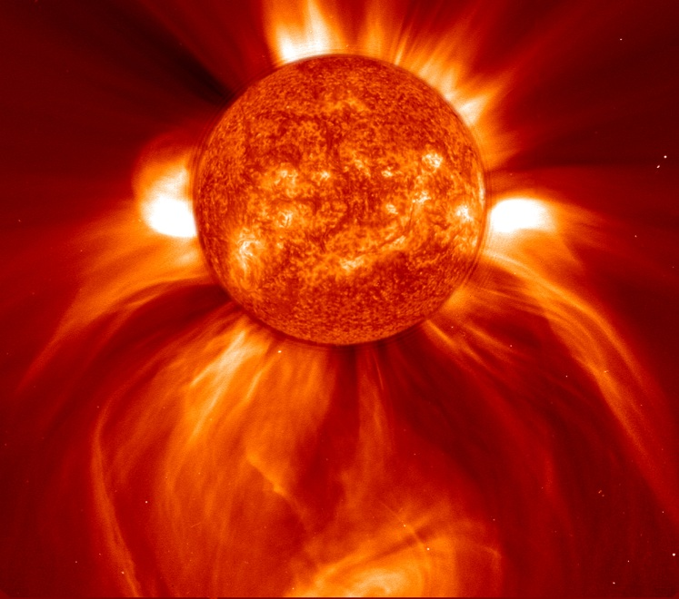
A solar flare, at the origin of space weather events (courtesy SOHO)

