Summary of progress towards objectives and details for each task
The Research objectives of this proposal were twofold. As a reminder, they are again disclosed below:
This objective has been achieved by characterizing a novel mouse model which selectively expresses mhtt in striatal astrocytes by fulfilling the following aims:
AIM 1- To determine the structural and neuropathological properties of both the striatal astrocytes and the MSNs in order to give a time-course of the progression of the HD-like pathology in our model.
AIM 2-To determine the functional properties of striatal astrocytes and MSNs by investigating glutamate transmission regulation via astrocytic glutamate transporters and energy metabolism.
The two lines of work in regards to these aims were initiated by the fellow researcher. At this time of the project, the fellow showed the feasibility of the challenging methodology proposed for analysis. The questions raised in the proposal have been addressed or are to be completed in a near future. See the update on the status of the tasks below. All experiments needed for the proposed investigation are pursued (details of each of the proposed task are furthermore developed in part III “Description of the main S&T results/Foregrounds”).
Task 1. The characterization of BACHD mice (aged 18-22 month) using electrophysiological and morphological approaches has been performed and analyzed. Energy metabolism 3D analysis of BACHD mice model has been pursued, achieved and further developed by a PhD. student in the lab. Finally, crossing of BACHD and GFAP-CRE mice has been performed and a colony of 40-50 mice (aged 18-20 month) is behaviorally characterized and now ready for the follow-up study.
Task 2. The characterization of mice injected with a lentiviral vector expressing the mutated huntingtin into astrocytes, using electrophysiological and morphological approaches has been performed. Analysis is currently performed.
The scientific objective was achieved using two different complementary experimental approaches based on two different animal models.

Summary of main S&T results
- To dissect out the role of astrocytes in HD, we generated mice that expressed the mutant Htt in all cell types but not into astrocytes. Using this mouse model, we aimed to characterize both the function of neurons using electrophysiological recordings and their morphology during the course of the disease and determine whether the absence of mhtt into astrocytes significantly change these two indexes. The characterization of BACHD mice (aged 18-22 month) using electrophysiological, morphological and biochemical/molecular approaches has been performed and analyzed. Crossing of BACHD and GFAP-CRE mice has been performed and a colony of 40-50 mice (aged 18-20 month) is now ready for completion of the study. We found so far that long-term effects of mhtt expression in BACHD mice do not lead to major neuropathological alterations. At 18-22 month of age, mice displayed a minor atrophy of the striatum and very few inclusions of huntingtin, a hallmark of the disease (Figure 1).
Figure 1. Minor HD-like neuropathology in 18-22 month-old BACHD
a. Detection of 2B4-positive inclusions in dorsal striatum (top) and cortex (bottom) of BACHD mice. Inclusions are globular, extra-somatic and of larger size in the cortex compared to the striatum. a. GFAP mRNA level are significantly higher and D2R are significantly lower in the striatum of BACHD mice compared to WT. No major neuronal loss as suggested by maintained expression of neuronal markers Neu-N and DARPP-32 (n=6 for both groups) c. Representative coronal sections of WT and BACHD brain immunostained with DARPP-32 antibody used for assessment of striatal volume and soma surface. d. No change in MSNs somal area.. e. Moderate but significant reduction in striatal volume of BACHD vs. WT mice (n=10 for WT and n=7 for BACHD). Scale bar: a: 15µm, c: top row: 2 mm; bottom row: 30µm. *p<0.05.

Despite these very modest alterations, we found “pre-degenerative” functional and morphological changes in MSNs. The vulnerability of this cell population mainly consists in dramatic spine loss, likely indicative of major decrease of excitatory input (Figures 2 and 3).

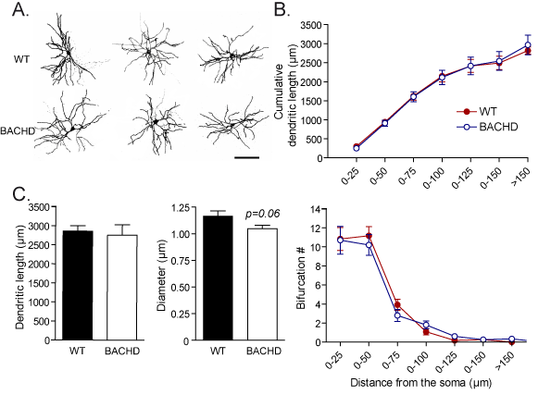
Figure 2. Normal dendritic arborisation of MSNs in 18-month-old BACHD mice
A. Representative 3D reconstructions of MSNs from WT (left) and BACHD (right) mice. B. Cumulative dendritic length (top) and number of dendrite bifurcations (bottom) at increasing distance from the soma do not change between the two mouse groups. C. Dendritic length (left) and diameter (right) are similar between WT and BACHD mice. Scale: A: 65 µm. n = 12 WT and n = 10 BACHD MSNs.

Figure 3. Major spine loss in 18-month-old BACHD mice compared to WT littermates
A. High resolution close-up on dendritic segments imaged for assessment of dendritic spine density and subtyping from MSNs of WT (left) and BACHD (right) mice. B. Total spine density (left) and spine density composition by subtype (right): mushroom, stubby and thin/filopodia. Note that the number of spines of all subtypes is significantly reduced in BACHD mice. Scale: A: 5 µm. n = 10 WT and 9 BACHD MSNs. *p<0.05

However, MSNs in BACHD mice simultaneously showed significant hyperexcitability (Figure 4) compared to control mice and a maintained, if not increased, excitatory synaptic signaling (Figure 5).
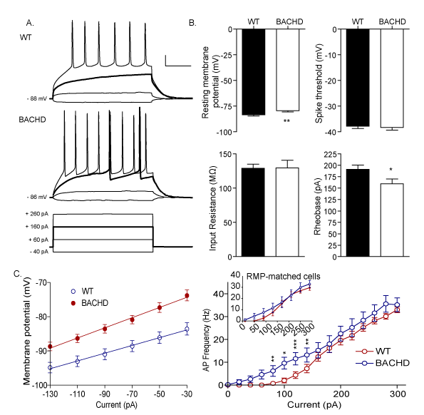

Figure 4. MSNs from 18-month-old BACHD mice are more excitable compared to WT littermates
A. Traces show voltage response from a WT (top) and BACHD (middle) MSN to injected hyper- and depolarizing current steps (bottom). Note that the third step (corresponding to +160 pA injection, in bold) elicits APs in the BACHD cell only, but not in WT (both in bold). B. Histograms showing resting membrane potential (RMP), spike threshold, input resistance and rheobase in MSNs from WT and BACHD mice. Note that both RMP and rheobase are decreased in BACHD. C. Left: input/output relationship between the injected current and membrane potential in the two groups; note that MSNs from BACHD mice are more depolarized compared to WT at all injected current values. Left: graph showing AP firing rates in response to depolarizing current steps; note the higher AP firing frequency in BACHD mice. Scale: A: 20 mV, 60 ms. n = 22 WT and 20 BACHD MSNs. *p<0.05; **p<0.02;***p<0.01.

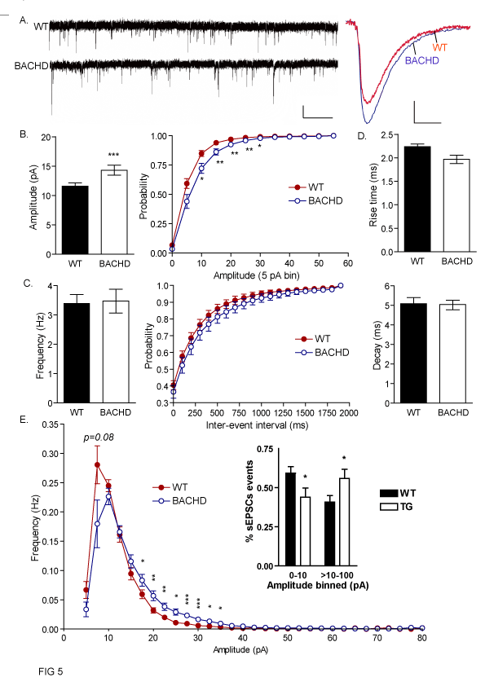
Figure 5. sEPSCs are larger in MSNs from 18-month-old BACHD mice compared to WT littermates.
A. Left: Sample traces from a WT (top) and BACHD (bottom) MSN. Right: Superimposed averaged sEPSCs of the corresponding recordings: note the higher average sEPSC amplitude in BACHD compared to WT. B. Average sEPSCs amplitude (left) is significantly higher in MSNs from BACHD compared to WT mice. Cumulative sEPSC amplitude distribution (right) shows a right-shift of the curve confirming the increase of sEPSC amplitude in the BACHD group, which is significant at "medium" values (between 10 and 30 pA). C. Average sEPSCs frequency (left) and cumulative sEPSC inter-event interval distribution (right) are similar between the two groups. D. Rise- and decay-time of sEPSCs are similar between the two groups. E. Amplitude-frequency plot showing the frequency of sEPSCs as a function of their amplitude; note the higher frequency of "medium" amplitude events. Inset: Bar graph showing the percentage of "small" (<10 pA) and "medium to large" (>10 to 100 pA) sEPSCs. Scale: A, right: 10 pA mV, 13 s, left: 2.9 pA, 6.5 ms. Bars indicates means ± SEM. n = 18 WT and 15 BACHD cells. *p < 0.05, **p<0.02, ***p < 0.01

Thus, despite compensatory mechanisms represented by the loss of dendritic spines, BACHD mice still show increased glutamatergic activity in the striatum that might ultimately result in excitotoxic phenomena. Such overload of glutamatergic activity could underlie the neuropathological features of this mouse model. A manuscript will be submitted soon.
In addition, we have initiated behavioral studies to check whether the absence of mutant huntingtin into astrocytes is affecting motor performance. Data obtained in 12 month-old animals did not show any difference between groups. Similar experiments are ongoing in 20 month-old animals. Also, the characterization of BACHD mice without mhtt into astrocytes (aged 18-22 month) using electrophysiological, morphological and biochemical/molecular approaches will be carried out soon.

- In parallel, we developed a second animal model in which the expression of the mutant huntingtin, responsible for the disease, is restricted to striatal astrocytes using a lentiviral approach (see figure 6 for details on model characterization).

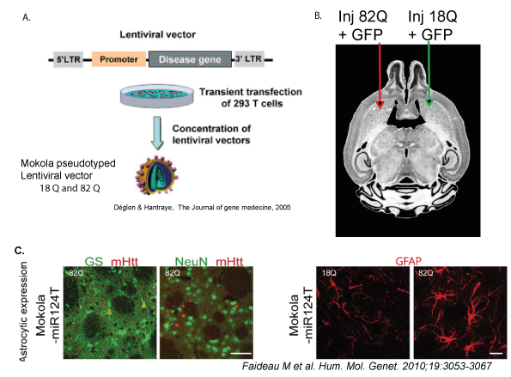
Figure 6. Characterization of the mouse model expressing Htt171-82Q in astrocytes.
A. Scheme of the methodology used for lentivirus production. Lentiviral vectors were pseudotyped with Mokola envelope to increase the tropism of the virus towards the astrocytes. B. Injection into the striatum of suspensions of lentiviral vectors encoding the htt gene with 18Q (wild type, right hemisphere) or 82Q (mutated, left hemisphere) mixed with vectors encoding GFP (3/1). Injections were performed 16 weeks before recordings. C. Left: Double immunofluorescent staining with either GS or NeuN (green) and Huntingtin-2B4 (red) confirmed that the lentiviral vector pseudotyped with Mokola and including miR124T induced the expression of mHtt in GS-positive astrocytes and not in NeuN-positive neurons. Right: Expression of Htt171-82Q in astrocytes leads also to a marked increase in GFAP expression but the cells do not lose their domain organization. Scale bars: C. left: 50 µm and right: 20 μm.

We aimed to characterize whether the expression of mhtt only into astrocytes is sufficient to alter the function and/or the morphology of striatal neurons. Experiments have been performed and the analysis of electrophysiological recordings and quantitative morphological analysis of neurons from mice injected with lentiviral vector expressing mhtt into astrocytes is planned to be completed by beginning of 2013. Preliminary data do not show any difference in terms of passive nor active properties of MSNs neurons located in the area of injection of Htt171-82Q virus compared to the control side. Analysis of synaptic signaling data is still under investigation. Below (figure 7) are displayed exemplar morphological data obtained in this study.

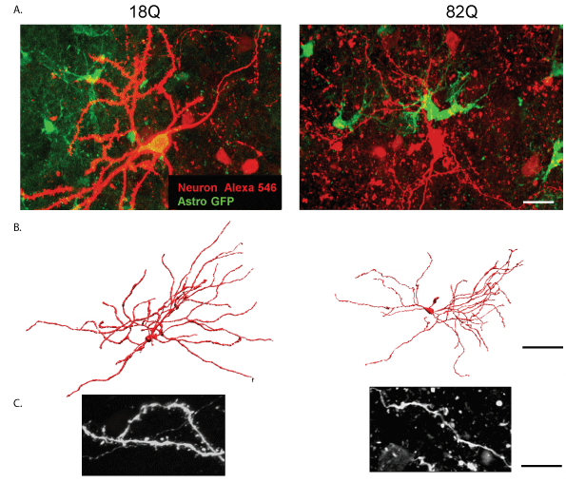
Figure 7. Confocal scanning of exemplar cells from Htt171-18Q (18Q) injection side compared to Htt171-82Q (82Q) injection side 16 weeks after lentiviral injections.
A. Confocal projections of neurons biocytin injected during whole-cell patch-clamp recording and thereafter labeled by streptavidin-546 (in red). Neurons are surrounded in the area of injection by astrocytes infected with GFP and expressing either mhtt-18Q or 82Q (in green). When Htt171-82Q is expressed in astrocytes, expression of Htt171-82Q in astrocytes leads also to marked prototypical features of reactive astrocytes. B. Dendritic arbor 3D reconstruction of neurons streptavidin-546 labeled. C. Dendritic segment projection illustrating beaded and varicosed aspect of dendritic segment in cells surrounded by astrocytes expressing Htt171-82Q. Scale bars: A. 15 μm, B. 50 μm, C. 7 μm.

