 Marie Curie Actions- Intra European Fellowship 

Project acronym: IN-SMC
Project full name: Smooth Muscle cell Transcriptomic and infectious agents

Marie Curie Actions
Final Report

Grant Agreement number: PIEF-GA-2009-254667
Project acronym: IN-SMC
Project title: Smooth muscle cell transcriptomics and infectious agents
Funding Scheme: Marie Curie Intra-European Fellowship (IEF)
Scientist in charge: Prof. Claudia Monaco
Researcher: Dr Leena Eloni Viiri
Period covered: from 1/9-2010 to 31/8/2012
Name, title and organisation of the scientific representative of the project's coordinator:
Prof. Claudia Monaco
Tel: +44 (0)20 8383 4444
E-mail: Claudia.monaco@kennedy.ox.ac.uk

- FINAL PUBLISHABLE SUMMARY REPORT

An executive summary (max 1 page)
The pathology of coronary heart disease (CHD) includes a complex series of events, the key steps being the loss of normal endothelial function, lipid levels favouring lipid entry into endothelial intima, leukocyte (monocyte and lymphocyte) recruitment to artery walls, smooth muscle cell (SMC) proliferation and inflammation. The key events leading to the transformation of a silent atheroma into a life-threatening ruptured and thrombosed coronary plaque are still uncovered. One of the most important hypotheses is that this is due to the development of inflammation within the plaque. The molecular mechanisms through which SMC can modulate the inflammatory response in atherosclerosis are currently unknown. Apoptotic death of SMC may cause thinning of the fibrous cap, leading to a rupture-prone plaque. Erosion or rupture of the fibrous cap exposes the pro-thrombotic lipid core to the blood flow causing thrombus formation, which can occlude the artery and lead to acute cardiovascular events. SMC are highly plastic, and can alter their state of differentiation in response to environmental cues. Recently it was shown that a periodontal pathogen P. gingivalis is able to promote transformation of a contractile SMC to proliferative phenotype and induce SMC proliferation.
We aimed to identify molecular basis of the pro-inflammatory phenotype of atherosclerotic plaque-derived SMCs. We wanted to study the initiation of the inflammatory process within the artery, specifically focusing on studying the role of oral bacteria. The overall goals of the present project were: a) to identify the molecular basis of the pro-inflammatory phenotype of atherosclerotic plaque-derived SMC via transcriptome analysis; and b) to investigate the contribution of oral bacteria and their components to induce inflammatory gene expression in SMC.
Our results show that the transcriptome of atherosclerotic SMC clearly differs from that of healthy SMC. In plaque-derived SMC pathways relating to protein metabolism (e.g. translation, protein folding) are up-regulated whereas pathways related to lipid metabolism are down-regulated. We also identified bacterial species and their relative amounts present in dental abscesses from patients. Bacterial preparates originating from these dental abscesses were used to stimulate SMC in vitro and cytokine production was measured from the cell culture supernatants, and patient samples with high amounts of certain bacteria were found to be more potent in inducing cytokine production in SMCs.
In summary, our studies demonstrate that SMC resident in human plaques acquire a distinct gene expression compared to control cells. Plaque-derived SMC seem to be translationally more active whereas pathways related to lipid metabolism are down-regulated. Moreover, bacteria have the ability, once deposited in plaques to activate SMC directly and promote their cytokine production thus possibly having an effect on plaque stability.

A summary description of project context and objectives
Coronary heart disease (CHD) remains the single most common cause of death in the EU; it is an enormous public health problem being the leading cause of morbidity and mortality in most Western countries. Until recently, most conceptualised atherosclerosis as a localized accumulation of lipids due to exposure of the arterial wall to risk factors. However, a decade ago, atherosclerosis has been defined as an “inflammatory disease”, where complex interactions between resident arterial cells and blood-borne mononuclear cells take place, involving a broad range of inflammatory and immune mediators. This paradigm change was paralleled by the growing awareness that the majority of patients with rheumatoid arthritis and other inflammatory diseases die of premature CVD.
In humans, atherosclerotic plaques develop within pre-existing diffuse intimal thickenings rich in extracellular matrix. SMC biology in atherosclerosis has been mainly focused on their key function of producers of extra-cellular matrix proteins. Seminal work by Campbell and Campbell on cultured vascular SMC demonstrated for the first time that SMC contained within the intima of an atherosclerotic plaque underwent a 'phenotypic modulation', from a quiescent state, to a synthetic state. This process involves a decrease in expression of contractile proteins such as actin and myosin, and enlargement of organelles such as the Golgi and endoplasmic reticulum to accommodate an increased synthesis of extracellular proteins such as collagens I and III. This collagen deposition leads to plaque growth in the first instance. However, in advanced stages SMC build the extracellular matrix within the fibrous cap and promote plaque stability.
To recognize important initiators involved in launching inflammation in the arterial wall is one of the key aspects of this study. We wanted to study what can induce SMC; does it result from environmental stimuli in the intima, and can oral bacteria act as inducers of pro-inflammatory behaviour. It has previously been show that coronary atheroma contain several species of bacteria from oral microflora. The oral cavity is well vascularized and infection in this site provides a direct route to the bloodstream. The traditional view that atherosclerosis is simply a lipid storage disease is challenged by a growing body of evidence that immunity and inflammation play a central role in all stages of atherosclerotic disease from the early initial lesion to late-stage plaque rupture. Coronary plaques contain several species of bacteria from oral microflora, including P. gingivalis, and inflammation or infections may play a role as a triggering factor in the rupture of unstable vulnerable coronary plaque. Dental pathology, especially periodontal infection is linked with the risk. However, intervention trials with antibiotics known to eradicate e.g. periodontal pathogens have failed. It has been shown that almost all DNAs extracted from coronary atheroma contain a mixture of DNA from bacteria originating from the oral cavity but no typical periodontal bacteria were found. The triggering factor for the rupture of coronary vulnerable plaque – the event leading to the activation of thrombogenic factors – might in many cases be a slow odontogenic infection. A competing explanation would be that DNA originating from oral bacterias is simply a result from the well-known bacteremia associated with tooth procedures and even with tooth brushing, and that these oral mainly non-virulent bacterias are simply attached to the surface of the plaque with no pathogenic role at all.
We aimed to identify molecular basis of the pro-inflammatory phenotype of atherosclerotic plaque-derived SMCs. We wanted to study the initiation of the inflammatory process within the artery, specifically focusing on studying the role of oral bacteria. The overall goals of the present project were: a) to identify the molecular basis of the pro-inflammatory phenotype of atherosclerotic plaque-derived SMC via transcriptome analysis; and b) to investigate the contribution of oral bacteria and their components to induce inflammatory gene expression in SMC. The detailed aims of the project were: i) to collect carotid plaques, isolate and culture SMCs from these plaques, ii) isolate RNA from SMCs and prepare the samples for microarray to study the transcriptomics of SMCs isolated from human carotid plaques; iii) perform the microarray and vast bioinformatics analyses, iv) collect periapical abscesses, v) use the bacterial preparates from periapical abscesses to stimulate SMC in vitro and study the inflammatory response of SMCs (cytokine production); and vi) study the bacterial genome in carotid atherosclerotic specimens.

A description of the main S&T results
Our results show that the transcriptome of atherosclerotic SMC clearly differs from that of healthy SMC. Several pathways and individual genes were found to be statistically significantly differently expressed between the atherosclerotic plaque-derived and healthy SMCs. We demonstrate that SMC resident in human plaques acquire a distinct gene expression compared to control cells: in plaque-derived SMC pathways relating to protein metabolism (translation, protein folding) are up-regulated whereas pathways related to lipid metabolism are down-regulated.
Regarding the second aim of the project, we studied cytokine production in SMCs stimulated by several reference bacteria. All reference bacteria were found to induce the production of pro-inflammatory cytokine in SMCs but their stimulatory potency differed. Moreover, we identified bacterial species and their relative amounts present in dental abscesses from patients. Bacterial preparates originating from these dental abscesses were used to stimulate SMC in vitro and cytokine production was again measured from the cell culture supernatants. Patient samples with high amounts of certain bacteria were found to be more potent in inducing cytokine production in SMCs.

The first aim of this project was to identify the molecular basis of the pro-inflammatory phenotype of atherosclerotic plaque-derived SMC via transcriptome analysis. This was done through microarray, which revealed 519 genes to be differentially expressed between the plaque and healthy SMC. The differentially expressed genes are presented as a volcano plot in Figure 1.
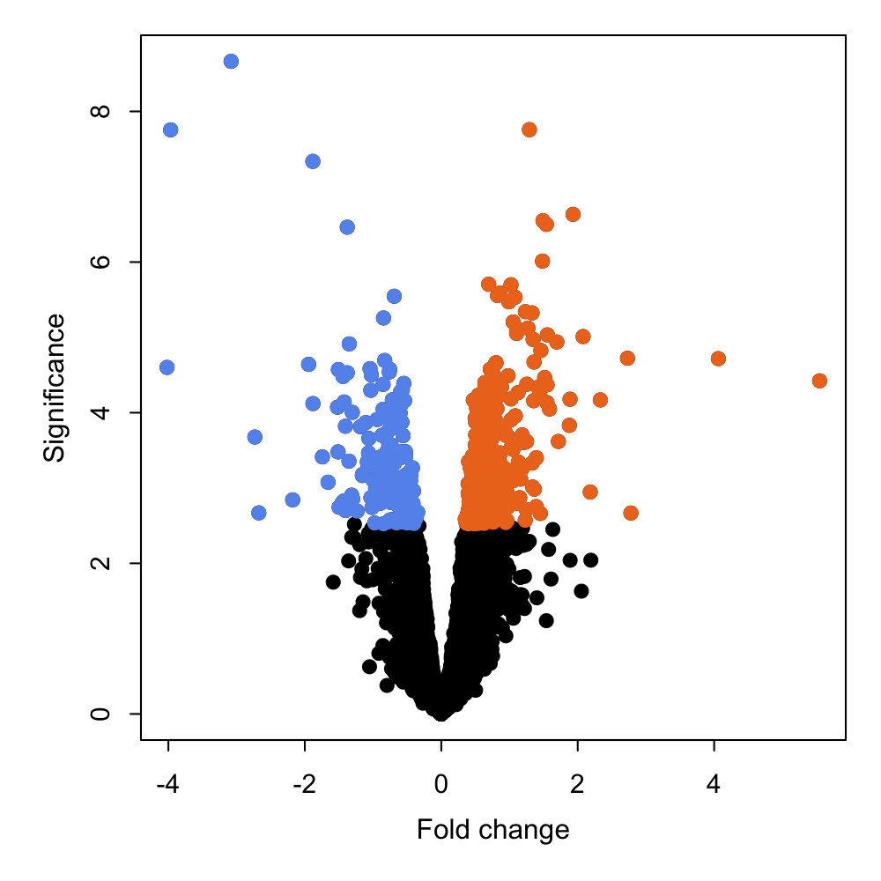
Figure 1. Volcano plot of differentially expressed genes in plaque compared to healthy SMC (blue=down-regulated and orange=up-regulated).

In order to identify active biological pathways, we calculated pathway activity score for all the differentially expressed genes by querying 880 literature curated pathways assembled from KEGG, Reactome and BioCarta databases. Positive or negative activity score corresponds to up- or down-regulated pathways, respectively and are presented in Figure 2. Furthermore, we performed validation experiments by RT-qPCR to confirm the increased expression of genes of interest that were found to be up-regulated in atherosclerotic vs. healthy SMCs.

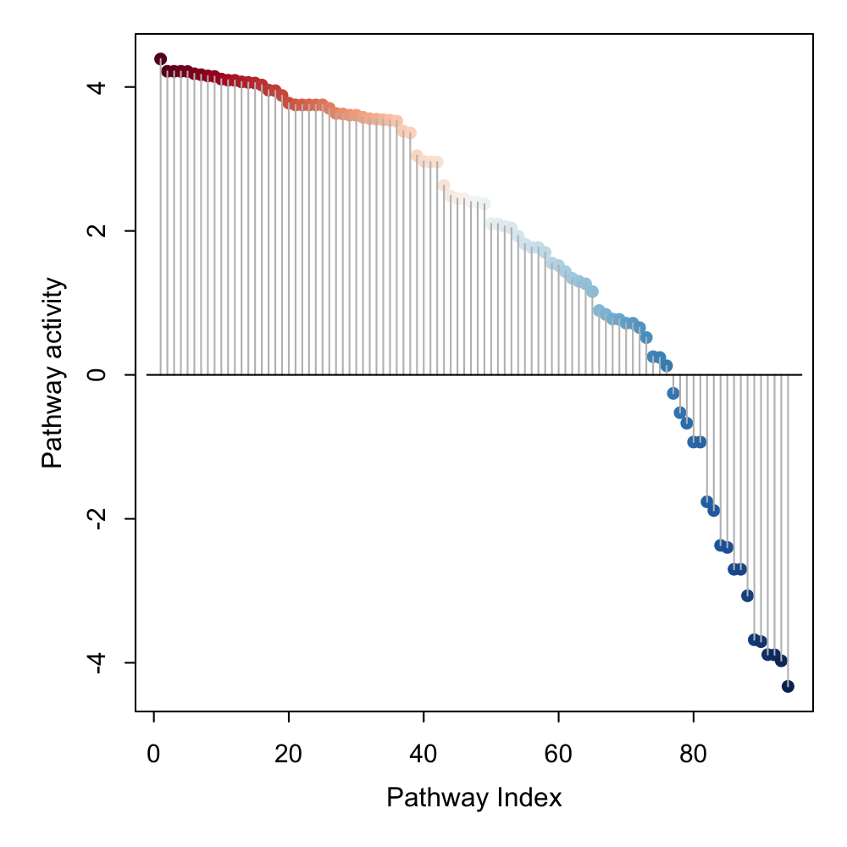
Figure 2. Pathway activity scores in plaque compared to healthy SMC. Pathways with positive activity scores are up-regulated while pathways with negative activity scores are down-regulated (blue=down-regulated and red=up-regulated).

When we compared the gene expression levels in plaque-derived SMC from symptomatic and asymptomatic patients, we found 171 up-regulated and 131 down-regulated genes, which are presented as a volcano plot in Figure 3.

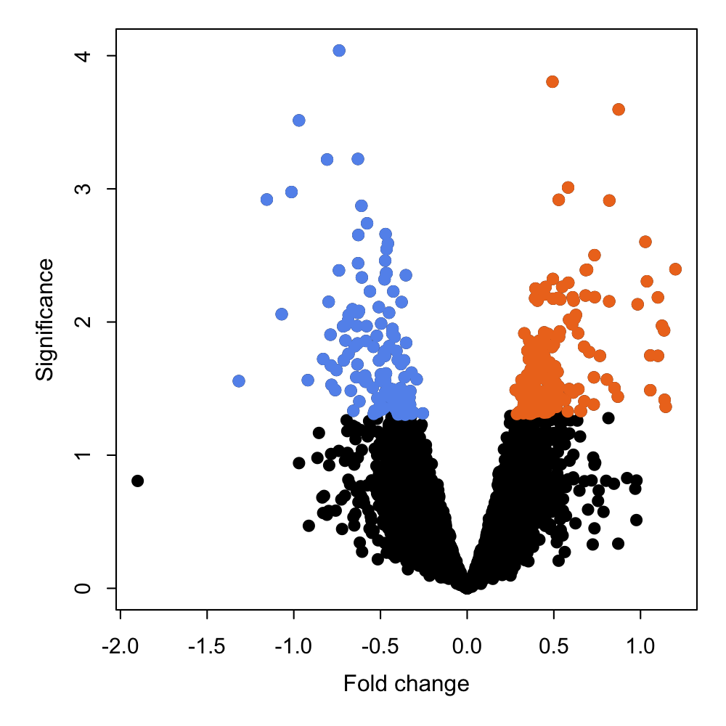
Figure 3. Volcano plot of differentially expressed genes in plaque-derived SMC from symptomatic compared to asymptomatic patients (blue=down-regulated and orange=up-regulated).

In order to identify active biological pathways, we calculated pathway activity score for all the differentially expressed genes. Positive or negative activity score corresponds to up- or down-regulated pathways, respectively and are presented in Figure 4. A lot less differentially expressed pathways were identified between the symptomatic and asymptomatic SMC as opposed to plaque-derived SMC compared with healthy aortic SMC.
Interestingly the pathways related to lipid metabolism, which were down-regulated in plaque SMC compared to healthy aortic SMC, were up-regulated in plaque-derived SMC from symptomatic compared to asymptomatic patients.
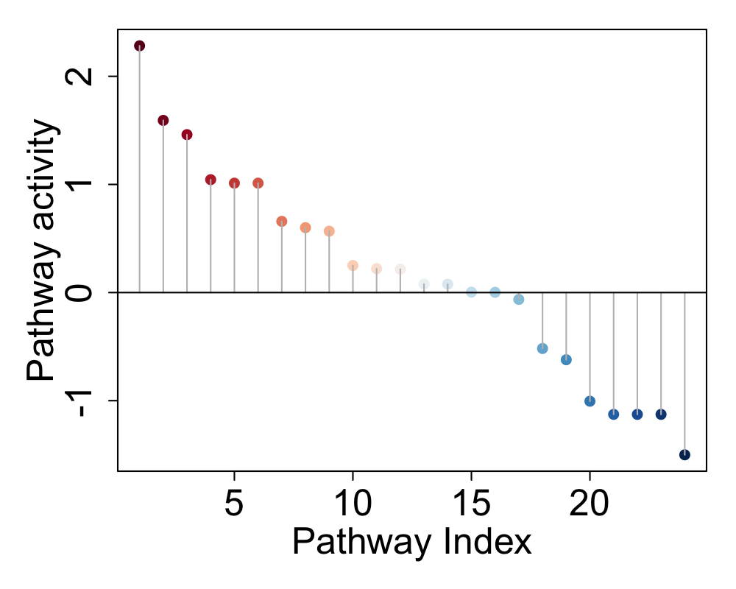
Figure 4. Pathway activity scores in plaque-derived SMC from symptomatic compared to asymptomatic patients. Pathways with positive activity scores are up-regulated while pathways with negative activity scores are down-regulated (blue=down-regulated and red=up-regulated).

To address the second aim of the project, which was to investigate the contribution of oral bacteria and their components to induce inflammatory gene expression in SMC, we collected dental abscess samples from patients. We used several commercial reference bacteria as well as bacterial preparates from the patient abscesses to stimulate SMC, and then measured the cytokine production from the cell culture supernatants. All reference bacteria as well as bacterial preparates from patient dental abscesses induced cytokine production in plaque-derived SMCas can be seen from Figure 5.
Figure 5. Induction of cytokine production by different reference bacteria (A-F) and bacterial isolates from patient abscesses (17x, 19x and 3x).

All the studied candidate bacteria are among the most frequently detected bacteria in atherosclerotic specimens and thus the most prominent candidates to have a role in the pathogenesis of atherosclerosis. Due to transient bacteremias all these bacteria may escape into the blood stream, localize into atheroma cell wall and induce the inflammatory responses. This study demonstrated that all studied bacteria induced cytokine production in SMCs. In conclusion, induction of inflammation by oral bacteria in atherosclerotic tissue- derived smooth muscle cells suggests their potent role in the development of vulnerable atherosclerotic plaque.
The resources originally planned for the identification of bacterial genome in carotid atherosclerotic specimens, was instead focused on studying miRNA expression in atherosclerotic and healthy SMCs. We used the ABI TaqMan microRNA Low density arrays (TLDA, LifeTechnologies) for miRNAs profiling. This system represents a comprehensive global screening tool for miRs and includes a total of 768 miRNA assays (Set v3.0). It consists of 2 arrays: panel A (384 functionally defined microRNAs) and panel B (384 microRNAs whose function is not yet completely defined). The statistically significantly differentially expressed miRNAs between atherosclerotic and healthy SMCs are presented as a volcano plot in Figure 6. The expression levels of statistically significantly different miRNAs were validated by using individual TaqMan miRNA assays (Life Technologies).

A
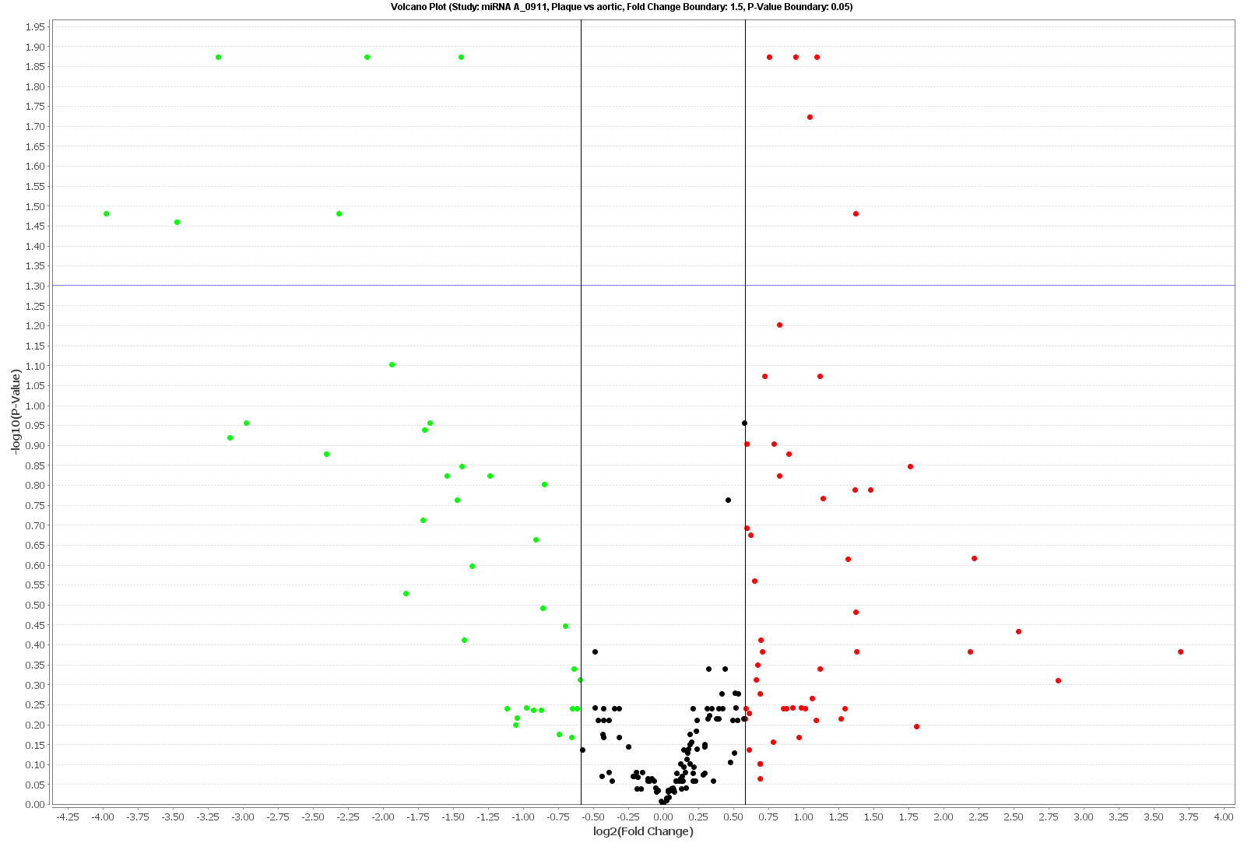

B
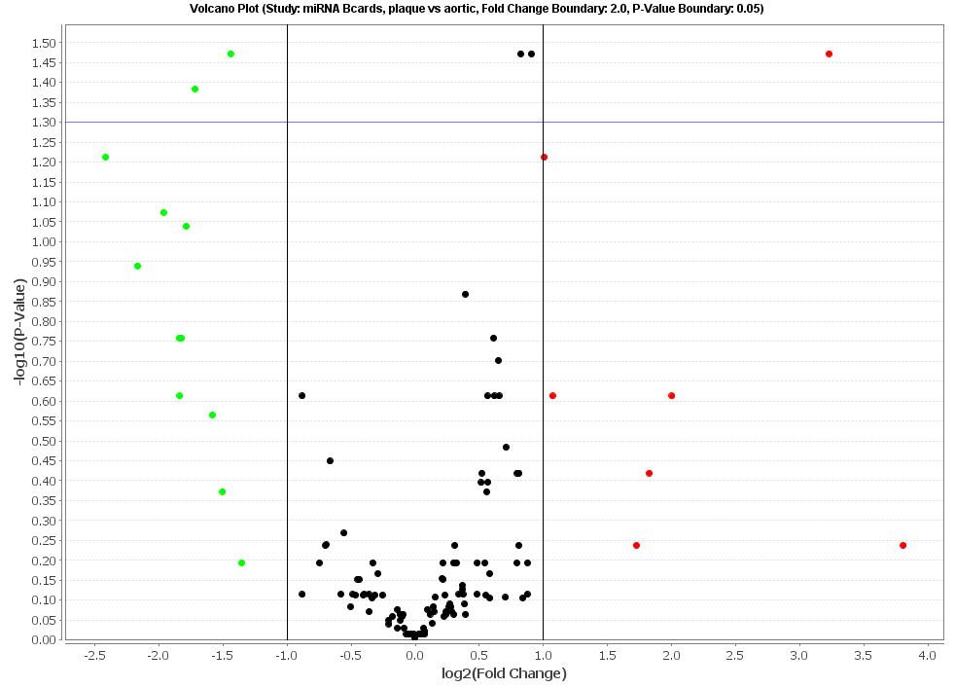
Figure 6. A Volcano plot presenting differentially expressed miRNAs between plaque-derived SMC and healthy control SMC. A) miRNAs from A card assays and B) from B card assays.

In summary, our studies demonstrate that SMC resident in human plaques acquire a distinct gene expression compared to control cells. Plaque-derived SMC seem to be translationally more active and the protein metabolism up-regulated whereas pathways related to lipid metabolism are down-regulated. Moreover, bacteria have the ability, once deposited in plaques to activate SMC directly and promote their cytokine production thus possibly having an effect on plaque stability.

