Figure 1. (Left) Graphics User Interface for advanced pulse sequence design. (Right) Graphics User Interface for output visualization and data handling, such as manipulation of k-space.
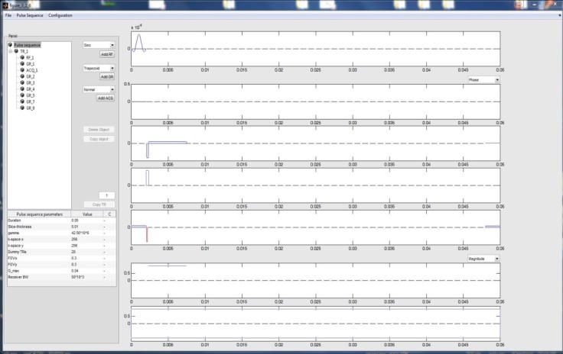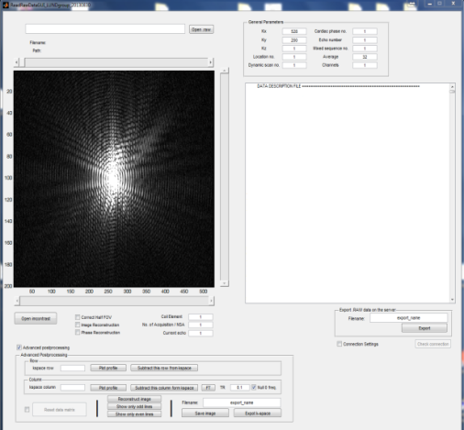
Figure 2. Series of CINE images of the heart motion model throughout the cardiac cycle after SPAMM preparation.  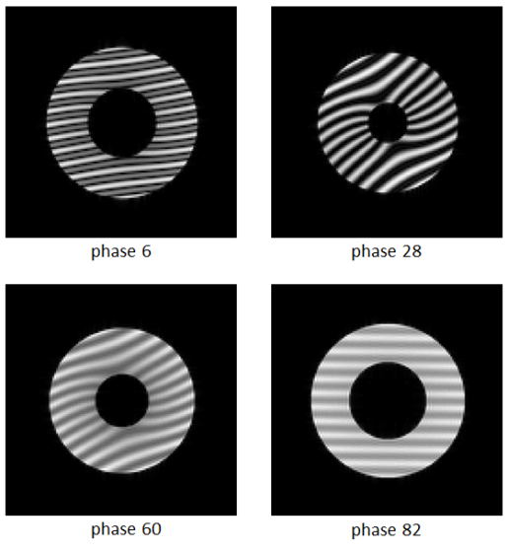 | Figure 3. Speedup of CUDA-C and OpenMP parallel executed C-code on a single GPU setup compared to serially executed C-code  