SUMMARY

A multichannel in vivo flow cytometer has been developed for the dynamic monitoring of multiple cell populations, such as tumor-associated cells or leukocytes, in the circulation of mice, for extended periods of time and without the need to extract blood samples. The first part of the project involved the development of a novel multichannel in vivo flow cytometer for the dynamic tracking of multiple cell populations, in the circulation of mice, for extended periods of time and without the need to extract blood samples. The second part of the project involved the application and validation of the multichannel in vivo flow cytometer for the dynamic monitoring of tumor cells in the circulation of small animals. The feasibility and sensitivity of the system to detect circulating tumor cells in experimental animals of various strains was extensively investigated using cultured breast cancer cells. The ability of the system to track circulating cells in real time and in a non-invasive manner, will thus open up enormous possibilities for new investigations into the mechanisms that govern the complex trafficking and tissue interactions of these cells in a variety of clinical and biological fields such as cancer, stem cell biology and immunology.

S&T RESULTS AND CONCLUSIONS

The development, construction and testing of a multichannel in vivo flow cytometer was implemented in the first phase of the project. The design of the system was based on the original concept of in vivo flow cytometry, which is the confocal excitation and detection of fluorescently labeled cells in circulation, and has incorporated new modifications and enhancements to expand its capabilities and the range of applications that it can be utilized for (Figure 1). The system has been designed and assembled with the spatial and temporal resolution to detect individual cells passing through a single blood vessel in vivo, thus providing quantitative information on circulating cell populations that is not available by other real time in vivo imaging techniques. The new system has been built with three lasers and detection channels that allow simultaneous tracking of three distinct cell populations and fluorescent markers. Experiments to investigate the sensitivity of the system were first done using fluorescent microspheres of known fluorescence intensity flown through a microfluidic channel across which the excitation laser was focused (Figure 2). After calibration of the system with the fluorescent microspheres, initial cell experiments were performed using cultured breast cancer cells. The cells were labeled in vitro with three different fluorescent markers, corresponding to the three detection channels, and were then flown through the microfluidic channel to test the feasibility of in vivo cell detection (Figure 3).

In the second phase of the project, the multichannel in vivo flow cytometer was applied to the dynamic monitoring of tumor cells in the circulation of experimental animals. Circulating tumor-associated cells have been attracting huge interest lately for their role in cancer growth and metastasis. The ability to quantitatively determine dynamic changes in circulating tumor cell numbers without the need to extract blood samples will enable the multichannel in vivo flow cytometer to evolve into an innovative tool for the long term monitoring of circulating tumor cells. The multichannel in vivo flow cytometer was utilized for the dynamic monitoring of circulating breast cancer cells that were injected directly in the circulation in of experimental mice. In these experiments, known numbers of cultured adenocarcinoma cells were labeled ex vivo with cell membrane specific carbocyanine dyes and were then introduced intravenously in the circulation of mice via tail vein injections for detection by the in vivo flow cytometer (Figures 4-5). Due to the rapid clearance of these cells from circulation, only a few cells were observed during the first few minutes following tail vein injection, however circulating cells were clearly observed in all the mice that had cells successfully introduced in the vasculature (Figure 6).

IMPACT

The development of the multichannel in vivo flow cytometer has enabled the establishment of a state-of-the-art small animal imaging facility that is now part of the Biomechanics and Living Systems Analysis (BioLISYS) Laboratory in the Dept of Mechanical Engineering and Materials Science and Engineering at the Cyprus University of Technology (website: www2.cut.ac.cy/mem/research/biolisys/research/projects/imaging/cytometry/). The facility is fully operational, with dedicated animal procedure and tissue culture capabilities and has significantly enhanced the research capabilities of CUT and has greatly expand the range of novel clinical biomedicine projects that can be undertaken at the institution. The knowledge and capabilities gained through this project, coupled with the establishment of the in vivo imaging facility will enable the pursuit of high level research projects that will result in high impact publications and attract additional research funds from EU and international funding agencies. The system is already serving as a basis for fostering new collaborations, involving researchers from across multiple disciplines of engineering, medicine and biology, to carry out cutting edge research and investigate important questions in clinical fields such as stem cell biology, immunology, blood pathologies, cancer biology and cardiovascular disease. This will in turn enhance the European research infrastructure and can potentially lead to quantifiable benefits to health and society as a whole, by encouraging new projects and investigations in order to develop innovative clinical modalities for the diagnosis and cure of disease. The ability to carry out such studies in Cyprus can have a direct impact on the level of health care on the island through the direct transfer of knowledge acquired on disease processes and novel therapies to the country’s health care practitioners, clinical investigators, and the medical and pharmaceutical industry. It is also anticipated that there will be extensive generation of intellectual property and patents related to the new technologies and techniques that will be developed through collaborative efforts, with clear benefits to the economy and society as a whole.

In vivo flow cytometry is becoming an extremely useful tool for tracking specific, targeted cells in circulation, and can complement other in vivo imaging modalities in order to obtain both local and systemic information from a single animal. This innovative technology can thus be utilized in research that aims to facilitate a better understanding of disease as well as provide a novel means for the non-invasive monitoring of disease progression or response to therapeutic intervention. One such project involves the monitoring of cancer cells that are shed in circulation by orthotopic tumors in order to non- invasively track tumor burden and assess important cancer treatment parameters such as tumor growth and response to therapeutic intervention. This will allow the monitoring of circulating cancer cells in animal cancer models and may potentially open the door for new investigations into the mechanisms of early metastatic growth that may contribute towards identifying potential therapeutic targets. Another project that is being pursued aims to utilize the new technology to investigate biological and clinical questions in the area of rare anemias and hemoglobinopathies, by in vivo monitoring and assessing of the trafficking kinetics of hematopoietic lineage cells and cellular immune components. A further application of the system involves the monitoring of the circulating cellular components of the immune response following cardiovascular stent implantation in the mouse aorta (in-stent restenosis). Potentially, the system can target any circulating cell component of interest however, a major development of the technology that is being pursued will involve the ability to monitor cells in the human vasculature in the context of a clinical device.
Data figures
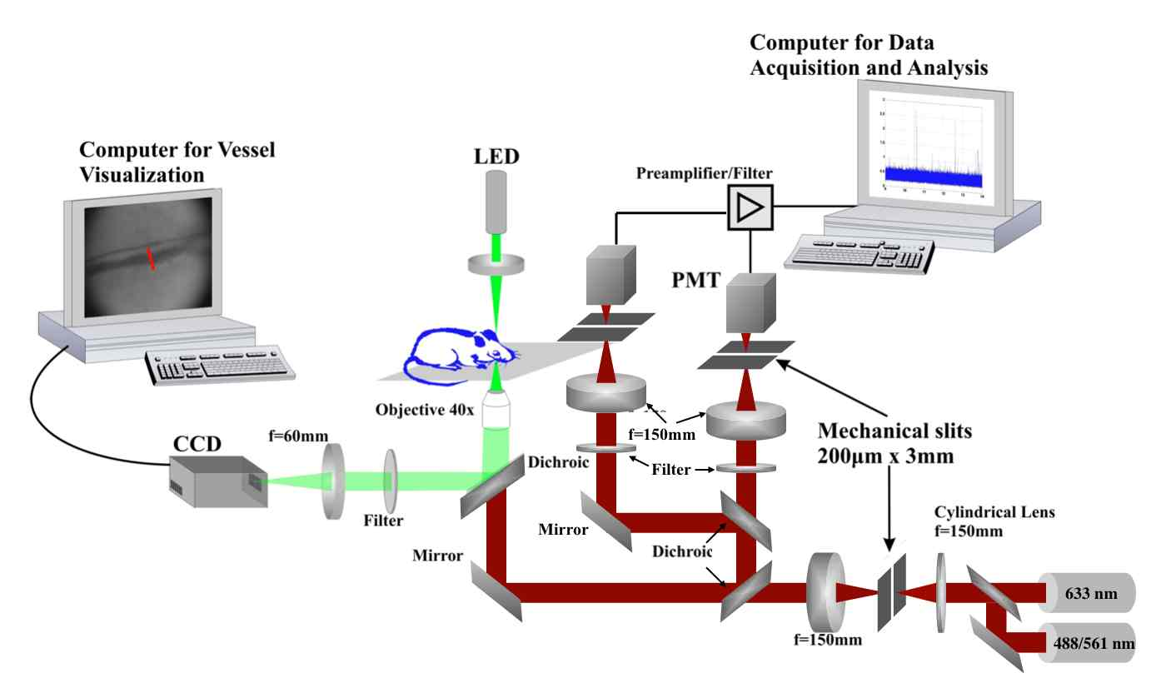
Figure 1. Schematic of the multichannel in vivo flow cytometry system
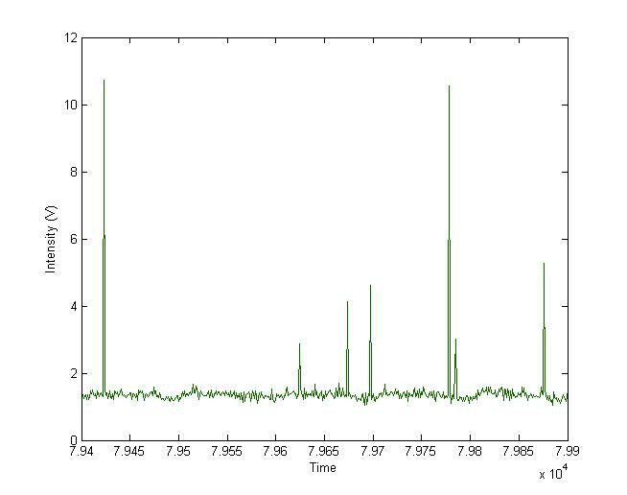
Figure 2. Detection of fluorescent microspheres flowing
in a microfluidic channel

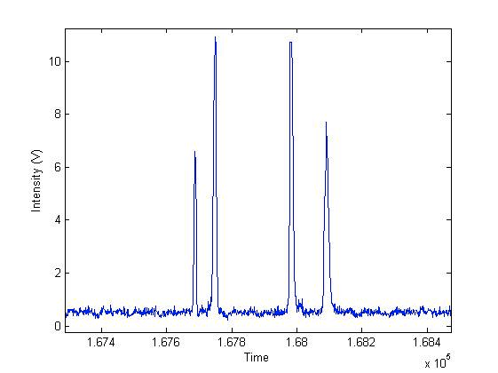Figure 3. Detection of fluorescently labeled MDA-MB-231 cells flowing
in a microfluidic channel
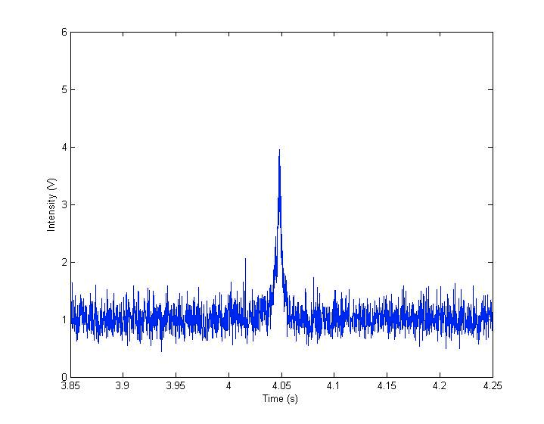
Figure 4. Detection of fluorescently labeled MDA-MB-231 cells in vivo
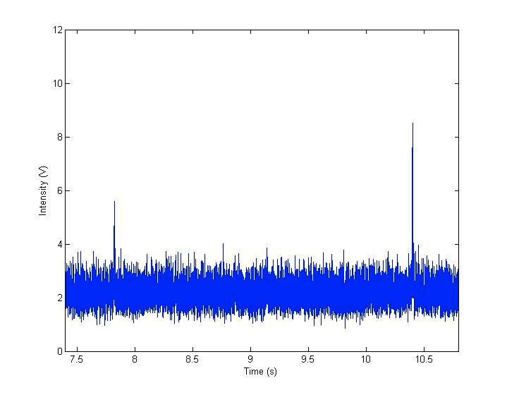
Figure 5. Detection of fluorescently labeled MDA-MB-231 cells in vivo

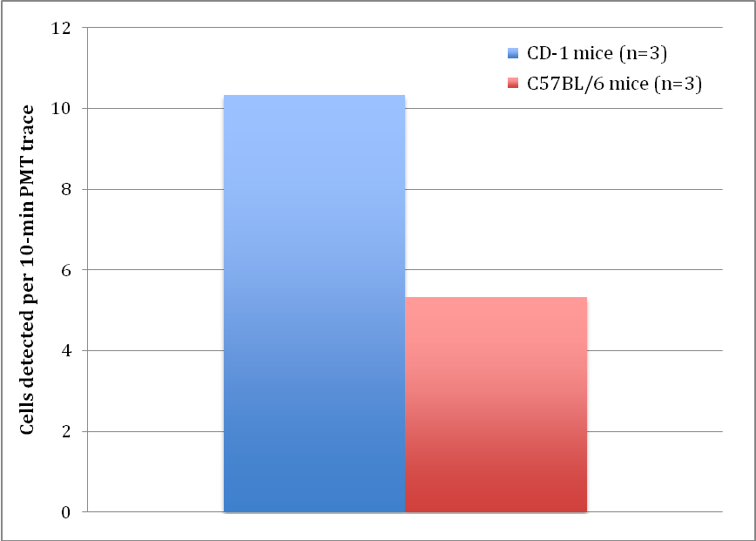
Figure 6. Quantitative summary of in vivo detection of MDA-MB-231 cells
in the vasculature of the 2 strains of mice used

