Infoman



Project no. 026352
Project acronym: INFOMAN

Project Title
Toward a Euro-Mediterranean Memory: Expert Workshop on Information Systems for Arab Manuscripts

Instrument: FP6-2002-INCO-MPC/SSA-2

The Final Activity Report

Proposal Acronym: INFOMAN
Date of Preparation: February 2005
Date of Revision: February 2008
Type of instrument: Specific Support Actions
Call Identifier: FP6-2002-INCO-MPC/SSA-2
Thematic Issues: B2. Protection and Conservation of Cultural Heritage
Call Title: B2.1. Materials, artifacts, monuments and sites: new technologies and characterization
Coordinator name: Dr. Fathi Saleh
Organization name: Center for the Documentation of Cultural and Natural Heritage (CULTNAT)
Coordinator email: fsaleh@mcit.gov.eg
Coordinator fax: 002 02 5392929

Table of Contents

Publishable summary

Background of the project
The Implementation of the Work Plan

Project organization

Project results
Work packages (work periods and their reports)

Deliverables (1-15)
The recommendations redefined Objectives, Impact and overall aims of the Project
Important Administration Issues (correspondences, extensions)
Conclusion

Publishable summary
Background of the project

The proposal for the Infoman Project indicated some strategic objectives and obstacles that were seen as the basis of the initiative interest in such a project from the departments at The Center for Documentation of Cultural and Natural Heritage Egypt.

Among the key issues addressed in the Proposal that identified the goals of the project were the follow: the main issue was the rarity and importance of Arabic manuscripts that face unsurpassed challenges due to the rapid change in our societies, physical threats, natural threats due to humidity and pollution, as well as their decay and negligence. The loss of such manuscripts accordingly forms a threat of losing our collective heritage and leads to a collective amnesia that result in the tampering of history, concepts and understanding of the past world. Perhaps the Arabic manuscript collections are more vulnerable of such decay than other collection, that may have been digitized, documented, and safeguarded, and accordingly they are more unfortunate than others, although their content may be related to not only the Arab World but the entire MEDA countries. Accordingly "This project aims to shed some light on the invaluable importance of scientific and illuminated Arabic manuscript heritage in EU and MPC countries, the difficulties pertaining to its conservation, documentation and preservation and finally identify a strategic plan of action for future regional cooperation among EU and MEDA countries in order to fulfill the long term objective of the project which is to preserve the collective memory of the peoples of the euromediterranean in order to maintain their cultural identity and enable them to play an essential role in sharing their common future".

The Implementation of the Work Plan
The goals of this project crystallizes in safeguarding and generating interest in Arabic manuscript collections distributed among euromediterranean countries as part of the regions combined effort to preserve its cultural heritage. Hence preserving Arabic manuscripts is considered vital to understanding the regions intertwined past and enhancing cooperation among its countries. Within this context this project aims to increase cooperation in research and the transfer of knowledge as a precursor to better heritage preservation and management and eventually sustainable development."

The proposal identified the objective and activities as follows:
- Gather professionals, decision makers, academics, historians, and researchers in an expert workshop on Arabic Manuscript Collections to view and compare ideas and problems related to the projects' developed proto portal and database information system.
- Develop a logical framework that produces an action plan that can assist the Community in developing its policies and prioritizing issues pertaining to the documentation and digitization of Arab Manuscripts and formulation of future activities on the basis of relative merit, urgency, and feasibility
- Establish a euromediterranean network for experts in Arab Manuscripts;
- Establish standards and protocols for manuscript data base transparency in web based information system manuscript collections.
- Disseminate project results among relevant Community and MEDA organizations and centers of excellence in the field as well as professional and academics experts.
- Integrate of social, environmental and technical data to provide a better understanding of the hidden dimensions of Arab manuscripts.

In parallel to these general objectives, a number of specific objectives have been identified as:

In order to achieve the objectives of the project throughout its full duration, the proposed projects' structure indicated a preliminary meeting with a steering committee, of which email consultancy took place and certain key issues identified. The project team felt it more compelling to understand the diverse nature of Arabic Manuscripts and the problems facing their documentation into a system. A complex web of variables affecting such manuscript collections started to come to light specially upon approaching different groups and use an interdisciplinary approach. The team members realized that Arabic Manuscript specialists such as historians, librarians, archivists, museum curators, academics, heritage specialists, publishers and Information technology specialists were to take part in all work phases of the project, yet they never came together and shared their requests and problems.

Infoman Project was to produce a proto portal for Arabic Manuscripts, to create a multi-disciplinary database, that can serve different professions related to the Arabic Manuscript World with understanding their needs, requirements, obstacles and liabilities, thus encouraging new legislations, affecting social behavior towards manuscripts within the MPC, surfacing the uncovered collections and contributing in more knowledge democratization. Having started from scratch, this gave us the opportunity to address and discuss standards of international level rather than a provincial approach to codifying the Arabic manuscripts; such framework took us to the UNESCO's Memory of the World Program as set standards.

The culmination of the project was a : Euro Mediterranean Expert Roundtable Meeting which gathered experts from different areas of specialization yet practice and/or study Arabic manuscript collections so that they enrich the meeting with diverse approaches to different problems related to manuscripts and their database. This multidisciplinary approach to cover all the issues pertaining to manuscript preservation and management took place on January 26-29, 2008. The experts Evaluation and critiqued a pilot manuscript information system presented during the meetings.

They also discussed the importance of the unification of cataloguing and indexing standards for documentation of private and public manuscript collections.
But above all, they discussed the status of Laws, rules and regulations of manuscript collections in EU and MPC countries, particularly those related to the ownership of private collections and copy right on the internet, and Egypt was a case study.
Finally the experts sanctioned recommendations and policy directions. This is the key component of work package 3 Milestone 4.

Project Organization

INFOMAN was a single partner project coordinated by the Center for Documentation of Cultural and Natural History, Egypt. A center that is affiliated to Bibliotheca Alexandrina, and supported by the Ministry of Information Technology in Egypt, thus has access to Manuscript Experts, Library Specialists and Information Technology Experts. This was certainly an advantage, which guided the deliverables of the Project.

These Work Packages were not numbered in order of importance but they supplement and support each other. All were considered essential to achieve the objectives of the project. The activities were implemented through targeted measures and milestones.

WP # | Work Package Title
WP1 | Management, monitoring and evaluation
WP2 | Pilot Information System
WP3 | Expert Meeting
WP4 | Dissemination

Project Results

Throughout the project all efforts concentrated on realizing these specific objectives and expected achievements:

The extensive research performed on the Arabic Manuscript Collections, identifying and categorizing them into type, and analyzing their codicology requirements, understanding the terminology and the MARC fields.

Compiling an Expert list of professionals from different work professions that are stake holders in identifying, understanding and regulating the use of Arabic manuscripts within the MPC

Producing a well organized SQL Database for the documentation of Arabic Manuscript that satisfies all the multi-disciplinary professionals.

Involved the national staff and trained them on the database and identified their potential concerns, as part of the disseminating and community benefit target.

Developed a proto-Portal for Arabic Manuscripts, after analyzing all potential portals and understanding their drawback, thus developing new standards with the guidance of the EU-Minerva project guidelines, and developing a management methodology to manage such proto – Portal http://infoman.cultnat.org/heba

Infoman facilitated the establishment of a nation-wide awareness of the pros and cons of current laws and regulations regarding Arabic manuscript collections, and how they affect the surfacing of private collections, thus leading to a loss in available knowledge and historical amnesia.

A Successful expert round table meeting was conducted and a total of 35 National, Middle Eastern, Arab and European scientists were hosted in Cairo.

Work Packages

.
WP1: Project Management

CULTNAT managerial staff carried out the management and coordination of tasks related to all the work packages. It was responsible for progress monitoring and evaluation throughout the different phases of the project. It presented progress and financial reports to the Commission as defined by WP1. The project management activity has been carried out by the coordinator in collaboration with the project Manager. Resources have been planned and organized to fulfill the obligations. Meetings convened and the activities of the Project Manager were coordinated, making sure that the Project Deliverables were delivered

The managerial tasks were divided between a content manager and a financial officer, guided by the head of the Center for Documentation of Cultural and Natural Heritage, and its financial department.
Deliverables:
D1: Periodic Technical Report 1 Month: 06
D2: Periodic Technical Report 2 Month; 12
D3: Final Report Month: 18
D4: Auditors Financial Report 1 Month: 12

1. Steering Committee Guidance and consultancy:
Step one in the management was to communicate with the steering committee which were formed of 4 experts in different aspects of the field of manuscripts of the Arab World.
- Morocco Dr.Shawki Benbeen Director of the Royal Safe
Of Manuscripts
- France Mrs.Gidone BNF & Arabic Islamic
Manuscripts expert
- Egypt Dr. Ayman Fouad Sayed Islamic history professor and
Manuscripts expert
- Holland Dr.Witkum Professor in university of Leiden

The Active committee members were Dr. Ayman Fouad Sayed, and Prof. Dr. Witkum from Leiden. The other two were not accessible or unwilling to help. Both Dr. Ayman and Dr. Witkum played a vital role in formulating the best methodologies and operational procedures, actions and regulating the sanctions of the meeting. The committee, during the meeting, orchestrated this expert meeting and was responsible for the issuing of the action plan and recommendations jointly with the projects' management

After the preliminary meetings with Dr. Ayman, (in the first 6 month of the project) and emails with dr. Witkum , an open day for the IT experts, private and governmental applicants, were invited to listen to the projects' needs and requirements for the information system to be developed and for the proto- portal.

2. Open-day for IT experts at Cultnat in January 2007
Cultnat organized an over view of the INFOMAN project to members of the IT / database units associated to and affiliated with it in order to allocate the job of the database and portal to a professional team, or to discuss the requirements and guidelines with professionals. The meeting resulted in two main trends, a web offer from a company Tarakeeb, and a database offer from individual experts in Cairo University department of informatics. Both offers were discussed with IT expert Dr. Sharkawy and evaluated. This in fact led to the 1st technical report. During the second reporting period, the project assigned a Database expert to develop the database using the extensive research done in the past 12 month, which leads to the second technical report.

69121521DeliverablesProject ManagementProject Planning, Progress Meetings, Monitoring and AssessmentFinal ReportWP Title | 0
3

Among the Results achieved during the First Work-package of the project – was the creation of an organized Preparatory chart for meetings. This chart is generic and was welcomed by the younger experts and spectators of the round table meeting conducted towards the end of the project.

Preparatory chart | INFOMAN Expert Roundtable Meeting (Duration: 3 days)
 | Launch date January 27 – 30, 2007 (To be confirmed with Dr. Fathi Salih's office)
PREPARATION | Executor | Working days
Concept & outline | Expert Meeting team
Division of task | Conference team sub committees
preparation of advanced program
preparation of registration forms | Conference team sub committees
INVITATIONS | Executor | Working days
Proposed launch date | C.C / Dr. Fathi
Confirm flow of events / approval | Events / PR /marketing
Conference Logo/print material design / approval | Graphic / Dr. Fathi
design of registration form
Printing of conference material | Supplier
Invitation cards delivered | Supplier
conference bags/folders -
Conference Guests | Executor | Working days
guest list/ invitee/participants
send invitation to VIP
WEBSITE announcement | Marketing / PR | 6 month b4 launch
Send out invitations & RSVP | Marketing
receive confirmation
receive c.v. and photo
Early registration - computer
accommodation information - options
confirm hotel reservation
guest information - pick up times
guest information- accompanying persons
Publications | Executor | Working days
Publication data Compilation | Conference team
Editing | editor | 10 days
Send all text to graphic | Conference team
Design of publications | Curatorial & Graphics | 3 months
Send final layout to Dr. Fathi |  | 5 days
Send printable material to printer | Publication unit - Yasser | 2 months b4 launch
Printing | Supplier | 20 days
Publications delivered to Cultnat | Supplier | 10 days b4 launch
Conference Premises | Executor | Working days
conference space layout | Conference team | 15 days
signage
Printing signage / hang | imaging department | 10 days
internet service available
photocopy service available
Audio/visual support for sessions
check equipments & requirements
security & day flow office
PROMOTIONS & PUBLICITY | Executor | Working days
PRESS RELEASE | Marketing/ PR | 5 days b4 launch
Press Conference
Highlights of the day
Conference in Press - Report
hospitality
Off-Premise Social Events
conference days | Executor | Working days
Early Registration @ hotel | Registration team
Registration manually/computer
give out name badges/conf. bags
Confirm MC & ushers | C.C | 14 days b4 launch
maintenance - full capacity
Confirm refreshment menu | C.C. / F&B / | 14 days b4 launch
confirm Coffee Breaks
Extra supplies
Translation services confirmed
Lunch catering

WP2: Development of Pilot Manuscript Information System

Background
To facilitate the studying and analyzing of existing manuscript systems (whether private collections or large governmental libraries) became a massive task, yet one that lead to facilitating storing, indexing, retrieving, and searching very large scale of information. Yet due to the interdisciplinary approach taken by the project steering committee, a system was to suit all concerned parties, and a portal had to present more than just a database system, and accordingly three phases were seen necessary:
First: studying and analyzing existing manuscript information systems in order to reuse the most important common features and adding more advanced features to avoid its limitations.
Second: Designing new system (portal) that has the ability to integrate between existing manuscript information systems and the new manuscripts that in need to be added.
Third: producing the following:
1) Document that describes the system (portal) design
2) System prototype that will be an initial demo version.
Deliverables:
D6: Private vs. Public systems (Month 06)
D7: Design document for Portal (Month 12)
D8: Pilot Information System (Month 18)

WP Title | 0 |  | 3 |  | 6 |  | 9 |  | 12 |  | 15 |  | 21 | Deliverables
Pilot Information System | M1 Comparative report on structure of private and publicly owned manuscripts information system | M2 Design documents for development of portal manuscripts information system | M3 Pilot Portal information system, Portal design document | Design document and Prototype for portal information system

Intensive researches lead to Milestone 1
Manuscript Collections found in Libraries, Archives, Museums, and Private Acquisitions constitute a main component of our cultural heritage, whether it is of global, national, regional or of state importance, it is part of a bigger picture that by documenting it in a scientific manner, reveals a great deal of information and serves a multitude of disciplines. The main obstacles for documentation are primarily to identify and know that a collection exists then subsequently strive to gain access to it. In the case of a Manuscript collection, two equally important constituents presents themselves during the documentation process: the need to create a solid base of information that would sever multidisciplinary professionals - followed by the ability to present it in an optimal manner, that can secure its retrieval by the diverse corps in an efficient and user friendly manner.
Before assessing the needs of the multidisciplinary users, the question of whether there is a difference between privately and publicly owned collections was posed. The differences and similarity between private and publicly owned collections played a role in the information base, and may need special attention in the documentation process. Previously, few fields within bibliographic databases indicated whether a manuscript was part of a privately or publicly owned collection. Most databases recognized such difference through fields related to the ownership, accessibility & copyright, leaving a great deal of ambiguity on the history of the collection as an intact unit and the connection between the collection and its own culture let alone the conditions that lead to its existence, and the role it play within its own surroundings.

The ownership status of a collection may also indicate a pattern, related to size, content, and condition. It may also encourage the re-categorization of private collections; distinguishing between the different types of privately owned collections such as: Private collections concealed from the general public, private collections in remote places, Private collections under the custody of Museums, Private collections donated to libraries and academic institutions, Private collections of no venue but tours from destination to another… became an essential launching point. The difference between the above-mentioned private collections would accordingly reflect on their physical condition and scope of information content thus contributing in the holistic understanding of such collections. Unlike a manuscript within a publicly owned collection/ holding, the manuscript within a privately owned collection is part of an entity; a component within a classified unit that has its own history and that reveals a great deal about its surrounding environment. According to the definitions posed by the UNESCO: “A collection is a set of documents selected individually. A holding is a collection or set of collections held by an institution or an individual, or a fund or record group, or a set of them held by an archival institution.” In this respect, an attempt to understand the difference between privately owned and publicly owned collections is addressed here, to better recognize & comprehend collections and properly identify necessary information-data fields and to assess the importance of not losing the “collections’” identity during the documentation process.

The research done on one remote manuscript collection yielded in the following:

- The need to differentiate between publicly owned and privately owned collections within Arabic Manuscript database
- The importance of Identifying the privately owned collections and encouraging them to surface
- Incorporating them within Arab Manuscript Portals and Databases, as they comprise an unaccountable number of holdings, with perhaps rare and unique codices
- The need to classify privately owned collections to further understand their conditions and their most immediate needs
- Incorporate the 'privately owned – related' fields in Databases

The most compelling finding related to the Privately Owned Collections is that some of the Arabic collections compared to the National Libraries collections are on either ends of the spectrum, thus various approaches and steps towards democratizing the collection and safeguarding it are at the initiative stages, and need different approaches to convince their holders of the importance of a portal and a machine readable system.

For decades, black and white microfilms, Internet low resolution Jpeg Images and printed photographs were the visual sources that scholars used. The bibliographic information accompanying the images were themselves not of much help; few lines recording the title of the manuscript, its provenance, apparent date, size and subject matter were all the information provided and perhaps available. Today scholars search for full colored catalogues with close-ups, online catalogues accessible and downloadable via the internet and interactive CD’s that displays the full content of manuscripts. Yet for a scholar to know that a particular manuscript is of importance to his field of study and target it for proper research, the base-line information must provide him with a clue that indicates the manuscript’s relevance to his discipline. This is certainly achieved by creating a solid base of information, which during its preparation, incorporates all the required fields that would serve a multidisciplinary community. The importance of the Fields of Information that constitute a database is beyond doubt an indispensable foundation for understanding, preserving, managing and appreciating heritage.

To create an Information Base, the question: Who are the concerned disciplines – poses itself. In the case of manuscript collection, which is the base of this research, the target groups that would make use of the documented Collection are: Art Historians (art critics, culture historians and material historians), conservators, collection managements, tourists, theologians, artists, policy makers, museum curators, education professionals and librarians. Each of the above disciplines looks for specific information to guide them. If such fields are found within the Information Base, the scholars will not only make full use of the available collection, but will be able to establish more effective communication with the other disciplines. The beneficiary disciplines/ end users are: Librarians at National Library and archives , Library Science & Manuscript Cataloging, Computer science specialists & database experts, Museum Curator of Arabic Ms Collection, Arabic Literature Specialists, Historians: Middle Eastern, History / Civilization, History of Arab Sciences, Islamic History, History Dept, Art historians, Arab Manuscript Specialist, Imaging Unit /Microfilm Unit specialists, Professor of Hadith, Researchers, Heritage specialists, Restoration & conservation specialists, Government officials, Scientists specialized in cultural heritage, and students.

The fields required by multidisciplinary scholars are divided into levels of importance, and accordingly it is the responsibility of the “Information Base” manager to fully understand the requirements of all disciplines in order to prioritize the fields. In some cases, the amount of fields posed by the multidisciplinary scholars is enormous and would needs to be evaluated. The Information Base accordingly aims at bringing the collection to the attention of a wide audience, highlight the fields of study that may find this collection of special interest and invite scholars to research the collection, enrich our knowledge and understanding of the collection, and thus contribute to the documentation of our heritage.

Milestone 2: The Information Base for Arab Manuscript Collections

The categorized fields of specific information related to Arabic Manuscript become a comprehensive reference tool to the multi-disciplinary information base of Arab Manuscripts.

The information accordingly was divided into levels: basic bibliographical information, advanced information and comprehensive information.

Recommendations

This brief investigation on Arab Manuscript collection led to several recommendations:
- The need to identify private collectors and privately owned collection and encourage them to surface
- The need to create an expert list for Arabic manuscript specialist
- The need to share problems and solutions related to the Arabic manuscripts
- The need to create searchable databases to all available Arabic manuscript collection
- The need to bridge the gap between collections via a specialized portal related to Arab manuscripts

Towards building up a system

The manuscript information systems that exist on the internet concentrate on providing the viewer with either a database of its collection, (providing a wide scale of retrieval options that facilitates a precise allocation of the requested manuscript) or sporadic information about a selection of their most important Arab manuscripts.

Examining several manuscript sites from Egypt (as a case study), the following was observed:
Conclusion:

This report identifies the following:
- The difference between the privately owned manuscript collections and the publicly owned ones from the content – the information base
- The nature of Private collection and their types
- The target groups related to Arabic Manuscripts
- The Data Fields needed to cater to the multidisciplinary approach to Arabic Manuscript Collections
- Problems related to Arabic Manuscript Collections
- Recommendations
The Infoman portal is to be designed with particular emphasis on end-users, supporting their requirements and scholarly needs. The design would accordingly focus on a multi disciplinary end user, putting in consideration their accessibility, familiarity and comprehension with the internet and database worlds.

Upon designing the portal, research was conducted on the fields concerning different users, and thus a mapping exercise helped identify overlapping key fields and areas that constituted the basic content components to be incorporated in the portal.

A research was conducted on manuscript portals available on the web, attempts of unifying databases into information system, as well as national, regional and international web sites that display on-line catalogues and searchable databases.

Research analysis

For the past 15 years the manuscript experts had aimed to gain more access to manuscript collections from around the world, while sitting in their work stations, via the internet. This dream of a virtual manuscript world lead to many research attempts conducted by the database experts to join in different sites and database collections, to reach this Utopia. From the librarian’s side, databases developed, filled with information and many of which were made available via the internet. Numerous private organizations and individuals added to the web their contribution to the Manuscript world. Today the field of Arabic Manuscripts can fetch over one million website on a search engine. Yet a great difficulty would be encountered when scholars try to search for specific subjects, collections, titles or authors.

Furthermore, attempts to unify some of these sites under an electronic portal to bring together records from different partner libraries into a single searchable XML / database were attempted. From the end user’s point of view, the dream was to have a portal with all the collections from around the euro med world available under one umbrella, to search, comment and print their manuscripts. Yet to libraries, individuals and museums, their web sites were of great importance to their image, to their contribution to the e-resources on the net, and in some cases to attract visitors thus building up some revenue. In such cases the dream started to be hazy and of some conflict of interest.

The component of the portal rotated around the following:

- Respecting the individuality of institutions and holdings
- Bringing together information pertaining to all disciplines related to Arab Manuscripts
- Encourage the appearance & surfacing of private collections
- Developing an collective Information system for Arabic Manuscripts

Milestone 3:

The component of the Portal is divided to:
- content
- interface
- information & technology systems
- security & management

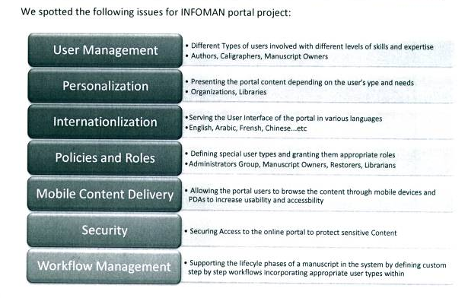
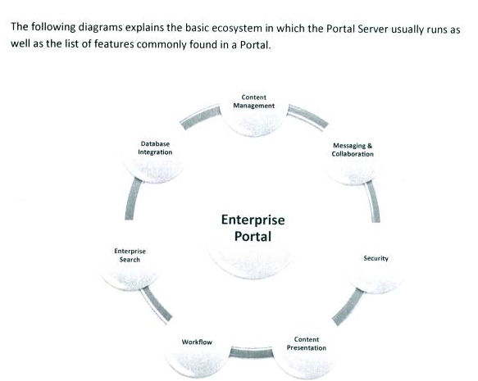
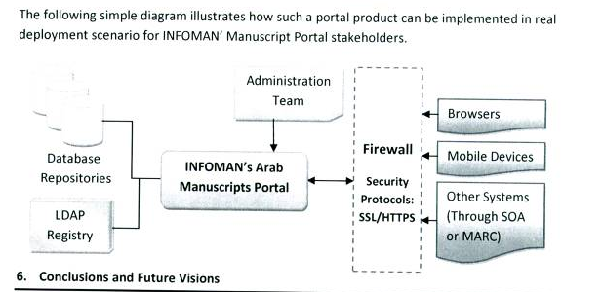

How to achieve a collective information system?

Two challenges had to be met when creating a prototype collective information system of Arabic manuscripts collections. Libraries and Private collectors were protective of their acquisitions, some as Al Azhar website which for few months offered their on-line database for free, totally brought this service to a standstill. Such libraries felt the need to create a sustainable system to help keep the web site running. Private collectors feared current artifact-acquisition laws & regulations imposed in several countries, and became apprehensive towards sharing their collections. They felt these century old regulations are infringing on their rights.

Secondly, a sudden interest in digitizing, scanning, recording, and keeping electronic records of Arabic manuscript collections resulted in the growing of databases and XML encoded systems on the web. Every day, a site emerges with an online searchable database, some complex others simple, the need to design a system that would be able to access the newly developed sites and search their databases, becomes an endless chain.

Accordingly the prototype portal was designed to meet all the above mentioned challenges:

The Portal Design

The Infoman portal similar to the UNESCO archives & library portals (http://www.unesco.org/cgi-bin/webworld/portal_archives/cgi/page.cgi?d=1) is a gateway to information pertaining to Arabic Manuscripts. The portal includes a Generic Database of Arabic Manuscript Collections within the region/world. This data base is searchable by: Country, Libraries & archives, Museums, subject and Private holdings. This database solves the first concern of manuscript experts, which is to know that a collection exists. This tool will also be able to indicate the different subjects that maybe found in specific libraries or museums within specific countries, thus bringing the researcher closer to their required query.
The portal will also include a second database: A Database of Arabic Manuscripts. This database will be available to all parties that have collections whether private or publicly owned, for them to make use of. This database can be used for remote collections, endangered holdings, and difficult to access acquisitions. The database will be accompanied by a Data sheet, which is supposed to be completed by the concerned librarian, for each manuscript, prior to plotting this information onto the database. The data sheet includes all possible fields that pertain to Arabic Manuscripts taking in consideration the Library of Congress specification and the widely spread MARC fields. Such database will eventually achieve the desired collective information system.
Both the Generic Database of Arabic Manuscript Collections and The Database of Arabic Manuscripts will be linked and will support each other in terms of information provided.
To achieve the aim of the Infoman portal of Arabic Manuscripts, the portal offers an array of services: tools & guidelines to professional members specialized in the areas related to Arabic Manuscripts. The services offered are divided into Useful Tools, Standards & Guidelines, Points of Interest, and Communication Channels. The Useful tools such as Date converters, Glossary of Terms, History of the Islamic World, The Art of the Book. Standards and Guidelines such as: Image guidelines, care, handling and storage of manuscripts, restoration guidelines & other services. The special interest points include available bibliography, policy & regulations, copyrights and IPR, Events, exhibitions & Festivals and scientific research pertaining to Arabic manuscripts. The communication channels: ask a librarian, online Discussion forum, and expert list database, what is new on this site and know more about your manuscripts. The last section of the portal relate to the Private collector as a communication channel to encourage them to surface. Services such as : authentication service, recording their collection in our database (extracted and sent back in a file), are but an example.
A web master will manage the site who will be in charge of updating the portal, receive suggestions and monitor and evaluate the portal's functionality. The site will include a –registration – possibility where a user name and password will be required. This will generate a list of users and thus a new 'manuscript' community. The site will also include a site map, and "how to use the portal" section, and the Launch of full revised and functioning Data Base.

Following is the back end of the database:

These milestones lead to the key deliverable of the project; A proto-portal with a functional database.

- Pilot website

http://infoman.cultnat.org/heba/

The Infoman proto-portal displays all the necessary fields for professionals in the field of manuscripts. It functions as a directory, organizing the important information found within the web into this portal. It would create automatically a renewal system through the RSS to update its information. The information is sometimes shown as links as in the date converter link, or as directly connected to the website as in the glossary of Terms where it skips URL to directly display the Islamic Art Network content. As this is a proto-portal not all the keys are functional, some fields are under construction, while others are un-functional as in the password and log-in info. The experts within the workshop realized the importance to choose the websites added to this directory and accordingly suggested that one expert in each field of manuscript updates the sections regularly. The original design attracted the viewers during the workshop.
- Pure Static Pages
- About us
- Policies and regulations
- Copyrights and ownership statements
- Set of external links → useful links / Standards and guidelines
- Site Map: guides the users on how to use the site and illustrates the site sections

- Administrator /Webmaster menu
- Managing references ( Books, journal papers, …etc): by initially adding the fundamental resources then adding emerging books or papers
- Managing news: where news represent any event like conferences, festivals, exhibitions, site news …etc .
- Managing Experts info: Adding experts’ info
- Manage posted questions: whether the questions are posted to “ ask the expert”, “ask the librarian” or to the suggestions part
- Managing Manuscript Database: where the administrator will fill in the existing manuscripts/collections data as well as the lookup tables like (institutions, subjects …etc)
- Authorize the registration of the site users: namely private collection owners.
- Grant and authorize the manuscript/collections info uploaded by private owners

- Private Owners corner
- Registering his/her personal info and getting a username and password, and accordingly login to the website later when try to use private owners corner
- Inputting his/her Manuscript(s)/Collection(s) data : this module is similar to that of the administrator’s data entry option except that it has limited authority, i.e. does not actually adds to the database but rather the data stays pending until confirmed and authorized by an administrator in order to be stored in the Manuscript database.
- Know more about my Manuscript(s)/Collection(s): this part will be implemented as a question to the webmaster who answers him/her back.
- Find related Manuscript(s)/Collection(s): applied advanced search to retrieve similar items from the database
- Download his/her Manuscript(s)/Collection(s) database which is organized with all available info by our system and sent to the user in a form of a file (XML, HTML or pdf file)

- Other website users
- Advanced search: which provides the users with a powerful search tool that combine multiple search criteria (title, language, author, calligrapher, subject, given data, and deduced date for Manuscripts) and (Institution or Country for Collections)
- Registration: for users who are interested to receive Newsletters from the website.
- Contact us: Sending a question or a suggestion to the administrator who answers back by email.

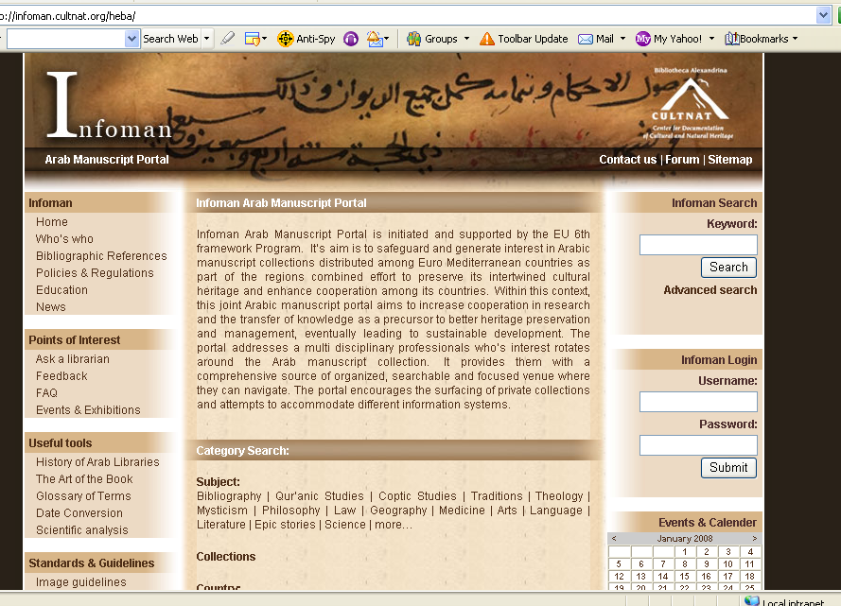

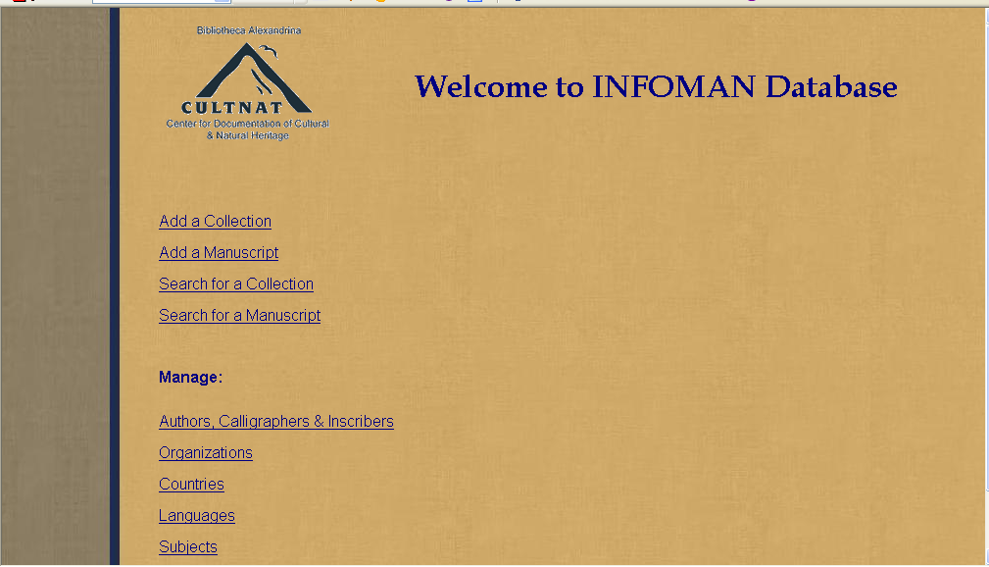

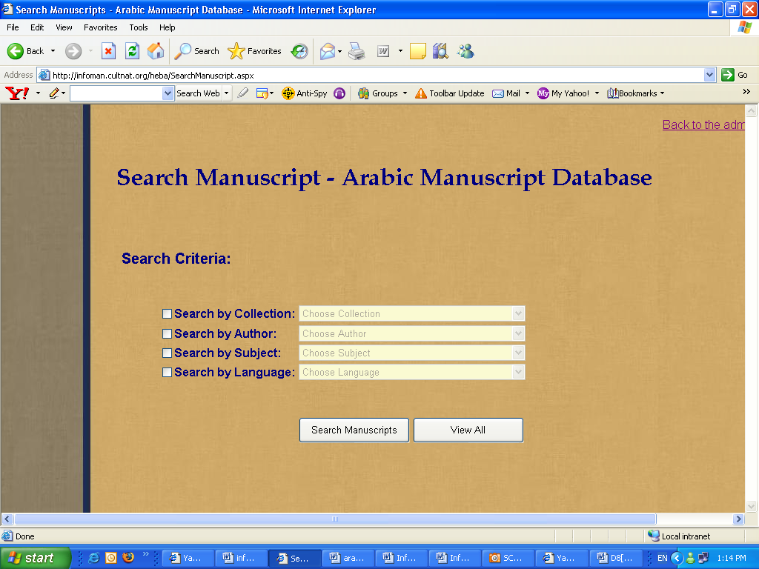

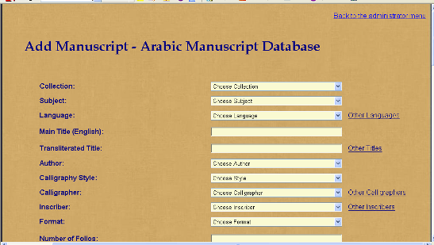

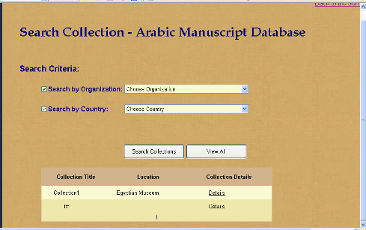

Arabic MARC fields:  م | حقول الفهرسة | الترجمة المقترحة | ما تم اعادة تسميته | Data Type | Marcحقول مارك
1 | رقم ديوي | Dewey No |  | Text | 82
2 | رقم المخطوط والفن | Manuscript No |  | Text | 90
3 | الميكروفيلم | .Microfilm No |  | Text | 091
4 | المؤلف من (صفحة العنوان/الغلاف/المقدمة والخاتمة) | Author (from Title page/Cover/Introductory &Final) |  | Text | 100
5 | المؤلف من المقدمة | Author from introduction |  | Text | 245:$c
6 | اسم المؤلف المنقحر | Transliterated name of author |  | Text
7 | العنوان من (صفحة العنوان/الغلاف/المقدمة والخاتمة) | Title (from Title page/Cover/Introductory&Final) |  | Text | 240
8 | العنوان من المقدمة | Title from introduction |  | Text | 245:$a
9 | جزء رقم | Volume |  | Text
10 | رقم الرسالة (ضمن المجموع) | Number of Treatise (Collective Volum) |  | Text | 091
11 | عدد المجلدات | Number of volumes |  | Text | 505
12 | الحاجة إلى الترميم | Maintenance |  | Text | 583
13 | السماعات | Audition note |  | Text | 561
14 | التوقيفات | Endowment |  | Text | 561
15 | الإجازات | Approvals / accreditation |  | Text | 561
16 | فاتحة المخطوط | (Introductory of manuscript )Incipit |  | Text | 500
17 | الخاتمة | (Final of manuscript)Explicit |  | Text | 500
18 | المحتوى | Summary |  | Text | 520
19 | الكلمات الدالة | Keywords |  | Text | 653
20 | تبصرة | Note |  | Text | 500
21 | عدد الأوراق | Number of Leaves | Number of Folios | Number | 300:A$
22 | المسطرة | Number of line per page | Page Ruling | Number | 500
23 | الخط | Calligraphy style | Ink Type | Text | 500
24 | إيضاحات | Illustrations | Illustrated | Text | 300:B$
25 | العنوان المنقحر | Transliterated documented title | Transliterated Title | Text
26 | مكان النسخ | Transcription Place | Provenance | Text | 535
27 | تاريخ النسخ | Transcription Date | Given Date | Date | 260:C$
28 | اسم الناسخ | Scribe’s Name | Inscriber | Text | 700:$a
29 | التمليكات | Ownership | Ownership Record | Text | 561
30 | مصادر التوثيق | References | Source of information | Text | 510
31 | مدخل البيانات | Data Entry Name | Inputter data:Date | Text | 900
32 | تاريخ ادخال البيانات | Data Entry Date | Inputter data:Date | Date | 900
33 | الجهة التي يوجد فيها المخطوط | Insert Location Info |  | Text
34 | اللغة المستخدمة في كتابة المخطوط | Language |  | Text | 041
35 | صورة لكل الصفحات بدرجة نقاء منخفضة | low resolution images |  | Text | 900
36 | صورة لكل الصفحات بدرجة نقاء عالية | High resolution images |  | Text | 900
37 | الحجم | Manuscript Size |  | Text | 300:C$
38 | الموضوع | Subjects |  | Text | 650

It was necessary to build the database first in English so that all can experiment with it and add content and retrieve information from it. Yet the importance of this proto-portal as a tool to the Arabic speaking community is clear and accordingly the fields were translated into Arabic.

This stage led to another activity which was unplanned, which was the manner in which the manuscript was broken into a codocology system and uploaded into the MARC fields:

WP3: Euro-Mediterranean Expert Meeting

Within Work Package 3; Euro Mediterranean Expert Roundtable Meeting, Task # 1 : Organize a three day expert roundtable meeting to evaluate the results of the pilot project within a larger Euro Mediterranean context and its applicability in the region- was performed. The Round Table took place on Monday 28th January up to Wednesday the 30th of January 2008 at the premises of the Center for Documentation of Cultural and Natural Heritage, Smart Village – Cairo, Egypt. Milestone 4 was accomplished taking in consideration the following:

- Prepare a set of working papers to be discussed during the meetings.
- Gather manuscript expert sub groups to cover all the relevant themes during the meetings to come up with well-articulated recommendations and a strategic plan.
- Prepare the event travel, accommodation, and insurance for participants.
- Prepare working document for the pilot project for review during the workshop.
- Provide simultaneous translation during the event
- Compile and publish proceedings in English and Arabic.
- Invite Euro Mediterranean experts in the field.

The main objectives were:

First: Evaluation and critique of the pilot manuscript information system presented during the meetings.
Second: Unification of cataloguing and indexing standards for documentation of private and public manuscript collections.
Third: Laws, rules and regulations of manuscript collections in EU and MPC countries, particularly those related to the ownership of private collections and copy right on the internet.
Fourth: Exhilarating public awareness of the collections means to encourage study and scholarship in this field among professionals and how to disseminate best practice and knowledge.
Last but not least the experts will sanction an action plan for the preservation and documentation of Arabic manuscript collections in EU and MPC countries as well as a set of recommendations and policy directives in support of enhancing research and innovation to achieve more cooperation between the above stated countries in fulfillment of the Barcelona Process.

Deliverables:
D9: Expert List Month 06
D10: Working Papers Month 15
D11: Round Table meeting Month 16
D12: Report Month 18
Roundtable Meeting | M1 Compiling Expert List | M2 Working Papers | M3 Expert Meeting | M4 Report on expert meeting | Policy recommendations and action plan

D9: Expert List

An Introduction:
An Experts Database aims at identifying and categorizing experts in the field of Arab Manuscripts (Islamic and non Islamic) from the MPC. The multi disciplinary approach of this project necessitates the identification of the below mentioned groups in each of the Mediterranean countries. A call addressed to individuals and institutions dealing with various fields related to the Arab Manuscripts will aid in the establishment of such databases and would secure the equal opportunity for participation of governmental and private individuals.

The Targeted Experts were:

- Librarians at National Library and archives
- Library Science & Manuscript Catalogers
- Computer science specialists & database experts
- Museum Curator of Arabic and Ms Collection managers,
- Arabic Literature Specialists
- Historians: Middle Eastern History / Civilization, History of Arab Sciences
- Art historians (art critics, culture historians and material historians)
- Imaging Unit /Microfilm Unit specialists
- Theologians, Professor of Hadiths, fiqh, and Religious sciences
- Heritage specialists
- Restoration & conservation specialists
- policy makers & Government officials

The Expert Database investigated the below mentioned categories and identified experts within the Euro-Mediterranean countries. Yet a more complete list will be attempted after the Expert’s Workshop.

The MPC list includes:

National Libraries with Arabic manuscript collections
Regional Libraries with Arabic manuscript collections
Private collections
Institutions with Arabic manuscript collections
Universities and research programme with Arabic manuscript experts
Conservation and preservation centers dealing with manuscripts
Institutes of Arab History, Culture and Sciences
Web sites of Arabic manuscript collections

D10: Working Papers

Call for Participation

The Center for Documentation of Cultural and Natural Heritage, Egypt, has the pleasure in inviting you to take part in an Expert workshop on Arab manuscripts:

Towards a Euro-Mediterranean Memory: Expert Workshop on Information Systems for Arab Manuscripts
Monday, 28 January - Wednesday, 30 January 2008
Cairo/Egypt

Invited to apply are: All scholars dealing with every aspect of Arabic Manuscripts, information systems related to Arabic Manuscripts, conservators, preservations experts, art historians, historians, codecologists, museum curators, librarians, academicians and researchers.

Deadline for application: January 20, 2008
Brief Description:

The goal of this workshop is to view a proto portal for Arabic Manuscripts initiated under the EU 6th framework Programme as part of the Infoman Project. The goal of this project is to safeguard and generate interest in Arabic manuscript collections distributed among Euro Mediterranean countries as part of the regions combined effort to preserve its intertwined cultural heritage and enhance cooperation among its countries. Within this context, a joint Arabic manuscript portal aims to increase cooperation in research and the transfer of knowledge as a precursor to better heritage preservation and management, eventually leading to sustainable development.

The workshop will analyze The Infoman’s pilot web portal for manuscript collections and discuss the possibility to solve problems as: The accommodation of different data base structures into one information system. Possibility for such proto portal to achieve a system that would allow for search and retrieval of data accessed on the internet in a user friendly manner. Furthermore it would address the possibility of bringing together records from privately owned and publicly owned manuscript collections under a joint XML / database.

The workshop sets the following objectives:
- Explore and identify initiatives taking place worldwide aimed to safeguard and generate interest in Arabic manuscript collections distributed among Euro Mediterranean countries as part of the regions combined effort to preserve its intertwined cultural heritage and enhance cooperation among its countries.
- Raise awareness of existing initiatives of Developing collective Information system for Arabic Manuscripts
- Bringing together information pertaining to all disciplines related to Arab Manuscripts
- Encourage the appearance & surfacing of private collections
- Address the commonalities and differences between such initiatives, as well as the challenges facing them.
- Exchange knowledge, experiences from the field and ideas on successful means to reach an ideal Arab manuscript portal
- Develop best strategies to address the need of all target groups dealing with Arabic Manuscripts.

The workshop will include working groups and discussion roundtables, case studies, and field visits.

Issues to be covered in the course:
- The Infoman Proto portal – cons and pros
- Information Systems for Arab Manuscripts
- The International approach regarding Manuscript collections
- Insight into different initiatives dealing with private vs. public collections.
- Case studies

Please note, that CULTNAT will not cover accommodation or travel expenses for participants from within Egypt. Only certain applicants will be taken into consideration for fully or partially coverage of course expenses. Please indicate whether or not you will be able to cover your own expenses in your application form and further indicate what expenses you are applying for the Project to cover.

Please contact:
Dr. Heba Nayel Barakat
Infoman Project
Center for Documentation of Cultural and Natural Heritage, Egypt
Smart Village, Cairo Alexandria Road Km 28
Tel.: +202 35343155
Fax: +202 35392929
Email: hobarakat@mcit.gov.eg

Infoman

Towards a Euro-Mediterranean Memory: Expert Workshop on Information Systems for Arab Manuscripts
28 January - 30 January 2008
Cairo/Egypt

Concept
The Workshop evaluates and discusses to enhance an Infoman Portal developed The Infoman Portal may seek to develop a collective information system. For many years, manuscript collections had been catalogued and online access made available in computers. Both the XML and database are means to organize collections of manuscripts with common elements. The difference between the two systems is that XML surrounds the text with tags while in the case of databases the words are separated into fields that are then retrieved via a program. Databases are easy to update entries & keeps tract of logging transactions. Databases related to codex manuscripts started to create several challenges, the fields grew longer and new relationships existed resulting in more complex data systems. The Infoman portal chooses to use databases as they may serve its purpose best but will also investigate the use of XML in sharing of information between websites.

How to achieve a collective information system?
Two challenges had to be met when creating a prototype collective information system of Arabic manuscripts collections. Libraries and Private collectors were protective of their acquisitions, some as Al Azhar website which for few months offered their on-line database for free, totally brought this service to a standstill. Such libraries felt the need to create a sustainable system to help keep the web site running. Private collectors feared current artifact-acquisition laws & regulations imposed in several countries, and became apprehensive towards sharing their collections. They felt these century old regulations are infringing on their rights.

Secondly, a sudden interest in digitizing, scanning, recording, and keeping electronic records of Arabic manuscript collections resulted in the growing of databases and XML encoded systems on the web. Every day, a site emerges with an online searchable database, some complex others simple, the need to design a system that would be able to access the newly developed sites and search their databases, becomes an endless chain. Accordingly the prototype portal was designed to meet all the above mentioned challenges. This workshop is to further discuss the Infoman Portal and to assess its strength and weak points, as well as to come up with recommendations.

^{Program}
Day 1 Monday, 28th January 2008
Session I
9.00-10.00: Opening

10.00-10.30: Welcoming statement by Cultnat Director – Prof. Dr. Fathi Saleh
10.30-11.00: Infoman - an overview

11. -12.00: Break & Tour

12.00-12.30: The need for an Arab Manuscript Portal and a common comprehensive Arab Manuscript Database

13.00-14.00: Lunch

Session II – Case Studies
14.00-14.30: 1. Private vs. Public: The Case of Egypt
14.30-15.00: 2. Information Systems
15.00-16.00: Discussion
End of Day One

Day 2: Tuesday, 29th January 2008

Session III – Workshop Open Discussions
10:30-11.00: Analysis of Infoman Portal
11.00-11.30: Break

Session IV – Case Studies:
11.30-12.30: Case 1: Testing the database – working with an original manuscript
12.30-13.00: Discussion
13.00-14.00: Lunch
14.00-15.00: Case 2: Memory of the Arab World – Manuscript division

Session V – Recommendations
15.00-16.00: recommendations
End of day 2

Day 3: Wednesday, 30th January 2008

Session VI – Field visits and excursions

The Center for Documentation of Cultural and Natural Heritage, Egypt

D11: Round Table meeting

The WP3: Euro Mediterranean Expert Roundtable Meeting gathered experts from different areas of specialization yet practice and/or study manuscript collections so that they enrich the meeting with diverse approaches to different problems related to manuscripts and their database. This multidisciplinary approach to cover all the issues pertaining to manuscript preservation and management took place on January 26-29, 2008. The experts Evaluation and critiqued a pilot manuscript information system presented during the meetings.
They also discussed the importance of the unification of cataloguing and indexing standards for documentation of private and public manuscript collections.
But above all, they discussed the status of Laws, rules and regulations of manuscript collections in EU and MPC countries, particularly those related to the ownership of private collections and copy right on the internet, and Egypt was a case study.
Finally the experts sanctioned recommendations and policy directions. This is the key component of this paper – Milestone 4.

Participants:
- Number of Participants: 34 guests
- Countries: Attended Infoman workshop experts from different countries such as Germany, Netherlands, Italy, England, Sudan and Egypt.
- Institutions: Lieden University , Exeter University, Al- Furquan institution, Arab States of the National Center, National library of Egypt, American University in Cairo, Faculty of Arts, law and Applied Arts from Cairo University.
- Professions: participated in the workshop different professions in the field of Paleography and Codicology, Librarians, restorers, civil law experts, IT engineers, Manuscripts experts, Art historians , Editors, Museum Curators, and Image Service

Poster

Brochure

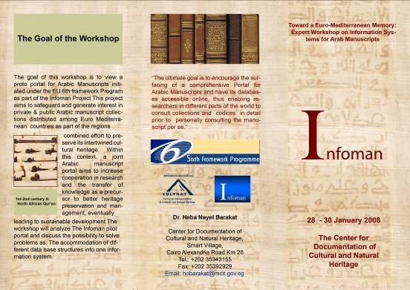

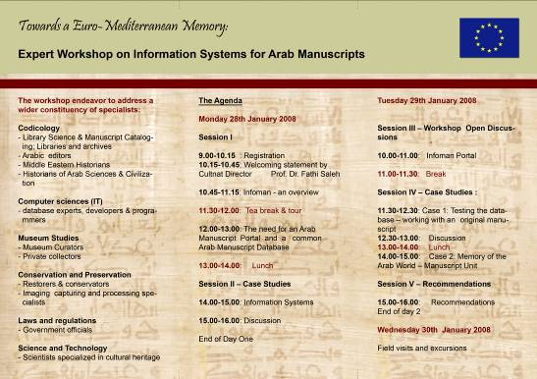

Name Tags:

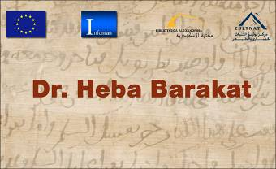

Photographs:

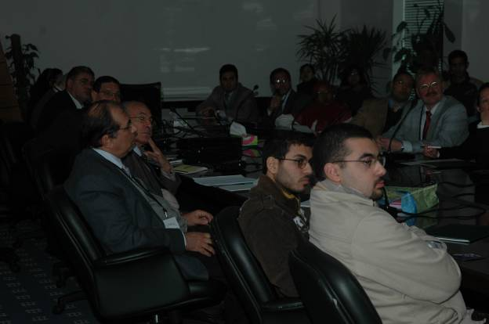

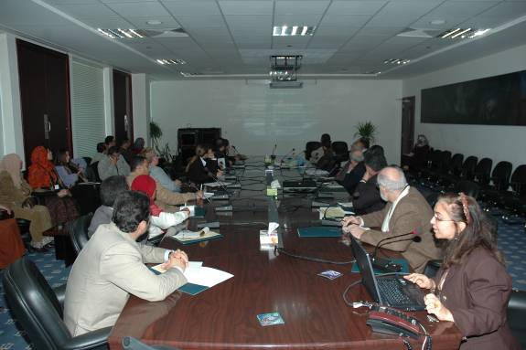

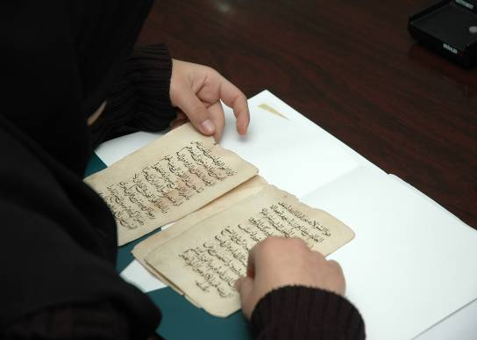

WP4: Dissemination
Dissemination activities included developing a dissemination plan for disseminating project results nationally, regionally and internationally. The Project and the EU support were announced through various publications in the press and during the meeting.

Deliverables:
D13: Dissemination Plan Month 06
D14: Survey of Ind. & Inst. Month 12
D15: Roundtable Proceedings Month 18
WP Title | 0 |  | 3 |  | 6 |  | 9 |  | 12 |  | 15 |  | 21 | Deliverables
Dissemination | M1 Dissemination plan | M2 Survey of target individual /organizations | M3 Web announcements and media coverage | M4 Published round table proceedings | Dissemination plan, raising Commission awareness of policy recommendations

Objectives of Dissemination of Information

The objective is to disseminate all the knowledge gained during the project among the different target groups nationally – regionally and internationally. Nationally: includes the government institutions dealing with manuscript collections. Taking Egypt as a case study; the National Library (Dar al Kotob) which houses the largest number of Arabic manuscripts in Egypt, Regional Libraries, the Manuscript centers such as The Institute of Arabic Manuscripts (Arab League), The Manuscript Center at the Library of Alexandria (Bibliotheca Alexandrina), Ministry of Culture, Ministry of Waqf, University Libraries, as well as The Privately owned collections.

Regionally& Internationally: includes EU projects and organizations concerned with Euro Mediterranean cultural heritage such as Euromed, Infratsonic, and Noesis, UNESCO, as well as National and international foundations as Anna Lindh Foundation and Thesaurus Islamicus Foundation as well as African Manuscript centers such as the Ahmad Baba Center, and the Mamma Haidara Commemorative Library and the Emirates Jumaa al Majid manuscript and heritage NGO. It will also identify European centers, libraries, and institutions and experts dealing with digitizing manuscript collections. All round table applications were announced on Cultnat’s Website, and via E-mail, to the target individuals / organizations.

The dissemination of information within the Expert Meeting was a two-way communication channel with stakeholders, academic communities and the target groups through the collective discussions, networking and interaction of the multidisciplinary Experts. The recommendations and actions were sent to all participants.. A logo for the project and a bilingual brochure published. Press releases prepared to reflect on the Project and further target interested groups, individuals and organizations.

The database has also been requested by a regional project – supported by the UNESCO – under the auspices of the League of Arab States. This project "Memory of the Arab World" would like to use the database as its main manuscript reference source, and share it within the Arab Mediterranean countries as well as the rest of the Arab Countries.

The launching of the proto-portal supported by the publicity made in the national newspaper and media, coincided with the new national laws concerning the Arabic Manuscript in Egypt. This roar is indeed giving this site a special importance within the manuscript expert world.

The Expert Group recommendations during the working days:

That manuscripts should be excluded from the artifact laws since it can be considered a support for information that are relevant to the advancement of knowledge and that has no copyright issues. The artifact laws in several MPC countries hinder the surfacing of historical manuscripts fearing its confiscation. The manuscripts in many cases maybe family inheritance and may smuggled, sold or broken down into single folios to escape these laws, and a large part of relevant information is accordingly lost.

The expert group acknowledged the importance of a portal to bring together all the diverse scholars together under one ceiling. This would give scholars & researchers & lawmakers a chance to revisit the manuscript world. A portal would further organize the massive amount of work and would see the Arabic manuscripts as one entity.

The expert group recommended that a working group would supervise the portal's sub fields. The working group, which should consist of experts in the sub, field (of manuscripts) such as "care and handling tips" should display the most important websites first and then have the site be generated under Google or another search engine and a mark of SSR/HM.

The IT group insisted that there is no problem to incorporate less than one portal different systems of retrieval as long as the MARC format is standard and the LC classification used.

A General recommendation was to work with manuscripts from a multi-disciplinary approach – it is not the property of the Librarians alone!

The conservation unit recommended that some fields are to be omitted from the database as it is enough to add it in the conservation history report.

The editors recommended that one more field should be added to the database to provide readers with relevant information.

In general the database and portal design were recommended to be placed as a portal under an organization as the UNESCO, since it already has several portals, and since this would encourage the surfacing of many unknown valuable issues related to manuscripts, the site should also concentrate on the legal aspect of manuscripts, the copyright and the intellectual property rights.

Investigate the possibility of working with manuscripts as books without ISBN numbers.

The Copyright, Intellectual Property rights and the current laws within the MPC, MENA regions needs to be identified, documented and regulated by a higher body.

Actions and Recommendations

The Project Team was pleased to receive the constructive and critical feedback at this key phase of the project. Many of the recommendations made by the round table group were long ranging and had implications beyond the remit of the Project. The main recommendations received during discussions are presented in summary below.

The action points emerging from the recommendations reflect the recommendations presented and reflect the aim and objective of the portal. The key actions are presented in summary below.

Summary of Recommendations

Recommendation 1
Several additional fields needs to be included in the database

Recommendation 2
Expand the terminology of the database fields and explain it to reflect the interdisciplinary nature of Manuscript Studies.

Recommendation 3
Organize information in the database field so as to include an expert team to evaluate new contributions

Recommendation 4
Stress the importance of "the flow of information" rather than just the searching of information related to manuscripts

Recommendation 5
The proto-portal buttons needs a committee of experts to evaluate the surfacing websites

Recommendation 6
This portal aims at changing the mentality of the authorities towards manuscripts, change rules and prohibitions related to dealing, surfacing and using manuscripts thus leading to a broaden outlook of the manuscript studies.

Recommendation 7
Expand and Harvest data from additional sources, Open the portal for contributions other than the ULL

.

.
Key Action Points reached from recommendation

Key Action 1
To test the proto-portal and enhance its database, create a well structured engine, expand the fields of MARC, and use the library of congress terminology and subject headings. The manuscripts can be linked to any library, without an ISBN number, and can be treated as an item record with a bibliographic record, with an indication that it is a manuscript. Thus a manuscript definition is important and it will reflect the nature of the container, not only that it is hand written, but that it may be placed in a special section, maybe vulnerable and careful handling needed, or that all information is not available at the moment as it may have been not edited, nor documented earlier. Such definition will then set them apart from any other media/containers. Thus the back end of the portal will be inspired by the consortium of libraries, as for example the consortium of University libraries of Egypt, which expands its resources allowing for more interaction with other html systems on the net.

Key Action 2
To create expert groups from the multi disciplinary facets of manuscripts. Aside of the steering committee for any Arabic Manuscript portal, a specialized groups must be formed from each disciplinary to regulate and admit to the portal the up to date information and guidelines regarding this disciplinary in particular. Thus they form sub-committees and among them they choose the manager who would represent them in the steering committee.

Key Action 3
To publish more information on the portal in the newspapers and conduct meetings with the officials to promote the idea of revising the manuscript rules and laws in Egypt as an example and the rest of the Mediterranian countries, as well as specifically for Arabic Manuscripts around the World. Thus a collective set of laws would guide such manuscripts upon identifying their presence in a collection, this is thus seen as world treasures and not just national treasures, and would be guided by a UNESCO set of concepts and guidelines.

Key Action 4
To investigate the best ways to integrate the Infoman portal with other ongoing projects found at Cultnat. The center for documentation of cultural and natural heritage, Egypt, shared all the available findings with the groups and posted them in its website, but also introduced the findings to several ongoing projects at the center. Among these projects was the Memory of the Arab World project, which is to follow the UNESCO memory of the World concept and create a collective portal for certain cultural fields, one of them is Arabic MANUCRIPTS. In this respect, the database fields, the Mysql database, and the recommendations will all be utilized. Another project is documenting the illuminated and illustrated Persian collections at Dar el kotob, and the documentation of the Coptic manuscripts at the Coptic Museum and libraries in Egypt.

Key Action 5
To explore potential partnerships as those of The Memory of the Arab World Project, with other institutions around the Euro-Mediterranean basin, which have a lot of Arabic Manuscripts, and fall into the same problems in the MARC fields, and in the multidisciplinary approach to the documentation process?

Conclusion

Disseminating the knowledge

Infoman achieved this by using various tools such as, conducting training on the Database and Portal that would primarily target the concept of integrating and strengthening ties with European Arabic Manuscript Experts and Middle East/ Mediterranean Experts and Professionals in the field. It also created a research knowledge base that would benefit the entire multi-disciplinary experts in the field and introduce guidelines to be followed. It organized the round table meeting and benefited greatly from the excellent contribution of the professionals, It accordingly had a great impact on the local and regional community as laws, regulations, problems of private collections surfaced and legislations discussed and changed. It also gave the young employee at the national library and regional universities the chance not only to attend but also to participate from a multi- disciplinary perspective, thus securing more defined research in the future as well as identifying new needed jobs in the local institutions.
Since Infoman was an SSA project aimed at developing a pilot information system for Arabic Manuscript Collections and discussing all aspects of this issue, there were several direct exploitable research results as the "private vs. public" "expert list" "SQL database and MARC field". However, it has produced a number of publicity materials to promote the project so that the achievement of milestones such as increased research collaboration with EU countries, increased participation in FP projects and increased scientific publications are facilitated.
Over 10 newspaper articles were printed outlining the activities of the project. Furthermore, the project and EU funding has been promoted with brochures, a booklet and a CD in 20 different Pdf of manuscript collections around the EU MPC countries.

