**PROJECT FINAL REPORT**

**

**Grant Agreement number: 263078**

**Project acronym: ROPAS**

**Project title: ROll-to-roll PAper Sensors**

**Funding Scheme: FP7**

**Period covered: from 1-5-2011 to 29-4-2015**

**Name of the scientific representative of the project's co-ordinator, Title and Organisation:**

**Mr. Corné Rentrop**

**TNO**

**Tel: +31 88 866 5391**

**Mob: +31 6 51640896**

**E-mail: corne.rentrop@tno.nl**

**Project website address: www.ropas-project.eu**

# 1 Final publishable summary report

## Executive summary

The incorporation of sensors and electronics into paper products is made available by recent advances in a number of technology fields, such as chemistry, printing, electronics, ICT and paper development. This allows the creation of **paper electronic devices and paper electronics packaging**. Electronic packaging can verify e.g. medicine authenticity and emails can be sent confirming when a package is opened by the correct person at the correct address.

The 'Roll-to-roll paper sensors' (**ROPAS**) project has made steps towards providing economically and technically feasible steps to produce paper electronic packages and labels with sensors in current industrial application.  
  
The focus of the project is a **low-cost** and **high-throughput** roll-to-roll (R2R) and sheet-to-sheet (S2S) printing of paper electronics. The project has developed a technological platform that integrates printed building blocks consisting of a paper substrate, conductive tracks, a display, an antenna, a battery and sensors (switches). The combination of the building blocks enabled a new product group that enables the creation of **paper devices.** The team optimised the technical building blocks, and completed functional prototypes for all three demonstrators. As an example researchers continued to work on fabrication of the organic radical battery (ORB). Technology for the latter is novel and the team has filed a patent application for the ORB electrolyte synthesis and printing methodology.

Three applications have **demonstrated** the ROPAS technological platform. A **security tag** will make it possible to determine whether or not a package has been opened. A **smart label** will enable customers to verify radio frequency identification-coded information easily for use in, for example, brand protection and privacy applications. On top of that the smart label is equipped with a temperature and humidity sensor, monitoring the history of a package. Finally, a **smart envelope** has been successfully developed providing, similar services to tracking and personal delivery of physical goods at a high security level, and at a lower cost. A patent was filed for the envelope application, and the potential market is huge. Economic feasibility of the devices was determined including necessary steps and end-use applications to come to commerciality.

In addition, **R2R** and **S2S** trials enabled commencement of mass production of the demonstrators. Scientists have improved the printing processes with use of flash sintering to cure the conductive ink at high speed on paper. The project also used hybridisation of electronic components on the printed devices on a larger scale. This enables introduction of logic and large distance communication on the paper devices.

LCA and recycling constraints were determined and set up with end-users. LCA impact of printed components was markedly lower compared to traditional component placing. Paper electronics did not disturb the paper recycling process so the products can be used in traditional paper applications.

The European paper industry requires **innovative** and **cost-effective** ways to add value to its products in order to remain competitive. ROPAS has delivered a potential new field for paper applications, with building blocks for the next generation of multi-functional fibre-based products for multi-billion euro market sectors including **food, packaging, medicine** and **logistics**.

## 1.2 Summary description of project context and objectives

Recent advances in the fields of nano-technology, bio-technology, ICT and sensor-technology enable incorporation of information to paper products which can interact with the user. Brand protection is enabled by incorporating electronic passwords. A letter or package can send an e-mail to inform you it was opened by the intended addressee at the correct location.

ROPAS has developed a technological platform, defined as a collection of functional components which are electronically connected and are integrated on a fiber based substrate by printing techniques. The technological platform consists of an electronic circuit in which sensors, batteries and communication devices are integrated on paper by printing techniques. The technologies function as the platform for creating various new products based on monitoring environmental changes like temperature, pH, bio/ chemical activity, etc over time and communication of the observation(s) to receiver and/or sender either by visual means or by wireless connection.

The targeted project has resulted in: design guidelines for the technological platform, the creation of printable devices like sensors, batteries, antennas and adherence of signalling chips, and processes for printing of such materials including conditioning of the fibre based surfaces. The results are demonstrated in three applications: security tag, smart label and smart envelope.

The technical platform is also a basis to facilitate the ICT paradigm, the internet of things (IOT). The term "Internet of Things" has come to describe a number of technologies and research disciplines that enable the Internet to reach out to physical objects. Technologies like RFID, short-range wireless communications, real-time localization and sensor networks are now becoming increasingly common, bringing the Internet of Things into commercial use by linking the physical world and cyberspace - a development that is not only relevant to researchers, but to corporations and individuals alike. The vision of the IOT is largely supported by ICT companies like SAP and IBM. [[1]](#footnote-1)

ROPAS - Application roadmap

The application roadmap of ROPAS has three stages of developing concepts with **increasing level** of functionality and **technological improvements**. The concepts are:

1) **Security tag**. The security tag informs the user whether the package is opened before. This application is realised with state-of-the-art printing techniques. The technological risk to create such application is from low to medium. This application is defined as milestone 5. High impact is expected in e.g. food and beverage industry.

2) **Smart label** is a communication device for anti-tampering applications. In this application screen-printed, low-power batteries and screen-printed sensors are integrated with a wireless communication device. Printing of conductive tracks on paper at large volume and speed was realised with flash sintering. This application is defined as milestone 6.

3) **Smart envelope** with a wireless communication device to monitor the status (opened or not-opened). In this application passwords are integrated with a signalling chip, battery and antenna to create a wireless connection. The wireless connection is established through available UWB networks. High peak power batteries are created using printing to enable the wireless connection. This application is defined as milestone 7. The smart envelope is patented.

Figure 1.1 depicts the **application roadmap** for ROPAS demonstrators as described above, the maturity of the technology as function of the time necessary to develop the products concepts.

Timing

**Security tags**

**Piracy control**

Screen printed battery

**Breaking wire sensor**

**SMART label**

**NFC communication**

Screen printed battery

Screen printed switch and paper humidity sensor

**SMART envelope**

**Wireless communication**

Placed components switches

Logic integration

Maturity of technology

M5

M6

M7

P1

P2

P3

P4

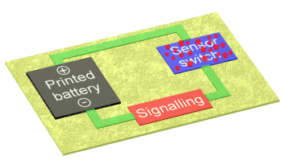

*Figure 1.1: technology roadmap, applications and maturity of technology,*

Why ROPAS? - The need for European SMEs:

The development of the technology in ROPAS focuses on a series of new functionalised sustainable paper-based products. Series of products, such as security tags, labels and transportation packages (including envelopes) are available at the moment.

The market for postal services and printed letters is a low cost commodity product in a declining market due to the upcoming of internet and courier services. The challenge that (SME) companies in these markets face is to develop and successfully market new added value products that offer novel functionalities and convenience to large groups of customers. The anti-counterfeiting market is continuously competing with piracy. To maintain or enhance their market share (SME) companies must constantly enhance or invent new security concepts to maintain their technological advantage and simultaneously prevent potential piracy (remaining one step ahead from piracy).

ROPAS - Concepts and enabling technologies

ROPAS enables a security system which enables its user to identify the **authenticity** of the product or whether the product has been tampered with. ROPAS allows fibre based applications in the packaging, postal and logistics domain for anti-tampering and/or anti-counterfeiting. The **proof of concepts** in ROPAS are **smart** **envelopes, smart labels** and **security tags**, with the aim **to personalize** the handling of the product (has the product been opened by its foreseen applicant.

The development of all ROPAS concepts are integrated in a technological platform which is depicted in Figure 1.2.

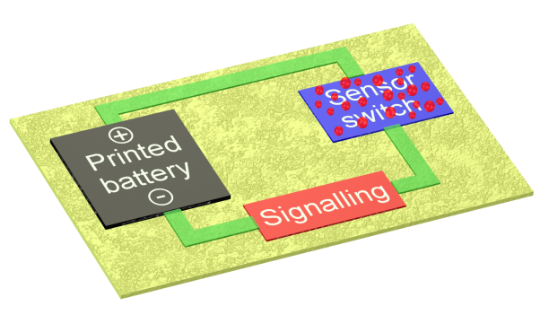

**Sensor switch**

**Printed battery**

**Fibre based substrate**

**Signalling**

**Humidity sensor**

**Temperature sensor**

*Figure 1.2: Schematic representation of the technological platform serving as the basis for functional concepts realized on fibre-based printing substrate.*

The building blocks of the technological platform all evolve from state-of-the-art technology into high tech (printed) functionalities. For the separate building blocks this means:

1. **Planar battery** devices are developed with the **highest possible peak power** (> 10 mW). Battery development evolves form a state-of-the-art screen printed Zn/ Mn dioxide battery into inkjet printed high peak power battery based on organic components to deliver high peak power at a low environmental pressure and low cost.
2. **Sensor switches** which evolves in the project from a **microcapsule** containingcolour changing **biochemical** active moieties, into a **pressure sensitive switch containing conducting moieties.**
3. **Signalling devices** for communication propagate in the project from a **colour changing** device, to a **display** and eventually into a **(wireless) communication** device.
4. The surface of the **fibre based substrates** is chemically modified to obtain optimal **printability** properties and sufficient **flow properties** for the electrolytes. Various paper types should be suitable for integration of the different components. The surface conditioning of the paper is of crucial importance. The naturally present pumping/ wicking function in paper makes it highly suitable for integration of encapsulated liquids, but in the same time difficult to print conductive circuits. The paper surface conditioning (paper morphology, wetting, porosity, acidity, coating application) is studied in the work package printing and processes. Also coating of the paper prior to printing to create a uniform surface will facilitate proper functioning of the biobased substrate.

ROPAS - key objectives

This project brings new developments which enable the industrial sectors paper, transport & packaging and printing to provide higher added value to their new products applications. Key objectives of this project are summarized in the table and show the relation with the topics of the call.

| **Key objectives of ROPAS** | **Relevance to the topics of the call** |
| --- | --- |
| **Digital track** and **trace** system for **letter/packages** using existing network. Tracking distance up to 300 m is required. | - integration **advances** in the fields of **ICT** and **sensor** technology for sustainable **paper** products having functionalities allowing to **report changes in their environment** |
| Electronic-**opening protocol** to control **personal opening system** of package based on circuit to activate for signal release containing at least 4 pressure sensors. | - new services for **anti-tampering** and **package tracking**  - creation of **high added value** products meeting **societa**l needs and with high potential of being **marketed** |
| **Flexible** **manufacturing printing** technology using inks with viscosity < 500 mPas for embedding **electric circuit and smart capsules** in **paper** products. | - **Paper printing** to provide higher added value and address rapidly changing **customer-demands**  - development of new highly **adaptable manufacturing** process  - Opening **virgin businesses** |
| Demonstration of the ROPAS concept in **different types** of **paper products** proving **robustness** of the (printing) technology.  **Conditioning** of the fibre based surface using **high-end** printing techniques to create a **uniform** surface | - **Paper printing** to provide higher added value and address rapidly changing **customer-demands** |
| New **pressure sensitive** sensors based on release-on-command **encapsulations** at a pressure of >200 g/cm2.  **Intelligent wireless communication** (ICT) between **paper-based** products and existing network are created | - new **functional components** based on state-of-the-art advances in the field of **material sciences** and **ICT**  - integration of **recent advances** in the field of **sensor** and **(sub)nano** technology for the next generation of **paper** products |
| Intelligent **architecture** platform for **wireless** communication between paper-based products and base station using existing networks. The battery should deliver every 30 min. a power burst of maximal 3 mW during 3 days | - paper products having functionalities allowing to **interact** with their user and **report changes** in their environment  - electronic papers with printed components and embedded systems  - new **services t**o provide information such as **anti-tampering** and **tracking** |
| **Minimise environmental** pressure of the newly developed products. The governmental regulation[[2]](#footnote-2). Also the recyclability of the paper products is studied | **- LCA** overview to stimulate optimal production |
| **Packages,** cheaper than €6,85 to compete with registered post. (e.g. target € 3.50)  To reduce costs **labels** are processed on large scale and should not exceed 10 cents | - development of **high added value** products meeting **societa**l needs and with a high potential of being **marketed** |

**1.3 Description of the main S&T results/foregrounds**

ROPAS integrates (printed) electrical building blocks into paper to create functional devices that are demonstrated as: security tag, smart label and smart envelope. In addition to development of the demonstrators, ROPAS has made advances in the development of the necessary building blocks.

### Period 1

In the first 18 months, work has been performed to optimise the building blocks' performance as well as defining the use cases and the design of the demonstrators (see 18 months' progress report). Three demonstrators are designed and the use cases, set of demands and evaluation protocols are in place. During the project, the demonstrators will evolve in complexity (including printing processes) and eventually result in the creation of the envelope demonstrator including a wireless protocol.

To verify that the demonstrators function properly (e.g. to verify the wireless protocol) the demonstrator was built with state of the art components or printed components when available, which resulted in the so called “spaghetti boards”. Methods to place the components have been studied here. Table 1.1 shows the flow and the status/result of the project demonstrators. This is the use case definition, which enables the creation of the electrical design used to create a spaghetti board to verify the working principle. The printing design is set up with the usage of the spaghetti board, and is eventually used to print the conductive tracks on paper. In period 2 the demonstrators further evolved, including production processes and component placing.

*Table 1.1: Use case, spaghetti board, print design and printed version of the demonstrators*

|  |  |  |  |  |
| --- | --- | --- | --- | --- |
| Demonstrator | Use case | Spaghetti board | Print design | Printed version |
| Security tag |  |  |  |  |
| Smart label |  |  |  |  |
| Smart envelope |  |  |  |  |

Development work has been done to improve the building blocks: sensor switches, paper and batteries. All building blocks were optimised in the first 18 months.

*Sensor switches*

In the project, capsules were developed that can create a conductive switch or a colouring signal. The capsules are amongst others filled with acid/water created by encapsulation printing or graphite/oil created by emulsification. Upon breaking the capsules, a conductive path is created and with that a switch is formed. The capsules need to be distributed in inks to make printing of the switch possible. It was concluded that the size of the capsules will always be too large to deposit the capsules by inkjet printing. In later research other methods to create a switch as well as other printing techniques for capsules were researched. A proof of concept with respect to acid release was demonstrated. Nevertheless it was found that the capsule size is too big to be printed for creating a switch. The strength of the capsules was limited as well. The capsules have a tendency to dry out.

Therefore, at the end of period 1 it was decided to discontinue the capsule activities and concentrate on the development of a humidity sensor. In period 2, a paper on capsule printing was written and published.

*Fibre based substrates, conductive tracks and antenna*

Various paper products were validated and printed with conductive tracks using inkjet and screen printing techniques. Preconditioning layers were also tested to optimise printing conditions. Antenna conductivity is regarded the most difficult target to reach and is therefore taken as a threshold.

Paper systems were studied for pH, smoothness and surface porosity. After printing, detailed microscopic studies revealed that the formation of the conductive layers seemed to result from the formation of a uniform ink layer on the substrate surface as could be expected. Papers that were regarded most suitable are LUMI silk and Hello Fat Mat, of which LUMI silk was chosen to be the most suitable paper used by ROPAS. It was demonstrated that comparable conductivity can be reached on paper and foil. In relation to the paper, printing of conductive tracks was optimised using inkjet printing and screen printing. Conductivity values were compared to the conductivity of inks on foil. Two types of ink were selected and distributed amongst partners.

### Period 2

In the second period, focus was on evolving and fine-tuning of the demonstrators and their use cases as well as a start of (roll-to-roll and sheet-to-sheet) mass production printing of the demonstrators. The printing processes were improved by introduction of (N)IR and flash sintering.

The introduction of R2R/S2S component placing has started. ORB battery synthesis was continued and the start of Roll-to-roll production of the Zn/MnO2 battery started. Newsletters were also published and the first workshop at the E-MRS in Warsaw took place.

The first demonstrator (security tag) was produced at large scale at VTT, with assistance by Enfucell and Starcke. Two variations of the smart label were created, using a display and using wireless NFC communication. The final use cases of the demonstrators are described in table 1.2.

*Table 1.2: Print design, printed version and component placing of the demonstrators*

|  |  |  |  |
| --- | --- | --- | --- |
| Demonstrator | Improved print design | Printed version | Component placement |
| Security tag |  |  | C:\Users\rentropcha\AppData\Local\Microsoft\Windows\Temporary Internet Files\Content.Outlook\SX8VFS72\foto (9).JPG |
| Smart label  (Display) |  |  | C:\Users\rentropcha\AppData\Local\Microsoft\Windows\Temporary Internet Files\Content.Outlook\SX8VFS72\foto (16).JPG |
| Smart label (NFC) |  | foto (23) | foto |
| Smart envelope |  |  | C:\Users\rentropcha\AppData\Local\Microsoft\Windows\Temporary Internet Files\Content.Outlook\SX8VFS72\IMG_0850.JPG |

*Security tag:*

The security tag demonstrator provides information on whether a package has been opened or if the package was recycled. The security tag is a paper tag which contains a placed battery and 2 coloured LEDs (and a resistor). Opening is monitored by disrupting a conductive track. After opening the package, the display will mention whether or not the package has been opened before. This will inform the user that the package (and content) is genuine. The security tag needs to be laminated for protection. In the project, lamination with paper and lamination with a printed graphical design are envisaged.

For the use case, packaging of expensive goods in logistic applications are envisaged. Partner Loginser integrated the security tag on boxes and former partner Buhrman Ubbens integrated the security tag on the sent box (discussed in the 18 months' report). The demonstrators are displayed in the pictures.

The final demonstrator was produced with flexogravure printing (including a printed resistor), and paper lamination (Figure 1.3).

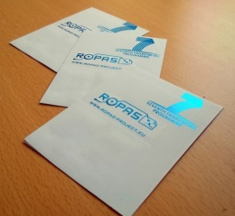 *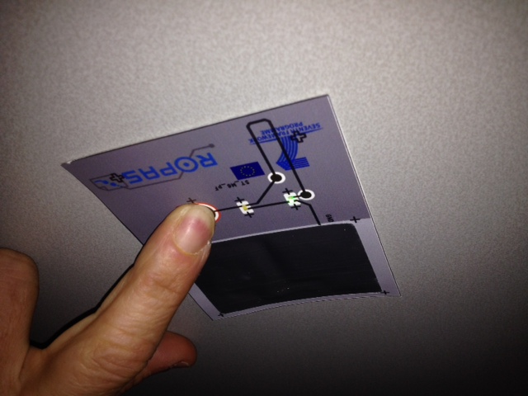*

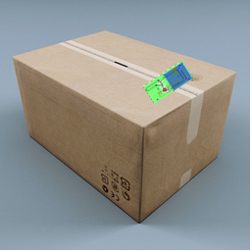 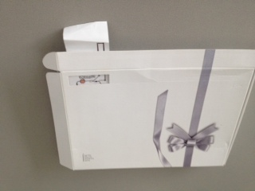

*Figure 1.3: Security tag demonstrator (1, VTT, 2, Océ, TNO) as integrated in a logistic applications box (3, LOG) and the Send Box (4, former partner BU)*

*Smart label*

The smart label monitors the temperature and humidity of a package in order to inform the user that the package was transported under correct environmental conditions. The smart label contains a placed battery and chip to monitor and report the conditions and time of transport of the label.

As a use case, the packaging of sensitive organs is envisaged. The Smart label is built in two variations. One version uses a display and another uses NFC communication. When equipped with NFC communication, the label can be read out by a mobile device. A functioning smart label with print circuit and temperature/ humidity conformation is depicted in figure 1.4.

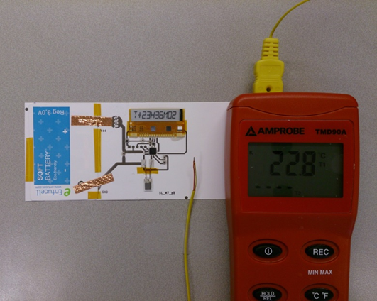 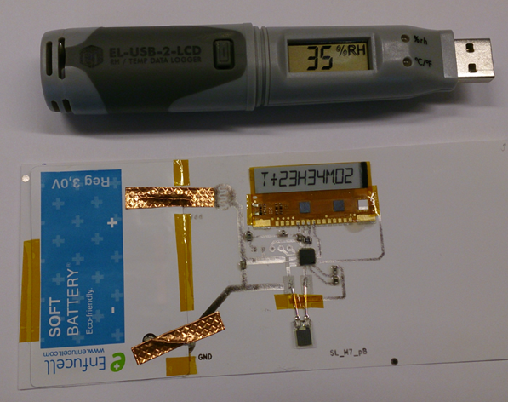

*Figure 1.4: Smart label demonstrator with display variation (TNO) Display mentions T+23H36M02, which means temperature = 23°C, humidity 36%, 2 measurements taken. 1.4.1. temperature verification and 1.4.2. humidity verification.*

In an advanced state of the smart label, the placed humidity sensor was replaced by a printed humidity sensor, consisting of an interdigitated finger structure printed on the LUMI paper acting as a capacitive humidity sensor. The display was also replaced by near field communication (NFC). In figure 1.5 the smart label communicating with an android tablet is shown.

*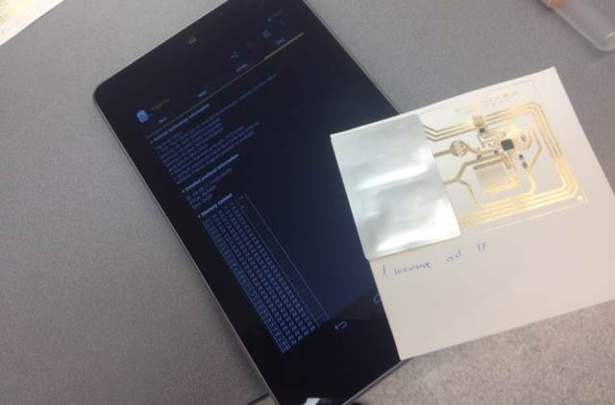*

*Figure 1.5: Smart label with NFC communicating with a tablet by Android.*

*Smart envelope:*

The smart envelope demonstrator provides information on the location and opening status of a parcel in order to inform the sender and receiver if the package is genuine and was delivered to the correct receiver at the correct place (registered mail). The smart envelope requires a method to create a password to verify that the envelope was sent to the right receiver, which will be created by sensor switches. The smart envelope also requires an antenna to cover large distances and advanced logic to enable wireless communication.

In period 2, the communication protocol of the envelope (> 300m), security and website were further set up. The print design was also adapted.

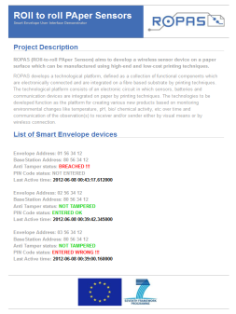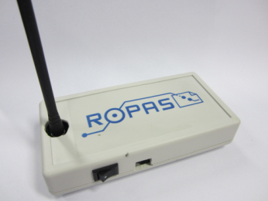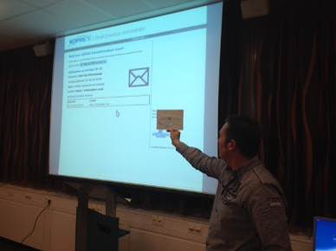

*Figure 1.6: Smart Envelope demonstrator (1, MPS, TNO) wirelessly communicating to the internet, (2) Base station, and (3) website*

*Battery*

The Organic Radical Battery (ORB) is expected to deliver more power than the Zn/MnO2 battery, is recyclable and may be printable using inkjet. These batteries are envisaged to be used in the smart envelope though a lot of development work needs to be done. In the first 18 months the power delivery was partly proven, using a newly synthesized electrolyte using TEMPO. In the second period it was found that the positive electrode could be made, but the negative electrode could not be printed. The created battery was tested in button cells and showed high peak power delivery, which would suffice for the power delivery of the smart envelope. A relatively large amount of material was synthesized. It is not likely that the ORB battery will be printed.

*Humidity sensor*

A humidity sensor was developed, consisting of interdigitated finger structures combined with the LUMI paper and effective in a range of Rh of 60%. The humidity sensor was integrated in the Smart Label.

*Processing*

An important factor to create an economically feasible process is to have production at large volumes and high speed. Roll-to-roll (Elep, Starcke) and Sheet-to-sheet (Océ) production are the ultimate processes for that. The printing methods are screen printing (TNO, VTT), flexogravure printing (ELEP, Starcke) and inkjet printing (Océ, Starcke). The project made advances by creating fast printing processes in a roll to roll environment for inkjet, screen printing and flexo gravure. In figure 1.7 the roll to roll processes available at VTT and Holst centre (TNO) are displayed.

Automation of placing the components was also started in this period. For this VTT uses the hybrid line.

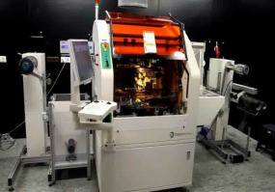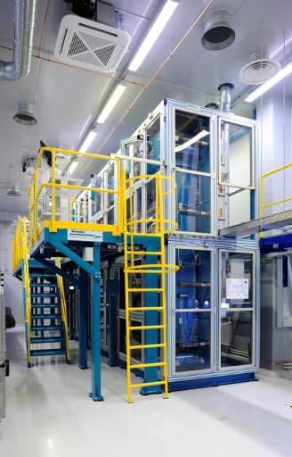 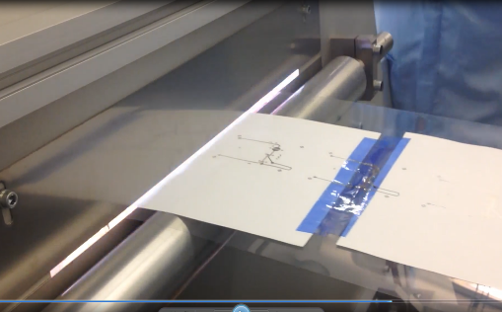

*Figure 1.7: Roll to roll printing lines at 1. VTT, 2. TNO/ Holst centre flash curing and 3.pick and place hybrid line (VTT)*

The VTT roll to roll line was used to produce the security tag with flexogravure printing. The components were placed by the hybrid line. The samples were laminated with embossed switch (produced by Starcke).

*Summarising*

In this period, the use cases of the security tag, smart label and smart envelope were finalised, after which the design, building blocks and production methods were further evolved. Functional prototypes of the security tag, smart label (Display) and smart envelope were created that included a functional switch (embossing) and a humidity sensor.

Printing on large scale was optimised. Flash sintering has been proven to be suitable to cure conductive ink at high speed. Pick and place has been proven to be effective.

The security tag demonstrator has been produced on a large scale at VTT/ Starcke.

Results of the project have been disseminated on the project website. Two newsletters and a flyer were sent to a group of interested parties for which a dissemination database was created. Poster presentations/ congress visits have also been done, including the organisation of a workshop at the E-MRS in Poland that included 4 talks and one poster presentation. Patents are filed for the ORB electrolyte synthesis and the smart envelope.

### Period 3

In the third period, focus was on final production of the envelope and smart label demonstrators as well as the optimisation by (roll-to-roll and sheet-to-sheet) mass production printing of the demonstrators. The printing processes were improved by roll-to-roll printing on paper using screen printing and flexogravure printing and sheet-to-sheet inkjet printing. Introduction of (N)IR and flash sintering resulted in fast curing of the conductive ink.

The introduction of R2R/S2S component placing was further explored, as well as decreasing the number of components necessary by printing bridges (e.g. in the envelope demonstrator by VTT and TNO). The ORB battery optimisation was further continued by creating an encapsulated battery pouch that was placed on the demonstrators. Enfucell produced a battery with integrated switch and attachment parts. Newsletters were also published and the second and third workshops took place (respectively at the ESTC conference in Helsinki (Technical conference) and GPS in Barcelona (industrial marketing conference)).

The smart envelope and smart label demonstrators were produced at large scale at VTT and TNO, with assistance by Enfucell, Océ, ELEP, MPS and Starcke. It was chosen to create a smart label using near field communication (NFC).

Printing of the functional electronic design was optimised as well as the component placing. In the final step the electronics are protected by a laminated paper or protected by a printed “over-coating” by OCE technologies. Loginser and Itene were involved in product verification and LCA and recyclability studies. The final printed versions, component placing and the laminated demonstrators are displayed in table 1.3.

*Table 1.3: printed version, component placing and final demonstrators*

|  |  |  |  |
| --- | --- | --- | --- |
| Demonstrator | Finalised printed design | Component placement | Final demonstrator |
| Security tag *(Finished in period 2)* | IMG_4252 |  |  |
| Smart label  Paper lamination | IMG_4253 | IMG_4250 |  |
| Smart envelope | IMG_4251 | C:\Users\rentropcha\AppData\Local\Microsoft\Windows\Temporary Internet Files\Content.Outlook\SX8VFS72\foto (29).JPG |  |

*Security tag:*

The security tags are envisaged to be used in packaging of expensive goods in logistic applications. Partner Loginser integrated the security tag on boxes and former partner Buhrman Ubbens integrated the security tag on the sent box.

Partner Loginser also started to integrate the security tag into their packaging boxes to protect the content. They performed a data survey amongst their partners to verify whether these partners are interested in applying the security tag. From this survey one can conclude an interest at the end-users. In figure 1.8, one can see the integrated security tag in a send box and the results of the data survey.

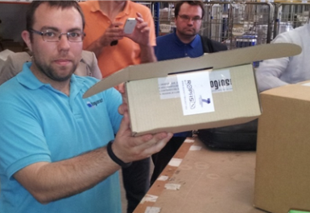  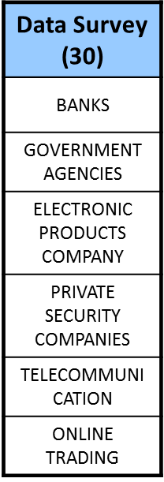

*Figure 1.8: 1. Security tag demonstrator integrated in send box (LOG, VTT) 2. Data survey of security tag usage amongst relevant end-users (LOG)*

*Smart label*

The smart label monitors the temperature and humidity of a package in order to inform the user that the package was transported under correct environmental conditions.

In the final smart label design a printed humidity sensor, consisting of an interdigitated finger structure printed on the LUMI paper acting as a capacitive humidity sensor was communicating through NFC with an android app (designed by MPS). The label is designed to measure the maximum minimum and current humidity and temperature. This way one can monitor the history of the label and to verify that it is functioning. Océ printed a coating on top of the label to protect the electronics. The coating could be printed directly over the electronics including the battery and other components. In figure 1.8 the printed smart label and the communication with an android tablet is shown.

*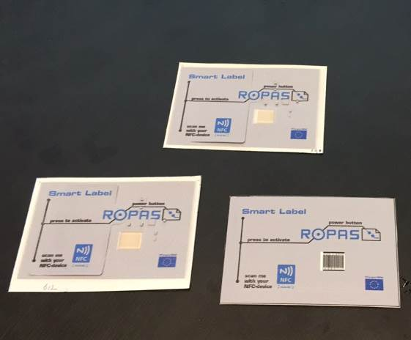 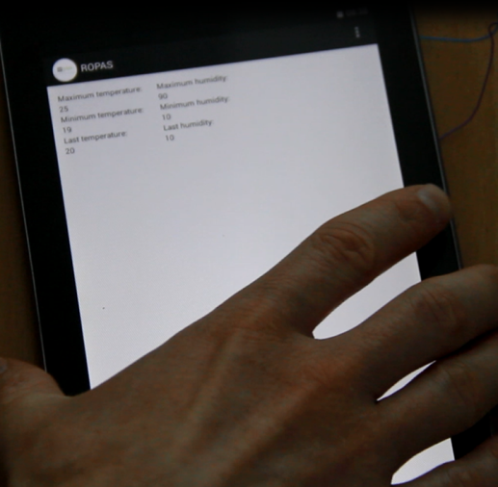*

*Figure 1.9: 1. Print protected Smart label (Océ) 2. communicating with Android based tablet (MPS).*

*Smart envelope:*

The smart envelope demonstrator provides information on the location and opening status of a parcel in order to inform the sender and receiver if the package is genuine and was delivered to the correct receiver at the correct place (registered mail). The smart envelope requires a method to create a password to verify that the envelope was sent to the right receiver, which will be created by sensor switches. The smart envelope also requires an antenna to cover large distances and advanced logic to enable wireless communication.

In period 3, the envelope design was further optimised. In the final form the smart envelope showed the following features:

* Printed antenna to cover 300 m.
* Keyboard
* LED integration to verify functioning of the envelope
* Password tracking (software)
* Encapsulation by a paper envelope
* Battery powered (ORB and ZnMnOx)

The smart envelope demonstrator consists of a paper envelope including a “posting section” and a section for an electronic inlay. The envelope itself acts as a protection layer for the electronics and includes embossed switches, printed with conductive ink on the inside for the password control.

In the electronic design a LED was included to verify the functioning of the envelope for the user. The printed antenna (flexogravure and screen printed) showed sufficient conductivity to cover large distances. The envelope can be powered by the optimised ZnMnOx battery and the developed ORB battery.

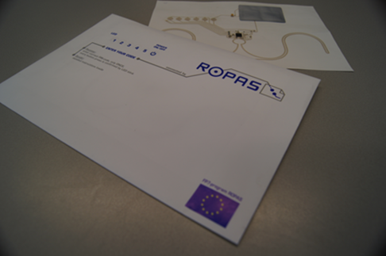 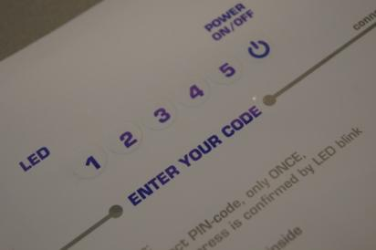 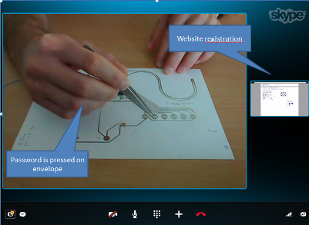

*Figure 1.10: 1. Smart Envelope demonstrator with inlay (ELEP, TNO), 2. Laminating envelope with embossed switches (ELEP), 3. wireless communication to the internet was verified with Skype (MPS, TNO).*

*Battery*

The Organic Radical Battery (ORB) was further explored and the synthesised electrolytes were incorporated in a battery pouch, resulting in a rechargeable battery. Though full industrial application could not be reached serious steps towards ORB functional batteries were taken including a patent on printing and a patent on electrolyte synthesis.

The Zn/MnO2 battery was optimised for the demonstrators and included in its final form an innovative step to make the battery applicable for integration in the demonstrators and tape for easy attachment. In figure 1.11 the produced batteries are depicted.

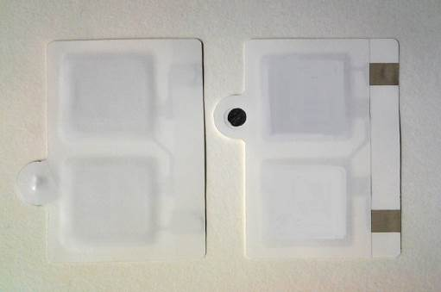 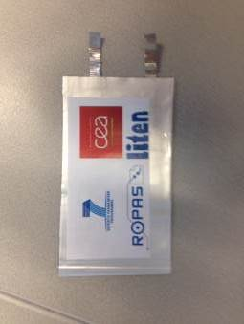

*Fig 1.10: ROPAS produced batteries. 1. Zn/MnO2 with integrated switch and attachment tape (ENF), 2. ORB (CEA)*

*Processing*

An important factor to create an economically feasible process is to have production at large volumes and high speed. The printing methods are screen printing (TNO), flexogravure printing (VTT, ELEP) and labscale inkjet printing (Océ). The project further advanced in creating fast printing processes in a roll to roll environment for screen printing and flexogravure and in sheet-to-sheet at Océ. The printing guidelines were optimised for the LUMI paper and summarized in table 1.4.

*Table 1.4: Roll to roll printing guidelines for flexogravure at 1. VTT, 2. Screen printing TNO/ Holst centre flash curing and 3. Inkjet printing (Océ)*

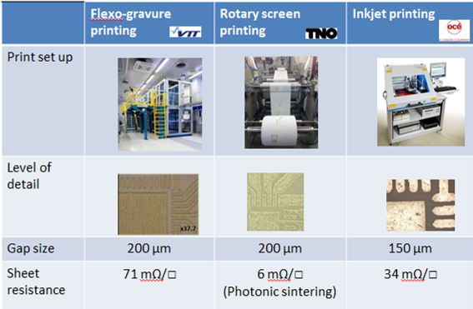

The VTT roll to roll line was used to produce the smart envelope with flexogravure printing. In this version bridges were also printed. The TNO roll to roll line was used to print the demonstrators by screen printing including the flash sintering. In figure 1.12 the resulting paper rolls are displayed.

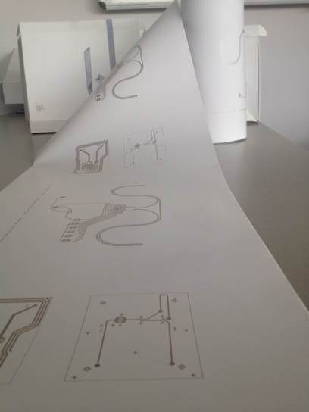 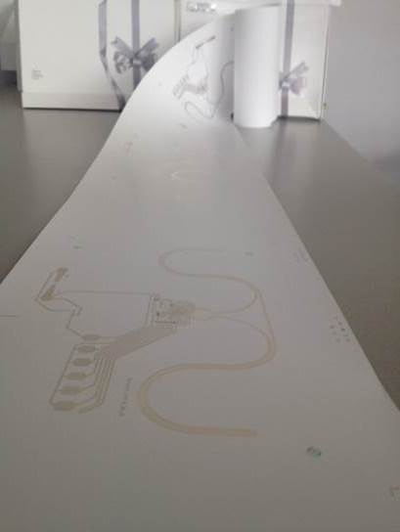

*Fig 1.12: Roll-to-roll printing 1.Screen printing (TNO), 2. Flexogravure printing (VTT)*

*Lifecycle analysis*

Lifecycle analyses of the 3 demonstrators was done using software approaches (SimaPro). A typical approach of the Smart envelope demonstrator (demo 2a) is shown in figure 1.13

*Fig 1.13: Typical LCA impact of the smart Envelope.*

The main conclusions than can obtained from the LCA results are:

* The majority of the impacts on the examined devices are caused by the use of conventional electronic components in the assembly. Such trend has been observed in all the prototypes analysed, although this was especially relevant in the case of the security tag, where the amount of nanosilver ink is minimal compared with remaining prototypes. Therefore, a change from conventional electronics to printed electronics could presumably lead to lower environmental impacts.
* Because of the dependence on the conventional electronic components, the changes in the layout of the device can largely influence the LCA results, as occurs for instance in smart envelope Proto 3, in which the overall impact is bigger in certain impacts like Acidification, Eutrophication, Photochemical oxidation and Ecotoxicity-related categories compared to smart envelope Proto 2c, while the expected result was a lower impact because of the use of an aluminium antenna instead of the silver-printed antenna. However, this result reveals that the aluminium antennas by hot foil transfer can definitely reduce the environmental impact of the smart envelope prototypes and likely the final cost of the device.
* The influence of nanosilver inks is generally small with few exceptions on the Human toxicity impact category. Additionally, the combination of the printing technique and the formulation of the ink largely influences the LCA results. For instance, in the smart label Proto 2 the use of the inkjet printing technique increases significantly the impact, while the contribution of the nanosilver ink to the impact is lower because of the change in the ink formulation (inkjet ink in smart label vs screen ink in smart label).

To sum up, printed electronics can contribute to a reduction of the environmental impacts of electronic devices, especially in single use/short life devices like the Security Tag, Smart Label and Smart Envelope. Moreover, it can be concluded that the impact of the nanosilver inks is generally small and largely dependent on the amount of ink used. Therefore, further optimization on the ink use could lead to better environmental results and lower costs.

Although printing is advantageous, the printed technique selected may influence the results largely. Therefore, further research is required to minimize the impacts of printing. Indeed, there is still room of improvement to decrease power consumption with more efficient printing systems. Based also in the comparative results of the different prototypes of smart label and smart envelope, is clear that finding the right balance between ink formulation and printing technique could lead to better environmental performance of printed electronics.

Even though these first results provided here imply a step ahead in the environmental assessment on printed electronics, further research is required, because these results refer to three specific case studies (smart tag, smart label and smart envelope). Indeed, a case-by-case study is recommended because the use of conductive inks could change substantially as function of the electronic design and the function desired for the printed device. Moreover, the printing technique as well as the formulation of the inks could also have a considerable influence on the LCA results.

*Recycling*

The recycling constraints of the produced demonstrators were assessed. Thereto a recycling process was set up to determine whether the mechanical and/ or optical properties of the paper are changed when electronic printing and SMD components are glued on the paper. In figure 1.13 the recycling setup is displayed. A typical result of the mechanical performance after recycling (tensile strength) is also shown for a blank and paper including silver ink, SMD components and batteries. The experiments showed that traditional paper recycling processes were not disturbed very much by the introduction of printed conductive ink and placing of the components (including large components as the batteries).

The results are published in the Journal of Waste Management (Aliaga et al. The influence of printed electronics on the recyclability of paper: A case study for smart envelopes in courier and postal services; doi:10.1016/j.wasman.2015.01.005).

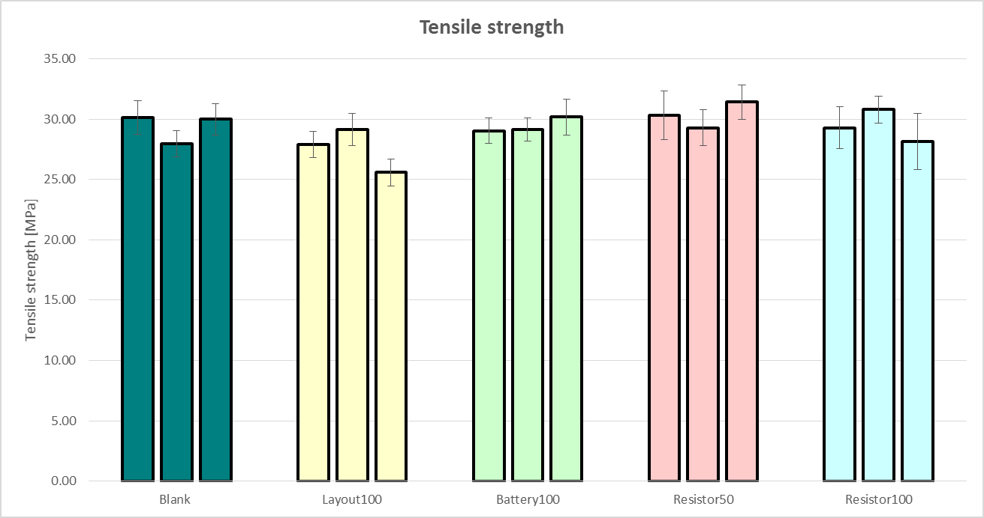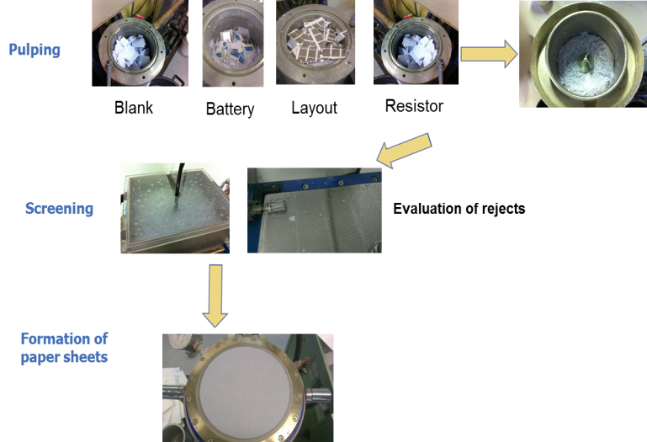

*Fig 1.13: 1. Recycling process set up. 2. Tensile strength for a blank paper and paper including silver ink, batteries and SMD components.*

*Summary of period 3:*

In period 3, the production of the smart label and smart envelope demonstrators were finalised. The demonstrators were tested under real conditions. The electronics were protected by printing of an “over coating” or by paper lamination. Envelopes suitable for electronics integration were fabricated including printed switches. Batteries were tailored for easy attachment and button integration for the smart label.

The prototypes were printed on a large scale using roll-to-roll and sheet-to-sheet techniques. The design guidelines for the available printing techniques were set up.

LCA and recycling constraints of the demonstrators were set up and performed.

Results of the project have been disseminated on the project website and were shown through a number of conferences. Workshop at the ESTC, LOPEC and GPS conferences were also given about the potential of ROPAS technologies. Three newsletters and a flyer were sent to a group of interested parties for which a dissemination database was created. A patent is filed for the smart envelope.

**Results of ROPAS compared to the objectives**

The results obtained in ROPAS are compared to the original objectives that were listed in the DOW in table 1.5.

*Table 1.5: Key objectives vs. results obtained.*

| **Key objectives of ROPAS** | **RESULTS obtained in ROPAS** |
| --- | --- |
| **Digital track** and **trace** system for **letter/packages** using existing network. Tracking distance up to 300 m is required. | The antenna design of the envelope is designed and verified in WP 4 and showed that the printed antenna was able to communicate up to 300m when the resistance of the total antenna was less than 12 Ω, which is achievable by screen printing (TNO) and flexogravure printing (VTT). The antenna design is integrated in the envelope demonstrator. |
| Electronic-**opening protocol** to control **personal opening system** of package based on circuit to activate for signal release containing at least 4 pressure sensors. | New services for anti-tampering and package tracking are provided by the security tag, smart label and smart envelope demonstrators. (WP5, 6). The opening protocol was created by embossed switches and personal opening was created with the use of keyboard for password entrance and NFC communication. (WP4) |
| **Flexible** **manufacturing printing** technology using inks with viscosity < 500 mPas for embedding **electric circuit and smart capsules** in **paper** products. | Paper electronics printing was realised by optimising use of ink and paper surface/coating (WP2 and 3) finally resulting in printing guidelines for flexogravure, rotary screen printing and inkjet printing. Guidelines included sheet resistance, level of detail and gap size (WP3, 5).  Smart capsules were created but did not have sufficient integrity for application in the demonstrators. Other solutions for the sensor and switch function were set up (WP3). |
| Demonstration of the ROPAS concept in **different types** of **paper products** proving **robustness** of the (printing) technology. | 3 paper electronic demonstrators are created which are security tag, smart label and smart envelope. (WP5) The demonstrators were printed using the printing techniques available. Each demonstrator is printed on a large scale. (WP6) Flash curing, and hybrid technology were necessary for the upscaling and are optimised for use in paper electronics (WP5). |
| **Conditioning** of the fibre based surface using **high-end** printing techniques to create a **uniform** surface | Demonstrators were tested in real conditions in the logistic chain which showed robustness issues in real life. The pick and place of the electronic components (e.g. chip and capacitors) and the attachment (gluing) were remarked as the most crucial steps in the process (WP6). The printing of conductive tracks, resistors and bridges were no cause for failure.  After testing of various paper materials, LUMI silk was chosen to be the best performing paper with respect to printing and (humidity) sensor activity. (WP2) |
| New **pressure sensitive** sensors based on release-on-command **encapsulations** at a pressure of >200 g/cm2.  **Intelligent wireless communication** (ICT) between **paper-based** products and existing network are created | The capsules did not show sufficient activity and are therefore replaced by the humidity sensor and switches that were created by embossing of paper (WP2).  NFC (Smart label) and UWB (Smart envelope) wireless communicating systems were utilised for creation of the demonstrators (WP4). |
| Intelligent **architecture** platform for **wireless** communication between paper-based products and base station using existing networks. The battery should deliver every 30 min. a power burst of maximal 3 mW during 3 days | The use-cases of the demonstrators are defined in WP1, and dictated the architecture of the demonstrators in WP4. Several iterations of the use-cases were necessary in the project to come to workable demonstrators (e.g. use of NFC in the smart label).  The batteries (ORB and SoftBattery) are constantly optimised and adjusted to fit the demonstrator demands. This resulted e.g. in a switch integrated battery (WP5). ORB battery electrolytes and printing have shown to be effective and supplies sufficient power to operate during lifetime of the demonstrators. Production at industrial scale still needs further development work. |
| **Minimise environmental** pressure of the newly developed products. | **LCA** overview was created for the demonstrators. The results showed that printing has a huge asset on impact over component placing. The influence of nano-silver inks is generally small with few exceptions on the Human toxicity impact category. Thought is influence is small, the combination of the printing technique and the formulation of the ink influences the LCA results. (e.g. in the envelope demonstrator) (WP7). |
| The governmental regulation are studied. Also the recyclability of the paper products is studied | Regulations were studied for applicability to the demonstrators and showed that WEEE applies over ROHS (WP7). This means that paper needed to be recycled. Demonstrators were subjected to the recycling trials and only minimal changes were observed in mechanical and optical tests, mostly caused by breakage of the battery. This concluded that electronics printing does not influence the paper recycling trials (WP7). |
| **Packages,** cheaper than €6.85 to compete with registered post. (e.g. target € 3.50)  To reduce costs **labels** are processed on large scale and should not exceed 10 cents | A comprehensive analysis of the economical perspectives of the demonstrators was carried out (WP5). The analysis was done on 2 levels. Costs of the demonstrators and the price you can ask for the demonstrators. The costs of the demonstrators on a large scale were estimated to be: Security tag (€0.89), Smart label €2.35), Smart envelope (€4.62). The prices are highly dependent on the placing of the components. Printing of components drastically lowers price. |

# Description of the expected final results and their potential impacts and use

The European paper industry is rapidly declining. The production rate of most paper mills is down with 16 to 25 %[[3]](#footnote-3) in recent years. With the outcomes and the platform developed within ROPAS, a new generation of paper/cardboard products are developed creating new market opportunities for the SMEs involved and the European paper, packaging and security tag industries.

The basis of these new possibilities originated from recent advances in nanotechnology and sensor technology, which enables new openings for start-up companies and follows the technological roadmap of the paper industry as well as RFID industry[[4]](#footnote-4) and the paradigm Internet of things. The high flexibility of the production due to the roll-to-roll manufacturing, and novel sheet-to-sheet printing processes enable potential new spin outs in different regions such as novel (food) packaging and security applications thus boosting the paper industry in Europe.

The demonstrators as well as the components to create these demonstrators have shown to impact in the paper and electronics community. The main results of the components are commercialised after the project life. From the environmental point of view, it was shown how the printed (paper) electronics have a positive effect on environmental impact (carbon footprint, toxicity, et cetera) including positive recyclabillity. In Figure 2.1 the impacts of the building blocks are listed.

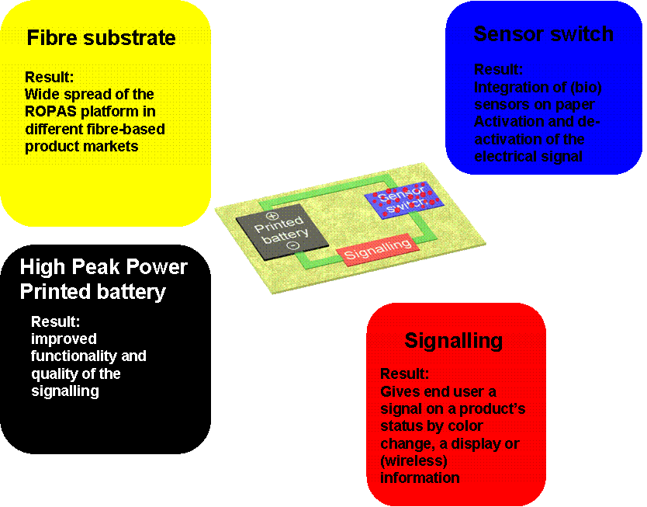

*Figure 2.1: impact of ROPAS building blocks*

***ROPAS demonstrated:***

The ROPAS technological platform provided the building blocks for the next generation of multi-functional fibre-based products and applications ranging from: improved packages, to sensors on paper, to authenticity tags, to secured delivery. These products can be implemented in various multi billion euro market areas ranging from food, packaging, medicine, chemical industry, financial services, ICT, logistics, et cetera.

The technological platform can also be an embodiment for the internet of things (IOT) paradigm. The IOT requires large numbers of cheap transmitting labels to create a global network. Printing of these labels on the things or on paper tags is a large step forward in the development of the IOT.

*Security tag demonstrator*

Starcke exploited the results generated in ROPAS in the development of novel security and packaging products particularly by combining holograms with substrates containing reactive, intelligent elements. Incorporation of microchips and microcapsules as well as ink jet printing of intelligent inks are of particular importance to Starcke. Starcke is also interested to integrate the printed, intelligent products with logistic systems and other applications involving information technology.

The security tags can be introduced in high safety markets like the Aerospace, automotive and/or medical/pharmaceutical market. Other markets like e-commerce, parcel services, et cetera may also be addressed.

Dissemination of technology developed within ROPAS could be realized through the international contacts network of MpicoSys, as well as through international business events like Cebit or CES that MpicoSys attends.

*Envelope and label demonstrator*

The marketing of the envelopes should be started through the established sales channels of Elep who has contacts with postal organisations. These postal organisations work more Europe-wide since the recent market opening for postal operations. The smart envelope should first be marketed through postal organisations as an intelligent alternative of the registered letter applications. In addition, packaging distributors will be targeted first. Elep has an international network in Europe through which these new products will be marketed.

After dispatch, valuable packages can be followed on line through applications currently in use by most operators. The difference is that tracing will be possible not only at certain dispatching points but throughout the distribution channel, with an additional security for opening the package/letter.

An important target group for ROPAS packaging solutions is online retailers (web shops) as this market is growing rapidly (e.g. Amazon, AOL and BOL). Another target group are parcel services where unambiguous/personal identification is a must (e.g. bank & insurance, financial services, public services, ICT, et cetera).

*Services*

S2 Grupo will present the technology from ROPAS at INTECO ENISE (National Encounter of Security Industry) in Spain. It will also be disseminated through PIN-SME, the European association of ITC SMEs, at European level and in their national counterpart in Spain.

## Public website:

[http://www.ropas-project.eu](http://www.ropas-project.eu/)

Contact: Corne Rentrop corne.rentrop@tno.nl

# 3. Use and dissemination of foreground

**3.1 Dissemination activities:**

For “Dissemination, training and preparative exploitation ”ROPAS identified 4 different activities, these are:

1. Identification of targeted audience to maximise the dissemination of results and to express them in terms that are readily understandable to stakeholders at governments, industry and suppliers in order to accelerate the implementation of the research findings.
2. Creation of the selected concepts by demonstrations/ demonstrators
3. Workshop organisation, presentations at conferences, scientific publications and preparing information for the project website to promote the dissemination of the project findings.
4. facilitate technology transfer and accelerate dissemination of ongoing research activities.

Important relations with other research activities and the printed electronics community and other (EU funded) projects were also established. Besides attending conferences, the project itself has organized workshops at conferences during the project execution time. Flyers and newsletters to promote the goals of ROPAS have been created and send to a deined group of interested people (dissemination database). A project identity was set up by creating the ROPAS logo and templates for documents, presentations and website. [http://www.ropas-project.eu](http://www.ropas-project.eu/)

ROPAS identifies 3 primary dissemination tools, these are:

* Public website;
* Newsletters and flyers distributed to stakeholders;
* Organising workshops.

To assist in the dissemination, we also created:

* Dissemination database;
* Project identity;
* Exploitation Strategy Seminar was organised.

The audience was identified by setting up a database with potential stakeholders. These stakeholders were invited to the workshops and flyers were sent to them. Further, active collaboration with other (EU funded) projects with comparable topics were established. These projects are: A3ple, Biognostix and CLIP. The highlights with respect to dissemination are the 3 workshops that were organised. Details on the workshop are listed below.

## RTD Workshop - E-MRS Warsaw

The E-MRS differs from many single-discipline professional societies by encouraging scientists, engineers and research managers to exchange information on an interdisciplinary platform, and by recognizing professional and technical excellence by promoting awards for achievement from student to senior scientist level. As an adhering body of the International Union of Materials Research Societies (IUMRS), the E-MRS enjoys and benefits from very close relationships with other Materials Research organizations elsewhere in Europe and around the world.

Each year, E-MRS organizes, co-organizes, sponsors or co-sponsors numerous scientific events and meetings. Each event publishes its own proceedings that document the latest experimental and theoretical understanding of material growth and properties, the exploitation of new advanced processes, and the development of electronic devices that can benefit best from the outstanding physical properties of functional materials.

ROPAS was represented at E-MRS 2013 fall meeting in September 16-20, 2013 at Warsaw University of Technology in Poland. The conference consisted of 14 thematic symposia, plenary session and satellite events.

|  |  |  |  |
| --- | --- | --- | --- |
| Type of activities | Main leader | Title | Size of audience |
| Poster | CEA | European Material Research Society | 1500 |
| Organize workshop | TNO | Paper electronics: a new challenge for materials a new opportunity for devices | 60 |
| Presentation | VTT | Inkjet-printed humidity sensors on paper substrate. | 60 |
| Presentation | VTT | Paper based electronics and functionalities for consumer products | 60 |
| Presentation | TNO | Printed electronic switch on flexible substrates using printed microcapsules | 60 |
| Presentation | TNO | Roll to roll paper sensors | 60 |
| Poster | VTT | Paper electronics: a new challenge for materials, a new concept for devices | 60 |
| Presentation | VTT | Inkjet-printed humidity sensors on paper substrate | 60 |

## Industrial workshop – ESTC Helsinki

Organized by IEEE-CPMT since 2006, the Electronics System-Integration Technology Conferences (ESTC) series is the premier venue for academics and industry to present and discuss the latest developments in assembly and interconnection technology and new applications.

ROPAS was represented at ESTC 2014, 5th Electronics System-Integration Technology Conference, September 16-18, 2014 at Finlandia Hall in Helsinki, Finland. AT the conference ROPAS was presented in lectures, stand and posters.

|  |  |  |  |
| --- | --- | --- | --- |
| Type of activities | Main leader | Title | Size of audience |
| Conference paper, and presentation | VTT | Printed Intelligence for Consumer products | ~300 (total conference), presentation ~80 |
| Conference paper, and poster | VTT | Integrated Printed Hybrid Electronics on Paper | ~300 (total conference) |
| Lecture at ESTC conference | TNO | Roll-to roll paper sensors (ROPAS). Wireless communicating sensors on paper in the logistic chain | ~300 (total conference), presentation ~80 |
| Lecture at ESTC conference | VTT | Intelligence for consumer products | ~300 (total conference), presentation ~80 |
| Conference paper | TNO | Roll-to roll paper sensors (ROPAS). Wireless communicating sensors on paper in the logistic chain | ~300 (total conference) |

## End-user/use cases workshop – GPS Barcelona

Organised by WTG since 2010, the Global Packaging Summit (GPS) is the must attend event for senior packaging professionals to investigate cost-effective, innovative and sustainable packaging solutions. The summit featured participants from market leading consumer goods companies.

ROPAS was represented at WTG’s 4th annual Global Packaging Summit, January 26-27, 2015 in Barcelona, Spain.

|  |  |  |  |
| --- | --- | --- | --- |
| Type of activities | Main leader | Title | Size of audience |
| Workshops | Océ/TNO | The ROPAS project | ~200 |
| Stand | Loginser/ Itene/ ELEP | ROPAS project demonstrators | ~200 |
| Questionnaire | Océ | Opportunities for paper electronics | ~200 |

During this conference, ROPAS project partners have presented and discussed their vision on the added value of electronics in packaging. Examples that have been addressed were: security, brand protection, monitoring, tracking and tracing. Furthermore, specific targeted applications and business cases will be discussed including a moderated discussion to answer the following questions:

* The opinion of the audience on opportunities of the described ROPAS use cases (authenticity check, sensor integration, track and trace solutions).
* How is the packaging industry served by adding printed electronic functionality?
* How does the audience see the added value of connecting your packaging and the packaged products to the outside world?
* Does the audience see any other possibilities/opportunities for printed electronics in packaging

**Other Dissemination activities**

Besides the 3 organised workshops ROPAS also filed 3 patents (and 1 patent pending) and filed for 4 reviewed papers. The details are listed in paragraph 4.2 section A and B.

.

## 4.2 Summary of dissemination actions

**Section A (public)**

|  |  |  |  |  |  |  |  |  |  |  |
| --- | --- | --- | --- | --- | --- | --- | --- | --- | --- | --- |
| **A1: list of scientific (peer reviewed) publications, starting with the most important ones** | | | | | | | | | | |
| NO. | Title | Main author | Title of the periodical or the series | Number, date or frequency | Publisher | Place of publication | Year of publication | Relevant pages | Permanent identifiers  (if available) | Is/Will open access provided to this publication? |
| 1 | Roll-to-roll paper Sensors (ROPAS); Wireless communicating sensors on paper in the logistic chain | Rentrop | ESTC | September 2014 | ESTC | Helsinki | 2014 | pp 26 in program | Proceedings: ‘presentation’ | No |
| 2 | Printed electronic switch on flexible substrates using printed microcapsules | Ten Cate | Journal of Materials Science | September 2014, Volume 49, Issue 17, | Springer | Strasbourg/ Warsaw | 2014 | pp 5831-5837 | (DOI) 10.1007/s10853-014-8271-7 | yes |
| 3 | Recyclability assessment of printed electronics on paper substrate: a case study for smart envelopes in courier and postal services | Cesar Aliaga | Waste Management | In press | Elsevier | Valencia | 2015 | Available online 31 January 2015 | (DOI)  10.1016/  j.wasman.2015.01.005 | No |

| **A2: list of dissemination activities** | | | | | | | | |
| --- | --- | --- | --- | --- | --- | --- | --- | --- |
| NO. | Type of activities | Main leader | Title | Date | Place | Type of audience | Size of audience | Countries addressed |
| 1 | Press release | ITENE | The paper becomes intelligent through the European project ROPAS | November 14, 2011 | ITENE website (http://www.itene.com/en/press/press-releases/i/604/60/el-papel-se-vuelve-inteligente-gracias-al-proyecto-europeo-ropas) | Media | 100 | EU |
| 2 | Interview | ITENE | Entrevista a Antonio Dobón, responsable del proyecto Ropas en  Itene | January 16, 2012 | Interempresas.net (http://www.interempresas.net/Envase/Articulos/60227-Entrevista-a-Antonio-Dobon-responsable-del-proyecto-Ropas-en-Itene.html) | Media | 100 | ES |
| 3 | Poster at HiPEAC | MPicoSys | ROPAS | January 23-26, 2012 | HiPEAC meeting 2012, Vienna, Austria | Scientific Community, and Industry | 60 | EU |
| 4 | Poster at Prinse | MPicoSys | ROPAS | March 14-15, 2012 | Printed Intelligence Industrial Seminar 2012, Oulu, Finland | Industry | 60 | Finland |
| 5 | Web site | TNO | ROPAS website | June 2012 | http://www.ropas-project.eu/ | Media | Media | Worldwide |
| 6 | Flyer | Océ | Flyer publication with general project information for public project dissemination | October 2012 | http://www.ropas-project.eu/, and available during conference and workshops | Media briefing | 500 | Worldwide |
| 7 | Newsletter 1 | Océ | ROPAS Newsletter | October 2012 | http://www.ropas-project.eu/, and available during conference and workshops | Media briefing | 100 | Worldwide |
| 8 | Poster at HiPEAC | MPicoSys | ROPAS as application for low power devices | October 15-16, 2012 | HiPEAC meeting 2012, Ghent, Belgium | Scientific Community, and Industry | 60 | EU |
| 9 | Poster at HiPEAC | MPicoSys | ROPAS as application for low power devices | January 21-23, 2013 | HiPEAC meeting 2013, Berlin, Germany | Scientific Community, and Industry | 60 | EU |
| 10 | Poster at LOPE-C Conference | MPicoSys | ROPAS | June 11-13, 2013 | LOPEC Meeting 2013, Munich, Germany | Industry | 2000 | Worldwide but mostly European countries |
| 11 | Poster at LOPE-C Conference | CEA | Large-area Organic & Printed Electronics Convention | June 11-13, 2013 | LOPEC Meeting 2013, Munich, Germany | Industry | 2000 | Worldwide but mostly European countries |
| 12 | Poster at E-MRS conference | CEA | European Material Research Society | September 16-20, 2013 | E-MRS Fall Meeting 2013, Warsaw, Poland | Scientific Community | 1500 | European countries |
| 13 | Organise workshop at E-MRS conference | TNO | Paper electronics: | September 16-20, 2013 | E-MRS Fall Meeting 2013, Warsaw, Poland | Scientific Community | 60 | European countries |
| 14 | Presentation at E-MRS conference | VTT | Inkjet-printed humidity sensors on paper substrate. | September 16-20, 2013 | E-MRS Fall Meeting 2013, Warsaw, Poland | Scientific Community | 60 | European countries |
| 15 | Presentation at E-MRS conference | VTT | Paper based electronics and functionalities for consumer products | September 16-20, 2013 | E-MRS Fall Meeting 2013, Warsaw, Poland | Scientific Community | 60 | European countries |
| 16 | Presentation at E-MRS conference | TNO | Printed electronic switch on flexible substrates using printed microcapsules | September 17, 2013 | E-MRS Fall Meeting 2013, Warsaw, Poland | Scientific Community | 60 | European countries |
| 17 | Presentation at E-MRS conference | TNO | Roll to roll paper sensors | September 18, 2013 | E-MRS Fall Meeting 2013, Warsaw, Poland | Scientific Community | 60 | European countries |
| 18 | Poster at E-MRS conference | VTT | Paper electronics: a new challenge for materials, a new concept for devices | September 18, 2013 | E-MRS Fall Meeting 2013, Warsaw, Poland | Scientific Community | 60 | European countries |
| 19 | Presentation at E-MRS conference | VTT | Inkjet-printed humidity sensors on paper substrate | September 18, 2013 | E-MRS Fall Meeting 2013, Warsaw, Poland | Scientific Community | 60 | European countries |
| 20 | Newsletter 2 | Océ | ROPAS Newsletter | November 2013 | http://www.ropas-project.eu/, and available during conference and workshops | Media briefing | 200 | Worldwide |
| 21 | Exhibitor at Interpack/ Savefood Düsseldorf | Starcke | general project information distribution | May 2014 | Interpack 2014 Düsseldorf, Germany | Packaking Industry | 100 | Global |
| 22 | Newsletter 3 | Océ | ROPAS Newsletter | June 2014 | http://www.ropas-project.eu/, and available during conference and workshops | Media briefing | 100 | Worldwide |
| 23 | Poster at  IMLB conference | CEA | International Meeting on Lithium Battery | June 9-14, 2014 | IMLB Meeting 2014, Como, Italy | Scientific Community, and Industry | 1200 | Worldwide |
| 24 | Press release | Loginser & ITENE | Especial Logística - Proyecto Ropas | June 17, 2014 | Economia 3 magazine (http://www.economia3.com/2014/06/17/26248-proyecto-ropas/) | Media | Spain | Spain |
| 25 | Demonstrators at conference, and ROPAS project mentioned in conference presentation | VTT | Paper diagnostics | September 7-11, 2014 | IS&T NIP30 conference, Philadelphia, USA | Scientific Community, and Industry | 400 (total conference), presentation ~100 | USA, Japan, Sweden, Germany, UK, Switzerland, Spain, the Netherlands, Italy, Belgium, Canada, China, Republic of Korea |
| 26 | Conference paper, and presentation | VTT | Printed Intelligence for Consumer products | September 16-18, 2014 | ESTC 2014 conference, Helsinki, Finland | Scientific Community, and Industry | ~300 (total conference), presentation ~80 | Finland, Japan, Germany, the Netherlands, Republic of Korea, Sweden |
| 27 | Conference paper, and poster | VTT | Integrated Printed Hybrid Electronics on Paper | September 16-18, 2014 | ESTC 2014 conference, Helsinki, Finland | Scientific Community, and Industry | ~300 (total conference) | Finland, Japan, Germany, the Netherlands, Republic of Korea, Sweden |
| 28 | Lecture at ESTC conference | TNO | -to roll paper sensors (ROPAS). Wireless communicating sensors on paper in the logistic chain | September 18, 2014 | ESTC 2014 conference, Helsinki, Finland | Scientific Community, and Industry | ~300 (total conference) | European countries |
| 29 | Lecture at ESTC conference | VTT | intelligence for consumer products | September 18, 2014 | ESTC 2014 conference, Helsinki, Finland | Scientific Community, and Industry | ~300 (total conference) | European countries |
| 30 | Exhibitor at Empack 2014/ Sisälogistiikka | Starcke | general project information distribution | November 2014 | Helsinki Empack 2014/ Sisälogistiikka, Finland | Packaging and logistics industry fair | ~150 exhibitors / ~3600 visitors | Mainly Finland |
| 31 | Press release | ITENE | ITENE participa en la 4ª Global Packaging Summit de Barcelona | January 2015 | http://www.alabrent.com/news.php?id=24729 | Media | 1000 | Spain |
| 32 | Presentation at Paperworld with envelope producers | ELEP | Meeting Frankfurt Paperworld | January 2015 | Paperworld 2015 Messe Frankfurt | Industry | +-20 companies | Germany, EU |
| 33 | Participating at Global Packaging Summit 2015 workshops | Starcke | general project information distribution | January 2015 | 4th annual Global Packaging Summit 2015, Barcelona, Spain | Packaging Industry | ~200 companies | European companies |
| 34 | Poster at HiPEAC 2015 | MPicoSys | ROPAS | January 19-21, 2015 | HiPEAC 2015, https://www.youtube.com/watch?v=-CCpgV0AwFc | Industry | ~200 companies | European countries |
| 35 | Workshops at Global Packaging Summit 2015 | Océ | Plenary workshop – The ROPAS project | January 26-27, 2015 | 4th annual Global Packaging Summit 2015, Barcelona, Spain | Industry | ~200 companies | European countries |
| 36 | Questionnaire via NVC | Océ | Questionnaire | February 2015 | http://www.en.nvc.nl/news/item/eu-project-ropas-ict-in-papieren-verpakkingen/ | Media briefing | ~500 companies | The Netherlands |
| 37 | Article verpakkingsmanagement | TNO | Printed electronics wordt volwassen | February 2015 | Article verpakkingsmanagement | Industry | 500 | Netherlands |
| 38 | Workshop at Graficus Vakdag | TNO | Opportunities printed electronics and ROPAS | February 4 | Graficus Vakdag Nieuwegein, http://www.graficusvakdag.nl/ | Industry | ~100 companies | The Netherlands |
| 39 | Article Graficus | TNO | Printed electronics in graphicalindustry | March 2015 | Article Graficus | Industry | 500 | Netherlands |
| 40 | Article KNACK | TNO | Printed electronics | March 2015 | Article knack | Industry | Nr. of copies 119.500 | Belgium |
| 41 | Lecture at A3Ple final conference, Synergies: ROPAS Project | TNO | Roll to roll paper sensors - ROPAS project | March 3-5 2015 | LOPEC 2015, München, Germany, http://www.lopec.com/de/a3ple\_workshop/ | Scientific Community and Industry | ~30 present, ~2000 participants (total conference) | World |
| 42 | Lecture at A3Ple final conference, Synergies: ROPAS Project | Itene | Recycling and life cycle analysis of electronic printed paper | March 3-5 2015 | LOPEC 2015, München, Germany, http://www.lopec.com/de/a3ple\_workshop/ | Scientific Community and Industry | ~30 present, ~2000 participants (total conference) | World |
| 43 | Lecture at A3Ple final conference, Synergies: ROPAS Project | MPS | Designing of printed electronic circuit | March 3-5 2015 | LOPEC 2015, München, Germany, http://www.lopec.com/de/a3ple\_workshop/ | Scientific Community and Industry | ~30 present, ~2000 participants (total conference) | World |
| 44 | Lecture at A3Ple final conference, Synergies: ROPAS Project | VTT | Demonstration printing of demonstrators on a large scale | March 3-5 2015 | LOPEC 2015, München, Germany, http://www.lopec.com/de/a3ple\_workshop/ | Scientific Community and Industry | ~30 present, ~2000 participants (total conference) | World |
| 45 | Newsletter 4 | Océ | ROPAS Newsletter | April 2015 | http://www.ropas-project.eu/, and available during conference and workshops | Media briefing | 100 | Worldwide |
| 46 | Invited talk | CEA | Organic electrode materials, a new opportunity for low cost and sustainable lithium battery? | April 20-23, 2015 | http://emneast.org/2015/ | Scientific Community, and Industry | ~300 (total conference) | Worldwide |

**Section B**

**Part B1**

|  |  |  |  |  |  |
| --- | --- | --- | --- | --- | --- |
| **Template B1: List of applications for patents, trademarks, registered designs, etc.** | | | | | |
| Type of IP Rights | Confidential | Foreseen embargo date  dd/mm/yyyy | Application reference(s) (e.g. EP123456) | Subject or title of application | Applicant (s) (as on the application) |
| Patent | NO |  | FR2989378 | Polymers as active materials for lithium battery | Gutel Thibaut, Kervella Yann, Picard Lionel and Denis Jean-Benoit |
| Patent | NO |  | FR3007206 | Process to assemble lithium battery | Solan Sébastien |
| Patent | NO |  | EP2827287 | Track and trace mail piece for registered mail and medicine wrapper | Smolander Maria Helena, Olkkonen Juuso Tuomas, Lewanczyk Dawid and Rentrop Cornelis Hermanus Arnoldus |
| Patent | YES (so far) | 31.8.2015 | (none yet) | Optimised battery | Eero Suomalainen |

**Part B2**

|  | **Type of Exploitable Foreground** | **Description**  **of exploitable foreground** | **Confidential** | **Foreseen embargo date**  **dd/mm/yyyy** | **Exploitable product(s) or measure(s)** | **Sector(s) of application** | **Timetable, commercial or any other use** | **Patents or other IPR exploitation (licences)** | **Owner & Other Beneficiary(s) involved** |
| --- | --- | --- | --- | --- | --- | --- | --- | --- | --- |
| 1 | Electroactive polymers  General advancement of knowledge | New organic materials for lithium batteries | NO |  | ARBIN equipment | Energy storage | 2020 | Patented | Beneficiary CEA (owner) |
| 2 | General advancement of knowledge | Know-how on pilot-scale printability of sensors and electronics on paper substrate | NO |  | Pilot-scale printing equipment | 1. Logistics  2. Health  3. Electronics industry | 2016 | Not Patented | VTT (owner), Industrial companies (licensing, end-users) |
| 3 | General advancement of knowledge | Know-how on pick-and-place process ability on paper substrate | NO |  | Pick-and-place machinery | 1. Logistics  2. Electronics industry | 2016 | Not Patented | VTT (owner), Industrial companies (licensing, end-users) |
| 4 | General advancement of knowledge | Humidity sensor demonstrator | NO |  | Humidity sensor | 1. Logistics  2. Health  3. Food quality  3. Material quality | 2016 | Not Patented | VTT (owner), Industrial companies (licensing, end-users) |
| 5 | General advancement of knowledge | Use of GSM network side channel signaling for envelope (or other items) tracking purpose (taking into account one way communication created in ROPAS) | NO |  | IoT type of products | 1.Environment  2.Monitoring  3. logistics | >2020 (due to possible long adaptation by GSM companies | Not Patented | MPicoSys (owner), Industrial companies (licensing, end-users) |
| 6 | Conductive track manufacturing by hot stamp foiling method / Embossing of switch  General advancement of knowledge | Know- how of conductivity of foiling materials ie. aluminium and copper | NO |  | Foiling/Embossing and Inserting  Aluminium and copper materials | 1. Logistics  2. Industrial  3. Traceability  4. Security | 2015 | Not Patented | Starcke (owner)  Industrial companies (licensing, end-users) |
| 7 | Inkjet technology  General advancement of knowledge | Inkjet technology suited for depositing liquid on a substrate | NO |  | Print head | Industrial printing, e.g. printing of electrical conductive tracks | 2015 | Patented outside ROPAS scope | Océ (owner)  Industrial companies (end users) |
| 8 | Internet connected devices  General advancement of knowledge | printed electronics on paper | NO |  | Connected label, Connected envelope | 1. Food packaging 2. Medical Packaging 3. Logistics | 2018 | Patent for envelope | ELEP as Beneficiary of Patent owned by VTT, TNO and MPICOSYS |
| 9 | General advancement of knowledge | All the methodologies and background data employed for the development of the LCA datasets in ROPAS project, including those related to inks, glues and components used in the ROPAS devices. This includes the knowledge on the environmental profile of printed electronics | YES | N/A | Use of this data, for consultancy, product design, publishable environmental claims and similar purposes | 1. Printed electronics  2. Intelligent packaging  3. Packaging in general  4. Electric & electronics sector | Commercial use from May 2015 onwards | Not Patented | Owner of the background data, LCA datasets: ITENE |
| 10 | General advancement of knowledge | New knowledge on pretreatment/recycling/recovery processes adapted of printed electronics, including all the methods and design of experiments for the recyclability tests of printed electronics in paper | YES | N/A | Use of this data for consultancy, product design, publishable environmental claims and similar purposes | 1. Printed electronics 2. Intelligent packaging 3. Packaging in general 4. Paper recycling sector | Commercial use from May 2015 onwards | To be negotiated | Owner of the methods and design of experiments: ITENE |
| 11 | General advancement of knowledge | flash sintering of printed conductive ink on paper | NO |  | printed,  paper products | printed electronics,  paper printing  graphical industry | 2016 | Patented | TNO (owner), Industrial companies (licensing, end-users) |
| 12 | General advancement of knowledge | envelope demonstrator | NO, patented |  | large distance communicating paper device | 1. Logistics  2. Health  3. RFID | 2016 | Patented | ELEP, TNO, VTT (owner), Industrial companies (licensing, end-users) |
| 13 | General advancement of knowledge | hybridisation of electric components on paper | NO |  | placing and curing of electric components on paper | paper, printed products | 2016 | Not patented | TNO (owner), Industrial companies (licensing, end-users) |
| 14 | Exploitation of results through innovation | Battery with a switch | YES | 30.11.2015 | Electronic device with an integrated battery. | C26 | 2015 | A patent application is being prepared. | Enfucell  Customer |

**How the foreground might be exploited and by whom**

An exploitation strategy seminar (ESS) was done at the kick off of the project. In the ESS a list of potential products were identified as well as partners that are interested and have rights to exploit these products. The exploitation claims are reported and listed. In Table 4 an example of the results are listed. A full report on the ESS results is available to the partners.

### Definitions

IPR’S ON BACKGROUND INFORMATION (B)

Knowledge, excluding foreground information, brought to the project from existing knowledge, owned or controlled by project partners in the same or related fields of the work carried out in the research project.

IPR’S ON FOREGROUND INFORMATION (F)

Knowledge, including all kinds of exploitable results, generated by the project partners (or 3rd parties working for them) in the implementation of the research project. In order to have an F in an exploitable result it is necessary that a partner has a task(s) in the project directly related to that very result.

EXPLOITATION CLAIMS (M,U,L,O)

The intention of the partners to exploit the results by:

* Manufacturing and selling them (M)
* Using them internally to make something else for sale (U). U applies also to universities and research centres willing to use the result in new research projects.
* Licensing them to 3rd parties (L);
* Providing services such as consultancy, training, et cetera (O).

Table 4: exploitation results and claims for the first 8 products.

|  |  |  |  |  |  |  |  |  |  |  |  |  |  |  |  |  |  |  |  |  |  |  |  |  |  |  |  |  |  |  |  |  |  |  |  |  |  |  |  |  |  |  |  |  |  |  |  |  |
| --- | --- | --- | --- | --- | --- | --- | --- | --- | --- | --- | --- | --- | --- | --- | --- | --- | --- | --- | --- | --- | --- | --- | --- | --- | --- | --- | --- | --- | --- | --- | --- | --- | --- | --- | --- | --- | --- | --- | --- | --- | --- | --- | --- | --- | --- | --- | --- | --- |
|  | 1. (Bio) Chemical active micro capsules | | | | | | 2.  Pressure sensitive sensor switch | | | | | | 3.  Printed zinc/ manganese dioxide- batteries | | | | | | 4.  Printed ORB based batteries | | | | | | 5.  Characterised and optimised  Paper based substrates. | | | | | | 6. Analogue printing of biochemically active components | | | | | | 7. Analogue printing processes for (sensor) switches, batteries and signalling unit | | | | | | 8.  Digital printing processes for (sensor) switches, batteries and signalling unit | | | | | |
| TNO | **B** |  |  |  |  |  | **B** | **F** |  |  | **L** |  |  |  |  |  |  |  |  |  |  |  |  |  |  |  |  |  |  |  |  |  |  |  |  |  |  |  |  |  |  |  | **B** | **F** |  |  | **L** |  |
| VTT |  | **F** |  | **U** | **L** | **O** |  | **F** |  | **U** | **L** | **O** |  |  |  |  |  |  |  |  |  |  |  |  | **B** | **F** |  | **U** | **L** | **O** | **B** |  |  | **U** | **L** | **O** | **B** | **F** |  | **U** | **L** | **O** |  |  |  |  |  |  |
| ITENE |  |  |  |  |  |  |  |  |  |  |  |  |  |  |  |  |  |  |  |  |  |  |  |  |  |  |  |  |  |  |  |  |  |  |  |  |  |  |  |  |  |  |  |  |  |  |  |  |
| VELPA |  |  |  |  |  |  |  |  |  |  |  |  |  |  |  |  |  |  |  |  |  |  |  |  |  |  |  |  |  |  |  |  |  |  |  |  |  |  |  |  |  |  |  |  |  |  |  |  |
| S2Grupo |  |  |  |  |  |  |  |  |  |  |  |  |  |  |  |  |  |  |  |  |  |  |  |  |  |  |  |  |  |  |  |  |  |  |  |  |  |  |  |  |  |  |  |  |  |  |  |  |
| Starcke |  |  |  |  |  |  |  | **F** | **M** |  | **L** |  |  |  |  |  |  |  |  |  |  |  |  |  |  |  |  |  |  |  |  |  |  |  |  |  |  |  |  |  |  |  |  |  |  |  |  |  |
| Enfucell |  |  |  |  |  |  |  |  |  |  |  |  | **B** | **F** | **M** | **U** | **L** | **O** | **B** |  |  |  |  |  | **B** | **F** |  | **U** |  |  |  |  |  |  |  |  | **B** | **F** | **M** | **U** |  |  | **B** |  |  |  |  |  |
| MpicoSys |  |  |  |  |  |  |  |  |  |  |  |  |  |  |  |  |  |  |  |  |  |  |  |  |  |  |  |  |  |  |  |  |  |  |  |  |  |  |  |  |  |  |  |  |  |  |  |  |
| OCE | **B** | **F** |  |  |  |  | **B** | **F** |  |  |  |  | **B** | **F** |  |  |  |  | **B** | **F** |  | **U** |  |  |  |  |  |  |  |  |  |  |  |  |  |  |  |  |  |  |  |  | **B** | **F** | **M** | **U** |  |  |
| CEA |  |  |  |  |  |  |  |  |  |  |  |  |  |  |  |  |  |  |  | **F** |  | **U** | **L** | **O** | **B** |  |  |  |  |  |  |  |  |  |  |  | **B** | **F** |  | **U** | **L** | **O** |  | **F** |  | **U** | **L** | **O** |
| Loginser |  |  |  |  |  |  |  |  |  |  |  |  |  |  |  |  |  |  |  |  |  |  |  |  |  |  |  |  |  |  |  |  |  |  |  |  |  |  |  |  |  |  |  |  |  |  |  |  |
| ELEP |  |  |  |  |  |  |  |  |  |  |  |  |  |  |  |  |  |  |  |  |  |  |  |  |  | **F** | **M** |  |  |  |  | **F** | **M** | **U** |  |  |  | **F** | **M** | **U** |  |  |  | **F** | **M** | **U** |  |  |

## Report on societal implications

Replies to the following questions will assist the Commission to obtain statistics and indicators on societal and socio-economic issues addressed by projects. The questions are arranged in a number of key themes. As well as producing certain statistics, the replies will also help identify those projects that have shown a real engagement with wider societal issues, and thereby identify interesting approaches to these issues and best practices. The replies for individual projects will not be made public.

|  |  |  |  |  |  |  |  |  |  |  |  |  |  |  |  |  |  |  |  |  |  |  |  |  |  |  |  |  |  |  |  |  |  |  |  |  |  |
| --- | --- | --- | --- | --- | --- | --- | --- | --- | --- | --- | --- | --- | --- | --- | --- | --- | --- | --- | --- | --- | --- | --- | --- | --- | --- | --- | --- | --- | --- | --- | --- | --- | --- | --- | --- | --- | --- |
| A General Information *(completed automatically when Grant Agreement number is entered.* | | | | | | | | | | | | | | | | | | | | | | | | | | | | | | | | | | | | | |
| Grant Agreement Number: | | | | | | | | | | | | | | | |  | | | | | | | | | | | | | | | | | | | | | |
| 263078 | | | | | | | | | | | | | | | | | | | | | |
| Title of Project: | | | | | | | | | | | |  | | | | | | | | | | | | | | | | | | | | | | | | | |
| Roll-to-roll paper sensors (ROPAS) | | | | | | | | | | | | | | | | | | | | | | | | | |
| Name and Title of Coordinator: | | | | | | | | | | | |  | | | | | | | | | | | | | | | | | | | | | | | | | |
| Corne Rentrop, MSc. | | | | | | | | | | | | | | | | | | | | | | | | | |
| B Ethics | | | | | | | | | | | | | | | | | | | | | | | | | | | | | | | | | | | |
| **1. Did your project undergo an Ethics Review (and/or Screening)?** | | | | | | | | | | | | | | | | | | | | | | | | | | | | | | | | | | ***No*** | | |
| **2. Please indicate whether your project involved any of the following issues (tick box) :** | | | | | | | | | | | | | | | | | | | | | | | | | | | | | | | | | | ***NO*** | | |
| **Research on Humans** | | | | | | | | | | | | | | | | | | | | | | | | | | | | | | | | | | | | |
| 1. Did the project involve children? | | | | | | | | | | | | | | | | | | | | | | | | | | | | | | | | | |  | | |
| 1. Did the project involve patients? | | | | | | | | | | | | | | | | | | | | | | | | | | | | | | | | | |  | | |
| 1. Did the project involve persons not able to give consent? | | | | | | | | | | | | | | | | | | | | | | | | | | | | | | | | | |  | | |
| 1. Did the project involve adult healthy volunteers? | | | | | | | | | | | | | | | | | | | | | | | | | | | | | | | | | |  | | |
| 1. Did the project involve Human genetic material? | | | | | | | | | | | | | | | | | | | | | | | | | | | | | | | | | |  | | |
| * Did the project involve Human biological samples? | | | | | | | | | | | | | | | | | | | | | | | | | | | | | | | | | |  | | |
| * Did the project involve Human data collection? | | | | | | | | | | | | | | | | | | | | | | | | | | | | | | | | | |  | | |
| **Research on Human embryo/foetus** | | | | | | | | | | | | | | | | | | | | | | | | | | | | | | | | | | | | |
| 1. Did the project involve Human Embryos? | | | | | | | | | | | | | | | | | | | | | | | | | | | | | | | | | |  | | |
| 1. Did the project involve Human Foetal Tissue / Cells? | | | | | | | | | | | | | | | | | | | | | | | | | | | | | | | | | |  | | |
| 1. Did the project involve Human Embryonic Stem Cells (hESCs)? | | | | | | | | | | | | | | | | | | | | | | | | | | | | | | | | | |  | | |
| 1. Did the project on human Embryonic Stem Cells involve cells in culture? | | | | | | | | | | | | | | | | | | | | | | | | | | | | | | | | | |  | | |
| 1. Did the project on human Embryonic Stem Cells involve the derivation of cells from Embryos? | | | | | | | | | | | | | | | | | | | | | | | | | | | | | | | | | |  | | |
| **Privacy** | | | | | | | | | | | | | | | | | | | | | | | | | | | | | | | | | | | | |
| 1. Did the project involve processing of genetic information or personal data (eg. health, sexual lifestyle, ethnicity, political opinion, religious or philosophical conviction)? | | | | | | | | | | | | | | | | | | | | | | | | | | | | | | | | | |  | | |
| 1. Did the project involve tracking the location or observation of people? | | | | | | | | | | | | | | | | | | | | | | | | | | | | | | | | | |  | | |
| **Research on Animals** | | | | | | | | | | | | | | | | | | | | | | | | | | | | | | | | | | | | |
| 1. Did the project involve research on animals? | | | | | | | | | | | | | | | | | | | | | | | | | | | | | | | | | |  | | |
| 1. Were those animals transgenic small laboratory animals? | | | | | | | | | | | | | | | | | | | | | | | | | | | | | | | | | |  | | |
| 1. Were those animals transgenic farm animals? | | | | | | | | | | | | | | | | | | | | | | | | | | | | | | | | | |  | | |
| 1. Were those animals cloned farm animals? | | | | | | | | | | | | | | | | | | | | | | | | | | | | | | | | | |  | | |
| 1. Were those animals non-human primates? | | | | | | | | | | | | | | | | | | | | | | | | | | | | | | | | | |  | | |
| **Research Involving Developing Countries** | | | | | | | | | | | | | | | | | | | | | | | | | | | | | | | | | | | | |
| 1. Did the project involve the use of local resources (genetic, animal, plant etc)? | | | | | | | | | | | | | | | | | | | | | | | | | | | | | | | | | |  | | |
| 1. Was the project of benefit to local community (capacity building, access to healthcare, education etc)? | | | | | | | | | | | | | | | | | | | | | | | | | | | | | | | | | |  | | |
| **Dual Use** | | | | | | | | | | | | | | | | | | | | | | | | | | | | | | | | | |  | | |
| * Research having direct military use | | | | | | | | | | | | | | | | | | | | | | | | | | | | | | | | | | 0 Yes 0 No | | |
| 1. Research having the potential for terrorist abuse | | | | | | | | | | | | | | | | | | | | | | | | | | | | | | | | | |  | | |
| C Workforce Statistics | | | | | | | | | | | | | | | | | | | | | | | | | | | | | | | | | | | | | | |
| 3. Workforce statistics for the project: Please indicate in the table below the number of people who worked on the project (on a headcount basis). | | | | | | | | | | | | | | | | | | | | | | | | | | | | | | | | | | | | | | |
| **Type of Position** | | | | | | | | | | | | | | | | | | | **Number of Women** | | | | | | | | | | **Number of Men** | | | | | | | | | |
| Scientific Coordinator | | | | | | | | | | | | | | | | | | | 0 | | | | | | | | | | 1 | | | | | | | | | |
| Work package leaders | | | | | | | | | | | | | | | | | | | 2 | | | | | | | | | | 7 | | | | | | | | | |
| Experienced researchers (i.e. PhD holders) | | | | | | | | | | | | | | | | | | |  | | | | | | | | | |  | | | | | | | | | |
| PhD Students | | | | | | | | | | | | | | | | | | |  | | | | | | | | | |  | | | | | | | | | |
| Other | | | | | | | | | | | | | | | | | | |  | | | | | | | | | |  | | | | | | | | | |
| 4. How many additional researchers (in companies and universities) were recruited specifically for this project? | | | | | | | | | | | | | | | | | | | | | | | | | | | | | | | | | | | |  | | |
| Of which, indicate the number of men: | | | | | | | | | | | | | | | | | | | | | | | | | | | | | | | | | | | |  | | |
| D Gender Aspects | | | | | | | | | | | | | | | | | | | | | | | | | | | | | | | | | | | | | | |
| **5.**  **Did you carry out specific Gender Equality Actions under the project**? | | | | | | | | | | | | | | | | | | | | | | | | | | | | | | | | | ⭘  ⭘ | | | | Yes  No | |
| 6. Which of the following actions did you carry out and how effective were they? | | | | | | | | | | | | | | | | | | | | | | | | | | | | | | | | | | | | | | |
|  | | | | |  | |  | **Not at all  effective** | | | | | | | | | | | | | | | | |  |  | |  | | **Very effective** | | | | |  | | | | | |
|  | | | | |  | | ❑ | Design and implement an equal opportunity policy | | | | | | | | | | | | | | | | ⭘ | ⭘ | ⭘ | | ⭘ | | ⭘ | | | | | | | | | |
|  | | | | |  | | ❑ | Set targets to achieve a gender balance in the workforce | | | | | | | | | | | | | | | | ⭘ | ⭘ | ⭘ | | ⭘ | | ⭘ | | | | | | | | | |
|  | | | | |  | | ❑ | Organise conferences and workshops on gender | | | | | | | | | | | | | | | | ⭘ | ⭘ | ⭘ | | ⭘ | | ⭘ | | | | | | | | | |
|  | | | | |  | | ❑ | Actions to improve work-life balance | | | | | | | | | | | | | | | | ⭘ | ⭘ | ⭘ | | ⭘ | | ⭘ | | | | | | | | | |
|  | | | | |  | | ⭘ | Other: | |  | | | | | | | | | | | | | | | | | | | | | | | | | | | | | |
| 7. Was there a gender dimension associated with the research content – i.e. wherever people were the focus of the research as, for example, consumers, users, patients or in trials, was the issue of gender considered and addressed? | | | | | | | | | | | | | | | | | | | | | | | | | | | | | | | | | | | | | | | |
|  | | | | |  | | ⭘ | Yes- please specify | | | | | | | | | | | | | | | | | | | | | | | | | | | | | | | |
|  | | | | |  | | ⭘ | No | | | | | | | | | | | | | | | | | | | | | | | | | | | | | | | |
| E Synergies with Science Education | | | | | | | | | | | | | | | | | | | | | | | | | | | | | | | | | | | | | | | |
| 8. Did your project involve working with students and/or school pupils (e.g. open days, participation in science festivals and events, prizes/competitions or joint projects)? | | | | | | | | | | | | | | | | | | | | | | | | | | | | | | | | | | | | | | | |
|  | | | | |  | | ⭘ | Yes- please specify | | | | | | | | | | | | | | | | | | | | | | | | | | | | | | | |
|  | | | | |  | | ⭘ | No | | | | | | | | | | | | | | | | | | | | | | | | | | | | | | | |
| 9. Did the project generate any science education material (e.g. kits, websites, explanatory booklets, DVDs)? | | | | | | | | | | | | | | | | | | | | | | | | | | | | | | | | | | | | | | | |
|  | | | | |  | | ⭘ | Yes- please specify | | | | | | | | | | | | | | | | | | | | | | | | | | | | | | | |
|  | | | | |  | | ⭘ | No | | | | | | | | | | | | | | | | | | | | | | | | | | | | | | | |
| F Interdisciplinarity | | | | | | | | | | | | | | | | | | | | | | | | | | | | | | | | | | | | | | | |
| 10. Which disciplines (see list below) are involved in your project? | | | | | | | | | | | | | | | | | | | | | | | | | | | | | | | | | | | | | | | |
|  | | | | |  | | ⭘ | Main discipline[[5]](#footnote-5): Natural Sciences | | | | | | | | | | | | | | | | | | | | | | | | | | | | | | | |
|  | | | | |  | | ⭘ | Associated discipline15: Engineering and Technology | | | | | | | | ⭘ | | | | Associated discipline15: | | | | | | | | | | | | | | | | | | | |
| G Engaging with Civil society and policy makers | | | | | | | | | | | | | | | | | | | | | | | | | | | | | | | | | | | | | | | |
| **11a**  **Did your project engage with societal actors beyond the research community?**  *(if 'No', go to Question 14)* | | | | | | | | | | | | | | | | | | | | | | | | | | | | | | | | | ⭘  ⭘ | | | | Yes  No | | |
| 11b If yes, did you engage with citizens (citizens' panels / juries) or organised civil society (NGOs, patients' groups etc.)? | | | | | | | | | | | | | | | | | | | | | | | | | | | | | | | | | | | | | | | |
|  | | | | |  | | ⭘ | No | | | | | | | | | | | | | | | | | | | | | | | | | | | | | | | |
|  | | | | |  | | ⭘ | Yes- in determining what research should be performed | | | | | | | | | | | | | | | | | | | | | | | | | | | | | | | |
|  | | | | |  | | ⭘ | Yes - in implementing the research | | | | | | | | | | | | | | | | | | | | | | | | | | | | | | | |
|  | | | | |  | | ⭘ | Yes, in communicating /disseminating / using the results of the project | | | | | | | | | | | | | | | | | | | | | | | | | | | | | | | |
| 11c In doing so, did your project involve actors whose role is mainly to organise the dialogue with citizens and organised civil society (e.g. professional mediator; communication company, science museums)? | | | | | | | | | | | | | | | | | | | | | | | | | | | | | | | | | | ⭘  ⭘ | | | Yes  No | | |
| **12.**  **Did you engage with government / public bodies or policy makers (including international organisations)** | | | | | | | | | | | | | | | | | | | | | | | | | | | | | | | | | | | | | | | |
|  | | | | |  | | ⭘ | No | | | | | | | | | | | | | | | | | | | | | | | | | | | | | | | | |
|  | | | | |  | | ⭘ | Yes- in framing the research agenda | | | | | | | | | | | | | | | | | | | | | | | | | | | | | | | | |
|  | | | | |  | | ⭘ | Yes - in implementing the research agenda | | | | | | | | | | | | | | | | | | | | | | | | | | | | | | | | |
|  | | | | |  | | ⭘ | Yes, in communicating /disseminating / using the results of the project | | | | | | | | | | | | | | | | | | | | | | | | | | | | | | | | |
| 13a Will the project generate outputs (expertise or scientific advice) which could be used by policy makers? | | | | | | | | | | | | | | | | | | | | | | | | | | | | | | | | | | | | | | | |
|  | | | | |  | | ⭘ | Yes – as a **primary** objective (please indicate areas below- multiple answers possible) | | | | | | | | | | | | | | | | | | | | | | | | | | | | | | | |
|  | | | | |  | | ⭘ | Yes – as a **secondary** objective (please indicate areas below - multiple answer possible) | | | | | | | | | | | | | | | | | | | | | | | | | | | | | | | |
|  | | | | |  | | ⭘ | No | | | | | | | | | | | | | | | | | | | | | | | | | | | | | | | |
| 13b If Yes, in which fields? | | | | | | | | | | | | | | | | | | | | | | | | | | | | | | | | | | | | | | | |
| [Agriculture](http://europa.eu/pol/agr/index_en.htm)  [Audiovisual and Media](http://europa.eu/pol/av/index_en.htm)  [Budget](http://europa.eu/pol/financ/index_en.htm)  [Competition](http://europa.eu/pol/comp/index_en.htm)  [Consumers](http://europa.eu/pol/cons/index_en.htm)  [Culture](http://europa.eu/pol/cult/index_en.htm)  [Customs](http://europa.eu/pol/cust/index_en.htm)  [Development](http://europa.eu/pol/dev/index_en.htm) [Economic and Monetary Affairs](http://europa.eu/pol/emu/index_en.htm)  [Education, Training, Youth](http://europa.eu/pol/educ/index_en.htm)  [Employment and Social Affairs](http://europa.eu/pol/socio/index_en.htm) | | | | | | | | |  | | [Energy](http://europa.eu/pol/ener/index_en.htm)  [Enlargement](http://europa.eu/pol/enlarg/index_en.htm)  [Enterprise](http://europa.eu/pol/enter/index_en.htm)  [Environment](http://europa.eu/pol/env/index_en.htm)  [External Relations](http://europa.eu/pol/ext/index_en.htm)  [External Trade](http://europa.eu/pol/comm/index_en.htm)  [Fisheries and Maritime Affairs](http://europa.eu/pol/fish/index_en.htm)  [Food Safety](http://europa.eu/pol/food/index_en.htm)  [Foreign and Security Policy](http://europa.eu/pol/cfsp/index_en.htm)  [Fraud](http://europa.eu/pol/fraud/index_en.htm)  [Humanitarian aid](http://europa.eu/pol/hum/index_en.htm) | | | | | | | | | |  | | [Human rights](http://europa.eu/pol/rights/index_en.htm)  [Information Society](http://europa.eu/pol/infso/index_en.htm)  [Institutional affairs](http://europa.eu/pol/inst/index_en.htm)  [Internal Market](http://europa.eu/pol/singl/index_en.htm)  [Justice, freedom and security](http://europa.eu/pol/justice/index_en.htm)  [Public Health](http://europa.eu/pol/health/index_en.htm)  [Regional Policy](http://europa.eu/pol/reg/index_en.htm)  [Research and Innovation](http://europa.eu/pol/rd/index_en.htm)  Space  [Taxation](http://europa.eu/pol/tax/index_en.htm)  [Transport](http://europa.eu/pol/trans/index_en.htm) | | | | | | | | | | | | | | |  | |
| 13c If Yes, at which level? | | | | | | | | | | | | | | | | | | | | | | | | | | | | | | | | | | | | | | | | |
|  | | | | |  | | ⭘ | Local / regional levels | | | | | | | | | | | | | | | | | | | | | | | | | | | | | | | | |
|  | | | | |  | | ⭘ | National level | | | | | | | | | | | | | | | | | | | | | | | | | | | | | | | | |
|  | | | | |  | | ⭘ | European level | | | | | | | | | | | | | | | | | | | | | | | | | | | | | | | | |
|  | | | | |  | | ⭘ | International level | | | | | | | | | | | | | | | | | | | | | | | | | | | | | | | | |
| H Use and dissemination | | | | | | | | | | | | | | | | | | | | | | | | | | | | | | | | | | | | | | | | |
| 14. How many Articles were published/accepted for publication in peer-reviewed journals? | | | | | | | | | | | | | | | | | | | | | | | | | | | 3 | | | | | | | | | | | | | |
| To how many of these is open access[[6]](#footnote-6) provided? | | | | | | | | | | | | | | | | | | | | | | | | | | | 1 | | | | | | | | | | | | | |
| How many of these are published in open access journals? | | | | | | | | | | | | | | | | | | | | | | | | | | |  | | | | | | | | | | | | | |
| How many of these are published in open repositories? | | | | | | | | | | | | | | | | | | | | | | | | | | |  | | | | | | | | | | | | | |
| To how many of these is open access not provided? | | | | | | | | | | | | | | | | | | | | | | | | | | | 2 | | | | | | | | | | | | | |
| Please check all applicable reasons for not providing open access: | | | | | | | | | | | | | | | | | | | | | | | | | | |  | | | | | | | | | | | | | |
| ❑ publisher's licensing agreement would not permit publishing in a repository  ❑ no suitable repository available  ❑ no suitable open access journal available  ❑ no funds available to publish in an open access journal  ❑ lack of time and resources  ❑ lack of information on open access  ❑ other[[7]](#footnote-7): …………… | | | | | | | | | | | | | | | | | | | | | | | | | | |  | | | | | | | | | | | | | |
| 15. How many new patent applications (‘priority filings’) have been made? *("Technologically unique": multiple applications for the same invention in different jurisdictions should be counted as just one application of grant).* | | | | | | | | | | | | | | | | | | | | | | | | | | | | | | | 3 | | | | | | | | | |
| 16. Indicate how many of the following Intellectual Property Rights were applied for (give number in each box). | | | | | | | | | | | | | | | | | | | | | | Trademark | | | | | | | | | 0 | | | | | | | | | |
| Registered design | | | | | | | | | 0 | | | | | | | | | |
| Other | | | | | | | | | 0 | | | | | | | | | |
| **17. How many spin-off companies were created / are planned as a direct result of the project?** | | | | | | | | | | | | | | | | | | | | | | | | | | | | | | | **0** | | | | | | | | | |
| ***Indicate the approximate number of additional jobs in these companies:*** | | | | | | | | | | | | | | | | | | | | | | | | | | | | | | | **0** | | | | | | | | | |
| **18. Please indicate whether your project has a potential impact on employment, in comparison with the situation before your project:** | | | | | | | | | | | | | | | | | | | | | | | | | | | | | | | | | | | | | | | | |
|  | | | | ❑ | | Increase in employment, or | | | | | | | | | ❑ | | | In small & medium-sized enterprises | | | | | | | | | | | | | | | | | | | | | | |
|  | | | | ❑ | | Safeguard employment, or | | | | | | | | | ❑ | | | In large companies | | | | | | | | | | | | | | | | | | | | | | |
|  | | | | ❑ | | Decrease in employment, | | | | | | | | | ❑ | | | None of the above / not relevant to the project | | | | | | | | | | | | | | | | | | | | | | |
|  | | | | ❑ | | Difficult to estimate / not possible to quantify | | | | | | | | |  | | |  | | | | | | | | | | | | | | | | | | | | | | |
| **19. For your project partnership please estimate the employment effect resulting directly from your participation in Full Time Equivalent (*FTE = one person working fulltime for a year*) jobs:**  Difficult to estimate / not possible to quantify | | | | | | | | | | | | | | | | | | | | | | | | | | | | | | | | *Indicate figure:*  ❑ | | | | | | | | |
| I Media and Communication to the general public | | | | | | | | | | | | | | | | | | | | | | | | | | | | | | | | | | | | | | | | |
| 20. As part of the project, were any of the beneficiaries professionals in communication or media relations? | | | | | | | | | | | | | | | | | | | | | | | | | | | | | | | | | | | | | | | | |
|  | | | | |  | | ⭘ | Yes | | | | ⭘ | | No | | | | | | | | | | | | | | | | | | | | | | | | | | |
| 21. As part of the project, have any beneficiaries received professional media / communication training / advice to improve communication with the general public? | | | | | | | | | | | | | | | | | | | | | | | | | | | | | | | | | | | | | | | | |
|  | | | | |  | | ⭘ | Yes | | | | ⭘ | | No | | | | | | | | | | | | | | | | | | | | | | | | | | |
| 22 Which of the following have been used to communicate information about your project to the general public, or have resulted from your project? | | | | | | | | | | | | | | | | | | | | | | | | | | | | | | | | | | | | | | | | |
|  | | | | ❑ | | Press Release | | | | | | | | | ❑ | | | Coverage in specialist press | | | | | | | | | | | | | | | | | | | | | | |
|  | | | | ❑ | | Media briefing | | | | | | | | | ❑ | | | Coverage in general (non-specialist) press | | | | | | | | | | | | | | | | | | | | | | |
|  | | | | ❑ | | TV coverage / report | | | | | | | | | ❑ | | | Coverage in national press | | | | | | | | | | | | | | | | | | | | | | |
|  | | | | ❑ | | Radio coverage / report | | | | | | | | | ❑ | | | Coverage in international press | | | | | | | | | | | | | | | | | | | | | | |
|  | | | | ❑ | | Brochures /posters / flyers | | | | | | | | | ❑ | | | Website for the general public / internet | | | | | | | | | | | | | | | | | | | | | | |
|  | | | | ❑ | | DVD /Film /Multimedia | | | | | | | | | ❑ | | | Event targeting general public (festival, conference, exhibition, science café) | | | | | | | | | | | | | | | | | | | | | | |
| 23 In which languages are the information products for the general public produced? | | | | | | | | | | | | | | | | | | | | | | | | | | | | | | | | | | | | | | | | |
|  | | | | ❑ | | Language of the coordinator | | | | | | | | | ❑ | | | English | | | | | | | | | | | | | | | | | | | | | | |
|  | | | | ❑ | | Other language(s) | | | | | | | | |  | | |  | | | | | | | | | | | | | | | | | | | | | | |

***Question F-10*:** Classification of Scientific Disciplines according to the Frascati Manual 2002 (Proposed Standard Practice for Surveys on Research and Experimental Development, OECD 2002):

**Fields of science and technology**

1. Natural Sciences

1.1 Mathematics and computer sciences [mathematics and other allied fields: computer sciences and other allied subjects (software development only; hardware development should be classified in the engineering fields)]

1.2 Physical sciences (astronomy and space sciences, physics and other allied subjects)

1.3 Chemical sciences (chemistry, other allied subjects)

1.4 Earth and related environmental sciences (geology, geophysics, mineralogy, physical geography and other geosciences, meteorology and other atmospheric sciences including climatic research, oceanography, vulcanology, palaeoecology, other allied sciences)

1.5 Biological sciences (biology, botany, bacteriology, microbiology, zoology, entomology, genetics, biochemistry, biophysics, other allied sciences, excluding clinical and veterinary sciences)

2 Engineering and technology

2.1 Civil engineering (architecture engineering, building science and engineering, construction engineering, municipal and structural engineering and other allied subjects)

2.2 Electrical engineering, electronics [electrical engineering, electronics, communication engineering and systems, computer engineering (hardware only) and other allied subjects]

2.3. Other engineering sciences (such as chemical, aeronautical and space, mechanical, metallurgical and materials engineering, and their specialised subdivisions; forest products; applied sciences such as geodesy, industrial chemistry, etc.; the science and technology of food production; specialised technologies of interdisciplinary fields, e.g. systems analysis, metallurgy, mining, textile technology and other applied subjects)

3. Medical Sciences

3.1 Basic medicine (anatomy, cytology, physiology, genetics, pharmacy, pharmacology, toxicology, immunology and immunohaematology, clinical chemistry, clinical microbiology, pathology)

3.2 Clinical medicine (anaesthesiology, paediatrics, obstetrics and gynaecology, internal medicine, surgery, dentistry, neurology, psychiatry, radiology, therapeutics, otorhinolaryngology, ophthalmology)

3.3 Health sciences (public health services, social medicine, hygiene, nursing, epidemiology)

4. Agricultural sciences

4.1 Agriculture, forestry, fisheries and allied sciences (agronomy, animal husbandry, fisheries, forestry, horticulture, other allied subjects)

4.2 Veterinary medicine

5. Social sciences

5.1 Psychology

5.2 Economics

5.3 Educational sciences (education and training and other allied subjects)

5.4 Other social sciences [anthropology (social and cultural) and ethnology, demography, geography (human, economic and social), town and country planning, management, law, linguistics, political sciences, sociology, organisation and methods, miscellaneous social sciences and interdisciplinary , methodological and historical S1T activities relating to subjects in this group. Physical anthropology, physical geography and psychophysiology should normally be classified with the natural sciences].

6. Humanities

6.1 History (history, prehistory and history, together with auxiliary historical disciplines such as archaeology, numismatics, palaeography, genealogy, etc.)

6.2 Languages and literature (ancient and modern)

6.3 Other humanities [philosophy (including the history of science and technology) arts, history of art, art criticism, painting, sculpture, musicology, dramatic art excluding artistic "research" of any kind, religion, theology, other fields and subjects pertaining to the humanities, methodological, historical and other S1T activities relating to the subjects in this group]

1. Conference IOT 2010 Tokyo [↑](#footnote-ref-1)
2. CEC (2003a): On the restriction of the use of certain hazardous substances in electrical and electronic equipment (RoHS). Directive 2002/ 95/EC, Commission of the European Parliament, Brussels, CEC (2003b): On waste electrical and electronic equipment (WEEE).Directive 2002/96/EC, Commission of the European Parliament, Brussels, CEC (2005a): Framework for the setting of ecodesign requirements for energy-using products. Directive 2005/32/EC, Commission of the European Parliament, Brussels [↑](#footnote-ref-2)
3. A manifesto for competitiveness and employment, Confederation of European Paper Industries, June **2009** [↑](#footnote-ref-3)
4. Tiiimonen et al. EUridice, SOTA on fibre based packaging (sustainpack) **2008**  [↑](#footnote-ref-4)
5. Insert number from list below (Frascati Manual). [↑](#footnote-ref-5)
6. Open Access is defined as free of charge access for anyone via Internet. [↑](#footnote-ref-6)
7. For instance: classification for security project. [↑](#footnote-ref-7)