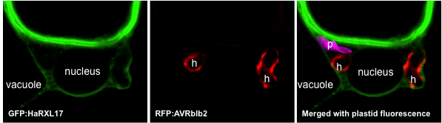

Figure 1. RXLR effctors as molecular markers labeling different host compartments during P. infestans infection. (A) GFP-HaRXL17 labeles peri-haustorial tonoplast (B) RFP-AVRblb2 marks the EHM. Haustoria are represented by h. (C) Merged channels. Magenta represents plastid fluorescence.

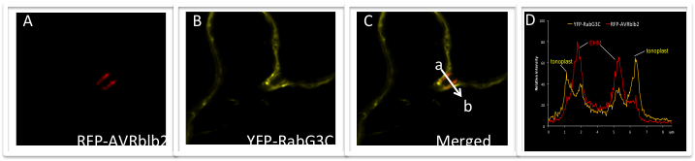
Figure 2. RabG3C traffics to the EHM. (A) RFP-AVRblb2 marks the EHM (B) YFP-YFP-RabG3C labels both the tonoplast and the EHM. (C) Merged YFP and RFP channels. (D) Relative intensity plots representing fluorescence intensities of YFP and RFP signals detected across the line drawn from a to b as shown in (C). YFP-RabG3C gives peaks at the tonoplast and the EHM while RFP-AVRblb2 only marks the EHM.

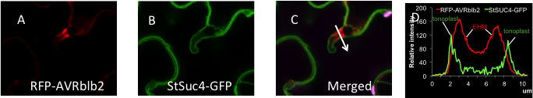

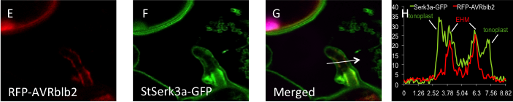

Figure 3. A selective vacuolar transport to the EHM. (A) RFP-AVRblb2 marking the EHM as control (B) StSUC4-GFP (Sucrose transporter GFP fusion) labels the tonoplast but not the EHM. (C) Merged GFP and RFP channels. (D) Relative intensity plots representing fluorescence intensities of GFP and RFP signals detected across the line drawn as shown in (C). StSUC4-GFP gives fluorescent intensity peaks at the tonoplast while RFP-AVRblb2 peaks the EHM. (E) RFP-AVRblb2 marking the EHM as control. (F) StSerk3a-GFP labels both the tonoplast and the EHM. (G) Merged GFP and RFP channels. (H) Relative intensity plots representing fluorescence intensities of GFP and RFP signals detected across the line drawn as shown in (G). StSerk3a-GFP gives peaks at the tonoplast and the EHM while RFP-AVRblb2 only marks the EHM.

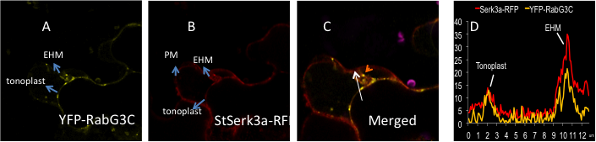
Figure 4. StSerk3a localizes to the late endosomes at EHM. (A) YFP-RagG3C labels tonoplast, EHM and the late endosomes at EHM (B) StSerk3a-RFP labels the plasma membrane (PM), tonoplast, late endosomes and the EHM. (C) Merged YFP and RFP channels showing co-localization of YFP-RabG3C and StSerk3a-RFP at the EHM, tonoplast and late endosome at EHM (orange arrowhead). (D) Relative intensity plots representing fluorescence intensities of YFP and RFP signals detected across the line drawn as shown in (C). YFP-RabG3c and StSerk3a-RFP both gives fluorescent intensity peaks at the tonoplast and the EHM.

