The research program focuses on a central theme relating governance and regulation of the sector of the social economy in a territorial context. This project is based on Vaesken and Zafiropoulou model centered to social innovation resulting from the articulation between modes of governance and modes of regulation. The model is presented as follow:

*Organizational Governance*

*Situated regulation*

**Type 2:**

Social capital from

private /public partnership

**Type 1:**

Social capital from

Social economic/private

sectors partnership

**Type 4:**

Social capital

from institutional production

**Type 3:**

Social capital from

public/corporate sectors

partnership

*Emergent regulation*

*Situated*

*Governance*

The program treats three specific research orientations of social policies and local development:

1. Cultural policies (cultural management, place of users in the construction of cultural policies, innovating systems and devices). This axis points the difficulty in taking into account the requests of stakeholders in the construction of cultural policies building oriented to social regulation.
2. Healthcare policies (centered on active participation of users, innovating systems and devices of management in isolated territories). This axis analyses news relationships, partnerships and services characterizing the healthcare sector, having for goal to manage medical territories.
3. Policies of social and economic integration of disadvantaged populations (innovating systems and devices of management). Within the framework of the social and professional integration it is important to study the roles of private and public operators in order to specify different types of configurations. These configurations aim to answer problems of social and economic insertion
4. Moreover, a transverse axis on home care and integrated services will be developed.

This multidisciplinary research project integrates both economic, public policies and public management approaches. Our goals of work are multiple:

• To share university knowledge in the fields of social economy applied to partners territories.

• To cross research on regulation practices integrated in social policies.

• To analyze the role of users and to identify the strategies of actors.

• To describe territorial specificities and to theorize managerial practices.

Currently, the analysis focuses on three areas: the cultural development of territories, issues of migration and home services. The cultural axe of the project is the most advanced. Case studies were carried out on the impact of cultural activities on the territory: Sacred Music International Festival in Fes (Morocco) and the festival of Gnawa music of Essaouira (Morocco), Sibiu (Romania) and Lille (France) European cultural capitals, the coming of the Louvre in Lens (France) and its economic and social impacts.

In these territories, studies have highlighted the interrelationship between different kinds of stakeholders. They allow to structure specific modes of governance. This led to new governance structuring of territories, urban, economic and social matters.

To explain the involvement of stakeholders in an area, we used the model of Michel Aggle and Wood (1997). In addition, the base model has evolved to include processes of value creation in an area, in process of value co-production and value co-creation. It is these tracks that are being actually developed.

The new model is organize as follow:

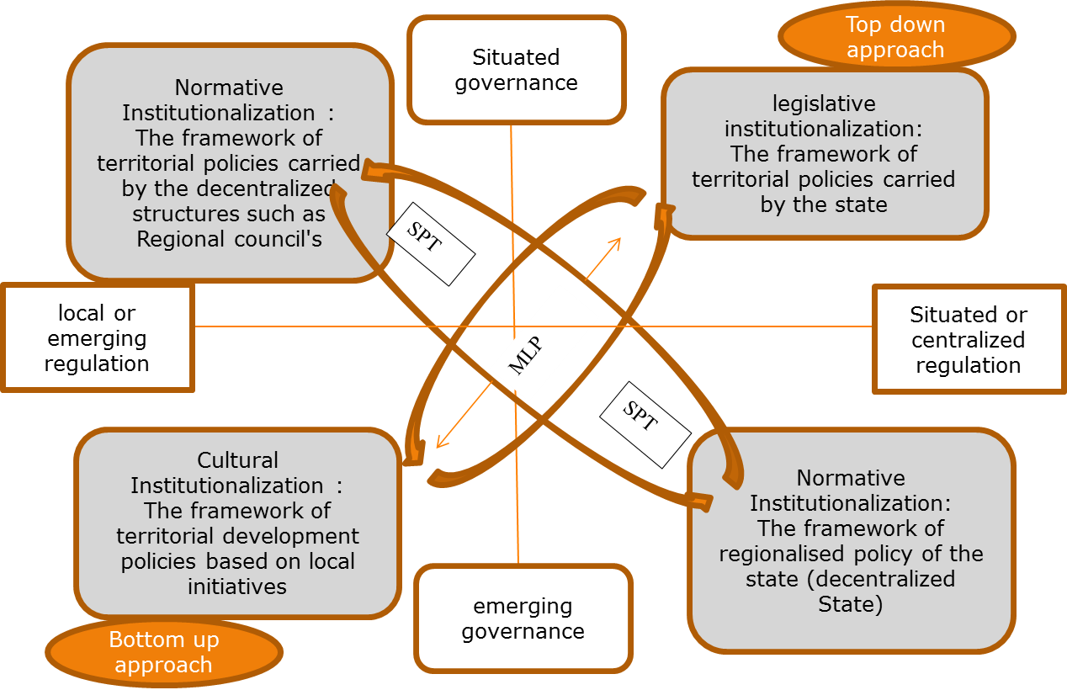

Use Value

Exchange value

Potential value

This new model meets the three dimensions worked during this project: the governance principle and logic of stakeholders, the regulatory process, as part of public policy (culture, employment, local development ...), and the intermediation rule, devoted to some actors, in order to allow the overall system operation.

Moreover, the concepts of creation and co-creation of values are integrated in this model. This contribution is essential to understand the behavior of the beneficiaries in the construction of public policies. Thus, the logical value is broken down into three areas:

- Potential values, taking into account all the potentialities that are offered (or can be offered by) to Beneficiaries after the implementation of a public policy,

- The exchange values that express the co-creation level that is required from the Beneficiary in the context of the public policy building.

- Use values, which impact more behaviors of beneficiaries.

The "VALUES" project has developed a business model to support the building of public policies within the framework of a democratic process. Indeed, the inclusion of stakeholders from the beginning of the construction of a public policy is fundamental to ensuring a balance between public policy demand and public policy supply. In this area, the introduction of the "values" concepts, developed in marketing, brings a global equilibrium to the model. This analysis is part of the neo institutionalists, economic theories that fits perfectly with crisis situations such as those currently crossings at European and international level. In this economic model, the program "VALUES" brings visions of public management in the context of a territorial development project.