Activation of Methane and Other Alkanes with Electrophilic Gold Complexes
C-H activation (functionalization) is the direct and selective substitution of a carbon-hydrogen bond by new, lower in energy C-X bonds.,These transformations have very broad potential in synthesis because C-H bonds are ubiquitous and their selective activation will change current practice of organic synthesis of complex molecules in research laboratories and in industry. The aim of this projects has been to initiate the development of new systems for the catalytic activation of methane and other alkanes based on gold chemistry in homogeneous catalysis. Additional objectives have been:(i). the gold(III)-catalyzed selective functionalization of activated aromatic C-H bonds; (ii). the development of new gold (III) complexes as catalysts for the oxidations of alkenes.
The potential of the planned approach and its difference from the state-of-art consisted in the discovery of innovative methodological strategies to activate the simplest, unfunctionalized class of molecules by using novel gold(III) complexes. Hence, in the first part of the research, synthesis of new ligand and the relative gold complexes was successfully accomplished. A straightforward general approach was designed for preparing a variety of symmetrical N,O,O-donor 2,6-diphenoxypyridines 1 (Error: Reference source not found). The ligands synthesis commenced by double Suzuki-Miyaura couplings to symmetrical 2,6-dibromopyridine and the corresponding boronic acid. The same protocol was followed to prepare the analogous bidentate (N,O) ligands 2 as well as the acid derivatives 3 following a similar procedure (Error: Reference source not found). Synthesis of complexes starting by simple molecules was also envisaged. Methodologies to access ligands featuring amides in position 2 of the pyridine and pyrazine motif were tested (i.e. compound 4, Figure 1). Moreover, the latter protocol was applied to the preparation of compounds of type 5 in a straightforward manner (Figure 1). Therefore the convergent procedures developed are useful tools to obtain a wide variety of ligands of interest.
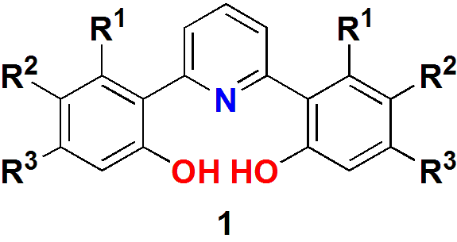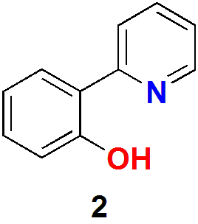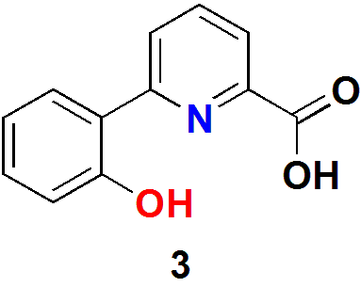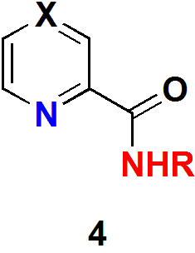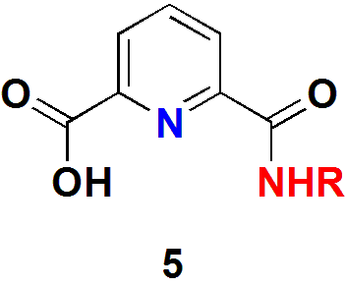
Figure 1
Hence as a part of our project, we prepared a series of robust pyridine-based gold(III) complexes which would mimic the desirable properties of that catalytic system but under milder conditions and studied their application in arene H/D exchange.
Unfortunately, all the attempts to prepare the corresponding gold(III) complexes with the bidentate ligand 2 and tridentate ligands 1 and 3, by any of the protocols tested, failed. On the other hand, gold(III) complexes were prepared by reaction of ligands 4 and 5 with either NaAuCl₄.2H₂O or KAuCl₄ as sources of gold(III), following a simple protocol. The structures of complexes 4a-d and 5a were confirmed by X-ray diffraction (Figure 2. For additional details see the attachment). Thus, the following part of this study focusing on catalysis will be described for the successfully synthesized Au(III) complexes.
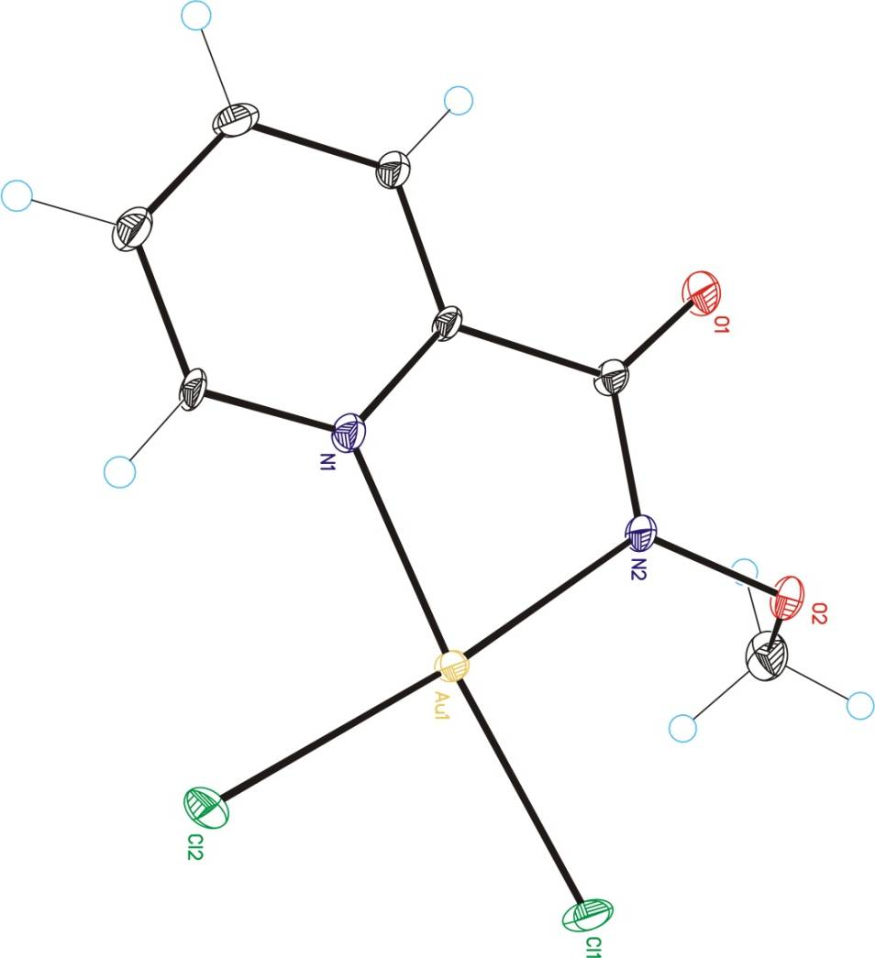4a 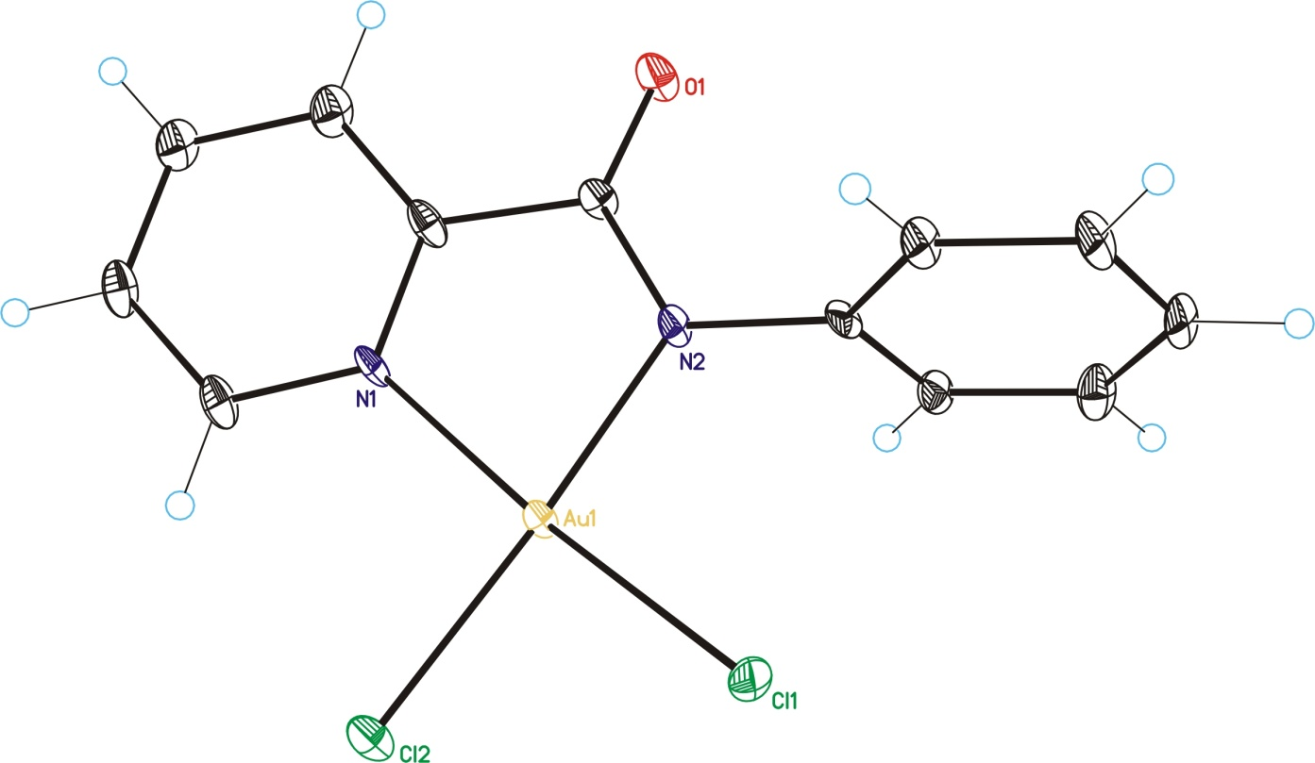4b 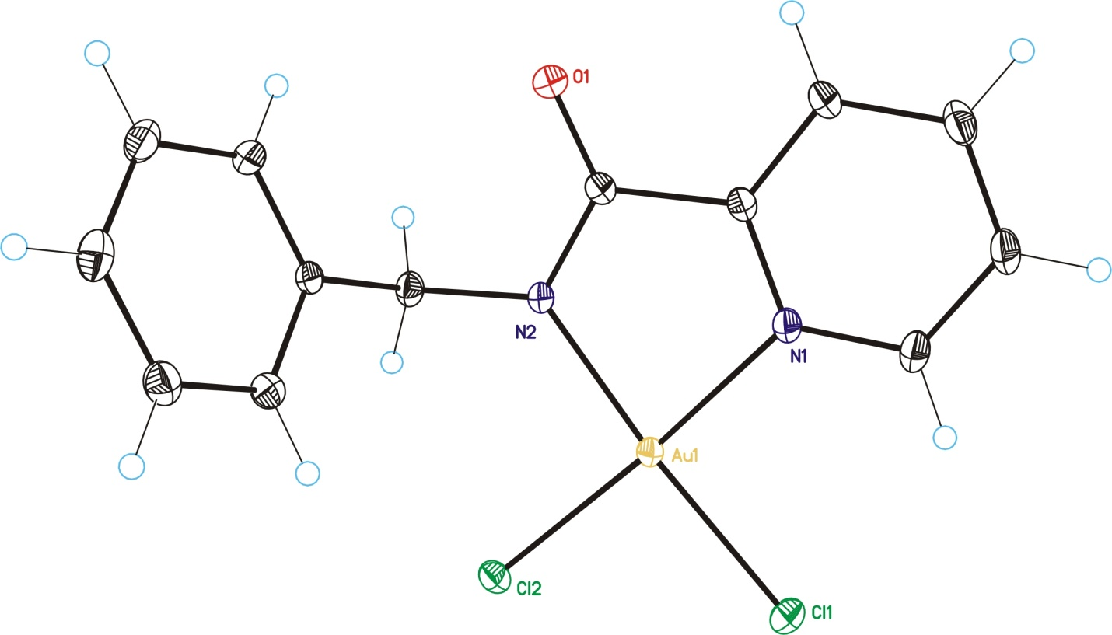4c
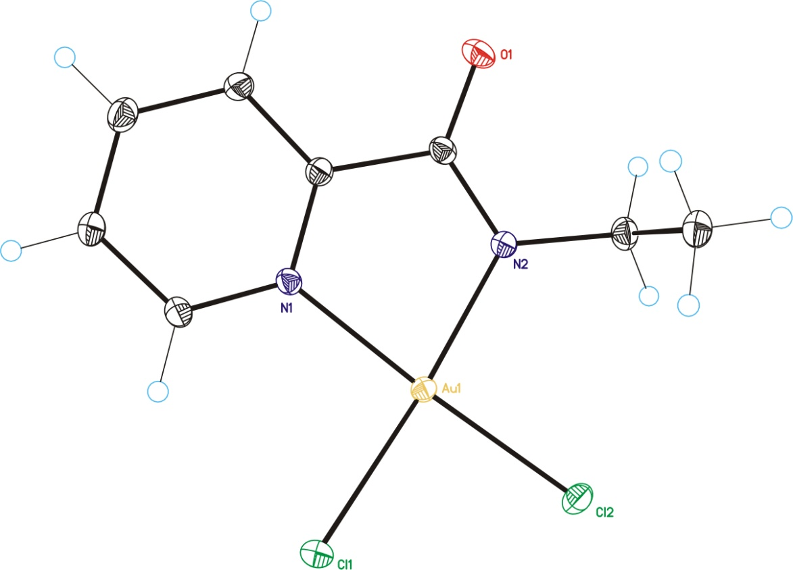4d 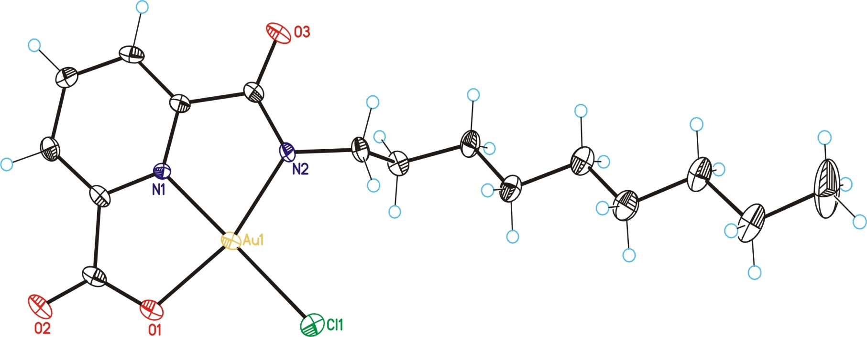5a
Figure 2
The first benzene H/D exchange reaction promoted by gold(III) was evaluated with complexes 4a-d and 5 as pre-catalysts for H/D exchange between TFA-d and benzene using and assay developed by Sanford and co-workers (Figure 3). Under the standard conditions (2 mol% of gold(III) complex and 4 mol% AgOTf) we obtained 16 to 100% deuteration with TON values of 8 to 205. The TOF values ranged from 9.3 × 10⁻⁵ to 2.4 × 10⁻³ s⁻¹. Different silver salts led to similar results. Moreover, the scope of the reaction was tested: electron poor and electron rich substrates did not undergo any deuteration process in either deuterated acidic solvents, and only bromobenzene led to a partial deuteration in ortho and para when the more acidic TFA-d was use as the deuterium source. This observation could provide some evidence to support an electrophilic aromatic substitution possibly dependent on the pKa of the deuterium source.
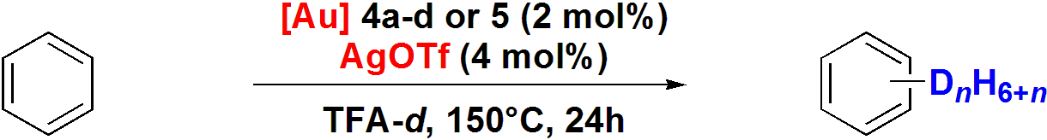
Figure 3
Blank experiments were performed in the absence of silver(I) salt or gold complex to verify whether a background reaction was occurring. In these experiments 10% deuteration was observed after 24 h. These results suggest that the active species is the complex formed by reacting Au(III) complex with the silver salt or the silver salt itself, and ruled out a role of AgCl as the active species.
Additionally, we decided to explore the H/D exchange reaction of benzene in the presence of a variety of silver salts. Deuteration levels of up to 95% were achieved with TONs ranging from 1 to 56. The activity of the silver salt significantly decreased by lowering the reaction temperature. The best result was obtained when gold(III) chloride was employed. Finally, by using triflic acid as catalyst demonstrated that the Lewis acidity of the gold salt or its hydroxy derivative as Brønsted acid can by itself catalyze the reaction. The latest results indicate a possible involvement of the acid-catalyzed electrophilic aromatic substitution mechanism in the reaction pathway. Two recent reports on Pd and Pt chemistry by Gade and Bergman supported this hypothesis.
As a model for the gold(III) complexes, related palladacycles were also prepared using ligand 4b. These new palladacycles form stable trinuclear structures in a supramolecular hexanuclear aggregates displaying three week d⁸-d⁸ interactions.
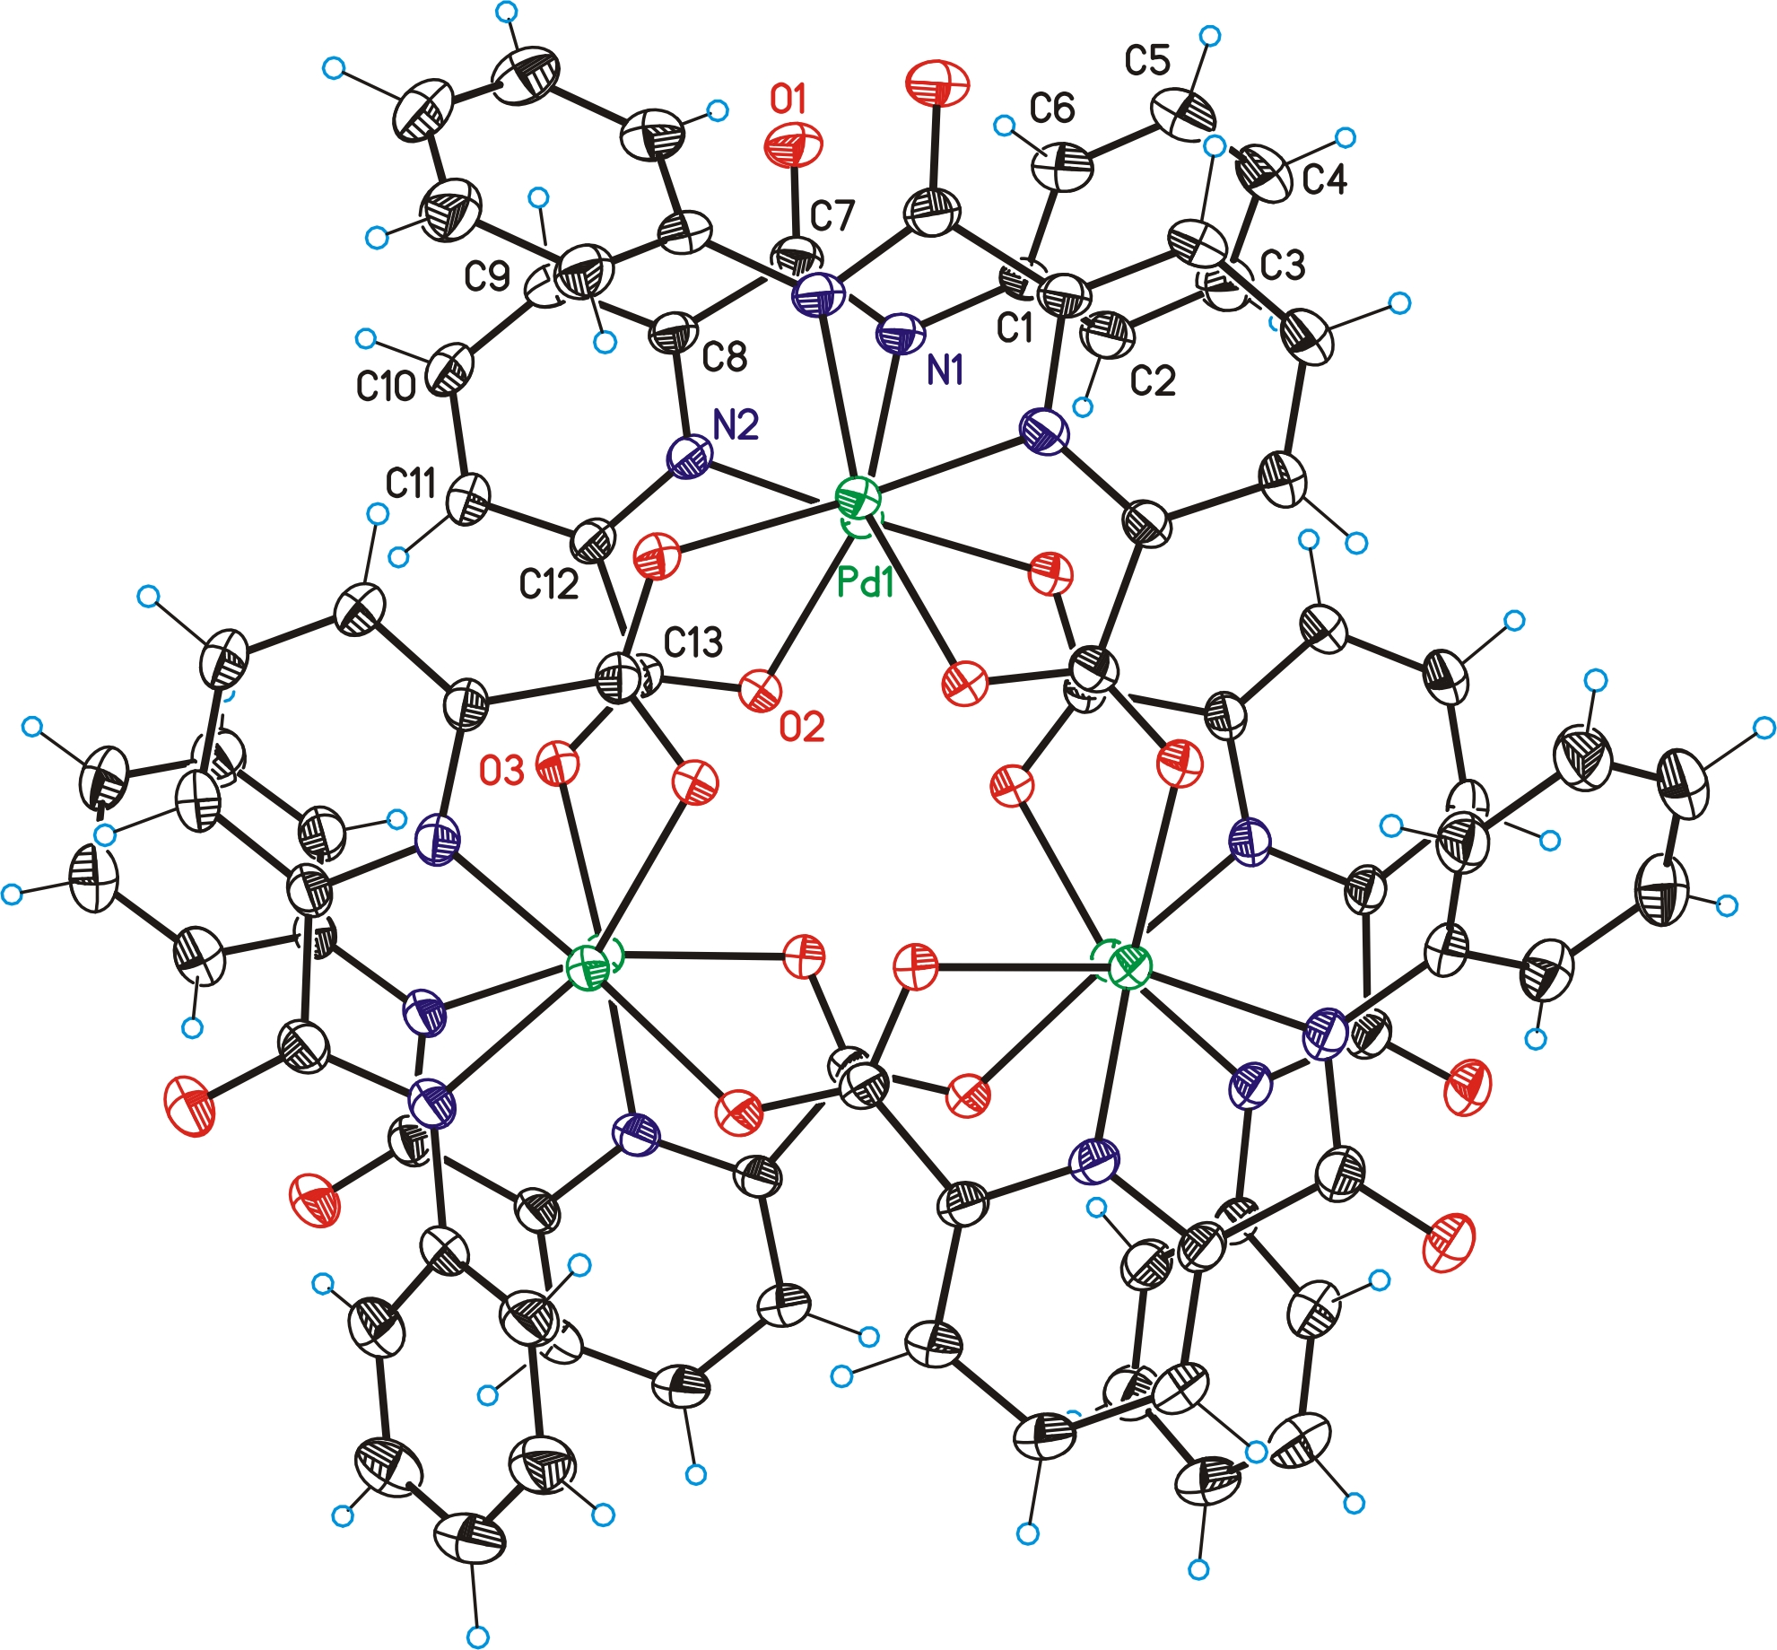

(a) Kakiuchi, F.; Chatani, N. Adv. Synth. Catal. 2003, 345, 1077-1101. (b) Labinger, J. A.; Bercaw, J. E. Nature 2002, 417, 507–514. (c) Shilov, A. E.; Shul’pin, G. B. Chem. Rev. 1997, 97, 2879-2932.
The term “C-H activation” is more specific and in the absence of mechanistic evidence it is preferable to use the more general term “C-H functionalization”: G. Dyker, Handbook of C-H Transformations, G. Dyker, Ed. Wiley. Weinheim, 2005.
Godula, K.; Sames, D. Science 2006, 312, 67-72.
Beaumard, F.; Dauban, P.; Dodd, R. H. Org. Lett. 2009, 11, 1801-1804.
. Couchman, S. M; Jeffery, J. C.; Thornton, P.; Ward, M. D. J. Chem. Soc., Dalton Trans. 1998, 1163–1169.
Takács, A.; Jakab, B.; Petz, A.; Kóllar, L. Tetrahedron 2007, 63, 10372-10378.
Emmert, M. H.; Gary, J. B.; Villalobos, J. M.; Sandford, M. S. Angew. Chem. Int. Ed. 2010, 49, 5884-5886.
Kang, Y-B; Gade L. H. J. Am. Chem. Soc., 2011, 133, 3658–3667.
Bowring, M. A.; Bergman, R. G.; Tilley T. D. Organometallics, 2011, 30, 1295–1298.

