Marie Curie Actions
Final Report

PROJECT MID-TERM REPORT
Grant Agreement number | 273088
Project acronym | ORGANO-CAS CAT
Project title | ORGANO-CASCADE CATALYSIS: A SHORTCUT TO STEREOCHEMICAL AND MOLECULAR COMPLEXITY
Funding Scheme | FP7-MC-IIF
Period covered-start date | 25/04/2011
Period covered-end date | 20/11/2012
Name, title and organisation of the scientist in charge of the project's coordinator | Prof. Paolo Melchiorre FUNDACIO PRIVADA INSTITUT CATALA D'INVESTIGACIO QUIMICA
Tel | +34 977 920 807
Fax
E-mail | pmelchiorre@iciq.es
Project website address

1. FINAL PUBLISHABLE SUMMARY REPORT
Final Publishable Summary Report
The emerging field of aminocatalytic cascade reactions provides a way of achieving stereochemical and molecular complexity while addressing the requests for atom and step economy or protecting-group-free synthesis. The synthetic potential of this bio-inspired approach has been validated by recent applications of asymmetric aminocascade reactions to the total synthesis of natural products. These studies support the idea that this cost-effective, energy-saving and sustainable synthetic strategy could become a reliable and versatile tool for modern asymmetric synthesis.
In the ORGANO-CAS CAT project, we further innovated around the development of novel organocascade strategies for rapidly converting simple achiral starting materials into complex compounds embodying features of natural molecules. Since the vast majority of natural products and drug-like compounds possess heterocyclic moieties, we focused more on preparing diverse heterocyclic compounds, such as spirocyclic oxindole or benzofuranone derivatives. We recognized as a necessary step the identification of novel reactivity concepts to enable the inclusion of unprecedented transformations into elaborate yet experimentally simple organocascade reactions.
During our research process, we produced research results of high quality and subsequently published them in top international journals and conferences :
1. We developed the first asymmetric organocatalytic Diels-Alder reaction of in situ generated heterocyclic ortho-quinodimethanes (oQDMs), reactive diene species that have never before succumbed to a catalytic approach. Asymmetric aminocatalysis, that uses chiral amines as catalysts, is the enabling strategy to induce the transient generation of indole-, pyrrole- or furan-based oQDMs from simple starting materials, while directing the pericyclic reactions with methyleneindolinones toward a highly stereoselective pathway. The approach provides straightforward access to construct a spirocyclic oxindole core with high chemical yield and excellent stereoselectivity (isolated yield 53-98%, dr 8:1->20:1, ee 94->99%).
Figure 1. Asymmetric Catalysis of Diels-Alder Reactions with in Situ Generated Heterocyclic ortho-Quinodimethanes (J. Am. Chem. Soc., 2011, 133, 15212–15218)
The reported strategy is conceptually original for asymmetric catalysis and we feel that the combination of novelty, high levels of yield and stereoselectivity, and application to indole-, pyrrole- or furan-based heterocyclic compounds using mild and simple reaction conditions will provide for the rapid application of this chemistry in synthetic and medicinal arenas.
In addition, expanding upon the recently developed aminocatalytic asymmetric indole-2,3-quinodimethane strategy, a straightforward synthesis of complex molecules has been devised. We have shown how its potential can be expanded to include a variety of different dienophiles to access a straightforward synthesis of structurally and stereochemically complex tetrahydrocarbazoles. The chemistry`s complexity-generating power was further harnessed by designing a multicatalytic, one-pot Diels-Alder/benzoin reaction sequence to stereoselectively access trans-fused tetracyclic indole-based compounds having four stereogenic centers with very high fidelity.
2．We then focused on the possibility of productively merging the iminium ion strategy with the concept of vinylogy. The resulting aminocatalytic activation mode, termed vinylogous iminium ion catalysis, contributes a strategy to forge a stereocentre at the remote carbonyl δ-position, a synthetically difficult issue for which few catalytic solutions are known. When a cinchona-based primary amine condenses with β-substituted cyclic dienones, an iminium ion intermediate of extended conjugation is formed, the electrophilicity of the δ-carbon atom of this intermediate is higher than that of the cyclic dienone substrate. This aminocatalytic activation mode was highly stereoselective and displayed high selectivity for reaction at the δ position.
3. We finally tried to address a significant limitation of asymmetric catalysis in that, when applied to processes that generate chiral molecules with multiple stereogenic centers in one single step, researchers cannot selectively access the full matrix of all possible stereoisomeric products. Mirror imaged products (complementary enantioselectivity) can be discretely provided by the enantiomeric pair of a chiral catalyst. But modulating the enforced sense of diastereoselectivity (control over the relative stereochemistry) using a single catalyst is an unmet challenge in asymmetric catalytic synthesis.
We have found an innovative solution by programming the catalytic functions of a single chiral small-molecule organic catalyst (J. Am. Chem. Soc. 2011, 133, 17934–17941). Applying an external chemical stimulus, it was possible to arbitrarily induce stereodivergent pathways. The strategy has been used to fully control the stereochemical outcome of the asymmetric conjugate addition of alkyl thiols to a challenging class of Michael acceptors (α-substituted α，β-unsaturated ketones, which have never served before as Michael acceptors of catalytic asymmetric reactions), a transformation which generates two adjacent stereocenters through an addition-protonation tandem sequence. The judicious choice of acidic additives and reaction media switches the sense of the catalyst’s diastereoselection, thereby affording either the syn or anti product with high enantioselectivity (Figure 3).
Due to its innovative aspect, our chemistry has been highlighted in Science 2011, 334, 570.

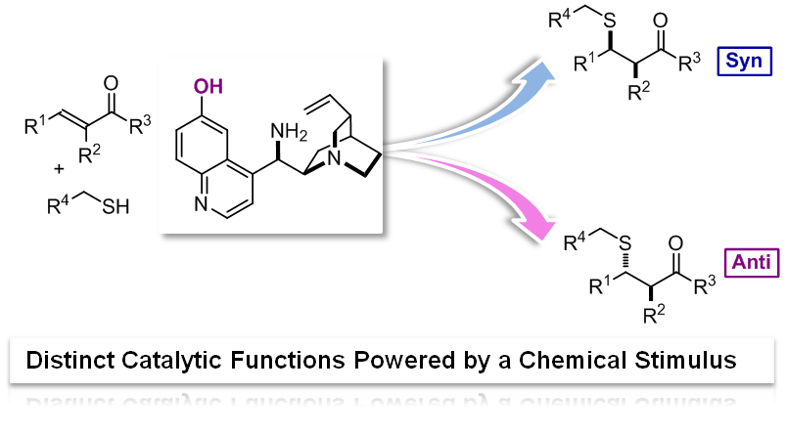

Figure 2. Switching the diastereoselectivity using a single chiral organic catalyst (J. Am. Chem. Soc. 2011, 133, 17934–17941).

2. USE AND DISSEMINATION OF FOREGROUND
Section A (public) – DISSEMINATION MEASURES
Comments:
Talks, seminars and other fora:
- The fellow benefited from the ICIQ seminar programme, a series of lectures held weekly by leading international researchers. Dr. Liu talked directly with established scientists during personal group meeting sessions, thus gaining confidence in discussing, with experts, a range of scientific topics not directly related to their own research.
- Yankai Liu periodically gave oral presentations on his own current research and also gave literature presentations on current areas of interesting research activity from around the world, which allowing him to develop his presentation skills, and also allowing project monitoring.
- Dr Liu helps in supervising PhD students in an area closely related to his project.

Publications:
- Xu Tian, Yan-kai Liu, Paolo Melchiorre*, “Aminocatalytic Enantioselective 1,6-Additions of Alkyl Thiols to Cyclic Dienones: Vinylogous Iminium Ion Activation”. Angew. Chem. Int. Ed. 2012, 51, 6439–6442
- Yan-Kai Liu, Manuel Nappi, Eduardo C. Escudero-Adán, and Paolo Melchiorre*, “Multicatalytic Asymmetric Synthesis of Complex Tetrahydrocarbazoles via a Diels–Alder/Benzoin Reaction Sequence”. Org. Lett., 2012, 14, 1310–1313
- Yan-Kai Liu, Manuel Nappi, Elena Arceo, Silvia Vera, and Paolo Melchiorre*, “Asymmetric Catalysis of Diels–Alder Reactions with in Situ Generated Heterocyclic ortho-Quinodimethanes”. J. Am. Chem. Soc., 2011, 133, 15212–15218
- Xu Tian, Carlo Cassani, Yan-kai Liu, Antonio Moran, Atsushi Urakawa, PatriziaGalzerano, Elena Arceo, Paolo Melchiorre*, “Diastereodivergent Asymmetric Sulfa-Michael Additions of alpha-Branched Enones using a Single Chiral Organic Catalyst” J. Am. Chem. Soc., 2011, 133, 17934–17941
Conference Participation:
- Participation to the ICIQ Summer School, June18-22, 2011 and July 22-27, 2012, Tarragona, Spain.
- Participation to 7th Asian European Symposium on Metal-Mediated Efficient Organic Synthesis, July 22-27, 2012, Tarragona, Spain.
- Participation to the “Southern Catalonia Nobel Campus”, July, 1-4, 2012, Tarragona, Spain. Poster title: “Asymmetric Catalysis of Diels-Alder Reactions with in Situ Generated Heterocyclic ortho-Quinodimethanes”
- Participation to the international conference “Catalysis in Organic Synthesis ICCOS-2012”, September 15-20, 2012, Moscow, Russia. Poster title: “Asymmetric Catalysis of Diels-Alder Reactions with in Situ Generated Heterocyclic ortho-Quinodimethanes”

