Summary Report

**BIRDISLAND: Ecological and Genomic Approaches to Speciation in Island Birds**

Intra-European Fellowship FP7-PEOPLE-2010-IEF - Project 273066

**A) INTRODUCTION**

The study of speciation, the process by which new species evolve, is providing exciting new insights into the drivers of biological diversification. However, the causes of the “origin of species” still remain controversial. Birds from oceanic islands offer a number of advantages over other groups for the study of speciation, because knowledge of bird ecology exceeds that in any other group, and because island environments provide excellent “natural laboratories” for evolution.

In the project BIRDISLAND, the Fellow (Dr. Luis Valente) was hosted by Prof. Vincent Savolainen (expert in biodiversity genomics, Imperial College London) and collaborated with Dr. Albert Phillimore (expert in avian speciation, University of Edinburgh), in order to attempt to answer the following unresolved questions: a) Which particular genes are involved in bird speciation on islands?  b) Are the same genes recruited in independent speciation events on islands? To do this, the project focused on investigating speciation genomics in white-eyes (*Zosterops*)species from Pacific islands as well as on phylogenies of the large bird group Thraupidae and allies.

**B) OBJECTIVES OF BIRDISLAND**

1. To understand how speciation in island birds takes place by using a  comparative phylogenomic approach in order to identify “speciation loci” that have been involved in divergence processes and by quantifying gene flow within and among islands, in order to gain insights into the evolutionary trajectory of different populations of birds.
2. To identify the genomic regions associated with speciation in Thraupidae birds and allies. To investigate whether similar genetic regions have been associated with speciation of the tanager family and allies at a global scale, by using a genomic meta-analysis that allows the identification of whether the same loci are recruited for speciation in both islands and continents.

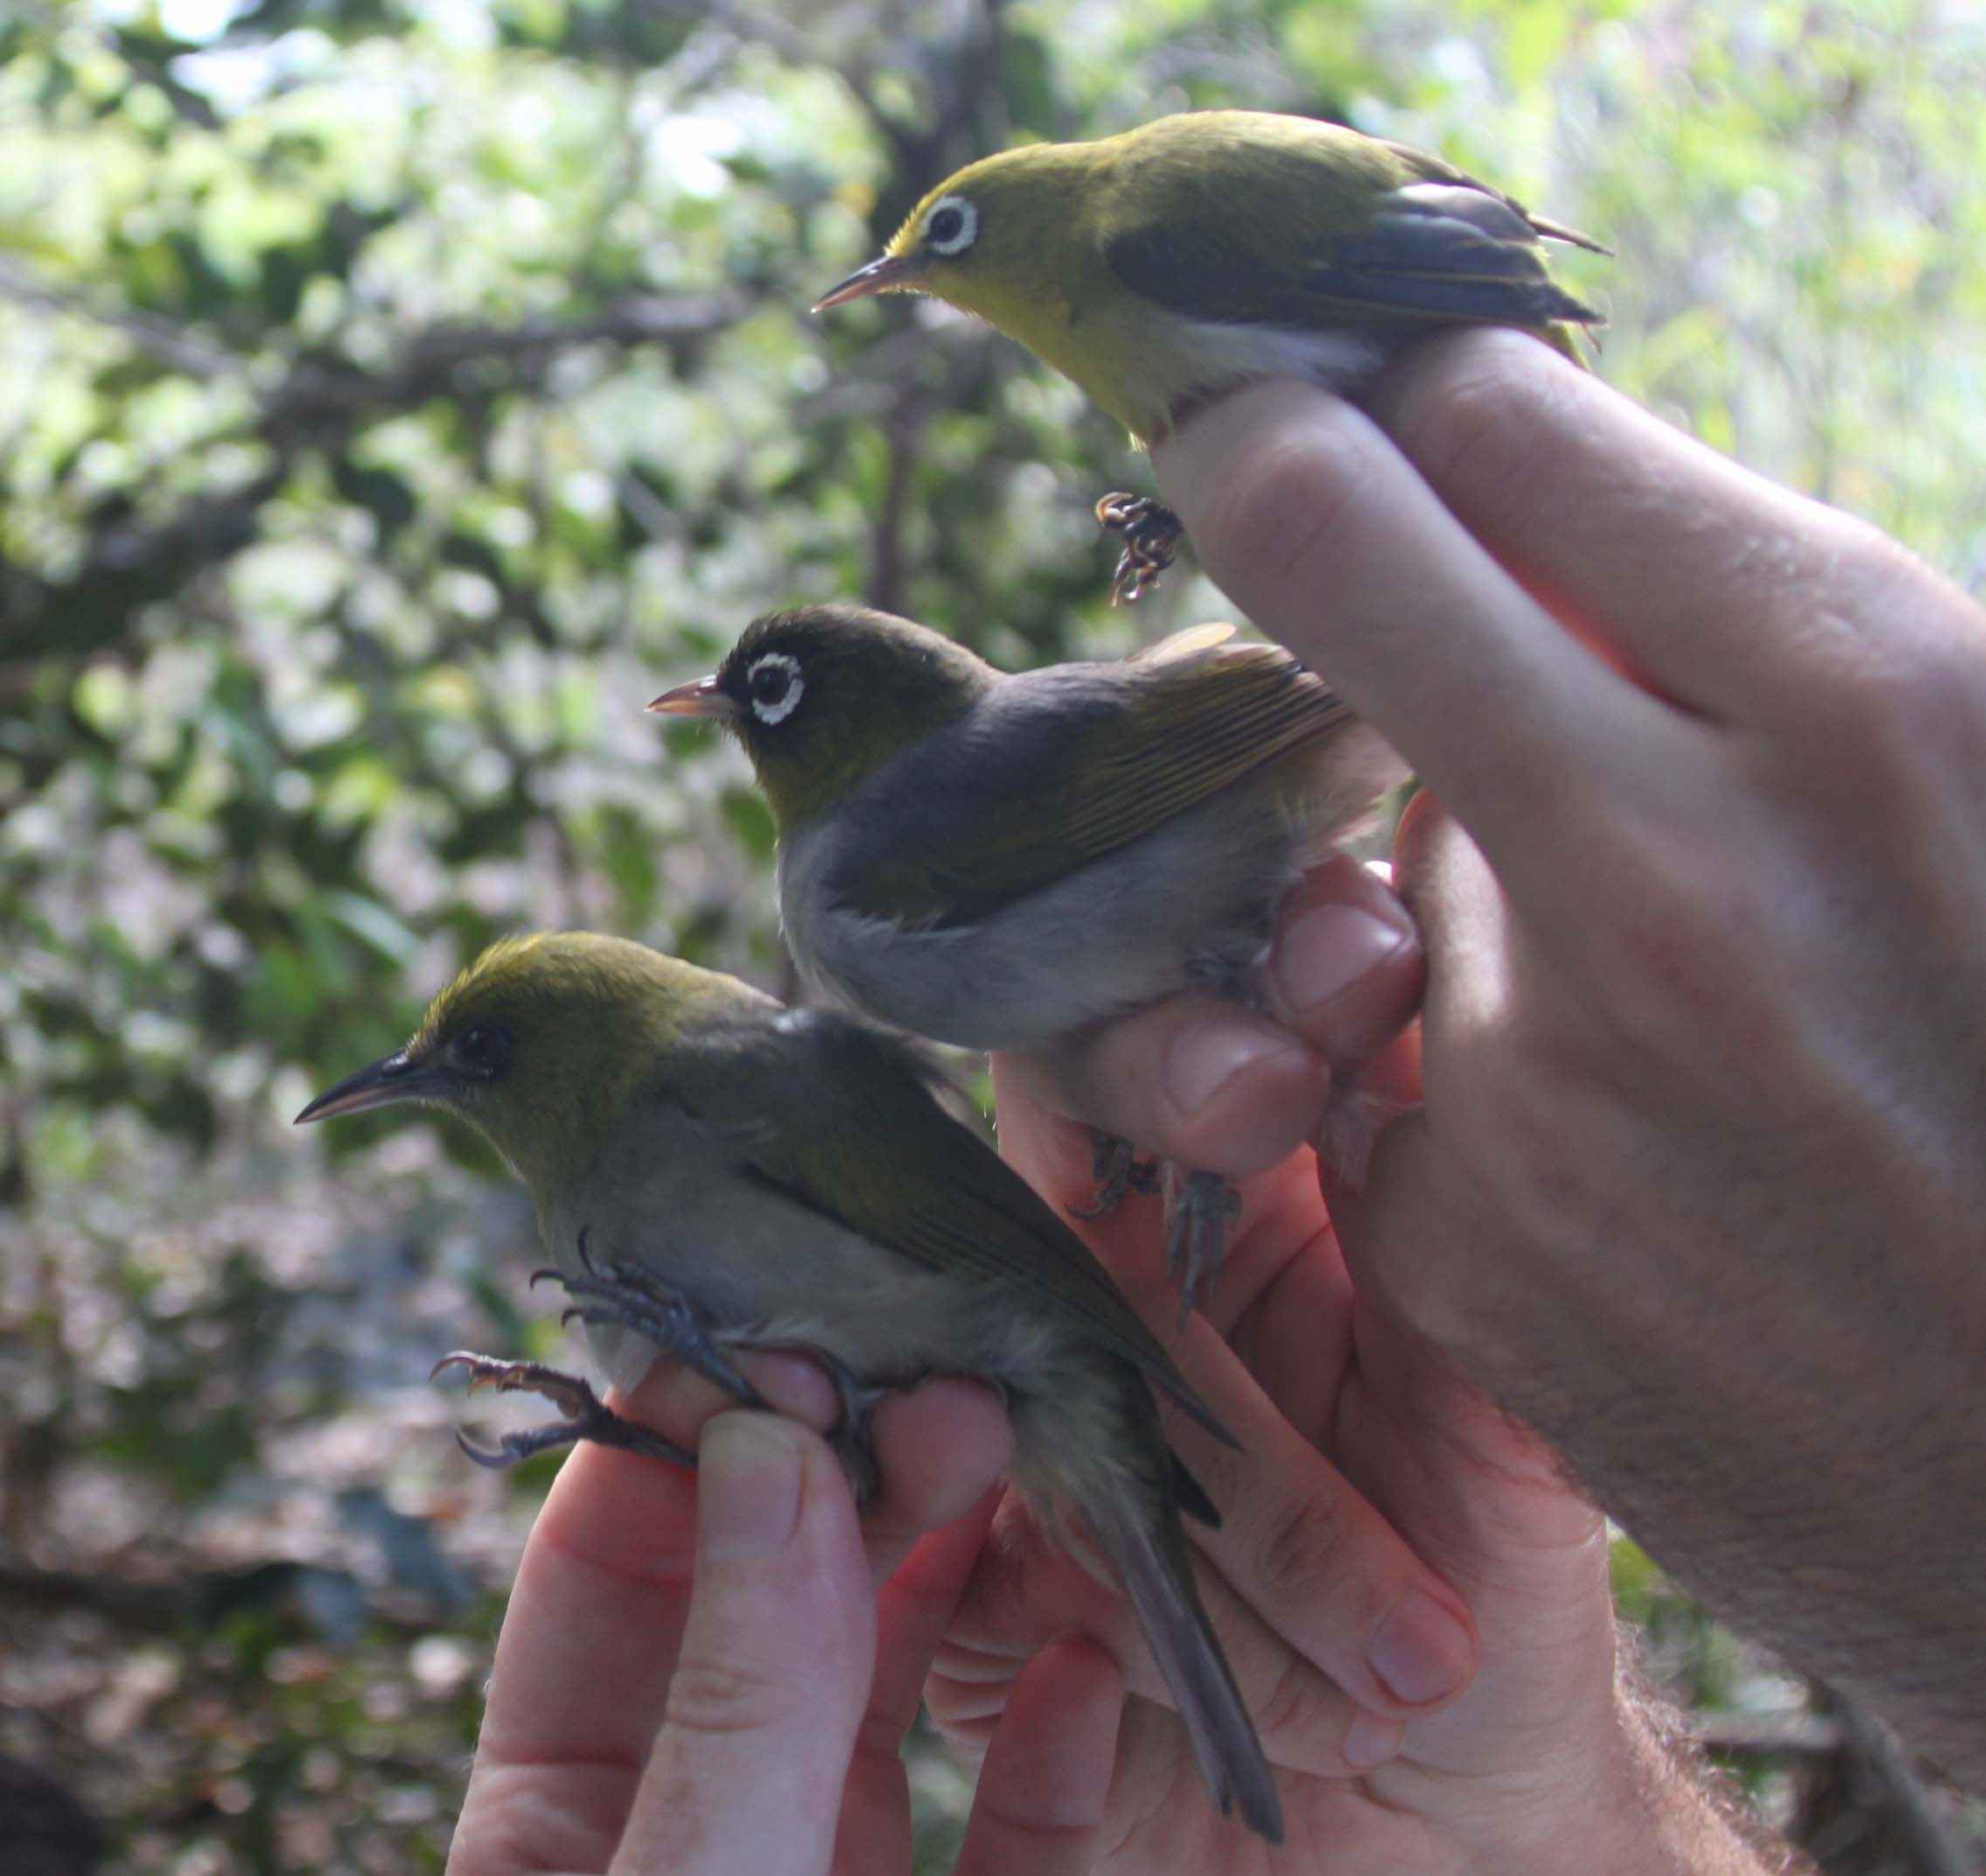

Fig. 1– In BIRDISLAND, the genomes of *Zosterops* species from New Caledonia, which differ in body size, colour and beak shape, were studied in detail to search for “speciation genes”. Photograph by Luis Valente.

**C) RESEARCH PERFORMED IN BIRDISLAND**

**Phase 1 – Speciation**

* **Field and molecular work -** A field trip to the oceanic islands of New Caledonia (3 months) was conducted in order to collect blood samples and morphometric measurements from the study species. Back at Imperial College, DNA was extracted in the laboratory from the blood samples obtained in the field (over 300 extractions). The samples were genotyped using restriction site associated (RAD) DNA next-generation sequencing method in an Illumina HiSeq2000 machine.
* **Data analyses -** The large, comprehensive, molecular datasets obtained with RAD markers were used to look for single-nucleotide polymorphisms in the bird populations. A genome wide scan to identify putative genomic regions under selection was conducted. Speciation genes are being identified by a comparative genomic analysis using the complete genomes of avian species that have recently been published. The Fellow has also sequenced and assembled the complete genome of four *Zosterops* species, which have allowed the characterization of the full suite of genes of these island endemics.

**Phase 2 - Speciation Genes**

* A dataset of phylogenies of Thraupidae and other passerines that occur on islands was compiled by the Fellow. Mitochondrial protein-coding sequences were downloaded from EBI/Genbank and analysed for over 300 species of tanagers and their allies from ca. 100 oceanic islands. A dataset of candidate speciation loci that may have been associated with avian speciation on islands was compiled and a set of genes including those involved in beak shape and plumage coloration have been sequenced by the Fellow in several avian samples. Geological and environmental data has been compiled for all islands considered, and divergence times for all populations have been calculated using molecular clocks.

**D) MAIN RESULTS OF BIRDISLAND**

* New tissue and DNA samples of 300 birds archived in the DNA and tissue voucher bank at Silwood park campus (Imperial College London).
* Morphometric database of 307 birds compiled including information on sex, plumage colour, and multidimensional measurements of beak, tail, wing, tarsus and weight.
* RAD next-generation genotyping profile of 30 individuals from three populations.
* Complete genome of four *Zosterops* species sequenced and assembled de novo.
* Identification of genomic regions associated with reproductive isolation in birds.
* Most comprehensive compilation of avian phylogenies from islands conducted to date, including all published phylogenies of birds from oceanic islands.
* Identification of 15 candidate loci potentially involved in speciation in island birds.
* Compilation of a database with geographical and environmental information of 200 islands.
* First database of divergence times (ages) of bird populations on islands based on molecular data.
* Nine publications with the Fellow as an author, acknowledging FP7 funding (three published, four under review, two in preparation).
* Two undergraduate and two MSc student dissertations at Imperial College London.

**E) IMPACT OF BIRDISLAND AND USE OF RESULTS**

* **Speciation genomics –** The genomic regions that were found to be involved in speciation in *Zosterops* and Thraupidae species will be the subject of functional genomic studies to identify their precise roles in reproductive isolation, thus providing an important step to understand how new bird species evolve.
* **Island biogeography –** The database of phylogenies of island birds will provide an important new tool for biogeographers, allowing the estimation of rates of speciation, colonization and extinction in birds in different islands and continents.
* **Contribution to development of EU Overseas Countries and Territories** - During the field trip to New Caledonia (France Overseas Territory) the Fellow engaged the local people of Lifou island by raising awareness about the importance of evolutionary biology and bird conservation. There are now two local people working on an eco-tourism project where they teach tourists and members of the tribe about New Caledonian birds, and they were partly trained by the Fellow (more information on this website: <http://wmw.nc/les-nouveaux-pinsons-de-darwin/>). The project also established a new research partnership between researchers in Imperial College , Griffith University (Australia) and the local government (Province des Iles, New Caledonia).
* **Publications -** Nine publications with the Fellow as co-author have arisen from this project. Three are already published (*Molecular Phylogenetics and Evolution, The American Naturalist, Systematic Biology*), four are in review, and two are in preparation to be submitted in 2013.
* **DNA and tissue bank -** All DNA extractions and tissue samples have been archived in Silwood Park’s DNA & tissue bank and are available to other scientists upon request.
* **Data made freely available to the scientific community -** All molecular data will be deposited on Genbank, after publication of the two final papers that are being prepared. The phylogenetic datasets of island birds compiled and produced in this project will be deposited on Dryad.
* **Website** – A web page has been set up with project information and will feature results when the final papers are published. [www.imperial.ac.uk/people/l.valente](http://www.imperial.ac.uk/people/l.valente)
* **Scientific presentations** - The Fellow has presented the project’s results in four scientific talks – at University of Groningen (Holland), University of Lund (Sweden), Imperial College London and the wildlife association Waco Me Wela in New Caledonia (French overseas territory).
* **Teaching –** Two undergraduate and two MSc student dissertations (Imperial College London) have arisen from this project.

**CONTACT**:

Dr Luis Valente ([l.valente@imperial.ac.uk](mailto:l.valente@imperial.ac.uk))

Prof. Vincent Savolainen ([v.savolainen@imperial.ac.uk](mailto:v.savolainen@imperial.ac.uk))

**Website**: <http://www.imperial.ac.uk/people/l.valente>