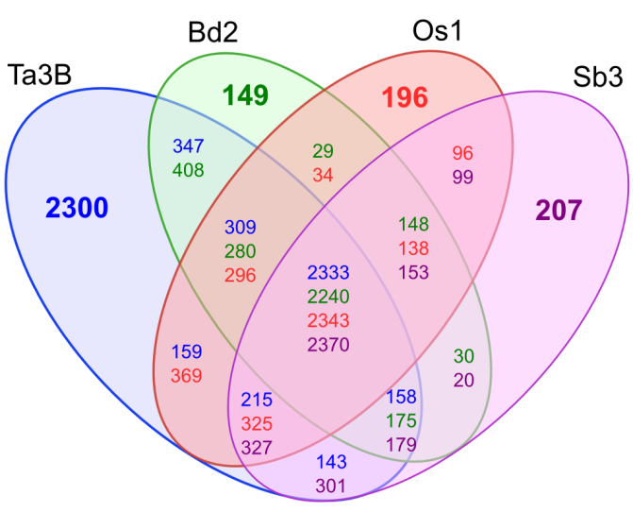

Figure 1: Venn diagram displaying the number of genes conserved between chromosome 3B (blue) and the orthologous chromosomes in the rice (red), Brachypodium (green) and sorghum (purple) genomes. The number of nonsyntenic genes is highlighted in bold for each species.

