Summary Report
Project No: 275095
Project Acronym: FOODCHOICE
Project Full Name: Understanding ways to improve the forecast ability of choice experiments in predicting consumers’ acceptance of healthy food products
Project Period: 01/06/2011 – 31/12/2014
Funding Scheme: FP7-MC-IIF (Marie-Curie Incoming Fellowship)
Project coordinator organisation: Aarhus Universitet, Denmark
Project coordinator: Prof. Joachim Scholderer (sch@badm.au.dk)
Incoming Research Fellow: Dr Simone Mueller Loose (simmu@badm.au.dk)
Overall Project Objective
The overall objective of this project was to improve the ability of choice experiments in predicting how consumers adopt food with nutrition and health-related claims by targeting dairy products as example case. Discrete choice experiments help us understand which product/service attributes drive consumer choices and how to predict the market potential of innovations. The contribution and value of choice models depend crucially on their external validity, that is, their ability to correctly explain current and to reliably predict future behaviour.
Detailed Objectives and Results
- To assess how amount, complexity, and modality of information presentation in discrete choice experiments affect respondent attention and information processing,
Work carried out: A cross-disciplinary research approach was utilised to objectively measure respondent information processing strategies in choice experiments by means of eye-tracking. A series of different laboratory experiments was conducted in the lab facilities in Aarhus with a total of more than N=300 respondents. Respondents were recruited to participate in a series of different choice experiments that differed in the presentation format of choice stimuli and product attributes.
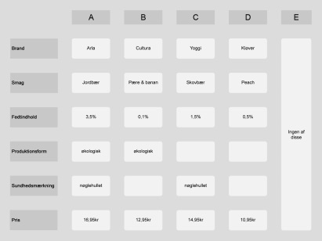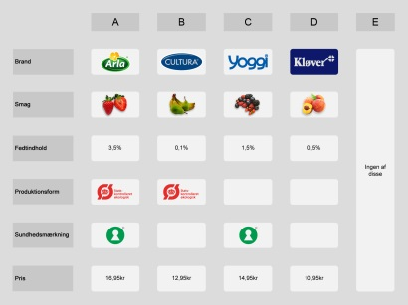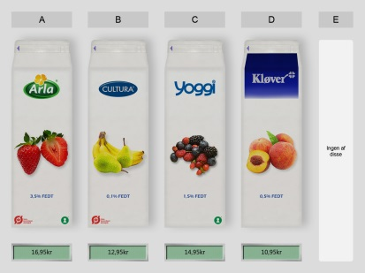
Main Results: The presentation format of stimuli in choice experiments has a significant impact on consumer attention and choices. Visual product simulations were found to trigger consumer attention and decision making processes that differ from more abstract presentation formats such as verbal tables. This finding has strong implications for the external validity of choice experiments not using realistic product presentations (e.g. verbal tables) that run the risk of biased estimates and policy recommendations.
In the consumer laboratory setting, there was no fatigue for choice experiments for the majority of respondents for experiments with 48, 170 and 370 choice sets, allowing to estimate individual level choice models. Nevertheless results indicate that drop-off rates for at home-experiments is likely to increase after about 20 choice sets.
- To develop and test instructions and response formats that can mitigate social desirability effects in discrete choice experiments,
Work carried out: An online experiment was conducted for fruit yoghurt and a food health claim (Nordish keyhole logo) with Danish members of an established household panel. Respondents were randomly assigned to two different response versions, a standard discrete-choice format where they choose for themselves, and an inferred-valuation format, where they choose like an average Danish household.
Main Results: We could not observe a social desirability effect for the health claim, which did not affect consumer product choice in any response format. Therefore, adoption of food products with health claims did not depend on the experimental setup. For both response formats, consumers with higher social desirability revealed lower price sensitivity. The direct response format resulted in significantly lower price sensitivity than the inferred valuation method.
- To test the predictive validity of different discrete choice methodologies by comparing experimental choices with real market sales.
Work carried out: Experimental choices from objective 2) were related to respondents’ records in the purchase panel, representing their market behaviour.
Main Results: The standard discrete-choice response format resulted in a significantly higher fit with individual purchase panel records (r=0.40) than inferred valuation (r=0.277). While inferred valuation slightly decreases respondents’ tendency to misreport their price sensitivity it results in a poorer predictive validity for products’ market share.
Socio-Economic Impact and Use for Target Groups
- Researchers using choice experiments (e.g. Market Researchers, Health Economists)
The project resulted in a series of recommendations for researchers using choice experiments:
- Recommendation on the modality of information presentation: choice experiments for marketed goods should use visual product simulations to prevent false predictions.
- Recommendation on the optimal amount of choice sets to be completed by respondents: there is mainly preference learning but no fatigue effects in choice experiment in the laboratory but drop-off rates increase after 20 choice sets for online experiments outside the control of the consumer laboratory.
- Recommendation on response format to mitigate social desirability: standard direct response format did result in a higher predictive validity for observed market shares, was only marginally affected by social desirability and should be preferred for preference measurement for marketed goods such as food with health claims.
- Food Industry and Food Policy Makers
The visual formatting of nutritional information and health claims made on food significantly impact visual attention and choice probability. Consumers pay more attention to product cues with high saliency (e.g. contrasting colour or shape) and larger size. For the organic product label but not for a health claim (Nordish keyhole label) this results in higher consumer adoption.
For the prediction of market success of food claims and health information Food Policy Makers should rely on advice from researchers using interdisciplinary approaches such as choice experiments with visual product simulation and eye tracking, measuring consumer attention.

