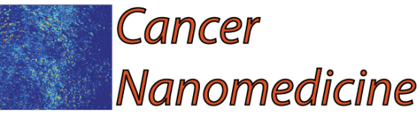
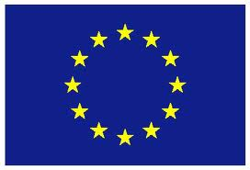
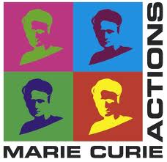

Cancer Nanomedicine
Optimizing the delivery of nanomedicine to solid tumors
Grant No. PIRG08-GA-2010-276894
Recent advances in nanotechnology have offered new hope for cancer detection, prevention, and treatment. While the enhanced permeability and retention (EPR) effect has served as a key rationale for using nanoparticles to treat solid tumors, it does not enable uniform delivery of these particles to all regions of tumors in sufficient quantities. This heterogeneous distribution of therapeutics is a result of physiological barriers presented by the abnormal tumor vasculature and interstitial matrix. These barriers are in large part responsible for the modest survival benefit offered in many cases by clinically approved nanotherapeutics and must be overcome to realize the promise of nanomedicine in patients. More specifically, we need to determine the design criteria - the size and charge of various nanoparticle platforms - that optimize drug delivery to tumors.

The objectives of the Cancer Nanomedicine project was the development of a mathematical framework for the delivery of therapeutic nanoparticles to solid tumors. The model accounted directly for the properties of the tumor microenvironment as well as for the properties (size and charge) of nanoparticles to predict their intratumoral distribution. The model was informed and validated with in vivo experimental data from mice bearing tumors in order to construct "design maps" that predict the nanoparticle properties that optimize intratumoral delivery and thus, the efficacy of cancer therapy. These models will provide guidelines for the optimal use of vascular normalization and solid stress alleviation treatments that modify the tumor microenvironment in order to improve the distribution of nanomedicines.

Within the first two years of the project, we developed a software to solve the equations that govern the transport of blood-borne therapeutic agents from the blood to the tumor interior. The model can incorporate a tumor vascular network of any geometry, the diameter of the blood vessels and the openings of the tumor vessel wall that defines the EPR effect. Additionally, it accounts for the particle diameter and charge. We tested the model predictions against experimental data of two murine breast tumors the 4T1 and EO771 and used model predictions to identify the proper particle size and charge that optimizes delivery of nanoparticles. Furthermore, we studied under what conditions modifications of the tumor vascular structure with vascular normalization strategy improves delivery of nanomedicines.

The main findings of this research are summarized as: 1) small nanoparticles with diameter less than 20 nm can be more effectively administered to solid tumors (article in Nature Nanotechnology), 2) cationic (i.e., positively-charged) nanoparticles have superior transvascular flux to solid tumors compared to their anionic (i.e., negatively-charged) or neutral counterparts (article in Annals of Biomedical Engineering), 3) Normalization of tumor blood vessels improves the delivery of nanoparticles in a size-dependent manner, enhancing delivery of only small particles (article in Nature nanotechnology).

In the last two years of the program, we investigated whether and under what conditions stress-alleviation treatment that normalizes the tumor microenvironment improves the delivery of nanoparticles and provided guidelines for the optimal use of both stress-alleviation and vascular normalization strategies. Particularly, we suggested for what tumor types and under what conditions the use of one strategy or the other or the combined use of both of them optimizes the delivery of nanoparticles (articles in Cancer Research and PNAS). Our research results provided valuable guidelines for cancer-specific treatment of solid tumors with nanomedicines.

The final goal of the project was to collect all new knowledge derived from the Cancer Nanomedicine project along with research performed by other scientists in the field and write a review article on the "Design Considerations of Nanotherapeutics in Oncology" published in Nanomedicine Journal.

