Project n°: 276199 - Project Acronym: Mycocarbose
Project Full Name: Managing AM fungi for enhancing C sequestration in an agroecosystem affected by salinity
Period covered: from July 1st 2011 to June 30th 2013
Scientist in charge: Prof. Matthias C. Rillig, Freie Universität Berlin

Soil degradation and salinization are two of the utmost threats affecting agricultural areas. It is estimated that more than 7 % of the earth is land occupied by saline soil (Tester and Davenport, 2003). Salt toxicity is one of the major edaphic factors limiting crop production and eco-environmental quality in saline and/or sodic soils throughout the world (Liang et al., 2005). The symbiosis between arbuscular mycorrhizal (AM) fungi and plants has been shown to contribute to the stability of soil aggregates, including soils of high salinity such as salt marshes (Caravaca et al., 2005). Therefore we isolated and evaluated different AMF strains from a salt marsh, which are able to ameliorate salt stress and to sequestrate C in soil. We successfully isolated several strains and also carried out experiments to evaluate their impact in growth of two agricultural crops and amelioration of salinity.
So we showed the possibility of use of AM strains in the amelioration of salt stress especially F. coronatus (Figure 1). We showed that part of the effect could be explained by the effectiveness of the inoculated AMF strains in soil enzymatic activities (Figure 2).

Figure 1: Shoot (A) and Root (B) of Sorghum bicolor (C und D) after 6 weeks of growth under greenhouse conditions with different levels of salt stress and different inoculations of AM fungi (n=6) (* p<0,05, ** p<0,01, ***p<0,001)
Figure 2: Phosphatase and dehydrogenase activity of rhizosphere soil of Sorghum bicolor after 6 weeks of growth under greenhouse conditions with different levels of salt stress and different inoculations of AM fungi (n=6) (* p<0,05, ** p<0,01, ***p<0,001)

But as we decided not to pursue anymore one of our objectives, to assess the glomalin or glomalin related soil protein (GRSP), as its effect in soil aggregation is questionable (Purin & Rillig, 2007) and since we also had problems detecting it, we decided to focus our objectives not only on AM fungi, but also on the evaluation of biochar.
Biochar is a carbon rich product of pyrolyzed organic material (heated under limited oxygen supply), which decomposes very slowly (Lehmann and Joseph, 2009). Therefore is its addition to soils thought to be an effective way of storing carbon to curtail the increasing concentration of CO₂ in the atmosphere (Sohi 2013). It simultaneously increases plant growth and soil fertility (van Zwieten et al, 2010, Lehmann et al., 2011). So, we wanted to examine in this study on the one hand whether biochar and AM fungi additions to plants interact in their effects on yield. On the other hand, we wanted to test whether biochar ameliorates salinity stress in plants, and whether it also here interacts with AM fungi. This was never done before. Therefore, we tested in a full factorial setup the effects of biochar, AM fungi and salt addition on growth and performance of Lactuca sativa in a greenhouse experiment.
In our study, we showed that both treatments, biochar amendment and inoculation with an AMF community, ameliorate salinity stress in L. sativa (Figure 3). We found a positive interaction between AMF and biochar on plant shoot biomass, although the additive effect was low (Figure 3). Probably the porous structure of biochar can act as a refuge for fungal hyphae and increased nutrient availability (Warnock et al., 2007).
Salt stress decreased dramatically net assimilation rate in our experiment so much that it was even negative (Figure 4) during the measurement in the middle of the experiment, which was a sunny day of 26 °C. Biochar could recuperate it partly at least that there was a positive assimilation rate. This was probably because of biochar retained ions so that electric conductivity decreased under a critical level. The mechanistic understanding is still unknown, but it is likely through the absorption of Na⁺ ions reducing so the electric conductivity in soil, which led to alleviation of the salt stress.
The mineral nutrient which showed an increase in plant content under biochar addition was mainly P, suggesting that a better P nutrition may have caused the increased plant growth in our experiment (see manuscript). This is also the case under AMF addition, where improved P nutrition is the most important factor leading to increased plant growth (Smith and Read 2008).

In conclusion, both, biochar and AMF have synergistic effect in plant growth under normal conditions. Both, but specially biochar could alleviate salt stress, which shows the possible use in salinized soils. Biochar ameliorated salt stress due to its capability to absorb ions and thus reduce electrical conductivity, but it has to pass first a process of aging. As biochar already is recommended for use in semiarid soils (Mulcahy et al., 2013), we also see a potential use in saline soils.

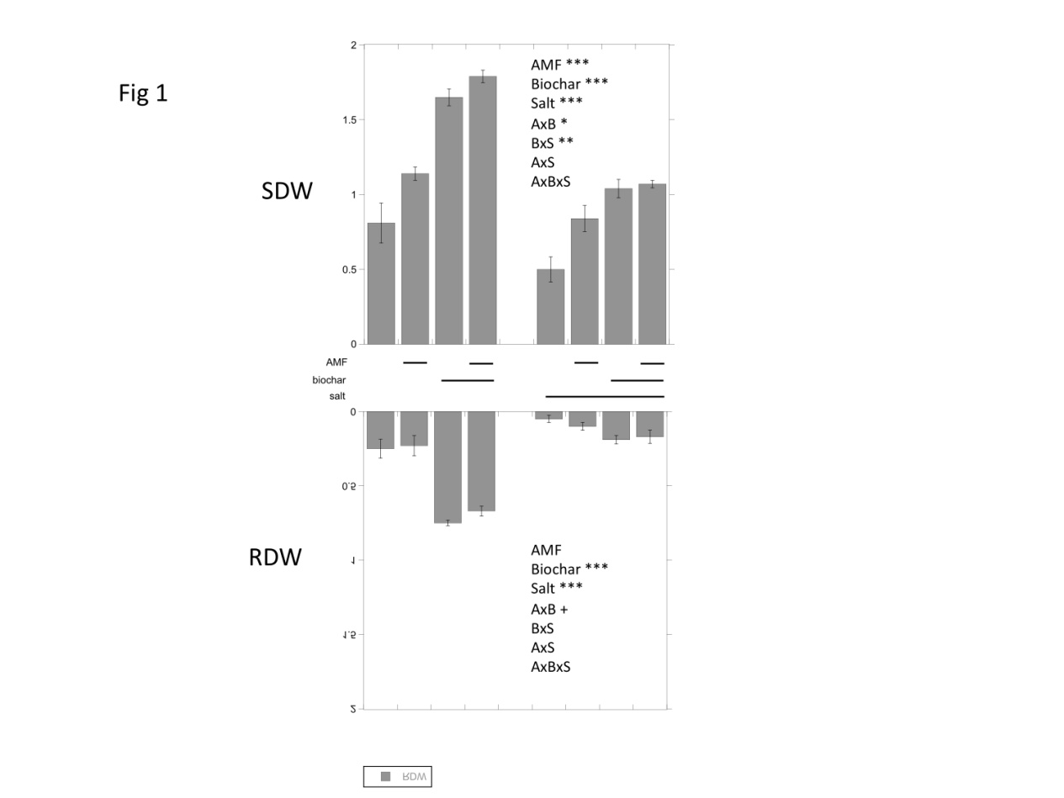
Figure 3: Effect of the biochar, inoculation with AMF and salt stress on root and shoot dry weight of L. sativa 5 weeks after starting the experiment (n=6). (* p<0,05, ** p<0,01, ***p<0,001). A bar in the x axis means the factor was applied.
Net Assimilation Rate
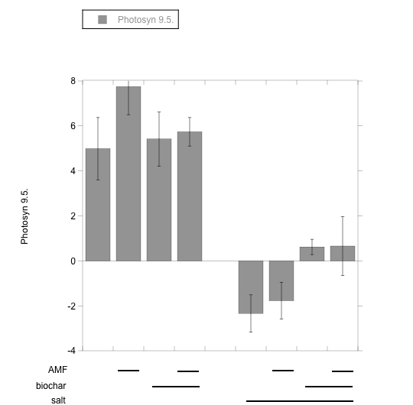
AMF +
Biochar
Salt ***
AxB
BxS *
AxS
AxBxS
Figure 4: Effect of the biochar, inoculation with AMF and salt stress on plant stomatal conductance (a) and net assimilation rate (b) of L. sativa 14 days after start of the salt addition to the plants (n=6). (* p<0,05, ** p<0,01, ***p<0,001)

Summarizing although there was a clear deviation from the original objectives during the project, main aspects could be figured out:

Selected AM strains could alleviate salt stress and also enhance C sequestration. But the most outstanding finding in the project was that the pyrolyzed organic material biochar had an alleviating effect in saline stress and it also interacts with AM fungi. This can be of high importance due to the increasing threat of salinization affecting agricultural areas. Furthermore biochar is a promising tool to sequestrate organic C in soil, to combat climate change.

