EU FUNDED FP7 PROJECT FLOODSAT (277183)
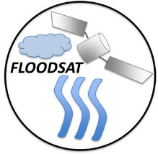

The overarching objective of the FLOODSAT project is to advance the utility of satellite-based precipitation estimates for hydrologic modeling, specifically for flood monitoring. The main objectives include evaluation of the satellite-based precipitation (SBP) products over the Western Black Sea Region in Turkey using the rain gauge network (Figure 1), devising a bias-adjustment algorithm for the SBP products and implementation of a hydrologic model in a selected watershed. An improved methodology for calibration and evaluation of the hydrological model utilizing streamflow observations measured at the outlet and interior points will be devised. The performance of the hydrologic model driven by satellite-based and ground-based observations will provide further insights into the value of existing and adjusted satellite-based precipitation estimates for basin-scale streamflow simulations.
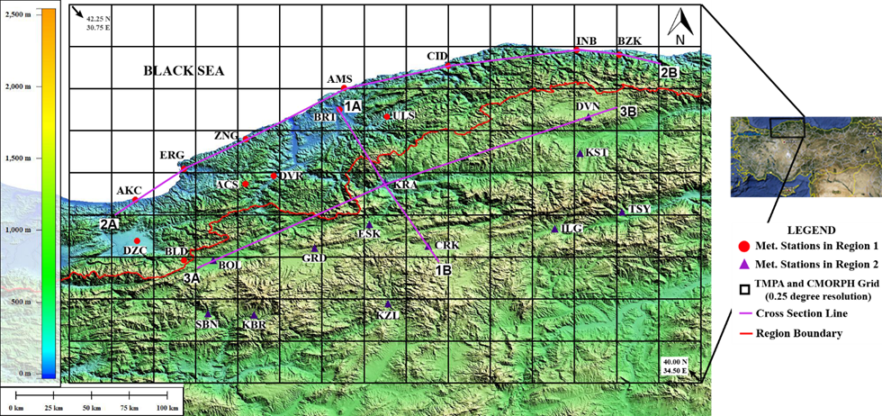
Figure 1. Western Black Sea Region, Turkey. Meteorological stations within windward side of mountains are marked by a “dot marker” and those within leeward side are marked by a “triangle marker”.
The Satellite-based precipitation (SBP) products utilized in this study include The Tropical Rainfall Measuring Mission (TRMM) Multi-satellite Precipitation Analysis (Version 7) including real time (TMPA-7RT) and gauge adjusted (TMPA-7A) products; Climate Prediction Center Morphing Technique (CMORPH) and the Multi Sensor Precipitation Estimate (MPE) of the European Organization for the Exploitation of Meteorological Satellites (EUMETSAT). The study area is characterized by a complex topography, marked by Northeast-Southwest aligned mountain ranges running parallel to the shoreline. Hence orographic precipitation is very characteristic at the windward (North) side of the mountains. A rain gauge-based gridded precipitation product was constructed considering the “physiographic similarity” concept in which a locally weighted linear rainfall-elevation relationship was used for precipitation estimation at 0.05º grids. The weights of the rain gauges were established using a combination of a set of physiographic descriptors including distance, elevation, coastal proximity, facet and effective terrain height.
Evaluation of the SBP products indicated that the orographic controls on the precipitation influences the performance of the SBP products (Figure 2). Evaluated SBP products generally had difficulty in representing the precipitation gradient normal to the orography. TMPA-7RT, TMPA-7A and MPE products underestimated precipitation along the windward region and overestimated the precipitation on the leeward region, more significantly during the cold season. CMORPH product underestimated the precipitation on both windward and leeward regions regardless of the season. Further investigation of the datasets used in the development of these SBP products revealed that, although both infrared (IR) and microwave (MW) datasets contain potential problems, inability of MW sensors to detect precipitation especially in cold season was the main challenge over this region with complex topography.

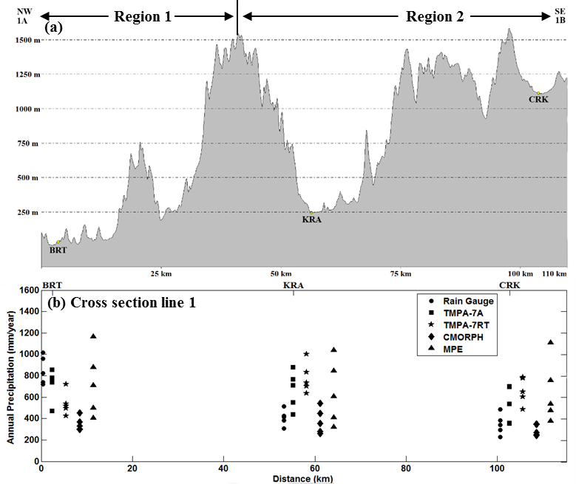
Figure 2. (a) Topographic elevations, (b) annual precipitation for each SBP product and rain gauge along cross section line 1.
A new bias adjustment methodology (BAPS) for the satellite-based precipitation products has been devised based on the “physiographic similarity” concept. In the proposed procedure, SBP estimates are adjusted based on a weighted scheme using rain gauges. Rain gauge weights were calculated based on physiographic similarity concept which is more suited to the complex terrain as opposed to the commonly used proximity concept. Comparison of SBP products before and after bias adjustment with BAPS algorithm indicated that the adjustment procedure successfully corrected for the precipitation detection problems. The bias adjustment procedure resulted in significant improvements in the performance of the CMORPH and MPE products with less significant improvements in TMPA-7RT product showing high spatial heterogeneity in precipitation estimates (Figure 3). Comparison of the BAPS algorithm with the baseline Inverse Distance Weighted Algorithm (IDW) using two independent stations showed that the BAPS algorithm generally provided better statistics.
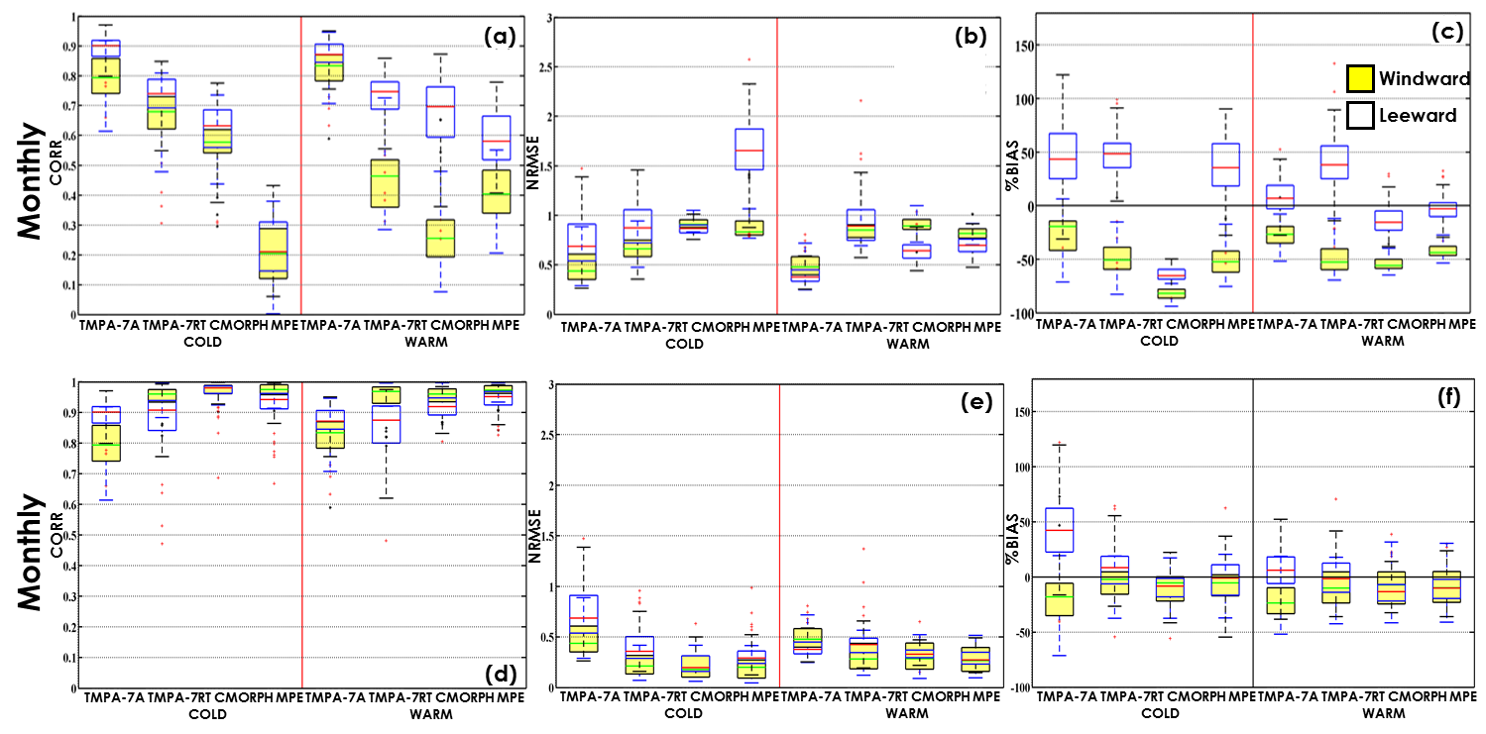
Figure 3. Box-plots showing seasonal monthly statistical results calculated between RGP grids in windward (Yellow box) and leeward (White box) regions and co-located SBP products before bias adjustment (a-c) and after bias adjustment (d-f). Note that TMPA-7A already includes rain gauge information and hence has not been adjusted.

A coupled distributed hydrological model, MIKE-SHE/MIKE-11 was implemented for the Karabük Basin located within the study area (Western Black Sea Basin of Turkey). Streamflow is observed at two stations in the Karabük Basin, at the outlet and at an interior location marking the outlet of the Araç Subbasin (Figure 4). A novel model calibration strategy has been devised that builds on the signature measure approach. In the proposed strategy, model parameters controlling different hydrological processes are grouped and constrained in a hierarchical, step-wise manner using signature measures sensitized to extract streamflow information relevant to the focused hydrological process in each step. The calibration procedure starts with random sampling of parameter sets from the feasible parameter space and calculation of signature measures extracted from streamflow observations. The procedure follows a bottom-up hierarchical order in the soil column where parameters controlling the groundwater component (baseflow) are constrained first using the selected low flow signature measure. In a hierarchical, step-wise procedure, parameters controlling interflow, unsaturated flow, overland flow and channel flow are constrained using signature measures selected for the focused hydrological process in each step. In the final stage of the hierarchical constraining procedure, a parameter set that provides the best performance in terms of all signature measures was selected and tested within the evaluation period. The proposed calibration strategy was first utilized in the interior Arac sub-basin using the RGP dataset. The MIKE-SHE/MIKE-11 model with the parameter values calibrated using the RGP dataset was then utilized to evaluate the value of satellite-based precipitation products (before and after bias adjustment) for streamflow simulation. It was found that the errors in the satellite-based precipitation products directly translates into the simulated flows, indicated by overestimation of flows when the
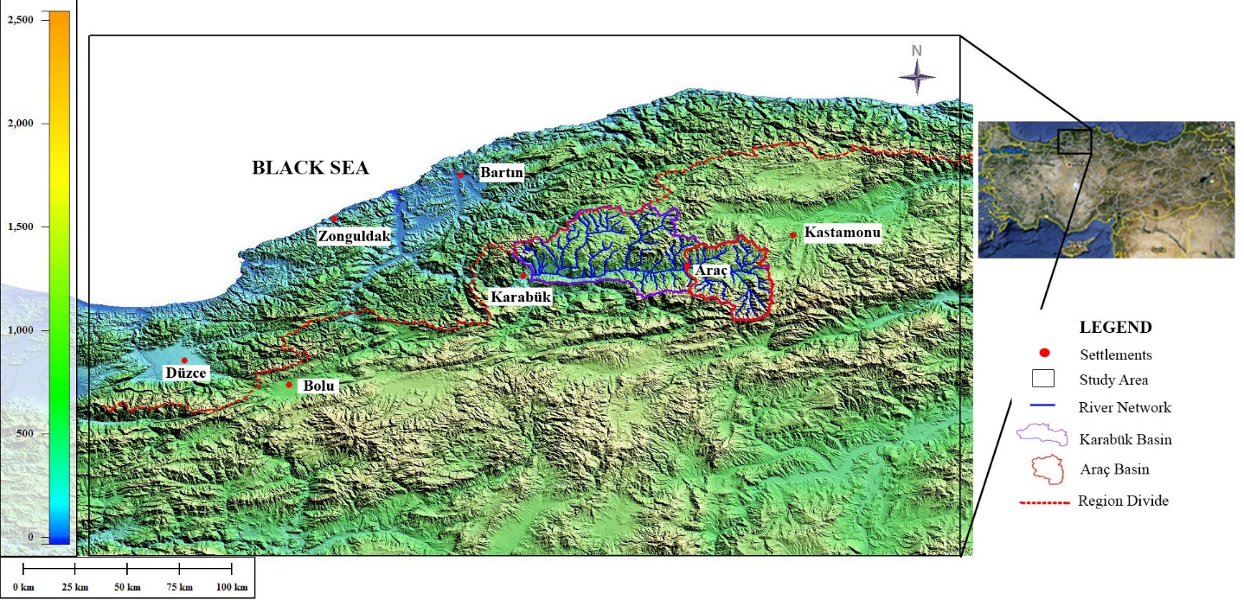
Figure 4. Karabük and Araç Basins in which the MIKE-SHE/MIKE-11 model was implemented.
model was driven by TMPA products and underestimation of flows when the model was driven by CMORPH product. Bias adjustment using the proposed BAPS algorithm improved the flow simulation performance significantly. It also was found that the model performance did not improve significantly when the model parameters were re-calibrated using satellite-based products instead of using RGP-calibrated parameters (Figures 5 & 6). These results indicated that bias adjustment of satellite-based rainfall products using relatively sparse raingauge network will improve the hydrologic model performance in simulating flood events in the study area.
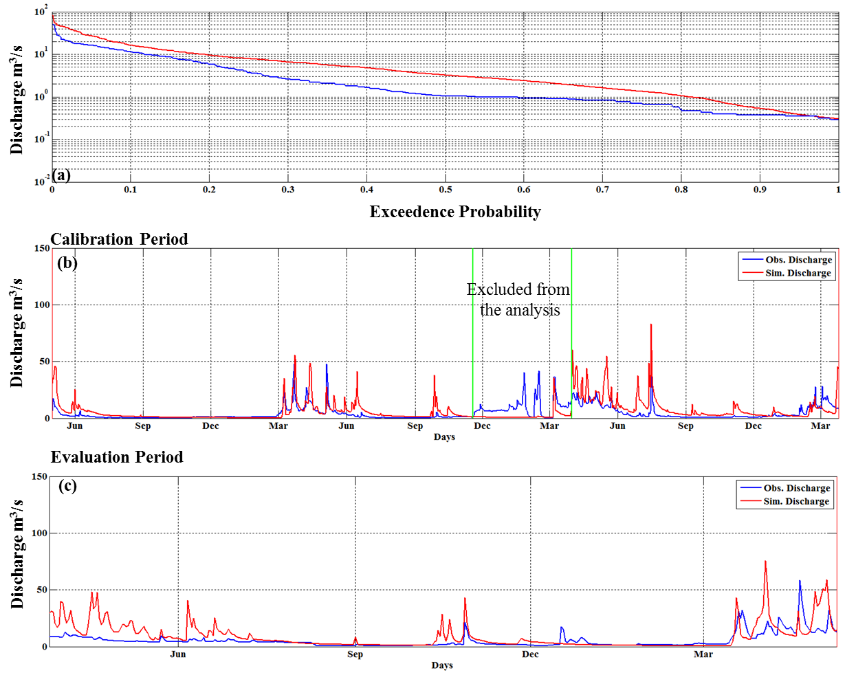
Figure 5. Simulated and observed (a) Flow duration curve and (b) hydrograph during calibration period and (c) hydrograph during evaluation period for RGP-calibrated model driven by TMPA-7RT BAPS in Arac Basin.
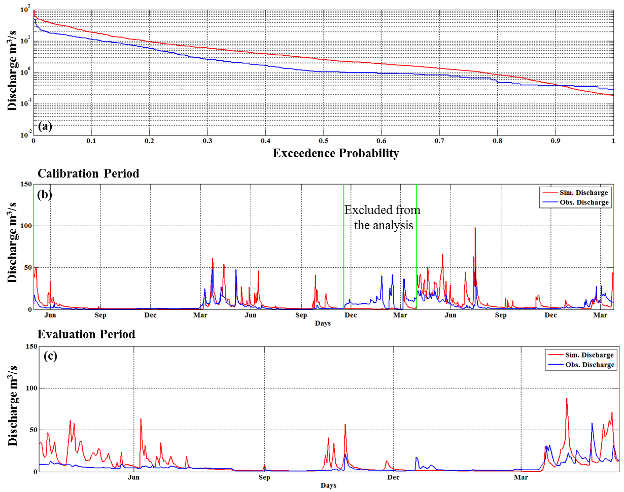
Figure 6. Simulated and observed (a) FDC and (b) hydrograph during calibration period and (c) hydrograph during evaluation period for TMPA-7RT BAPS -calibrated model driven by TMPA-7RT BAPS product in Arac Basin.

In an effort to check the model parameter transferability for the ungauged basins within the study area, the parameter set calibrated for the Arac Basin was transferred to and evaluated for the downstream Karabuk Basin. It was found that the model with the transferred parameters are able to adequately capture the high streamflow events.

At the international level, the project resulted in two important advancement beyond the state of the art. First, a bias adjustment algorithm for satellite-based precipitation estimates (BAPS) has been devised based on the ‘Physiographic similarity’ concept which is well-suited to regions with complex topography with relatively sparse raingauge network. Bias adjustment algorithms in the literature generally rely on the proximity concept and is not suited to topographically complex regions where topographic features significantly impact the precipitation patterns at short distances. Second, a novel model calibration strategy has been devised that builds on the signature measure approach. In the proposed strategy, model parameters controlling different hydrological processes are grouped and constrained in a hierarchical, step-wise manner using signature measures sensitized to extract streamflow information relevant to the focused hydrological process in each step. The calibration procedure starts with random sampling of parameter sets from the feasible parameter space and calculation of signature measures extracted from streamflow observations. The procedure follows a bottom-up hierarchical order in the soil column where parameters controlling the groundwater component (baseflow), interflow, unsaturated flow, overland flow and channel flow are constrained sequentially using signature measures selected for the focused hydrological process in each step. The use of signature measures, and parameter constraining based on sensitivity analysis are the main advancements beyond the current state of the art in the field of parameter estimation.

Project Duration: April 2011-March 2014
Website: http://www.metu.edu.tr/~yilmazk/html/floodsat.html
Contact: Assist. Prof. Dr. Koray K. Yilmaz, yilmazk(at)metu.edu.tr

