If you are thinking about *fast* changes, what kind of time scale do you keep in mind? What is really *fast* to you? How long the events take place? Hours, minutes, seconds, milliseconds - what can you really do during this period of time? Here, I would like to introduce you to the fantastic *ultrafast* world of changes, to the time scale in which the chemical reactions take place!

The *Ultrafast Charge Transfer in ion-atom collision investigated by Molecular Quantum Dynamics Methods* (**DYNAMICOL**) project has been devoted to the study of the dynamics of charge transfer (CT) processes taking place in a collision in the femtosecond (1 *fs*=10-15 s) and attosecond (1 *as* =10-18 s) time scales. With the advent of the laser pulses of such ultrashort duration an unprecedented opportunity was given to investigate and observe the nuclear and electron motion in real time. Now, it is possible to watch molecular “movies” in which molecules are playing the main roles!

With **DYNAMICOL** we wanted to exploit these discoveries to gain a deep understanding into the real-time charge transfer in molecular collisions especially at very low-energies. This has been performed by developing innovative theoretical methodologies – known as wavepacket propagation techniques - which allow the description of the elementary processes taking place during the collision. To achieve this goal we combined the state-of-the-art quantum chemical and quantum dynamical techniques and apply them to a series of ion-atom/molecule collision systems. These include interactions between carbon ions Cq+ (q=2,3,4,6) with hydrogen and helium atoms, which play a role in interstellar objects, as well as with the RNA base Uracil, which has been shown to be essential in the study of radiation damages on biological systems. With **DYNAMICOL** we wanted also to merge the experimental observations and theoretical simulations at low-energy to observe the real-time CT in a molecular collision.This requires models as we have chosen, simple enough to be computationally attractive and including sufficient details of the problem to reproduce the essential features of the process.

In **DYNAMICOL** we employed the time dependent wavepacket methodology developed by Dr. Marta Łabuda to treat ion-atom collisions, so that we can test the accuracy of the developed technique and extent it to the calculation of charge transfer cross sections with impact energies far below 1 keV. The wave packet propagation technique is useful in obtaining a time-dependent picture of the collision, which can reveal the complexity of the process, such as the interference effects arising from the intersections of the different channels of collision. These effects are visible in the time evolution of the wave packet and give rise to structure in the differential cross sections.

Combining the data obtained by using merged-beam apparatus at low-energies with the time-dependent wave packet simulations we brought a detailed insight in the dynamics of CT phenomena. A wide range of the communities involved in this field of studies may be interested of the results obtained in the project. Finally, the **DYNAMICOL** project has a multidisciplinary character since it integrates concepts from fundamental physics, astrophysics and chemistry, and even biophysics, which we expect will lead to promising results and fruitful cooperation. By gaining deeper insight into the dynamics of collision induced CT processes on the ultrafast time scale, we can foresee strong and direct impact on different areas in medicine, photochemistry and nanotechnology, that might lead to future applications.

Major results of **DYNAMICOL** have been published or are on the way to publication in scientific journals of high impact. Moreover, the work has been presented in different international conferences and workshops. Besides the scientific training objectives, Dr. Marta Łabuda has been involved in other activities inside the group of Prof. Józef E. Sienkiewicz providing her the possibility to increase her competencies as a highly qualified scientist. All of experience gained during the fellowship (published results, collaboration and participation in scientific conferences, transfer of knowledge with the students and colleagues, reintegration with the host institution) make her capable of achieving a competitive career as an independent scholar, supervising and supporting other young researchers.

Summarizing: during the MC Reintegration Fellowship Dr. Marta Łabuda has been supported in the development of state-of-the-art quantum chemistry and reaction molecular dynamical methods as well as in their applications in systems of different size and complexity. The multidisciplinary character of the project has integrated different concepts from chemistry, physics and biophysics, which we expect will lead to promising results and fruitful co-operations.

The prestige associated with the Marie Curie fellowships certainly offered me a wide range of subsequent possibilities for continuing research career. The obtained financial support from the Marie Curie European Reintegration Grant (MC ERG) will help to capitalize the scientific work and fully use the skills and the knowledge gain by me during the previous Marie Curie Intra-European Fellowship, when I stayed in Germany working on the **ATTONEW** project. Now, I can work independently in my homeland bringing here a high expertise in the area of theoretical physics and quantum chemistry.

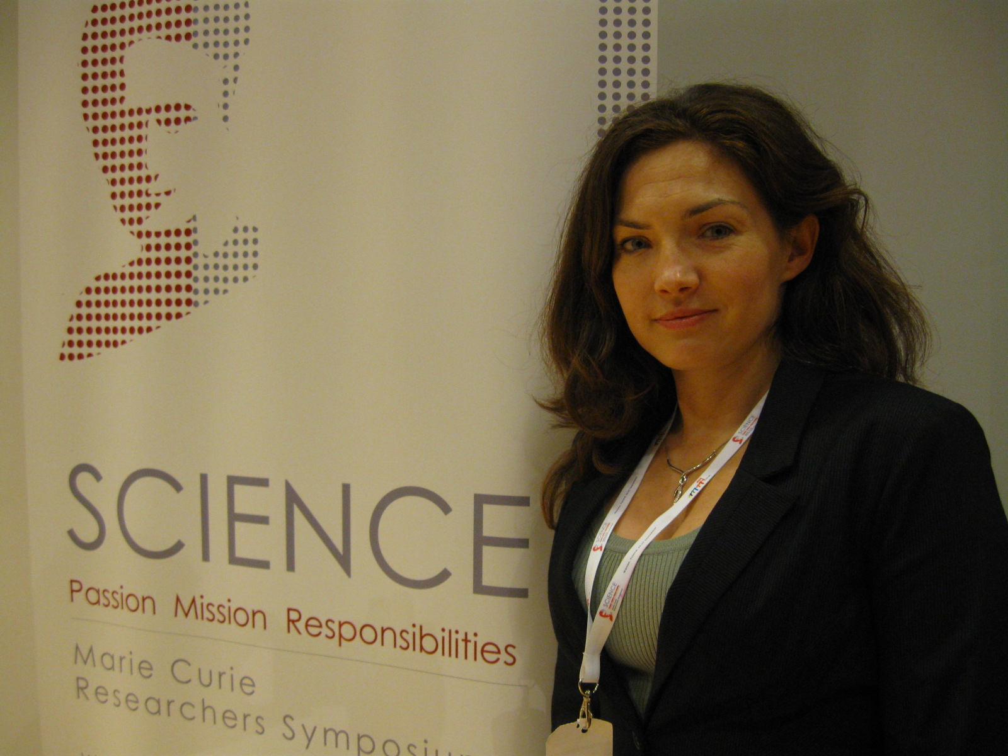

Fig. 1 Marie Curie Researchers Symposium

in Warsaw (2011)

With an individual fellowship, the Marie Curie program offered me a support and gave the opportunity to complete my scientific projects as well as enhanced mobility and my reintegration with scientific community in Poland.

The experience and complementary skills gained during the fellowship are crucial for establishing myself as an independent scientist in the field of the ultrafast dynamics. The financial contribution of the ERG supports my efforts to set up my own research group at my *alma mater* in Poland. Bringing the new, innovative scientific methodologies applied to physical processes at the Gdańsk University of Technology, will help to attract and open up opportunities for other researchers and industrial partners. The interdisciplinary distinction of the **DYNAMICOL** project and applied methodologies can be employed in other areas of research within European Community, specifically those regarding medicine, bioelectronics and technological applications of the lasers with ultrashort pulses.

# Contact

Dr. Marta Łabuda

**e-mail**: marta@mif.pg.gda.pl

Gdańsk University of Technolpogy

Faculty of Applied Physics and Mathematics

Department of Theoretical Physics and Quantum Information

**Project website**: <http://aqualung.mif.pg.gda.pl/dynamicol/>