# Publishable Summary

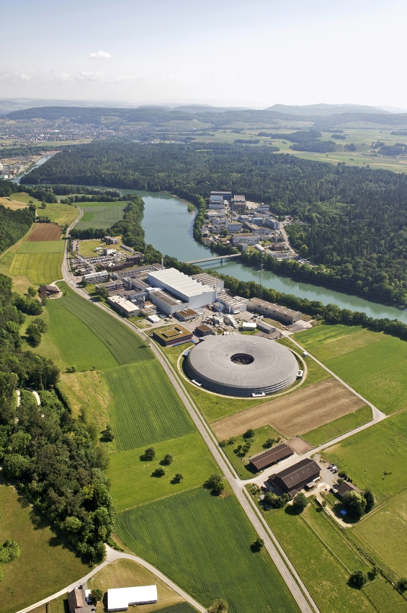The 60 month PSI-Fellow postdoctoral program at the Paul Scherrer Institute (PSI, see figure) was open to candidates from all over the world and was intended for experienced researchers after their PhD study to further their scientific training in four broad areas of expertise at the PSI: materials and matter, energy and environment, human health and life sciences, and new accelerator concepts, beam characterization methods and detectors. In brief, the program strived for transparency in the selection process, merit-based evaluation of applicants by a reviewing panel of internal and international experts and client-friendliness towards applicant researchers. The application process including guidelines is outlined in detail on the PSI-Fellow webpage <http://www.psi.ch/psi-fellow>.

The PSI-Fellow program was active from April 2012 until March 2017. In two rounds of applications a total of 64 fellows were recruited as postdoctoral researchers at PSI for up to 24 months. The first call cycle in 2012 resulted in the employment of 31 candidates while the second call cycle in 2014 led to the successful appointment of 33 fellows. A distribution of the successful candidates shows the following numbers (in brackets) per PSI division: Biology and Chemistry (4), Centre for Proton Therapy (1), General Energy Research (7), Large Scale Facilities (6), Nuclear Energy and Safety (8), Neutrons and Muons (14), SwissFEL (2), and Synchrotron Radiation and Nanotechnology (22).

The PSI-Fellow program was managed by a dedicated program management unit at the PSI who was not only responsible for quality management of the program, but also delivered on administrative capacities needed for the execution of the program. The program management unit was also supported by an Advisory Board Committee with expert members that provided advice on various activities of the program.

The program generated significant scientific output with PSI-Fellows presenting at more than 170 scientific conferences and publishing more than 190 peer-reviewed journal articles. The broadening and deepening of scientific capabilities of PSI-Fellows was complemented with career development in non-scientific and transferable skills, e.g. by courses in career starting and planning, scientific communication (oral and writing) and research proposal writing. Outcomes from surveys involving both first cycle (during and after the program) and second cycle PSI-Fellows concluded that participants shared both a high level of host satisfaction in choosing the PSI as a world-leading institute for scientific excellence and job satisfaction with regard to various factors including attractiveness of work-life balance, team work and collaboration, opportunities for problem solving, etc.