Figure 1. Wastewater treatment plant (left) and the Serge River (right), which the plant discharges into, studied in detail (Puigcerdà, North-East Spain)

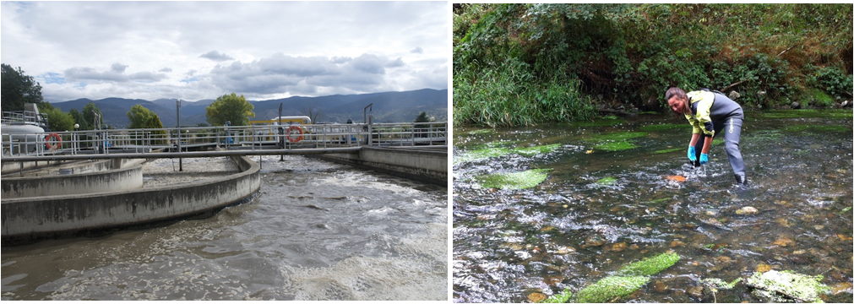

Figure 2. Screen shots of the four parts of the educational game: the household part teaches the relationships between actions and contaminants released into the sewer; the sewer part highlights the importance of appropriate maintenance to ensure proper transport of wastewater to the WWTP; the WWTP part teaches the biophysical processes required to remove contaminants; and the river part imparts an understanding of the biophysical processes occurring and the effects from wrong sewer system maintenance or bad WWTP management.

