INCOMMET: Improving National Capacities in Observation and Management of Marine Environment in Tunisia (FP7-INCO-2011-6)

Logo

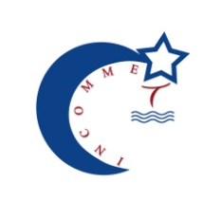

Partners

- National Institute of Marine Science and Technologies, Tunisia (INSTM)
- The Oceanology Centre of Marseille (Aix-Marseille University, France, AMU)
- Staione Zoologica A. Dohrn of Naples, Italy (SZN)

Contact

Coordinator : Malika BELHASSEN (belhassen.malika@instm.rnrt.tn)

Project Manager :Walid MEDHIOUB (Walid.Medhioub@instm.rnrt.tn)

AMU Contact Person: Michel Denis (michel.denis@mio.osupytheas.fr)

SZN Contact Person: Raffaella Casotti (raffaella.casotti@szn.it)

Training course on European Framework Programme, 29 to 31 May 2012, INSTM Salammbô, Tunis, Tunisia

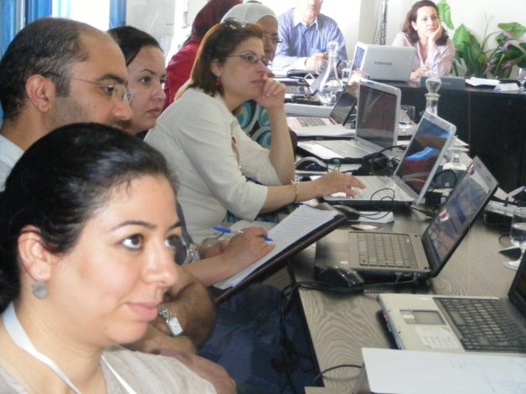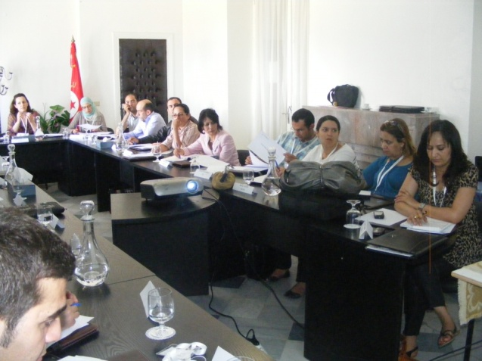

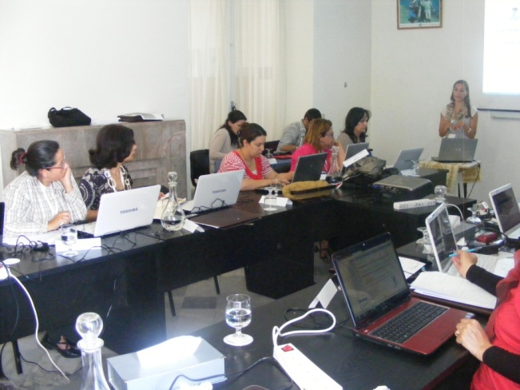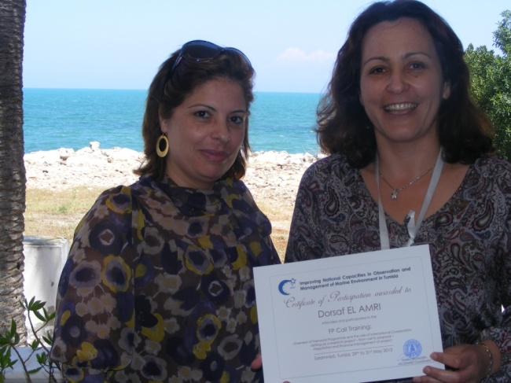

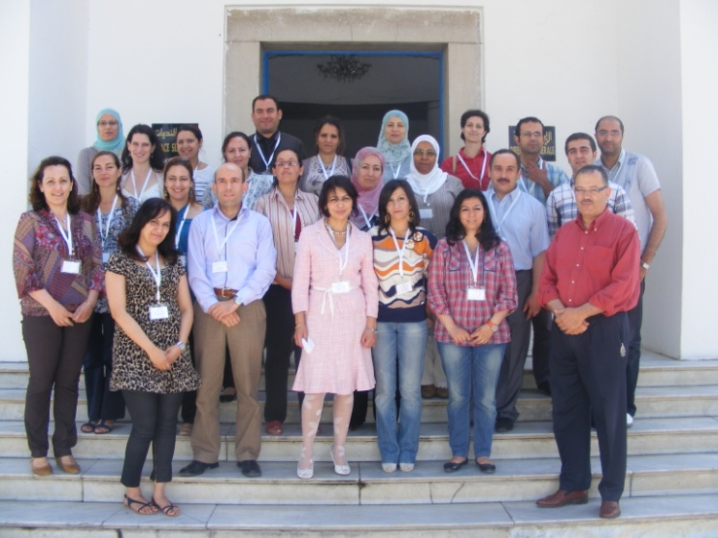

Training course on toxic phytoplankton in aquaculture production area, 18 to 22 September, INSTM Sfax, Tunisia.
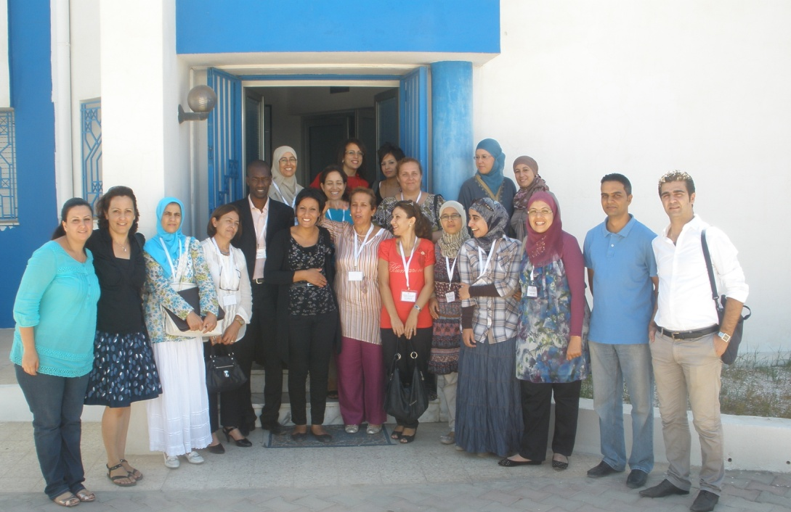
Thorought Assessment of the INSTM’s strengths and needs, 06 to 08 June, Tunisia.
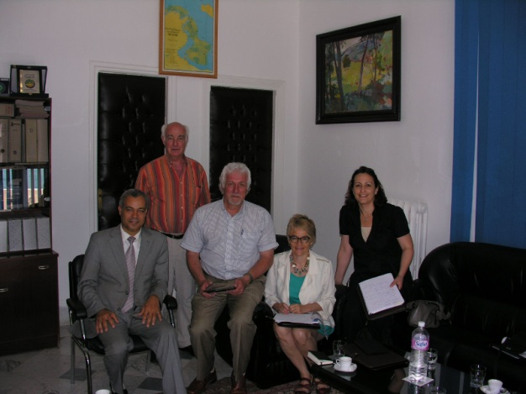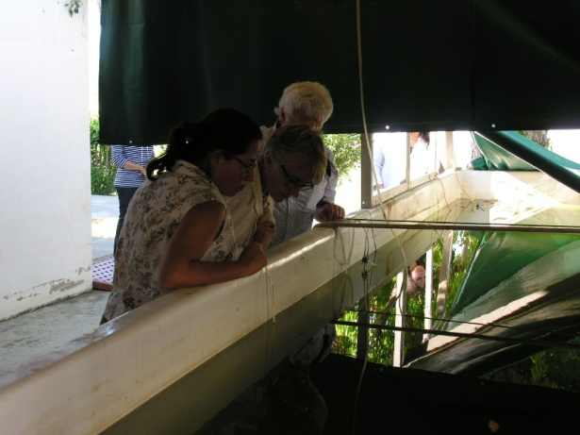
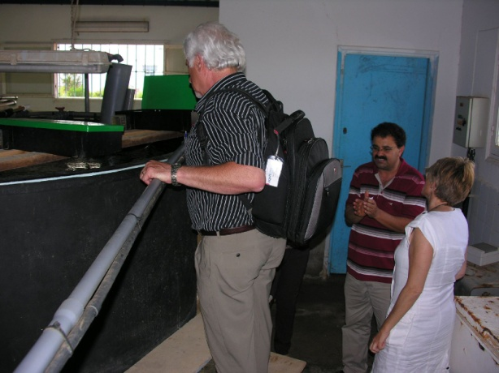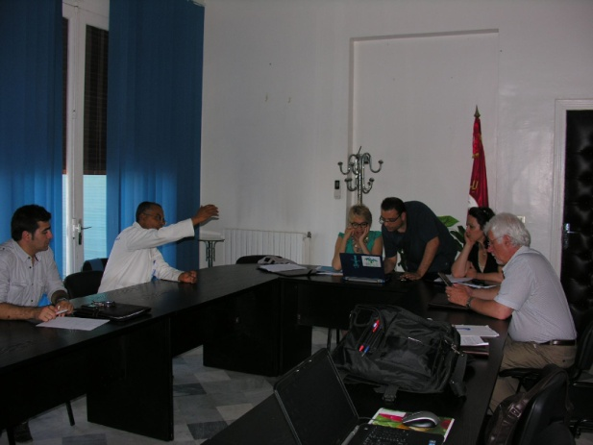

Training course on statistics and data treatment, 29 October to 01 November 2012, INSTM Salammbô, Tunis, Tunisia

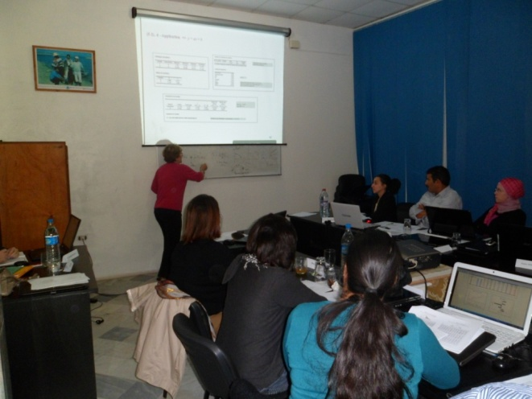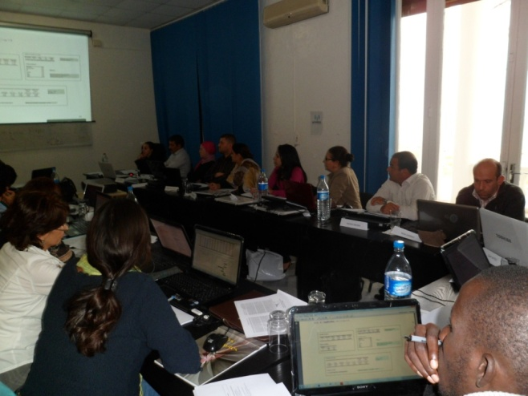

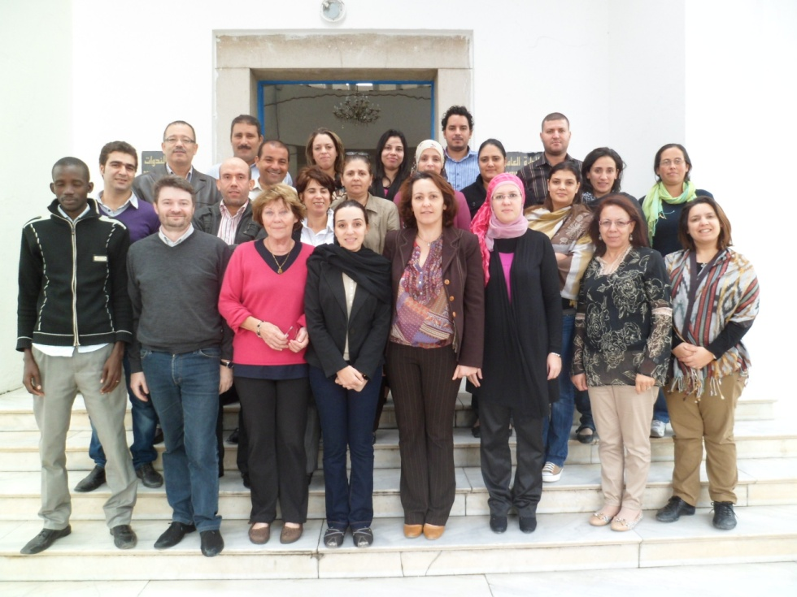

Training course on remote sensing, 03 to 07 December 2012, INSTM Salammbô, Tunis, Tunisia

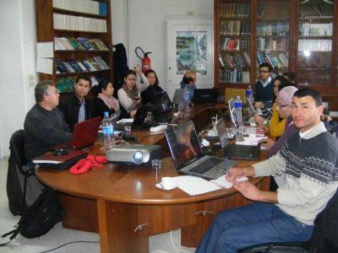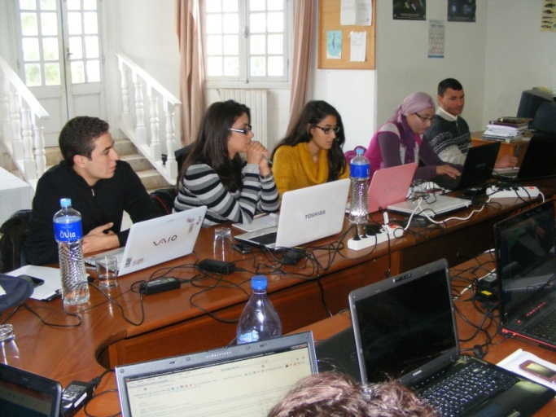

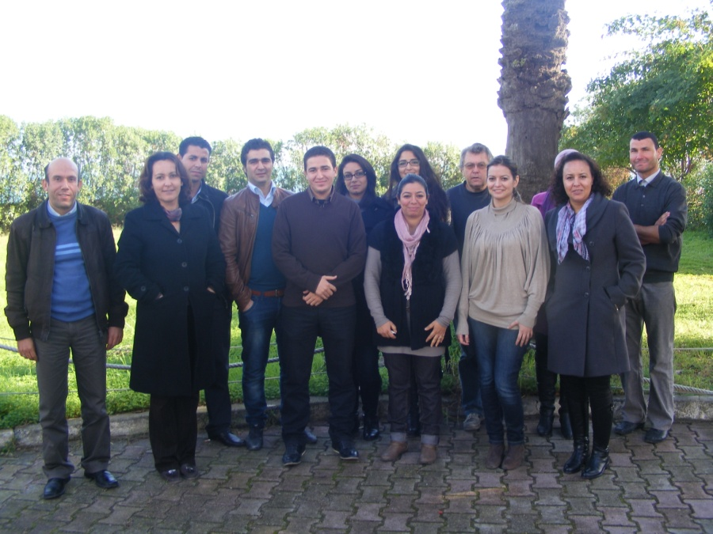

International Course in Marine Microbial Ecology Methods: who does what, 05 to 09 November 2012, SZN Naples, Italy.
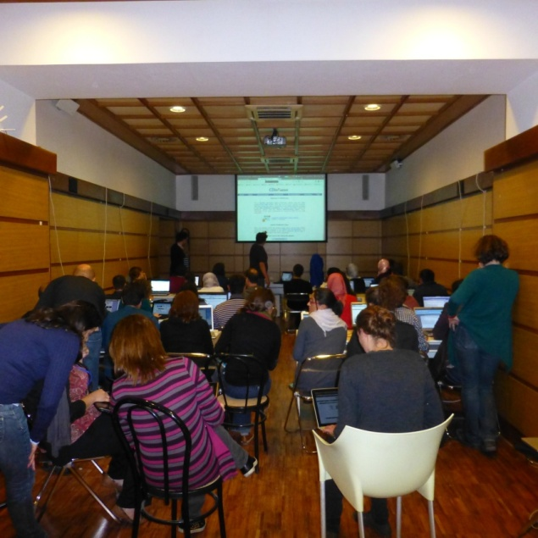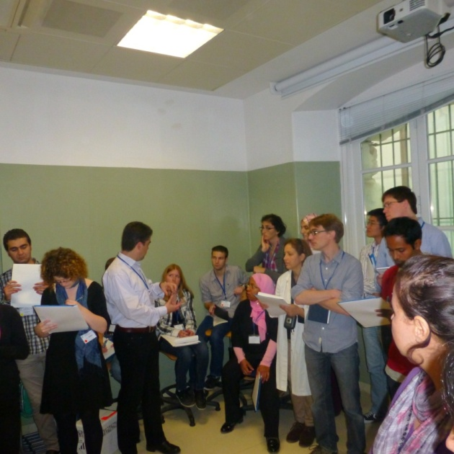
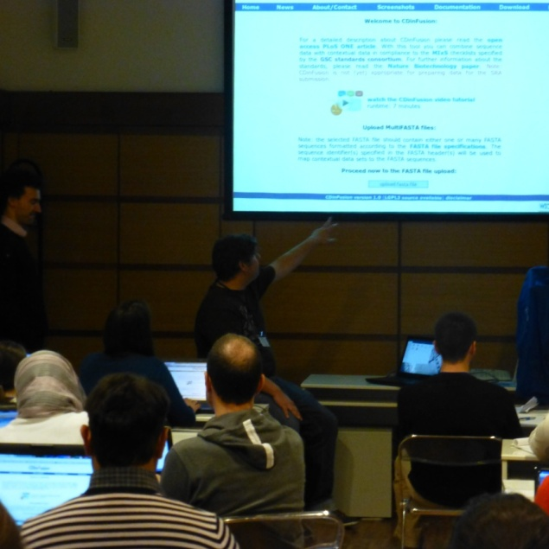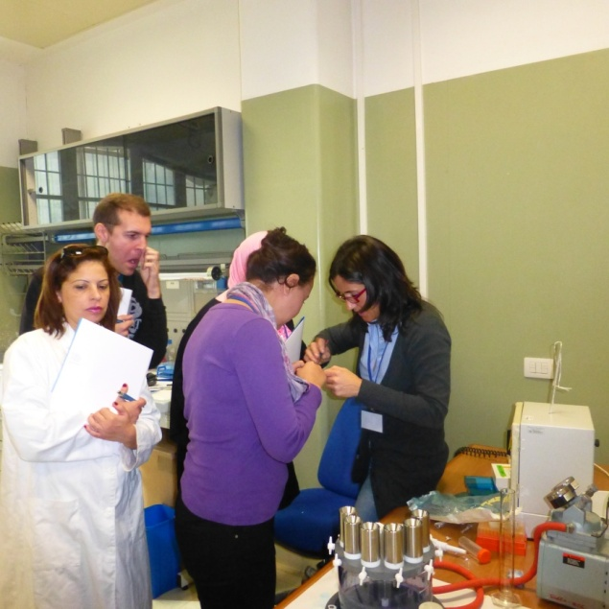
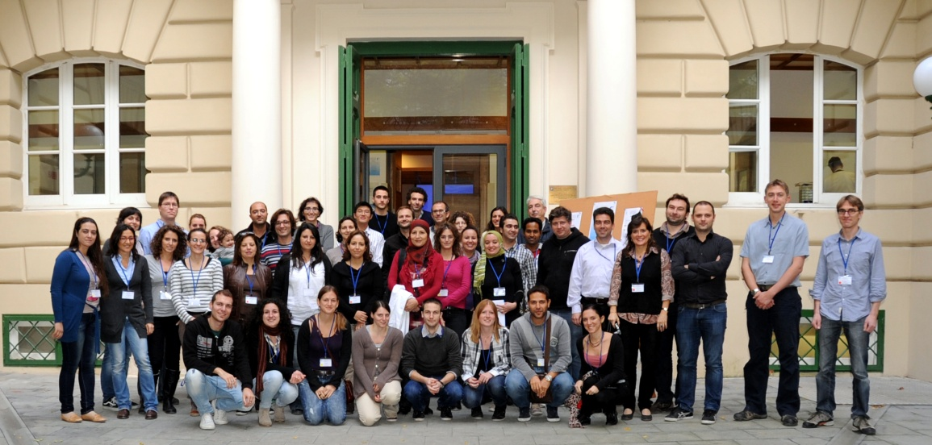

Training course on flow cytometry applied to the marine field, 28 to 30 January 2013, INSTM La Goulette, Tunis, Tunisia

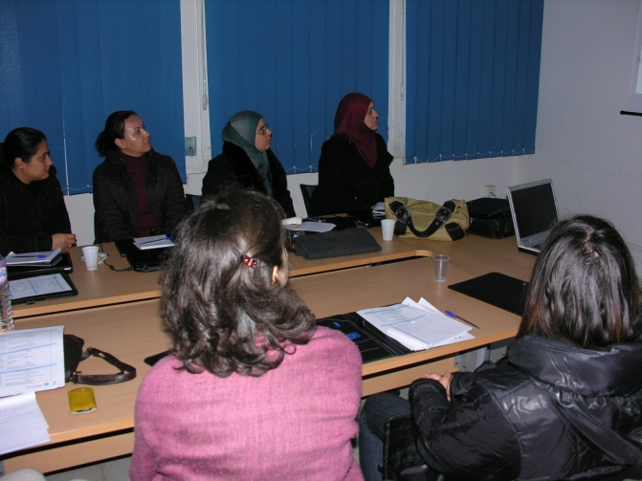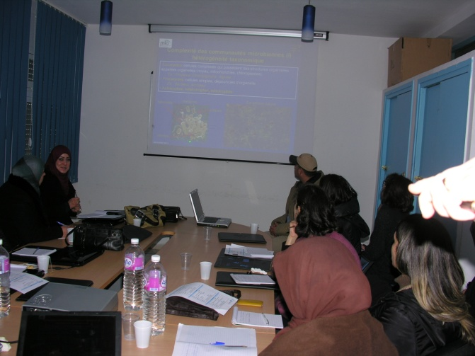
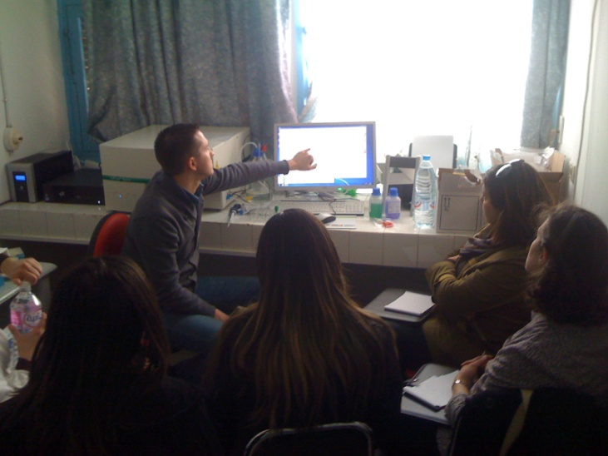
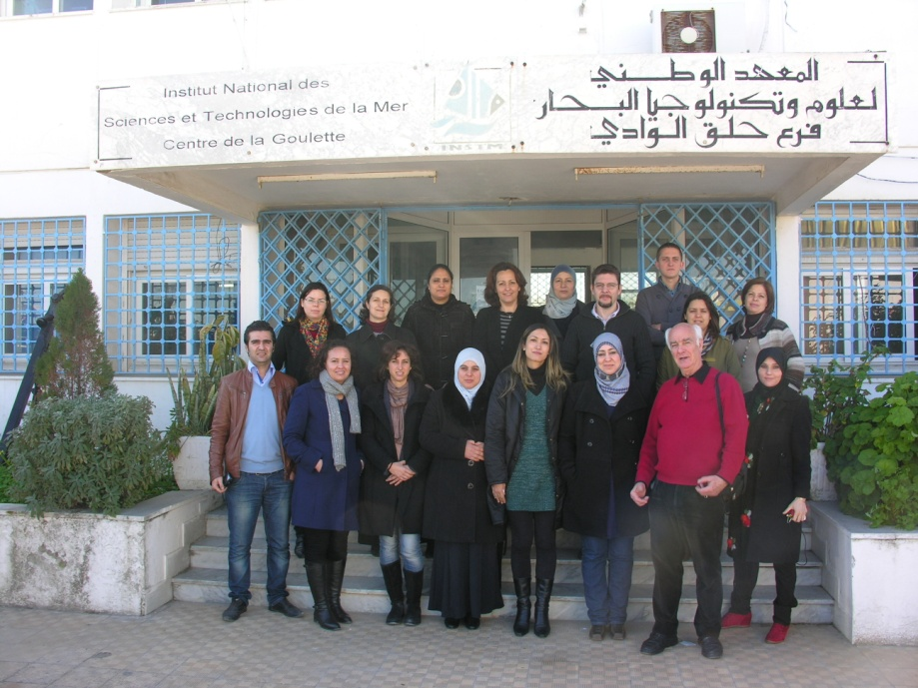
Training course on Taxonomy of Mediterranean Toxic Algae, 04 to 08 February 2013, SZN Naples, Italy.

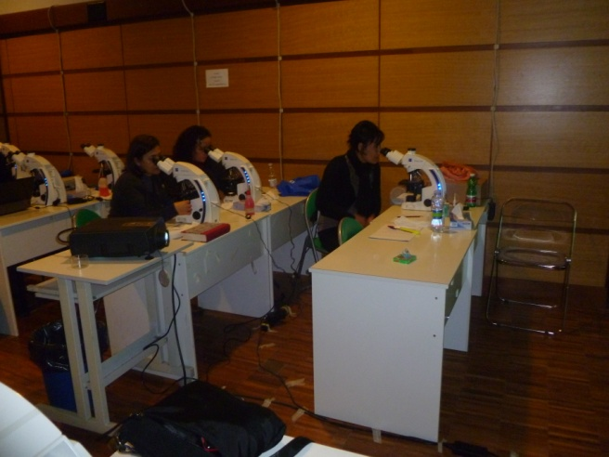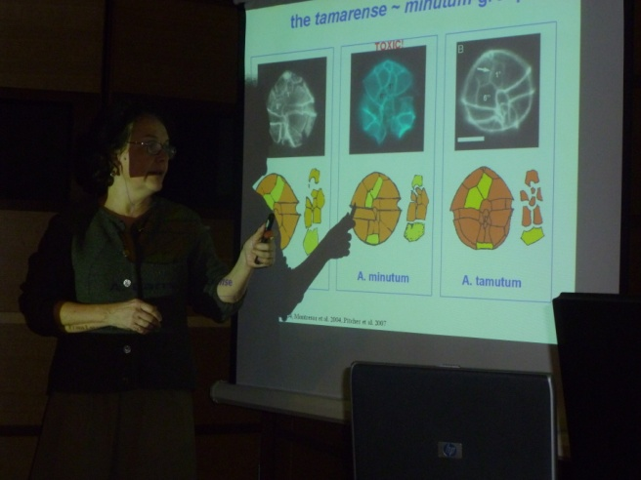
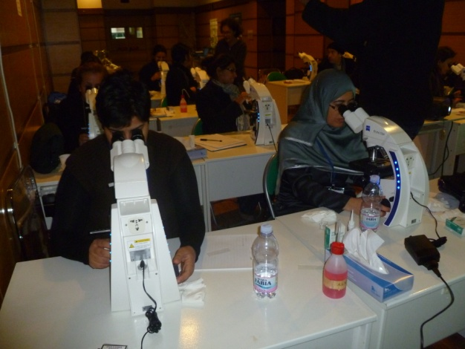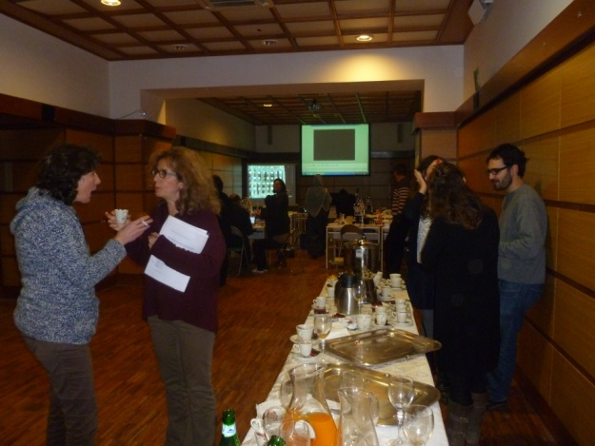
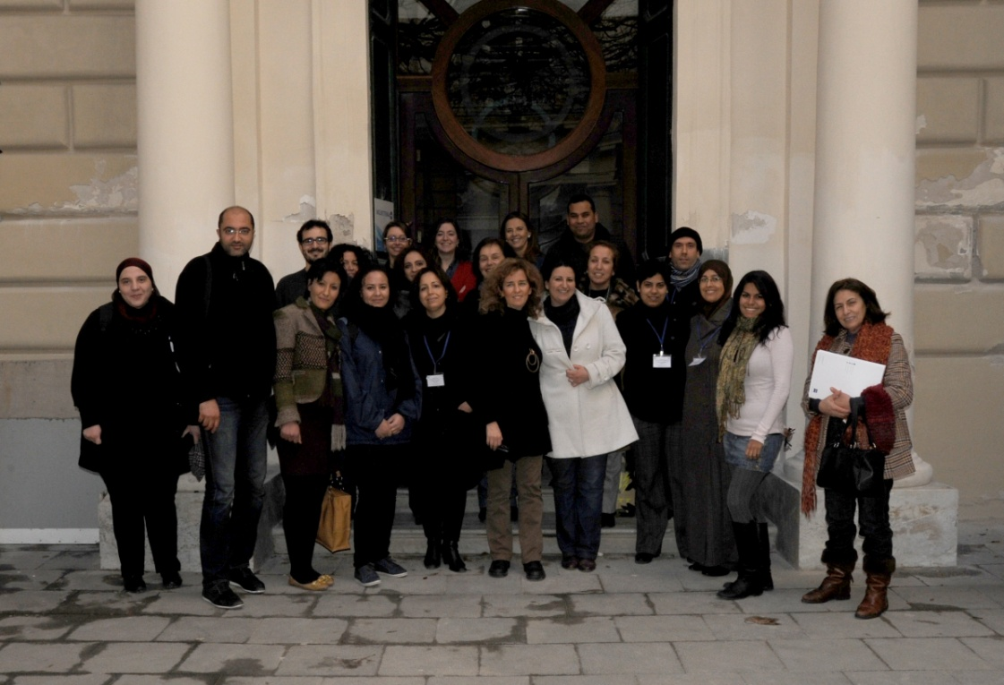

Training course on Fluorescent In Situ Hybridization: Application on planktonic organisms, 22 to 26 April 2012, INSTM La Goulette, Tunis, Tunisia

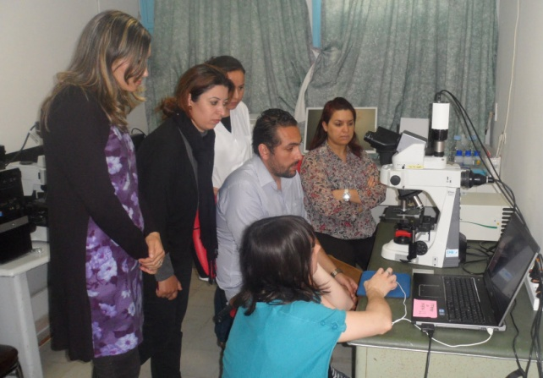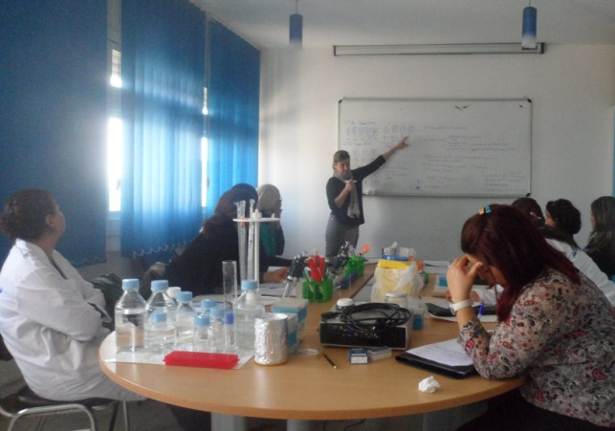
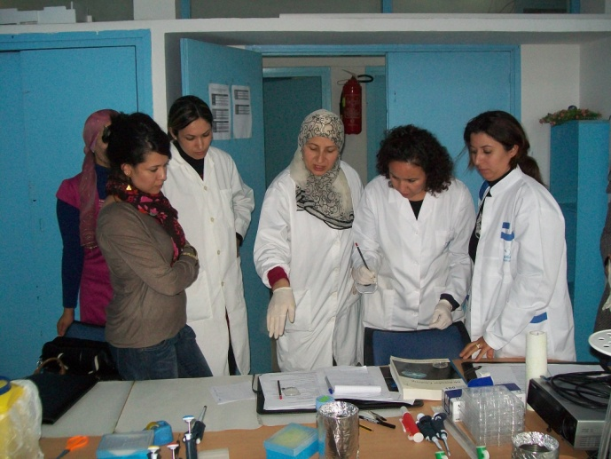
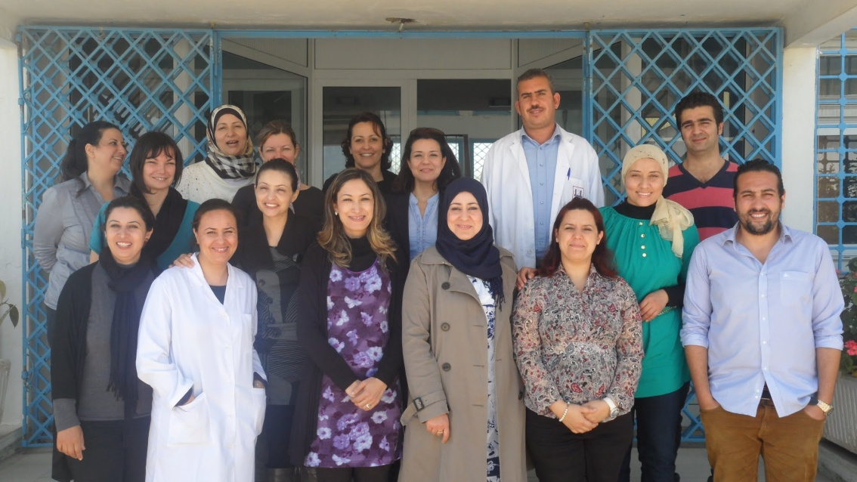

Workshops at Sea “Instrumentation at sea, 16 to 21 september 2013, INSTM Salammbô and High Frequency Observation Of Phytoplankton and Zooplankton, 11-17 November 2013.INSTM Sfax
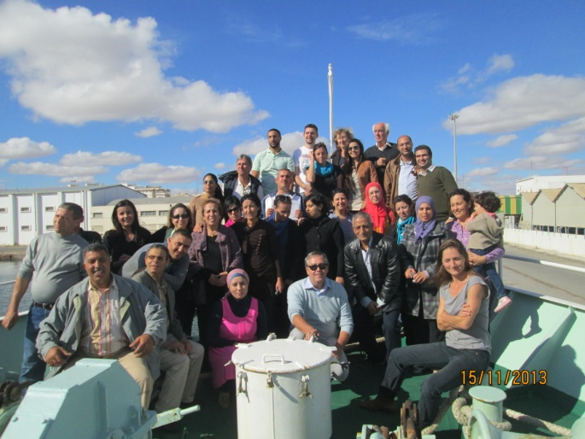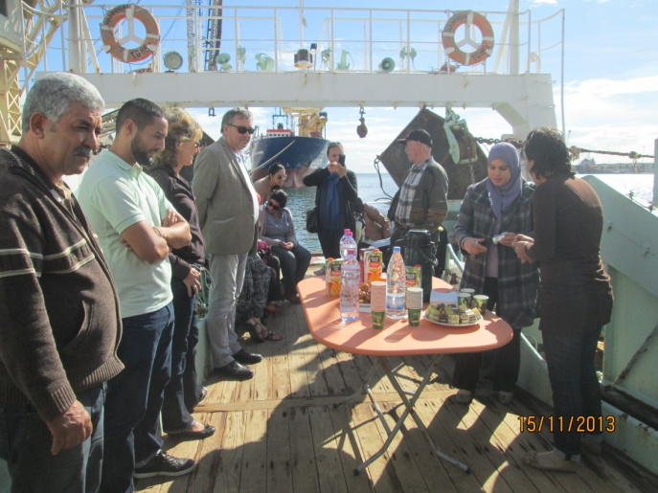
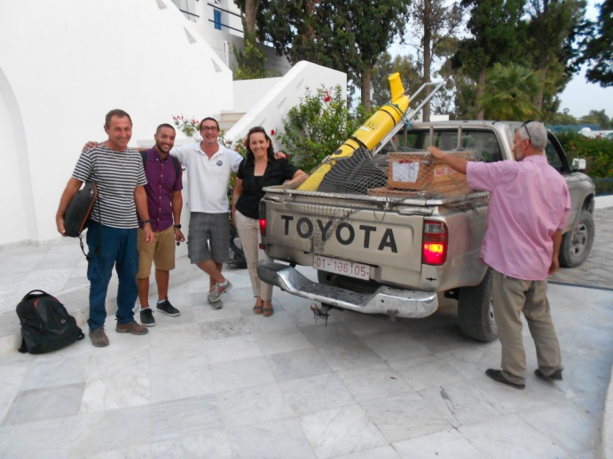
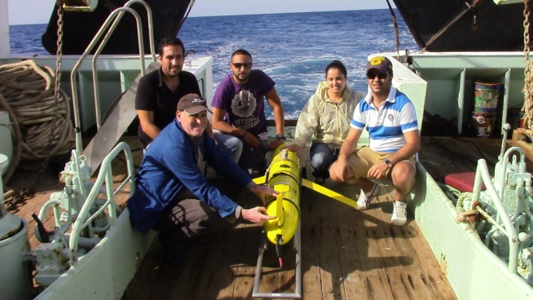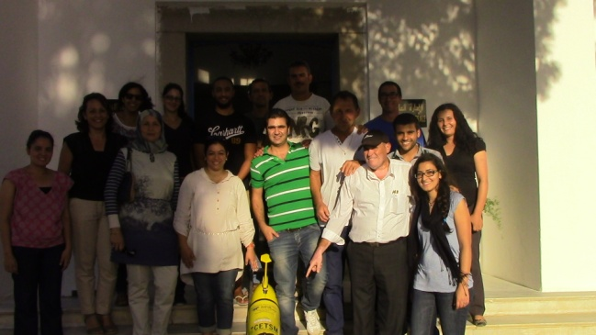
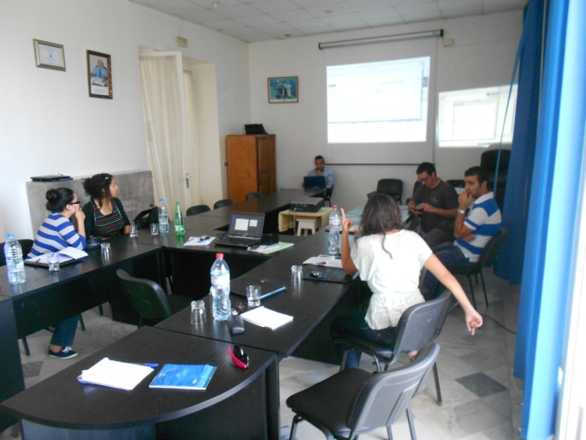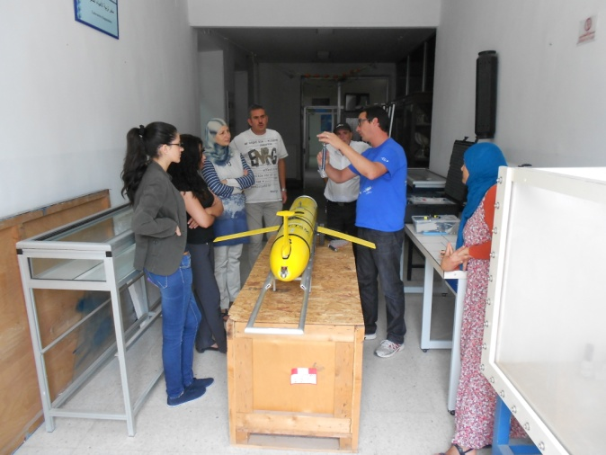
Training course on Prokaryotes in extremes Environments, 25-29 November 2013, CBS Sfax.

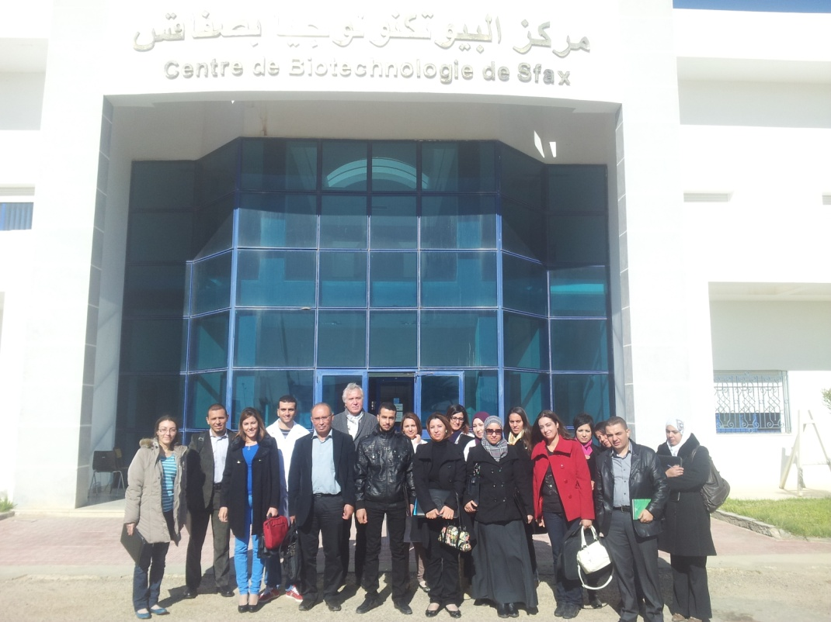

INCOMMET FINAL CONFERENCE
“International Conference on Mediterranean Sea Marine Research: Scientific Priorities and Societal Challenges” Hammamet Tunisia November 18th-20th, 2014.

