Publishable Summary (max 2 pages)
Thrips are small insects that cause direct damage to agricultural and horticultural crops and forest trees world-wide and some species transmit damaging plant viruses. Many species are of quarantine concern. Current thrips management requires significant inputs of agrichemicals, which creates risks for workers, consumers and the environment so that additional thrips management tools are urgently needed. Semiochemicals are chemical compounds that are used for communication between organisms including insects and some, such as sex pheromones, have been exploited for management of a range of large insects. However, these technologies have been under-exploited for small insects such as thrips. To address this issue, the Europe Australasian Thrips Semiochemical (EATS) Network was initiated in 2012 to develop semiochemical-based tools for management of thrips.
The project focused on two groups of semiochemicals: thrips aggregation pheromones, chemical compounds produced by thrips for interspecific communication and non-pheromone semiochemicals, such as plant odours or their mimics, that act as attractants or repellents for thrips. An EATS Network website was developed: www.Keele.ac.uk/eats on which information on progress of the workpackages is provided. In total, 4 yearly EATS Network workshops were organized: 2012 in Cabrils (ES), 2013 in Christchurch (NZ), 2014 in Vienna (AU) and 2015 in Cabrils (ES).
The main results and conclusion from the workpackages in the program are:
Factors that affect thrips’ responses to odours. The influence of intrinsic (thrips population) and extrinsic factors (temperature, wind speed etc.) on the response of thrips to odour was investigated in depth and new effective odour formulations were designed to maximise thrips response (capture). Effective formulations for a range of environmental conditions were understood and discussed with industry for market development. Confirmation that the active ingredient of LUREM-TR is an effective attractant for a number of key thrips pests in Spain, including western flower thrips (WFT), thereby indicating its potential for thrips management in Spain. An understanding that baited traps influence trap capture of neighbouring traps was also developed indicating that previous work may have underestimated the effect of these semiochemicals to increase trap capture especially where there is a high concentration of baited traps in a given area.
Pheromones. This work built on the “mass spectrum library” (EU Project number 252258, Pheromone Identification for Environmentally Responsible Control of Thrips, PERFECT) to carry out an initial identification of the male-produced sex/aggregation pheromones of Frankliniella schultzei. Headspace volatiles were collected from this thrips species in Perth Australia for analysis at Keele University. The aggregation pheromone of Frankliniella. schultzei, a major thrips pest in Australia, Africa, S. and N. America and a potent threat to European agriculture has been identified. It will provide a relatively accessible enhancement for existing monitoring and control technology in protected and field crops. It could be used for enhanced monitoring traps at the European border were large quantities of crops are imported from countries were the species is endemic.
Integration of attractants and repellents. The jasmonate compounds, cis-jasmone and methyl jasmonate, were identified as efficient feeding and oviposition deterrents against WFT. Thrips females avoided settling on bean leaves treated with either deterrent over 6-hours. Continuous exposures of thrips females to low or high concentrations of the jasmonates did not alter their feeding and oviposition behaviours indicating that WFT did not habituat to these deterrents. The response of WFT to attractive or repellent plant volatiles when presented alone or in combination in the presence of background odours emanating from different plants confirmed the attractiveness of methyl isonicotinate (MI) to be consistently significant. In contrast, WFT responses to the olfactory repellent salicylaldehyde were clearly influenced by plant background odours. We could find some evidence that that the attractiveness of an olfactory attractant can be increased when combined with a repellent compound indicating a potential use in thrips pest management.
Exploring the use of semiochemicals in outdoor crops. In semi-protected strawberry crops in the UK, mass trapping of WFT using blue sticky roller traps reduced adult thrips numbers per flower by 61% and fruit bronzing by 55%. The addition of the WFT aggregation pheromone, neryl (S)-2-methylbutanoate, to the traps doubled the trap catch, reduced adult thrips numbers per flower by 73%, and fruit bronzing by 68%. The addition of blue sticky roller traps to an integrated pest management programme maintained thrips numbers below the damage threshold and increased grower returns. In two trials in a nectarine orchard in Spain, the highest numbers of WFT and onion thrips were caught in white water traps with methyl isonicotinate (MI), significantly higher than caught in the control and higher than with most of nine alternative odour compounds tested.
Exploring the effect of semiochemicals on natural enemies of thrips. MI was attractive for one species of predatory bug but not for the other two species under laboratory conditions. No attraction or repellence for predatory bugs was observed for the thrips pheromone. Confirmation that MI is also attractive for predatory bugs (Orius spp.), the key natural enemy of WFT in outdoor crops opens a new perspective in the use of MI for implementing biological control programs.
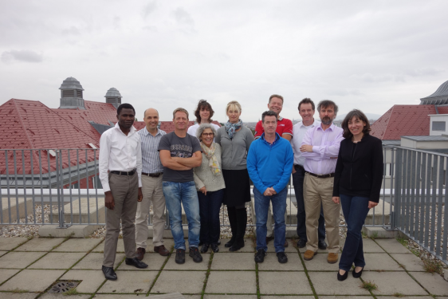
Members of the EATS network at Vienna meeting in 2014.

