European and South African HIV co-infection research consortium (ESAHIVcoinfRes)
The overall aim of the ESAHIVcoinfRes staff exchange program was to establish a long lasting collaboration between South African and European research teams involved in HIV co-infection research. The consortium consisted of very complementary partners, 2 South African partners: the University of Cape Town (UCT) and University of Limpopo (UL) and 4 European partners: the Institute of Tropical Medicine and the University of Antwerp (Belgium), the Academic Medical Centre of the University of Amsterdam (The Netherlands) and the Francis Crick Institute (UK). The ultimate goal was to identify new ways to improve care and treatment for patients with HIV and HIV co-infections in order to decrease the still high mortality rate among people with HIV infection in Africa.
South Africa is the country with the largest number of HIV tuberculosis (TB) co-infected patients in the world. Therefore with this program we explored new ways to diagnose and treat TB, including multidrug resistance TB, more rapidly and studied the pathophysiological mechanisms responsible for the immune reconstitution inflammatory syndrome (IRIS).
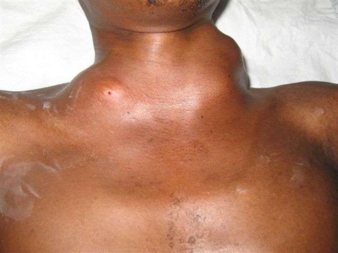
Large abscesses caused by an immune reconstitution inflammatory syndrome (IRIS) in a patient with a HIV tuberculosis co-infection who recently started antiretroviral treatment. (Picture provided by Colebunders R)
High baseline M. tuberculosis antigen load drives an inflammatory response that manifests clinically as TB meningitis IRIS in most, but not in all, patients with TB Meningitis. (Marais S et al., Clin Infect Dis, 2013 ).
Vitamin D levels in HIV TB infected patients are low but does not seem to influence the development of TB IRIS. (Conesa-Botella A et al., Clin Infect Dis, 2012)

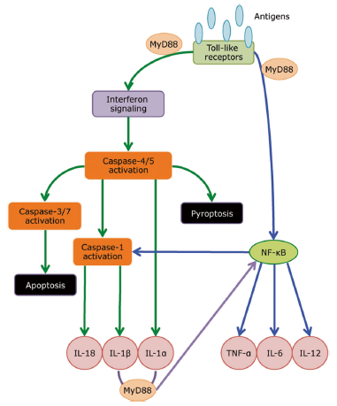
Model of innate receptor signalling in mediating TB-IRIS pathogenesis. (Lai R et al., Semin Immunolopathol 2015)
An important randomized placebo-controlled trial is ongoing to investigate whether prednisone may prevent the development of tuberculosis-associated immune reconstitution inflammatory syndrome (TB IRIS) in high-risk patients (Pred-ART trial) (PI G Meintjes). End October 2015, 210 out of 240 participants were enrolled in the study.
https://www.predart.org/site/index.

We discovered two new dimorphic fungal infections in Southern Africa. Emmonsia africana causes disseminated infections in severely immunocompromised HIV infected and non HIV infected patients. We have found its environmental niche in particular soil types. Blastomyces israeliensis presents in a number of ways including as brain abscesses.
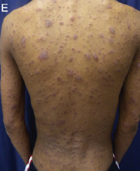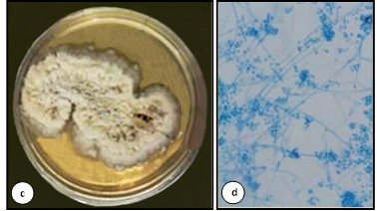
2
1
3
1. Emmonsia skin lesions
2. Emmonsia culture
3.Emmonsia hyphae
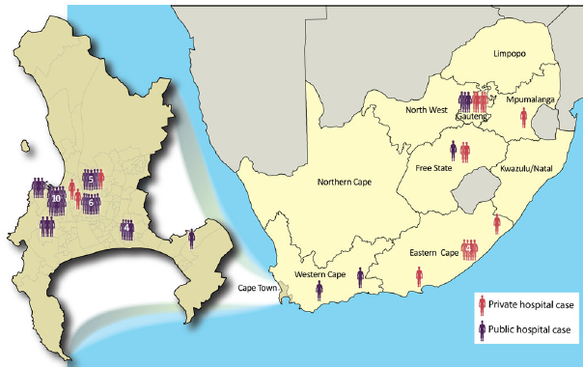
Geographic and healthcare sector distribution of disseminated emmonsiosis in South Africa
Schwartz I et al. Clin Infect Dis 2015

We studied different determinants of generalized HIV epidemics and highlighted the importance of concurrent sexual relationships as an important determinant of generalised HIV epidemics. We performed several studies investigating how to optimally use antiretroviral treatment (ART).
South Africa also has a huge burden of disease caused by Hepatitis B and Human papillomavirus (HPV) infections. Therefore we carried out research concerning hepatitis B vaccine coverage and about new ways to diagnose HPV infection. At the Dikgale surveillance demographic site, Polokwane in the Limpopo province we started a project that assessed how to manage chronic diseases in a rural area and performed a study to determine cardiovascular risk factors in persons with HIV infection. In primary health care centres in the Pretoria region we evaluated an information-motivation-behavioural skills model to reduce alcohol use in patients with HIV. Of the 2230 persons with HIV infection treated at these centres 25.1% were hazardous or harmful drinkers and 2.0% had possible alcohol dependence.
During the project we trained early stage researchers in state-of-the-art field research, laboratory techniques, data collection and data analysis, have built a network of researchers interested in HIV co-infection research, formulated and performed new collaborative research projects by intensifying research partnerships and networking activities. Thanks to the project 79 papers were published and 8 researchers obtained a PhD; several others will defend their PhD in the near future.

