Marie Curie Intra-European Fellowship (2011)

Project No: 297925
Project Acronym: N-LINK
Project Full Name: Normannitas: Landscape, Identity and Norman Kingdoms

Final summary report

4 July 2014

Table of contents

Page no.
1. Executive summary 2
2. Summary description of project context and objectives, 2
3. Description of the main S&T results/foregrounds, 5
4. Potential impact (including the socio-economic impact and the wider societal implications of the project so far) and main dissemination activities and exploitation of results, 27
5. The address of the project public website, if applicable as well as relevant contact details 35

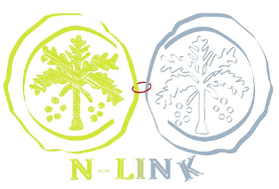

1. N-LINK PROJECT - FINAL PUBLISHABLE SUMMARY REPORT
1.1. EXECUTIVE SUMMARY
1.1.1. Introduction
Defining landscape is a difficult issue. According to the ELC (2000) Landscape is ‘…an area, as perceived by people, whose character is the result of the action and interaction of natural and/or human factors’. Landscape must therefore also be seen as the result of an historical process of transformation, in a variously extended space during a variable length of time. It should be possible to identify particular features in the current landscape that can be linked to past phases of landscape modification. Thanks to a new awareness of the importance of landscape, studies on historic landscapes have been increasingly taken into account in land management and planning.
A comparative method such as the one proposed in this project and help substantially in understanding similar dynamics in different contexts and in investigating how people perceived the landscape where they lived. For the Italian part of the project, this was a new concept. That said, the N-LINK project focused its research on the Norman period and aimed to compare England and Italy before and after the Norman Conquest, exploring specific case studies of historic landscape evolution. The objectives of the project were: 1. to address historical and archaeological questions related to the impact of the Norman Conquest on the English and Italian landscapes; 2. to implement and extend the use of historical documents in archaeological practice; 3. to test and develop a new method in the Italian archaeological context, which can support the study and the analysis of European landscapes by developing a new GIS tool, called Historic Landscape Characterization.
1.1.2. Methodological guidelines In pursuing these objectives, we considered: a - current landscapes as the starting point in archaeological research; b - understanding of the different perceptions of the same landscape across the centuries; c - reconstruction of political and historical events fundamental in shaping landscapes by influencing local communities, finally determining the creation of Norman kingdoms in UK and Italy; d - recognition of a specific Norman identity that could have characterized the Viking diaspora in European territories; e - comparative analysis carried out on selected cases studies; f - exploitation of documentary, literary and epigraphic sources for reconstructing medieval landscapes.
1.1.3. Achievements. The following important results have been achieved: elaboration of a targeted Historic Landscape Characterization and database for Italian landscapes; enhancement of methods for landscape archaeology using historical sources; successful combination of Italian and British academic approaches to historical landscapes.

1.2. SUMMARY DESCRIPTION OF PROJECT CONTEXT AND OBJECTIVES
1.2.1. Research context: Landscapes, Identity and Norman Kingdoms
The N-LINK project has focussed on the historical landscapes of a specific time, but to do so it has had to consider all the transformations that have changed its earlier state. Landscape may rarely be considered unaltered, because human actions have been continuously working on it. This project has linked people and countries across Europe, applying a new comparative method for discovering traces of one of the most important historic European migrations.
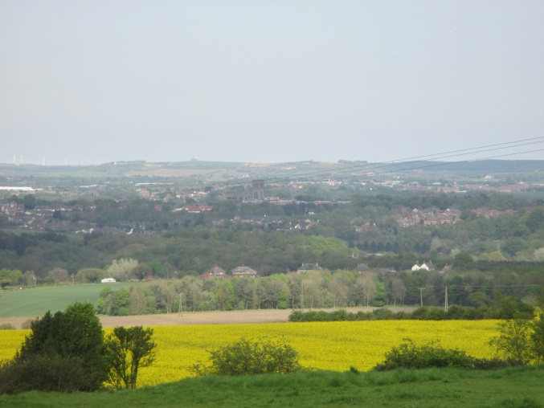
Fig. 2. County Durham landscape, from Brandon old village
The project analysed to what extent political change and Norman migration led to similarities and differences between two conquered territories, Southern Italy and England [Fig. 2], by applying new interdisciplinary landscape-focused methods and tools. The research questions were whether, how and why the Normans had changed the settlement patterns within their Kingdoms. This was the first project that aimed to tie together British and Italian landscapes, sharing methodologies and historiographical issues in order to develop a new method of research on historic landscapes. N-LINK has successfully promoted the possibility of recognising a precise ‘Norman Identity’ and its contribution to the living medieval and present day landscape.
1.2.1.1. Landscape
Archaeology and landscapes are directly connected. It is impossible to imagine an archaeological site without archaeological stratification, and in an analogous way it is unrealistic to think about landscape without a global historical, geographical and stratigraphic vision.
This research has attempted to integrate the study of epigraphy, literary texts and documents more effectively with archaeology. Medieval and modern documents are often misunderstood tools, which need to be systematically integrated in landscape studies: all such sources can provide important data for landscape study, but it is a truly challenging process. Thanks to the analysis and studies of the current landscape, linked to data collected from various modern documents and verified by field surveys, during the implementation of the N-LINK project the appropriate interpretation of different categories of documents has further enhanced current knowledge of the missing parts of the landscape, little considered in previous research.
1.2.2. Identity
N-LINK’s aim was to examine whether a specific Norman Identity (‘Normannitas’) was expressed in the ‘building’ of conquered landscapes. European historians have been attempting to prove the persisting existence of a ‘Norman Identity’ in medieval society in occupied England and southern Italy (Drell 1999): they preferred to underline differences between the two kinds of conquest and great attention has always been reserved for people or for historical sources or for the most evident traces of the Norman presence, like the major architectural monuments (Fernie 2002).
In each society people exercising power decide how the land is exploited, even if the land is shared among/with local lords and people of different origins and cultures (e.g. in southern Italy). In this project, the term ‘Norman identity’ meant that complex mixture of cultural, military, social and material exigencies, shared by people with the same language, customs and origins. It contributed to decisions about shaping the living landscape, choosing where to create or remove settlements, build houses, dig ditches, plant trees, hunt animals, farm, plough, and so on. N-LINK investigated the existence of a ‘Norman identity’ in the creation of European historic landscapes, by recognizing changes within them, emphasizing the mutual relationships/dynamics and the contexts/environments in which every landscape feature was placed.
1.2.3. Norman Kingdoms
Using insights from previous historical research, N-LINK selected Norman territories by comparable historic, economic and social issues: it explored, contrasted and compared the complex settlement dynamics and patterns within the medieval Principality of Capua, central-southern Italy, and the former kingdom of Northumbria, northern England, both border lands which were controlled by Norman conquerors; both were subject to strong ecclesiastical powers, similar border positions, processes of cultural interaction among different ethnic groups, and comparable economic and geographical environments.
N-LINK differentiated the effects of the conquest on both landscapes by analysing both 4 case-studies in Italy and England, using a multidisciplinary and interdisciplinary approach (integrating archive research and archaeological data through GIS).
(1) Ambrifi, an abandoned castrum mentioned for the first time in the Norman Period, and today belonging to the municipality of Lenola (LT);
(2) Esperia, former Roccaguglielma (FR), a village, which still preserves a Norman castle, and its territory;
(3 - 4) The municipality of Rocca d’Evandro (CE), a very complex territory, which includes two case studies: (3) - The Garigliano river case study, which involves the lost village/castrum of Bantra, an abandoned monastic settlement located in the territory of Rocca d’Evandro, and its neighbouring monastic settlements of S. Andrea del Garigliano, S. Ambrogio sul Garigliano, and S. Apollinare; (4) - Rocca d’Evandro case study, linked to other villages in its own territory, as Cocuruzzo and Camino, and lost or abandoned castella, as Mortula, and S. Salvatore di Cocuruzzo.
These Italian case-studies have provided the necessary case studies in locations where Norman Lordship was certain since the second half of the 11th century. They have enabled the research to analyse the consequences of the Norman re-organisation on different types of landscapes in mountains and river valleys.
Two case studies in County Durham, with connected Benedictine priory and estates, and two case studies in Northumberland, almost likely Norman settlements, have been the base for the work on England.
(5) Mitford, an abandoned Norman castle with its territory in Northumberland;
(6) Morpeth, a Norman town in Northumberland;
(7 - 8) Durham, in County Durham, the most important historic town in Northern England; the GIS has considered two specific areas around Durham, (7) the Witton Gilbert area and (8) Brancepeth with Brandon, on the west site of the territory of Durham;
Two other settlements were considered as comparative case-studies using the existing HLC data and collected bibliography (the temporary closure of archives in York and at Alnwick castle meant that original documents were inaccessible during the project). These were: a) Hexham, today a market town in Northumberland, organised around an early medieval Abbey replaced by an Augustinian priory in Norman times: its church was re-built by Thomas, Archbishop of York in 1112; b) Topcliffe, a village and civil parish in North Yorkshire, preserving an important Norman motte established soon after the rising of the north in 1069 and owned by the Percy family.
1.2.4. Research Objectives
a) to analyse three inter-dependent components:
- pre-existing settlement organization and land exploitation;
- geo-morphological conditions and previous use of natural resources compared to the new exigencies of the conquerors;
- results from archaeological excavations and surveys relating to material culture and landscape features;
b) to identify Norman settlements and features, reconstructing their networks and defining Norman development phases in already known medieval settlements.
c) To test the application of GIS-based HLC in Italy and develop it further as a tool for medieval landscape research.
In the next part of the report, the main topics and arguments will be summarised, but they will be exhaustively debated in forthcoming publications, which will definitively confirmed the importance of N-LINK in the European context.

1.3. DESCRIPTION OF THE MAIN S&T RESULTS/FOREGROUNDS
N-LINK achieved its aims with the following results:
1 – The project built a bridge between two different traditions of studies, focusing its research to create a useful tool for Italian Archeologia dei Paesaggi and ancient topography and to spread a new awareness on the value of the analysis of the current landscape as first step in Italian archaeological research.
2 - It explored and exploited the potential of GIS/HLC at a new level, testing its capacity in order to enhance its scientific value and to develop a more competitive tool in landscape management, which was a necessity felt by the specialists (Turner, 2010).
3 – It reconstructed medieval landscapes with related features and temporal dynamics in County Durham and Northumberland, in UK, and Southern Lazio and Campania, in Italy (case-studies).
1.3.1. The-State-Of-The-Art
From an historical perspective, the Normans and their ‘diaspora’ marked a turning point in both societies, whether in Italy or England. However, surprisingly, their contribution to the overall reconstruction of social and economic life has not been sufficiently considered outside historical studies and in archaeological contexts. Historians continue working on documents and archaeologists on excavations, with little interest in effective exchanges of data. Developing effective ways to achieve this was one objective of this research.
On one hand, a strong tradition of Norman studies is present in England but with different outputs. The case of Northumberland speaks clearly: in fact, as often in the case of ‘marginal’ areas (Faulkner et al., 2010) after the ‘Golden Age’ of Bede in the seventh and eighth centuries, Northumbria received little attention: even today it is Bede's legacy and his monasteries that attract most scientific and economic resources. On the other hand, a new focus on medieval Norman history and archaeology has been gradually involving scholars in the south of Italy (e.g. Cuteri, 2003; more recently Fasolo 2013), but the Principality of Capua has been marginalised even in historical studies. Despite the fact that this was the first Italian country to be conquered by a Norman family, who ruled there for a century before the organisation of the Kingdom of Sicily, Palermo (Bresc 2012), or Scribla (Flambard Héricher 2013) and Mileto (Cuteri 2008) in Calabria are still the symbols of the Norman Conquest in Southern Italy.
The necessity of understanding the Norman contribution to the development of these landscapes and, more generally, to medieval material culture, was highlighted by the results of recent excavations and studies in the South of Italy (Arthur 2010; Cuteri 2008; Molinari 2010) and also in Britain (Creighton, 2004). N-LINK focussed on this subject considering that, often, data do exist but they are simply not gathered together. Numerous studies, especially in the Mediterranean area, have used comparative landscape archaeology to approach different issues (e.g. Alcock, Cherry, 2004), but N-LINK is not a simple comparison between two different landscape surveys carried out independently by two national teams to be compared at the end, as usually happens in the archaeological field. However, the two countries developed different approaches to landscape studies, either from a historical perspective or from archaeological research and environmental studies (Pietrobono and Turner 2013); therefore the-state-of-the-art must be reconsidered independently in England and in Italy.
1.3.1.1. Italy
Historical studies on the Norman period have a long tradition: the University of Bari and its Centro di Studi Normanno-Svevi, or the Centro Europeo di Studi Normanni at Ariano Irpino, which runs the local Museum of the Norman Civilization. However, universities or institutes have never been engaged in promoting landscape archaeological studies specifically on Norman Period. This underlined the importance of new research on this subject, exploiting already known sources and new data and re-interpreting old information in a wider European project.
From an archaeological perspective, there was initially no intention to update the proposed interpretation of the general European survey of Norman culture dated from 1994 (D’Onofrio, 1994). The idea of a substantial settlement pattern continuity for the conquered South of Italy, from the Lombard, Byzantines and Arabs (sixth – eleventh centuries) to the Normans (beginnings of the eleventh century - end of the twelfth century), is normally accepted by historians (e.g. Cherubini, 2006), but without sufficient landscape research or excavations to confirm this conviction from an archaeological perspective. The same commentary of the Catalogus Baronum, a sort of list of contributions that the Norman Barons gave to the kings in order to provide troops of knights and soldiers from military expeditions in East Mediterranean (Jamison 1972), lacks useful research to support a topographical analysis. Studying this source and its edition (e.g. Pietrobono, forthcoming), has once more confirmed that this can lead to serious misunderstandings of the historical data.
1.3.1.2. England
In the British context, besides the obvious predominant historical interest, a great deal of attention has been devoted to the Anglo-Saxon period over the centuries, and archaeologists knew still relatively little about Norman landscape phases when N-LINK was launched. Normans built castles and cathedrals, so a considerable volume of publications is related to architectural issues. A Norman-focused interest has recently arisen, and some archaeologists have considered castles and settlement patterns in the landscape as a whole, especially in Southern England or in Anglo-Norman towns (Creighton, 2005). However, a strong interest in the Anglo-Saxon transformations still drive the attention from the Norman Period, as in the case of the Society of Medieval Archaeology's first new annual conference at the University of Nottingham (20-22 September 2013), which was centred on the archaeological evidence for the Norman Conquest of England. The wide range of the papers, which was generally focused on the eleventh century, gave particular attention to Norman expansion and made efforts to recognize in archaeological terms the Norman Conquest of England, and of other parts of British islands. Despite this, even in that occasion the Archaeology of Anglo-Saxon period became the most relevant issue and, slowly, the meeting aimed to confirm the prevalent idea of continuity from Anglo-Saxons to the Normans. N-LINK avoids using the term continuity, because if similar features are present in different historical moments, this is not necessarily evidence of continuity in meaning and identity.
1.3.2. Archaeological Maps, Forma Italiae, OS and HLC
The landscape as inseparable unity is the subject of study of landscape archaeology, which absorbs and analyses data from a range of humanities and scientific disciplines alongside previous tradition and established history. Nevertheless, British Landscape Archaeology can be only partially compared with the archaeology of the landscape in the Italian tradition of research.
The difference is concrete in methods and perspective. Both of them exploit a variety of sources: texts, inscriptions, coins, archives records, historical cartography, place names, iconographic sources, satellite photos and aerial photographs, studies of geomorphological character, cultural and anthropological research, archaeological excavations and results from field surveys. The latter integrates a tradition of studies in ancient topography, a legacy of schools such as those of Rome and Siena, including research by scholars such as Lanciani, Lugli, Castagnoli, or more recently, Francovich. Within the most recent trend of the Archeologia Globale, it tends to study the stratification of a succession of landscapes, trying to solve uncertainties on chronological phases by increasing and emphasizing the use of new technologies (Pietrobono and Turner 2013).
British Landscape Archaeology is a discipline constantly in transition. It differs from the Italian tradition particularly on theoretical bases, because it underlines the incidence of subjective and interpretative contribution in the “perception” of the landscape. The term “perception” plays a key role in understanding its unity; it is widespread in British theoretical Archaeology, but it is still unusual in Italian archaeology because its singularity and variability. Perception does not satisfy the “processualism” or “neo-processualism”, positivistic and Marxist approaches that informed and shapes the new technological trend of Italian archaeology (Valenti 2012).
Taking into account the previous notes on the state of the art, it is comprehensible why, regarding landscape archaeology, the Norman Principality of Capua is still neglected and there is an obvious lack of knowledge about Norman settlement patterns. Miles away from Rome and Naples, Capua and its former principality is an area as marginal as Northumberland, even if a better-defined cultural and political situation has developed inside its territory and consequently landscape compared with the rest of southern Italy. In this area, as in England, scholars have been attracted mainly by the architecture of castles or general historical issues, or, for the Roman period, by composing ‘archaeological maps’, which represent the traditional Italian way of mapping and reading archaeological phases in the landscape.
In ‘archaeological maps’, the current landscape is basically a plan/base where archaeological features are categorised according to chronological phases and described in technical record cards (for instance, the most recently published archaeological maps on the province of Caserta, in North Campania, by Quilici, Quilici Gigli 2012). An archaeological map can be composed by embodying only bibliographic and archive data, basically already known data, in order to give a quick basic contribution to research in the field. One of the key limitations of Italian ’archaeological maps’ is the tendency to lose a global vision of the landscape and become a simple inventory of sites and monuments.
British archaeologists have never used archaeological maps as analytical tools in the same way their Italian colleague. In the British context archaeological databases structured with ‘point’ data are used alongside OS maps (Ordnance Survey, the state mapping service) at a variety of scales. Researchers can take a wide range of information from these datasets.
Archaeological maps are not the only tool in Italian Archaeological management, which also benefits from the more complex Forma Italiae. This is the main methodological achievement of University of Rome La Sapienza's School of Topography (http://www.formitaliae.it/fi/) and CNR (Consiglio Nazionale delle Ricerche). These maps (based on 1:25,000 cartographic scale) aspire to be the most complete example of record and mapping in archaeological context with the highest technological level. In fact, the last version of the project, implement by the Paolo Sommella’s IT team (Sommella 2009) has emphasised the connection with IT technology. Furthermore, after archive and bibliographic research, building a Forma Italiae map requires carrying out a complete field survey covering the whole extension of the cartographic base, and this is why they usually take a long time to be completed. There is no way to substitute the personal authopsia on the field, and google-maps or satellite photos are only helpful tools to support the initial stage of that research.
However, it is true that Italian Landscape Archaeology focuses on monuments, trying to reconstruct the ancient or medieval landscape concentrating on excavations or existing buildings, written sources, and historic maps (Pietrobono, 2006). Even useful experience as long-term topographical research or “Archaeologia Ambientale” developed experimentally in Genova University, which shows similarities in using historic maps (Stagno 2009), could not provide a solid background for the N-LINK project, because its impact is still limited.
Fig. 3. Devon HLC.
By contrast English Landscape Archaeology, interpreting the current landscape, tends to consider every feature in the landscape at the same level, e.g. woodland, trees, open fields, buildings, and so on (e.g. Turner, Fairclough, 2007, 137). However, by applying strong processes of abstraction, the British method tends to become too interpretative and theoretical, losing contact with the reality of the data.
Based on a process of interpretation, the Historic Landscape Characterisation (HLC) was a particular approach to the landscape pioneered in the UK in the ‘90s [Fig. 3]. It is a method for understanding and mapping the landscape with reference to the historic processes that have shaped its development and character (Pietrobono and Turner 2013). To date most HLC projects have been carried out by public institutions, as in Yorkshire (English Heritage, the Yorkshire Dales National Park, the North York Moors National Park, City of York Council and Tees Archaeology); in Northumberland (English Heritage, Northumberland County Council, and Northumberland National Park); in Durham (English Heritage and Durham County Council). Designed as a management tool, its potential as a research tool is increasingly recognized in Britain and in Europe more widely.
1.3.3. N-LINK Historic Landscape Characterisation
It is only by combining the excellence of both methods and traditions of study, possible in a European perspective, that a researcher may obtain maximum benefit from them. N-LINK has confirmed that HLC is an excellent interpretative support, especially in understanding and explaining long term transformations in the landscape.
Investigating Norman identity needed the histories of two European countries in the Middle Ages to be tied together, working simultaneously on both territories and applying the same methods and criteria. So N-LINK developed a tailored HLC data-base for each of the study areas identifying different historic land-uses by adapting the existing English Heritage HLC for northern England to its needs, and by creating a new HLC for the Italian case-studies after having established a common list of types.
1.3.3.1. Concept - ‘HLC differs in important ways from traditional methods for describing the historic ‘resource’ such as inventories of archaeological sites or intensive field surveys. Instead of plotting individual archaeological sites as points or lines on a map, HLCs present more generalised interpretations of the whole landscape’ (Pietrobono and Turner 2013). This is why HLC has been chosen as a valuable way to integrate both Italian and British backgrounds into a unique analytic tool, targeted and aimed to establish a flexible GIS which could offer assistance in interpreting data on Norman Period.
‘In Europe, there are hardly any landscapes that have not been radically modified by people, but even the wildest places are still visited, lived in, changed and valued according to cultural meanings. Landscapes in the present therefore have historic character that results from natural processes combined with the activities of people in the past. Landscape is fundamentally about both physical features and the ways they are perceived by people. HLC maps perceptions/interpretations based on landscape archaeologists’ understanding of historic processes, but it recognises that the same landscapes can be seen and valued by different people in different ways’ (Pietrobono and Turner 2013). The HLC was not yet used in an Italian context where it was a totally new tool, but new publications are divulgating its theoretical background and method (Pietrobono and Turner 2013).
Being a flexible method, the exact nature of the HLC types defined for any given project will vary depending on the goals of the project in question. Classifications developed by previous landscape studies are likely to be useful and influential when deciding how to define HLC character types, but there is not necessarily a set of pre-existing ‘correct’ interpretations of the landscape that stands ready to be used by researchers making HLCs. Instead, it is important to consider each new project’s particular research questions when devising its HLC methodology (Crow et al., 2011).
1.3.3.2. Types - HLC is not an archaeological inventory, so it does not map individual archaeological features, but it gathers together features like field boundaries, lanes and farms that are linked by their historical development and then maps them as areas. The present-day landscape has been examined and characterised into ‘HLC types’. According to other HLC projects, N-LINK has defined shared “types” classified in advance of mapping and tailored to the both UK and Italian regions, established on the bases of documentary and archaeological data. One main reference for England has been the Tyne and Wear HLC (Collins 2014, but work in progress in 2012-2014), as well as the Durham and Northumberland HLC reports, also recently created; the British cartographical base was a wide series of OS maps from 1:1250 to 1:50,000, dated from c. 1850 to the present. The cartographical base for Italy were Italian maps (IGM 1:100,000; 1:50,000; 1:25,000), Pre-Unitarian maps (1:86,500), regional maps (CTR 1:10,000) and historical maps from the Montecassino Archives.
A preliminary landscape analysis was implemented in order to produce a first functional characterisation finalising the analysis of landscape data from topographical map survey for both areas, and the types were defined on the base of historical sources matched with the preliminary landscape analysis, which led to a deeper reading of the landscape before proceeding to the assignation of types. In this way, the comparative method has immediately produced useful data and suggestions. First of all, it has underlined how patterns in the landscape reflect its historical development, and how the physical features that make up the landscape relate to one another. Although used for reference, there are no direct connections to other mapping methods, like the European Corinne Land Cover or the British Landscape Character Assessment by Natural England, because the aim was to reconstruct medieval landscape using the evidence of the landscape itself. One effective strategy of this new method consists in starting with the present characteristics of each type.
This process represents the opposite of common archaeological methods, but also the application of the stratigraphic approach starting from the current landscape. The most significant archaeological features have been reordered in a specific GIS point database listed as place names, by specifying chronology, typologies and brief descriptions of the ancient remains. All types, woodland, open land, field system and terraces, and so on, underline current and existent areas always linked to previous types in the GIS records, by interpreting their previous status before, during and after the Norman period. Each type has been described following this classification: broad type, previous broad type, scope note, class scope note, place name, document, confidence, note map, tithe award or cadastre, period (Norman, Medieval, Modern), bibliographical references, and record number for the remains. Using these criteria, every single type has been chronologically related to the others and interpreted.
By compiling a connected archive of relevant individual archaeological and architectural features [casalia, churches, castles, manors houses, etc] useful records have been provided to build a linked scientific commentary, where every feature has been mapped and described in targeted records. To collect data, detailed research was conducted in libraries and archives in Italy and England, particularly the Vatican Secret Archive, the State Archive of Rome, the Central Archive of the State, the Archive of State of Caserta, and the Archive of Naples. In England, research has been conducted in archives including the Durham County Council Archive Tyne and Wear archives in Newcastle, Northumberland archives at Woodhorn, the Palace Green Library in Durham, York libraries and archives, and the British Library. Further data was collected from recent ‘grey literature’ reports from developer-funded archaeology available from the ADS (http://archaeologydataservice.ac.uk/) and from the Durham County Archaeological service.
The selected types had to be simple and clear, in order to propose a first effective Italian targeted HLC, which could be later the base for following analysis. It was important to simplify the process by giving more attention to the interpretation and the analysis of the sources selected for designing types rather than to focus on a more articulated list of HLC types that are not relevant for understanding the Middle ages (though that could be pursed in future research).
Types have been identified as polygons in the GIS (specific natural features, water, communication, woodland, open land, field system, terraces, settlement and activities, medieval settlements, historic military sites) / lines (communications, boundaries), and points (specific ecclesiastic settlement and boundary features). The following section provides a brief overview of the key HLC types defined in the project:

A. Water. This group includes every kind of water features and areas predominately water either natural or artificial present from the Middle Ages until nowadays or disappeared water features which have significantly shaped the landscape, like disappeared karst lakes and rivers, frequent in Italian context. The most of selected case-studies in both countries are located along rivers, which were one of most flexible natural features in the landscape: river can be used as borderlines, sources of water, of food, sewers; they are fluctuant in the landscape because they can easily change their bed streams, water flow, and so on; their presence could support settlement development but their water can also immediately destroy it. In Italy, the River Liri, which flew through the lands of three case-studies, has shown a great transformation over the centuries, much more than the rivers Wear (County Durham) or Wansbeck (Morpeth-Mitford).
Ditch | Ditch, either natural or artificial. Fossatum
Fishing pond | Manmade Open Water, fishing pond. Vivarium
Lake/pond | Lake/pond, also for karst lake evident in Medieval times. Lacus
Marsh | For areas of ground that are waterlogged throughout the year; also the Italian “lama” or “limata”. Palus
Pit | Artificial pits – puteus
Reservoir | Reservoir – Cisterna
River | For the large major rivers. Flumen
Source | Source – fons
Stream | Creek or stream – Rivus

B. Communications. This complex group classifies historical areas of transport networks and associated services, often built in Roman period but still in use in the Middle Ages and preserved over the centuries, although visibly transformed. To historical separate functions and meaning, highway and certain modern road have been intentionally excluded from this group and included in modern settlement types. Viae antiquae – ancient roads, as the Roman road in Durham, are usually marked as lines.
Ancient road | Ancient road not better qualified, usually a Roman road, still in use in the Middle Ages. Via antiqua and also Via Publica
Bridge | For large and small bridges across major and minor rivers. Pons
Common road | For areas of land set as common use road, via communis. Secondary road, maybe linked to Roman centuriation, like Via Traversa or Via Vicinalis.
Ford | Line marked as ford: Vadum
Harbour | Harbour and dock. For artificial and natural harbours. Traditionally where ships, boats etc can be stored or seek shelter. Portus
Market | Market or square along roads. Also statio or forum
Medieval road | Certain medieval road, even when previously built. Strata
Post medieval road | Established before 1834; in few cases already attested before 1705-7. Sometimes it might have medieval origins, but it has certainly consolidated in post medieval time.
Scafa | For small transport or people instead of a bridge, by boat. Scapha

C. Woodland. According to Natural England classifications, linked to Italian definitions of wood, this group gathers current woodlands, which were important for hunting, food, timber and many other resources in the Middle Ages.
Ancient and Semi Natural Woodland | For areas of land that have had a continuous woodland cover since at least 1600: Silva antiqua, Lucus, Nemus, Gajum, Gazium, Gagium, Waldum and Gualdum.
Ancient Replanted Woodland | For areas of woodland where the original native tree cover has been felled and then replaced.
Mixed Woodland | A mix of both deciduous and coniferous trees.
Orchard | For areas marked as orchards.
Park woodland | An area of prevalent wood annexed to a medieval park.
Plantation | An area of planted woodland.
Pre-1870 woodland | For areas of pre-1870 woodland
Scrub/Macchia | An area of scrub.
Scrub and terraces | Terraces with not recognisable pattern that are currently the base of an area of scrub and wood
Wet Woodland | For areas dominated by carr or for areas of osier beds. Also, in Italy, an area of tree on an old bed river.

D. Open Land. All areas of open land that do not show evidences of continuous ploughing and cultivations, such as common or heath are gathered in this group, included open or common pastures.
Common | Areas of open land for public use and often located near settlement and named as 'common' on map. Also includes greens where large enough.
Derelict Land | For areas of land that have been cleared of buildings but have not been put to further use. Also where there is no indication of what the land use is/was, or where aerial photography shows no vegetation. Previous possible type must be later specified and recorded.
Marginal Riverside | Areas of grassland or scrub at rivers edge.
Reclaimed Land | Former tidal mud flats or docks that have been reclaimed. Only to be used as a current type if there is no evidence for further land use post reclamation.
Rough Grassland/Scrub | For areas of rough pasture which is largely made up of grassland with some bushes.
Unenclosed | Areas of open uncultivated land such as heaths, waste or moorland, usually named on map.

E. Field System. This group considers all areas of enclosed fields arable, vineyards and enclosed pasture, all land which reveal some forms of organisation. This list much own to previously studies on English landscape and retains the most of the common previous classification. It is the most difficult type to be established because of the different quality of previous research that was possible to gather together, so in Italian context it must be consider as a first useful proposal; for this reason, where necessary, not all fields have been classified, and the most problematic have been marked as uncertain.
Agglomerated Fields | Fields which are large and date to the 20th century. They clearly demonstrate a significant alteration from post-medieval enclosure commonly as a result of field boundary loss or re-organisation.
Ancient fields | For a field system that may represent continuity in size and shape with Roman Centuriation.
Clausurae, septa, and medieval enclosure | For those are commonly small and irregular. They were created in the medieval period by clearance or assartment of wooded landscapes, moorlands and wetlands.
Modern enclosures. | Fields which date to the 20th century, generally after the World War II. Mixed cultivation.
Other Enclosed Fields and gardens. | For assumed field systems which cannot be identified as anything else - especially where they have been built upon at an early period. Some of them can be medieval.
Paddocks and Closes | Small irregular fields that are closely associated with settlement; often loacted on the edges. Commonly consist of small dry meadows, paddocks and closes of varying date.
Park | Park field enclosures, perhaps medieval enclosures, which are characteristically marked on maps within fixed boundaries.
Piecemeal Enclosure | Fields which are characterised by irregular boundaries and pre-date the main period of surveyed (parliamentary) enclosure. In Italy they pre-date 1815.
Post-Medieval enclosure | Post - Medieval enclosures, for hunting and pasture, in Italy also Difesa/Defensa.
Re-organised Piecemeal Enclosure | Fields with many straight boundaries but which are probably based on medieval strip fields. They have been enclosed (piecemeal enclosure) but have been substantially re-organised during the post-medieval period.
Squatter Enclosures | Small piecemeal fields associated with squatter settlement often in areas of collieries or former common land.
Strip Fields | Fields which are characterised by reverse S curves or dog legs and/or ridge and furrow
Surveyed Enclosure | Fields which are characterised by ruler straight boundaries often in a regular, grid-like pattern with the appearance of being laid out as a piece by a surveyor. Often also in limate, or clay soil .

F. Terraces. Inside this group are listed all kind of terraces and artificial walls, included the dry stones walls named macere, widespread in Italy, especially in karst context, when they are big and strong enough to be considered as structures. When this kind of feature has certainly ancient or medieval origins, it has been distinguished.
Braided terraces | For patterns of interleaved terraces that appear to have developed piecemeal over several different phases of use, are terraces built across small stream gullies or other features with V-shaped profiles.
Check-dams | Small dam, which can be either temporary or permanent, built across a minor channel, swale, bio swale, or drainage ditch.
False terraces | Modern terraces created by bulldozing in the 20th century
Lynchets | Bank of earth that builds up on the downslope of a field ploughed over a long period of time.
Mixed terraces and macere | Mixed Step terraces – contour and check-dams, or contour and terraces fields when strictly related. Often resistant macere with enclosures for animals.
Pocket terraces | Small slope benches which are generally semi-circular in plan form and are specifically linked to the cultivation of trees
Polygonal Masonry Terraces | Ancient terraces made with Polygonal Masonry wall.
Step terraces – contour | Terraces following the contour of the hillsides, so they tend to be sinuous in form..
Step terraces – straight | Straight step terraces are cut straight terraces across the hillsides to create rigidly parallel straight lines
Terraced fields | Somewhat broader than step terraces, forming squarer enclosures with terraced downhill edges

G. Settlements and activities. This group underlines the existence of post medieval settlements and human activities that have permanently or recently altered the overall organisation of the landscape. Modern features had to be recorded in the final HLC, e.g. modern settlements and industries, because they have deeply transform the environments by producing several issues, which influence correct interpretations of the past landscape layers, so their presence must be constantly taken in account. However, this has been done by managing all possible modern types into a single articulated group; this type-group had to be analytic but selective, because N-LINK HLC aimed to emphasise the medieval landscape.
Dispersed Settlement | Where small settlements are depicted. Areas of residential housing. Also disused dwellings.
Extractive quarry | For areas of mining with associated outbuildings, industrial equipment and rough grassland. Areas predominately quarrying/mining. Also for former extraction sites.
Farm Complex or Masseria. Country house | A complex of farm buildings which, if large, include the farm house, farm yard, barns and any other associated outbuildings. Areas of residential housing. Isolated house in the country with not recognisable function except residential and gardening. For area of farming and plantation infrastructures
Highway and modern road | Highway and modern roads, with infrastructures
Industrial site | For areas which indicate industrial activity. Areas marked as 'Modern industrial site'.
Military sites and airport | For areas marked as military airfields. For military camps or depots marked on the map. To be defined as areas directly owned by the military and operated by them. Even former and disused military Airfield and sites.
Mixed settlement | Industrial and dwelling site.
Modern dwellings. | Area of residential housing, also with small fields. 20th century settlement (post II WW development).
Pre-1860s settlement | Areas of residential housing settled before 1860. Sometimes post medieval “casalia”. They might have also Medieval or Roman origins.
Recreation | Area of recreating activities
Temporary settlement | For areas of mainly dry stone hut – shields, tuguria, capanne, etc
Traditional Industrial site | Area for legnaie – carbonaie – neviere or similar traditional activities.

H. Natural features. By proposing this type definition, the project points out some natural features, which are peculiar landmarks in the landscape and are expressively connected or mentioned in medieval documents.
Caves | Caverna
Sinkoles | Dolina or natural well
Outcrop | Pesclum
Cliff | Praeruptus locus
Mountain range | Serra

I. A. Boundaries. This group collects specific administrative and ecclesiastic divisions, which may be useful in delimiting medieval administrative territories.
Civil Parish | For civil parish administrative division. Modern delimitations.
Parish church | For ecclesiastic parish administrative division, sometimes with medieval origins.
Township | For administrative or property division, which may maintained some characteristics from Middle Ages.

I. B. Boundaries. This group includes specific rocks, natural or carved, as stone crosses are, used as landmarks and boundary’s single features.
Cippus | Small pillar
Columnella | Small Columna
Petra scripta | Written stone, usually epigraphs
Stone or sculpture | No otherwise specified, but peculiar landmarks underlined in the documents, like Omomorto (sculpture) or Arcus Gizzuli, or similar

L. Medieval types. In these groups of types, the border between archaeological features and HLC types is much reduced. The choice of establishing polygons and points to remark the existence of medieval sites is based on the exigencies of immediately reflecting links to features that can have causal effects for the formation and development of the previous types. This choice reflects precise useful experiences from the Italian landscape traditions.

L. A. Historic Military sites. This group classifies areas and features related to military development.
Battlefield | Medieval battlefield
Castellum and/or motte-and-bailey | Early Norman castle. Also disused Norman defensive structure, now transformed for other uses.
Fortified medieval town | Fortified settlement or urban area with late medieval development, often with market place. This is the type used for civitates when they are fortified settlement.
Fortified Roman Site | Roman fortified site
Fortilicia and Rocca/castle | Medieval castle and fortress. Also when comprehensive of structures used for civil defense such as artillery batteries, barrage balloons, bunkers or tank traps.
Post medieval fortified site | Certain post medieval site; 14th and 15th century fortified sites.
Turris | Medieval tower or bastle house, also fortified mills

L. B. Medieval Settlement. This complex group classifies areas of medieval settlement with specific functions. All the features of these types clearly show medieval origins but they may have been subjected to posteriors transformation.
Bath | Public bath or balneum.
Canapina | For marked rope and hemp making sites. Rope Walk/Hemp Factory
Casale | Hamlet and medieval dependent settlement. Also Casalinus, an areas planned to be built.
Castrum | Castrum. Fortified medieval site, with uncertain origins, usually with cortina and bailey. Also medieval fortified enclosure, sometimes transformed in modern settlement defensive walls.
Civitas | Town
Ecclesiastical site | Area with ecclesiastical buildings
Extractive site | Medieval extractive site, not specified, and also coal mining or clay
Farm | For areas marked as 'Starza' or 'podere'.
Manor | Manor house or seigniorial residence. Manerium domus
Mill | For areas marked as mill, watermill or windmill and associated mound. Molendinum
Pottery production Site | For areas where pottery is produced, to include any associated extraction pits. Sometimes is called Pignatarium – officinae.
Various industrial activities | Medieval industrial activities
Vico | Vicus. Very small settlement
Villa | Medieval large settlement with its own “campo” or fields

L. C. Medieval ecclesiastical settlement. This complex group collects areas medieval ecclesiastical sites distinguished for significant buildings.
Infirmitorium or nosocomium | Hospital
Hospitium | Hospice
Cella | Monastic dependence
Monasterium | Monastery, monastic area (church and residential)
Abbatia | Abbey or priory
Ecclesia maior or cathedralis | Bishop church or settlement main church
Ecclesia | Church or parish
capella | Chapel, medieval church but not parish
The implementation of this new HLC has confirmed its principal advantages that is to be quick and flexible, providing total coverage of the selected areas, and is easy to integrate with other datasets using GIS, as for instance the Durham Archaeological county service data set, made kindly available.

1.3.4. – Landscape reconstruction and case studies
It is impossible to summarise the whole results of this project in these pages, but we can easily demonstrate with the following paragraphs that these types have been the “guidelines” to an effective interpretation of the landscape.

1.3.4.1. Introduction
Although in England British archaeologists are still struggling to debate recognisable changes in the landscape or to accept continuity in settlement patterns from the Anglo-Saxon period (mid fifth century – 1066) to the Norman Age (1066 - 1154) (Higham, Ryan, 2010), N-LINK results suggest that this should be considered a problematic perspective.
Many factors can produce effects in the landscape: changings may derive from social, environmental and economic issues, which are only partially reflected by archaeological evidence. To reach a full understanding of the deep dynamics that transformed it, landscape must be studied through long periods and from several points of view.

1.3.4.2. Case studies
Despite the distance, the histories of England and Italy in the period under consideration reveal similar conditions, such as conflicts and political instabilities, or external pressures, e.g. Saracens’ and Vikings’ raids. In England we had to consider the previous Anglo-Saxon social developments of the country, settlement distributions and also influences previously received from Normandy, thanks to personal relationships built between Norman and Anglo-Saxon lords. In Italy, Lombard domination did not allow a peaceful social context, and groups of local lords were continuously fighting each other. Above these groups, the abbot of Montecassino and the counts of Aquinum emerge as the main actors in the region examined.
As the Principality of Capua in Italy had essentially been neglected in medieval studies, the N-LINK project had to start from previous work carried out during the fellow’s Ph.D., in the south-east Lazio. Because of a predominance of studies on the Romans, a strong interest on the Lombard and only little attention to the Norman phases, from an archeological point of view the focus remained on the passage from late antiquity to the early Middle Ages. Such research relied on few data.
By contrast, Northumberland and Durham have benefited from good historical research, although there is still a difference between Northern and Southern England. Laudable historical studies on Northumberland (e.g. Rollason 2003) offer a useful base for further research, e.g. the most recent edition of Simeon of Durham. Many scholars are still focusing their efforts on the early phases of Northumbrian landscapes (Petts, Turner, 2011), and much work has still been dedicated to the Anglo-Saxon churches and monasteries (Turner et al. 2013).

1.3.4.3. UK
Today Durham is famous thanks to the Norman Cathedral which stands upon the peninsula [Fig. 4]. It has intriguing origins: beside the church of St. Cuthbert, did an Anglo-Saxon centre flourish on the place of a previous settlement, perhaps Roman (as the memory of St. Oswald could suggest)? Or must a new Norman foundation be considered as the real engine of development in the area? Simeon of Durham suggested that beside the peninsula, where the cathedral was located, an earlier settlement already existed, perhaps on the site of the current Elvet where today St. Oswald’s Church is preserved in a flatter and more accessible place, especially from the river. Simeon wrote that dense woodland occupied the upper spot where local farmers came to plough and sow a small cultivated plain before 995. Two other factors relating to the natural environment of the area support this possibility: Elvet lies inside the curve of the river, the best position for a fluvial harbour; the geological composition of the peninsula, Low Main post sandstone, could furnish a dry soil. The settlement of St. Cuthbert’s community could have been found its first location, with two churches, one made of branches (perhaps wattle and daub), and the so called White Church in 995, again at Elvet. Only three years later, after having cleared the peninsula from trees and woods, the great church on the top of Durham was consecrated, on the 4th September 998 (Libellus, chap. 37).
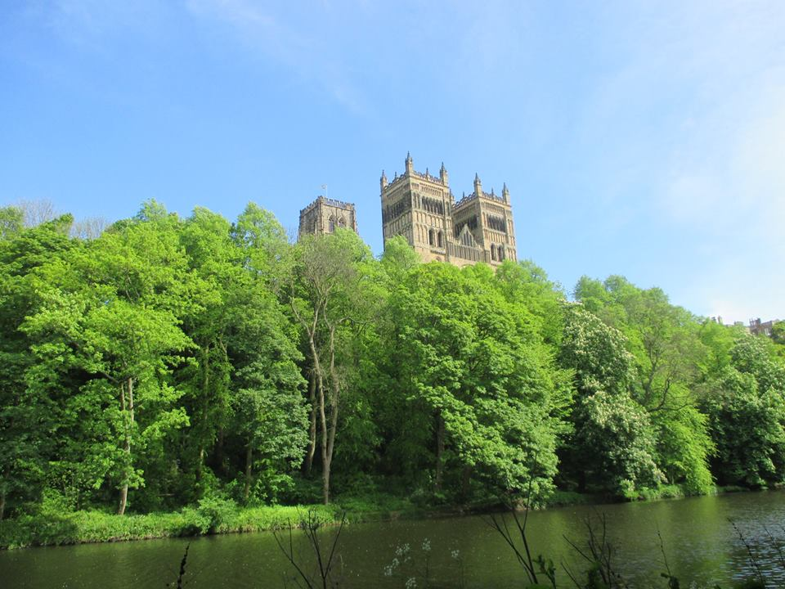
Fig. 4. Durham. Woodland on the riverside.
N-LINK has considered a similar situation in Italy, where the first cellae of the Benedictine community were preferably built in flat lands: only later, when the defensive necessities prevailed, were cults and population moved up to the hilltops, and new churches built (e.g. after the end of the dangerous raids of the Saracens). However, comparison with a new interpretation of the Italian sources suggest that Simeon, a Norman monk of the Durham community, who was interested in accrediting Cuthbert’s community with a peaceful occupation of an abandoned site , could have presented a slightly smoothed version of the story. Defensive reasons are a credible motivation for building a stone church on the top of the hill, but three years to clear a small peninsula from trees seems too much: perhaps much of the peninsula was already occupied, not only a small green in the middle, as Simeon affirmed, but a bigger area where local people cultivated, worked, traded and lived. Three years were necessary to transform this space into a new fortified space surrounded with a timber wall and occupied with new houses.
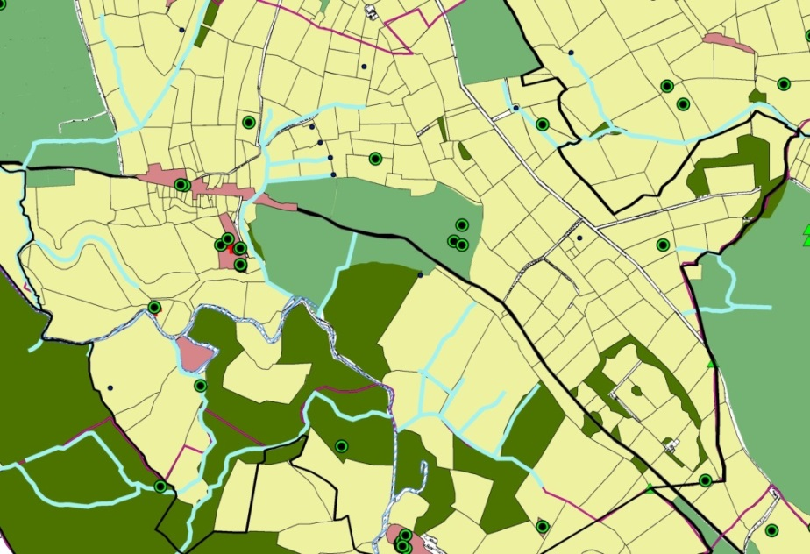
Fig. 5. N-LINK HLC: Witton Gilbert.
A peaceful solution was basically impossible to reach after the Conquest in 1066: when the Normans arrived in Northern England, William I was forced to ravage and destroy the country from Durham to York, in 1069. A few years later, in 1072, the Normans built the castle, and 20 years later the construction of the new cathedral was started. These two massive works completely transformed the site, whose management was entrusted to the bishop. What is more, with the constitution of a Benedictine Priory annexed to the cathedral, the main production of literary sources was carried out by the monks, and the Durham archive reflects the origins of the documents.
Archive research has been targeted at different level, in Italy and in England, according to the differences of conditions and typology of documents. Working on this set of document, the importance of a capillary annotation of place names clearly appeared [the English HLC has been capillary divided into records, which include all recognisable place-names from maps and documents Fig. 5]. Linked to this, a previous Anglo-Saxon settlement pattern can be proposed on the basis of few but important data, especially place-names and archaeological data on some early medieval churches. However, the subsequent analysis of these data does not allow us to accept the use of the word “continuity”, as in the case of Finchale [Fig. 6], which is likely to be the place of at least three meetings in Anglo-Saxon England (in AD 792, 798 and 810); this assembly point in the middle of a waste area of moors and woods, mainly concentrated along the riverside of the Wear, was transformed into a powerful monastery, linked to Durham Priory, after having been an hermitage in about 1104. Finchale, a former assembly place, became the first actor in behalf of Durham Priory engaged to control almost the whole area to the North of Durham.
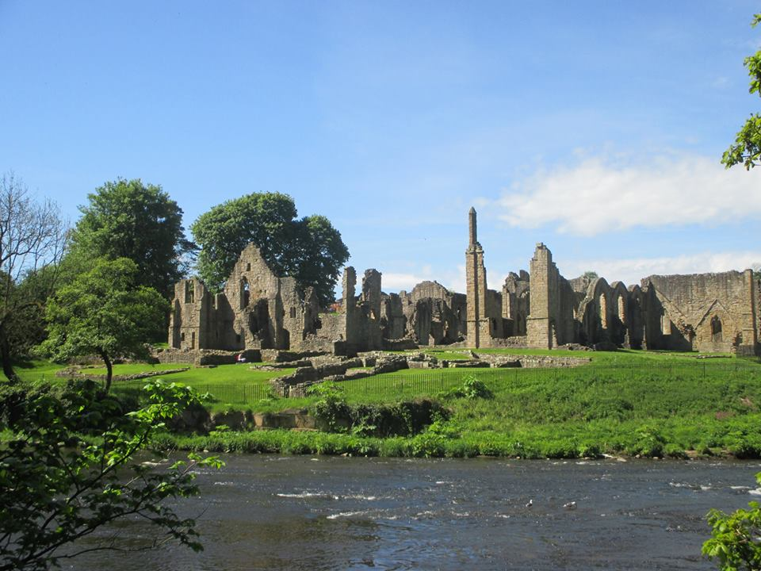
Fig. 6. Finchale Priory.
On the East side of Durham, this research has built on a previous project carried out by Durham University (Britnell 2004), extended from Durham to the sea, which already had recognised a great extent of wasteland around Durham. On the western site of the town, N-LINK has encompassed the land of Newton, Framwellgate, Sacriston Heugh, Witton Gilbert, Pity Me, Bear Park, Alding Grange, Broom, from Finchale to Baxterwood. Besides, the land of Brancepeth and Brandon, on the west side of Durham, have been useful comparisons in trying to understand the difference between the kind of exploitation of land carried on by the Priory and that of important lords around Durham.
Farmers and peasants at Brancepeth and Brandon exploited a huge extension of common land, waste and woodland. A ditch with a particular name (of the Forest) recalls the presence of a large area for hunting, and the organisation of two parks recall the exploitation of land for recreational purposes. Using maps dated from the 18th century it was possible to detect the differences in shape and dimensions for the fields that divided these two parks after the Middle Ages.
Mitford and Morpeth (Northumberland) are by contrast settlements developed from the Norman period forward. Studying their territories was disappointing at the beginning, because of the scarcity of documents; later, the exploitation of tithes awards and other modern sources has suggested a new path to follow, which has been extended to County Durham.
Archaeologists are keen on looking for a previous Anglo-Saxon settlement patterns inside this area, but the results of the N-LINK project suggest that all lands of this territory was radically re-organised after the Norman Conquest. These two settlements are located along the river Wansbeck, and were subjected to a great transformation in more recent times. Two fortified structures (at Morpeth and Mitford) and one important abbey were founded along the river, marking its importance as communication route. No evidence of early medieval life in Mitford has been recorded yet, although Anglo-Saxon people were living and farming in the surrounding area; the idea of “continuity” in this context must be challenged: the creation of a unified kingdom provided the conditions for constant political development, which gradually changed the meaning of many previous features. This concept will be illustrated in forthcoming publications.

1.3.4.4. Italy
Monti Ausoni-Arunci. These two areas were selected on the basis of the Catalogus Baronum (1150-1160s), commissioned by the Norman Italian kings (n. 999, 180), and other available documents, mainly produced from the Montecassino Abbey: these historical sources related to real landscape data have demonstrated that the counts of Fondi (a former Roman town, and later Norman local County, which was the main political centre of the area), considered their main interest to control these mountains and the communications system with the Latina Valley to the North. It makes sense that the lord of Ambrifi, subordinate of the count of Fondi, was Andrea de Pofo, nowadays Pofi, a castrum of the Middle Latina Valley.
In the mountains of Aurunci, more exactly at Roccaguglielma, another Norman lord, “Guillelmus Blassaville tenet feudum j militis et cum augmento obtulit milites ij” (Catalogus Baronum, 816, 149). N-LINK has made clear that the power of this family of Norman lords covered the whole area of the Ausoni and Aurunci Mountains up to the territory of Aquinum. The entries inside the Catalogus related to this mountain area show that all castles (Vallecursa, Lenola, Itri, Campo di Mele, Pastena, San Giovanni, Pico, Pontecorvo) were under Riccardus filius Comitis Goffridi de Aquila.

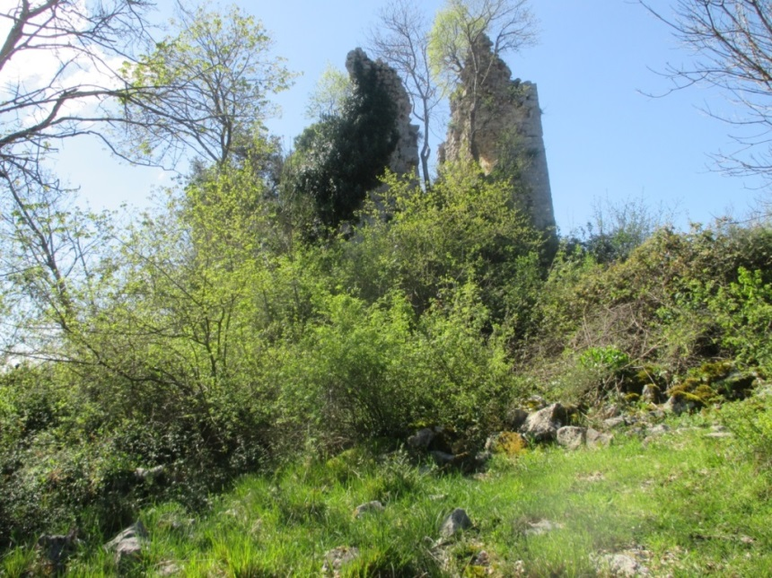
Fig.: 7. Ambrifi. Il Castello
Ambrifi [Fig. 7] is an abandoned castle among the Ausoni Mountains, in the municipality of Lenola (LT): its first mention comes from a document of Montecassino in 1072/1073 but its origins are basically unknown. The situation of complete abandonment, the historical phase during which it appears in medieval sources and the indisputable landscape value in the area of the Ausoni Mountains, led to its inclusion as a case-study for the project.
The land was clearly defined in 1690, when the dismissed feudo d’Ambrise despite being unified with Lenola maintained its own identity with boundaries established since the Middle Ages. These boundaries include different secondary geographical units such as the plain of St. Lucia, at 800 m, the plain of St. Martino, at 670 m ca, and finally the plain of Ambrifi, at 463 m, where the castle at 639 m overlooks a little rural church titled Madonna del Campo, with unknown origins.
The castle was intended to exploit the previously occupied plain lands, and the hills at the same time. Archaeological discoveries of the Roman period at the bottom of the hill (dolium, covered walls, imperial pottery) are recorded: these have demonstrated a kind of soil exploitation, whereas on the mountains around unexpected human activity was revealed up until recent times. This has shaped the profile of the mountains to the North and the South, from the plain of St Lucia up to the top of Mt Chiavino as well as St Martino: shepherds and peasants intensively used the lands by building small macere and complex terraces which marked small or medium karst “terra rossa” plots of land to be cultivated, maybe the arable lands mentioned in the uncial cadastres since the end of the 18th century. A complex system of pits allows the necessary water supply for animals and those people who lived in these areas. Their construction is attested in 19th century maps, but it is likely to have earlier origins. Archaeological excavations started thanks to public funding were carried on in the castle and revealed parts of the medieval quarters of the castrum beside the already visible internal church and the tower, built in order to watch and control the road between Pastena and the sea.
The castle of Ambrifi was built in the course of a specific territorial organisation more than likely due to counts of Fondi, with the clear aim of occupying a useful area for communications and soils between Fondi and Pastena. The contribution of monasteries was relevant for its initial organization from the first decades of the 10th century onward, when after the defeat of Saracens there areas were consequently free for a new economic uses. It is also possible that a first local community grew thanks to the presence of a monastery of St. Elias later developed in a new settlement with a tower and a church. The different climatic assets and the natural existence of lakes, whose memory remains in the local place names, characterised the Ausoni Mountains; this memory supports the hypothesis that a diffuse pasture activity since the Middle Ages tied to seasonal arable activities, enabled this castrum to attain a sustainable autonomy.
Distinctive soil exploitation results from the complex type morphology: a forest occupied the area to the North up to the inclusion of the southern part of the territory of Pastena and the Mounts of the plain of St. Martino. This area of woodland was devoted to hunting, which nowadays is still practised outside the protected area of the Regional Natural Park of Mountains Ausoni and of the Lago di Fondi. The same area comprehended ecclesiastical settlements, particularly monasteries, such as St. Elias and St. Martin, whose possible Greek origins remain to be studied; only after their foundations were they brought into Montecassino’s ownership.
Analysis on the territory of Roccaguglielma’s castle, apparently a Norman Rocca, has reinforced the conclusions from Ambrifi; the land combines a similar karst hinterland with a previous agricultural land use of the plain surface on the valley, where the Liri river flowed separating the territory of Aquinum from that of Roccaguglielma. At the beginning this was territoryof the castle of Pontecorvo, the first fortified village of the counts of Aquinum, which was the 10th century castrum of the area and which successfully managed the region from its site upon the river. The foundation of the Rocca is usually attributed to Guillelmus de Blossaville at the beginning of the 12th century, but a mention of a castle of William may referred to this place already in the second half of the 11th century. Roccaguglielmait is certainly the most complex Italian case-study and enables us to investigate the issue of continuity or not before and after the Norman Conquest in the landscape at its best.
Four different areas can be recognised in the landscape’s territorial organisation. The first is located alongside the river Liri, which was immediately involved in Montecassino’s business, being the site of the church of St. Stephan since the 9th century. Strong evidence of previous land exploitation confirms links between a Roman field system and medieval settlements including monastic Benedictine sites and small villages distributed in the flat area.
The second was the so-called La Foresta, partially woodland and partially flat lands, which was formerly occupied by a Roman villa, and later entrusted to Greek monks by the Counts of Pontecorvo; this was an area called “empty and wild” in modern scholars’ reconstruction, which instead has been shown to have more complex origins thanks to the presence of a Roman villa whose owners occupied an interesting low valley crossed by the La forma Quesa, or Rio Vitellati. Along this ditch, a series of medieval casalia present in the documents from the first half of the 11th century grew over the centuries. Thanks to these dependent settlements, the transformation of the area into a peculiar settlement system of monastic churches (Greek at the beginning, Benedictine later) and villages controlled by the Norman tower at the top of the mountain became the base of an irreversible network, partially preserved until now.
The third was the mountain area called pubblica, which like La Foresta reveals the presence of already organised woodland exploitation in Roman times which continued in the middle ages. It suggests that a local strong economy, connected to pasture and agriculture, had been rationally and effectively organised in this mountains before the end of the 10th century. This land organisation was appealing enough to attract the interests of Montecassino Abbey that succeeded in acquiring these woodlands in the second half of the 11th century. This area is important for showing the passage of the publica into the hands of the community of Roccaguglielma. The term forest applied to the Roccagugliema hinterland area opens other historical problems, but even more interesting is to see this land again destined for public exploitation, with the wider political aim of weakening Montecassino’s power.
The fourth area, consisted of the hills which linked the flat area to the North East of Roccaguglielma with the mountains to the South. Today it is occupied with terraces and terraced fields. This was the area immediately related to the community of Roccaguglielma and that of St. Peter in Curulis once they became the main settlements in this area; both needed to be provided with arable lands just outside the villages but the terraced field system surrounding the castle is usually to be considered as the consequences of the development of the local economy in modern times, starting from the 17th century.
Roccaguglielma appeared in 1107 after the acquisition of Pontecorvo by the Abbey of Montecassino in 1105. This does not confirm that the chronological mention is also the date of construction of this Rocca, but only that, in 1107 and in the area outside the land of St. Benedict with their new boundaries, the castle was important enough to become the main reference of the Norman power. The Rocca is the best example of a Norman castle in the area and the strongest evidence of the different idea of territorial organisation, which developed beside the incastellamento normally considered the main way to exploit the land.
First of all, the case-study has revealed close relationships between the bottom of the valley and the mountains, from ancient times to the Middle Ages: this relationship was never interrupted but transformed over time. In the valley, maintaining a previous exploitation of the flat areas was possibly a legacy of Roman times, resumed by the implantations of Benedictine cellae (two churches of St. Stephen) along the River Liri and later 11th century casalia (unfortified villages). The importance of the river Liri as the main communication route is the strongest explanation for the connection.
In this karst environment, scholars did not considered the difference in climate, in water distribution (presence of place-names like “lake”, or “old lake”, and other linguistic traces that show different hydrological assets in earlier periods), in population, in the Fondi’s territory (the town had a natural barrier toward the sea, an unhealthy marsh and the lake of Fundi, which strengthened the relationships with the hinterland, the Mountains), and they have almost completely ignored the evident considerable influence that the count of Fondi, besides the dukes of Gaeta, had on the Latina Valley. This influence is still visible in the first document that records the presence of the castle of Ambrifi in the area, which is the proof of a comprehensible attempt of the counties of Fundi to establish good relationships with the powerful abbot of Montecassino by donations in this borderline castle’s lands.
The other two case studies and Rocca d’Evandro have been essential in comprehending how the Normans acted in the region, by occupying the only available land remaining to the south, during a slow process of definition, and by confronting Montecassino in a long dispute on the ownership of the lands along the Garigliano. On one hand, these were the areas that have suggested the most consistent “continuity” in the medieval landscape in terms of settlement pattern, based on the first territorial organisation of the Abbey of Montecassino (St. Andrea, St. Ambrogio, St. Apollinare, on the right hand of the River Liri, but also Bantra, the monastery of St. Salvatore de Cocuruzzo on the left side of the river). On the other hand, they have revealed a considerable number of ignored abandoned medieval sites with undefined origins (Mortula, Cocuruzzo, St. Terenziano, Casa Fortini, etc), sometimes named as castra or Rocca, and possibilities of further archaeological research in the field.
Bantra monastica has been finally recognized in a castle at the bottom of a small hill in the territory of Rocca d’Evandro, whose walls are still visible around the top. The site of the medieval Cocuruzzo has been recognized thanks to a place name preserved in the medieval maps, but at Mortula, late medieval farming buildings are preserved at the bottom of the hill where the medieval church still stands. At St. Andrea, St. Ambrogio and St. Apollinare, wartime destruction has led to a complete transformation of the ground during the last century. A further reading of the sources suggested that the Normans occupied these Montecassinos territories, especially the lands along the Garigliano River, remaining as new effective lords for about 30 years. The consequences of this occupation have never been considered: how could scholars be certain that this group of knights looking for power did not produce any effect on the landscape with their choices? What is more, near Rocca d’Evandro, the two castra of Mortula and Camino appeared around 1045, long after the Normans arrived in the region, and we still have no archaeological data from excavations, which could give evidence of their origins. Consequently, we cannot exclude that these castra were a Norman foundation, even because it was only in 1065-1067 that the abbot Desiderius of Montecassino obtained Mortula, Frattarum, Casa Fortini, the Rocca of Cucuruzzo, with the Castellum Teramense, closing any further claims from the Counts of Aquinum along the River Garigliano.

1.3.5. Comparing landscapes as a new approach
This comparative method has uncovered new ways for new approaches without ideological prejudices. Continuity in settlement and landscape exploitation is usually a tendency linked to environmental conditions, which only in few cases can be radically transformed, but a Norman contribution to the landscape exists in terms of the re-organisation of the previous settlement pattern in Durham county after the Harrying of the North (1069-70); similar changes can also be suggested for Northumberland on the basis of the results on Morpeth and Mitford. This important effort made by the Normans in a region where one of the most dangerous constant threats came from the Scottish raids from the North, must be considered of primary importance. The fact that the territory was not included in official surveys like the Domesday Book may signify that a specific policy was thought appropriate for Northumbria, considering its status as a frontier.
The ‘obsession’ for discovering Anglo-Saxon precedents for settlements across UK, might be compared with the reaction of the Italian archaeologists to the famous thesis Toubert’s, who proposed, in 1973, that the phenomenon of the incastellamento was a revolutionary phase in the Italian Middle ages, a rupture between two ideas of settlement pattern, a revolution. In the latter case, archaeologists undertook excavations with the aim of collecting data to counter the core of Toubert’s thesis by highlighting all evidence supporting a continuity of settlement before the building of a castrum.
In England, a Norman castle often stands in a place where an Anglo-Saxon place-name is supposed to justify the existence of a previous settlement. The reconstruction of previous settlement patterns in Northumbria (Northumberland and County Durham) is not simple. Data are dispersed but also sometimes limited to very generic descriptions or considerations on place-names, without archaeological evidence on the ground (e.g. Witton Gilbert). It is interesting to note the lack of research on landscapes to the North of Hadrian’s Wall, even for otherwise well-known periods such as the Roman era. These Northern English Countries need further research.
Results from excavations, compared with written sources, always show that the reality was more complex. In Northumberland archaeological evidence for both Anglo-Saxon and Norman period settlement is meagre, but it is only from the Norman period that many places can demonstrably be shown to be connected into wider networks, usually managed by feudal lords through great castles. Even for those castles where a previous Anglo-Saxon settlement or fortification is reasonably certain (e.g. Bamburgh), the presence of the later Norman fortress is charged with other meanings: the perception of a new landscape becomes immediate. In Northumberland, these fortified features were not numerous, but their distribution in space and time show a precise strategy in occupying lands and controlling roads or rivers.
It is matter of fact that comparing England with Italy, and studying mottes such as Mitford or Morpeth, it is been possible to individuate similar features in Italy (Gallinaro, and Terame), or at least to propose an association between them. If, or when, future archaeological excavations in Italy support this proposal, the consequence will be important even for England: this will confirm that the motte was a widespread Norman tool of conquest in a conquered land, even in Italy.
Similar frontier situations clearly showed a slow process of infiltration that might coincide with an established strategy, in England as in Italy. In both situations, the Normans adopted a slow policy of occupation, which in Italy was justified by the pre-existence of a strong network of Lombard castles. In this part of the country, the evidence from the landscape matched with the data from the sources reveals that this previous settlement pattern became stronger thanks to the Normans, who occupied the only “free” strips of lands in the area examined (the Ausoni - Aurunci Mountains) in two different phases by establishing new rules, for instance in managing previously monastic lands.

4. The potential impact (including the socio-economic impact and the wider societal implications of the project so far) and the main dissemination activities and exploitation of results
4.1. Impact
In the late spring of 2012, on the 7th of May, N-Link project started, aiming to relate landscape studies, historical issues on Norman Diaspora and archaeological GIS. It has been an intense and demanding project from several points of view, with numerous different valuable outputs. The implementation of this project has proved the potential of comparing landscapes as a method to understand historical issues and has transformed the British HLC in a new tool targeted for Italian contexts. Italian archaeologists have already shown interest in this new method and it is ready to facilitate debate, as demonstrated by some of the final activities presented in Italy at the end of N-LINK. The concept of perception applied to landscape archaeology has been immediately received as innovative and interesting.
On the opposite, more difficulties lie in explaining the potential of Italian archaeological map method applied to British context, which is based on a specific strong tradition of studies. Such approaches could be useful for England, but British scholars have yet to recognise their potential.
N-LINK rigorously used appropriate methods to link archaeological data (from field survey, aerial photographs, historical cartography, etc.) to document data using GIS – Geographical Information Systems. In this respect, N-LINK refined methods for using non-archaeological sources in landscape archaeology and the fellow achieved great confidence in using British historical and archaeological sources, comparing methods and different practices. N-LINK collected relevant historic sources and documentation related to the history of the Normans in Italy and UK. Developing a clear knowledge of the history of each area has been fundamental in order to recognise settlement dynamics and decide where and how to research suitable documents, by starting considering and elaborating all kinds of available documents as useful sources (including epigraphy, historical sources, historical maps, medieval and early modern documents, and so on).
This research program has added significant new information and new interpretation of existing data in order to increase knowledge of little considered Norman settlements in a context of political change, opening out studies, before restricted to single countries, to a wider perspective. 'N-LINK' has strengthened digital methods applied to humanities, having demonstrated that archaeologists can contribute to a range of new techniques.
The fellow has operated at two levels: she started from a wider area than necessary to understand needs and methods compared with the full range of issues linked to the British territory. Later, she focused on smaller areas. The GIS reflects this process: it is now possible to implement it for landscape analysis on the selected case studies but it is also ready to be further developed for other projects, first of all the reconstruction of the monastic landscape around Durham and Montecassino, starting from the consideration that the fellow has examined and recorded all available documents before using a selection for the research.
N-LINK has contributed to advance the “State-of-the-Art” on Norman Landscapes in content and methods, and even in practise (“comparing landscapes”): just one year later, other comparative projects on Landscapes or on the Normans have been presented and accepted; this has been considered a further confirmation of the good quality of N-LINK’s original proposal. It has shown that is possible to identify how the Normans contributed to shaping landscapes by understanding particular trends and settlement patterns along the Kingdoms’ borders. The Normans managed the legacy of a previous settlement pattern and established the base for further development. The English tradition of archaeological studies has provided new ideas for explaining old phenomena like incastellamento, but the Italian context has also been revelatory for England.
One of the main sources of data is archival documentation, but medieval documents are basically monastic: in England they are related to the administration of the priory and the bishop of Durham; in Italy, instead, to the administration of the Abbey of Montecassino. This fact means that now it is possible to focus on achieving the aim of reconstructing of the monastic landscape of Durham Priory in a range of 10 miles from the priory site. This will be the next step for future applications by the fellow.
Furthermore, the final publication will also contain the result of an introductory survey aimed at considering the theme of identity and landscape in a wider context, by analysing some of the most important research related to parks and gardens in Norman Italy, starting from the extraordinary example of Palermo. How the Normans approached landscape management in the main centres of their kingdom is also important in explaining the Norman mentality. These results have been anticipated in a seminar for the MA course in Byzantine archaeology at Newcastle University led by Dr Mark Jackson.
N-LINK has begun to demonstrate that the perception of landscape across the centuries is an area of crucial importance. N-LINK has already been successful in promoting the importance of “perception” in Italian landscape studies (Pietrobono and Turner 2013). N-LINK has therefore contributed not only to the professional development and skills of the fellow but also to the diffusion of new perspectives in archaeological contexts.
An example comes from the Ausoni Aurunci mountains, a disadvantaged area today and perhaps the most neglected part of the Lazio region. N-LINK has demonstrated that there has been a deep misunderstanding of the value and role of these places in the Middle Ages. As karst areas, they have been considered lands without water for the last millennia and for this reason, almost never been exploited, with few exceptions, as in the case of Ambrifi. This is erroneous interpretation is deeply rooted in the scientific literature; N-LINK has been able to point out that these mountains were the core of a vital economy in the Middle Ages based on forests and pastures (Fig. 8). In this environment, it has significantly demonstrated that the Normans played a role in shaping and exploiting two border lands in their Kingdoms of England and Sicily (in the former Northumbria and the Principality of Capua), carefully and politically choosing where to develop new or even old settlements.
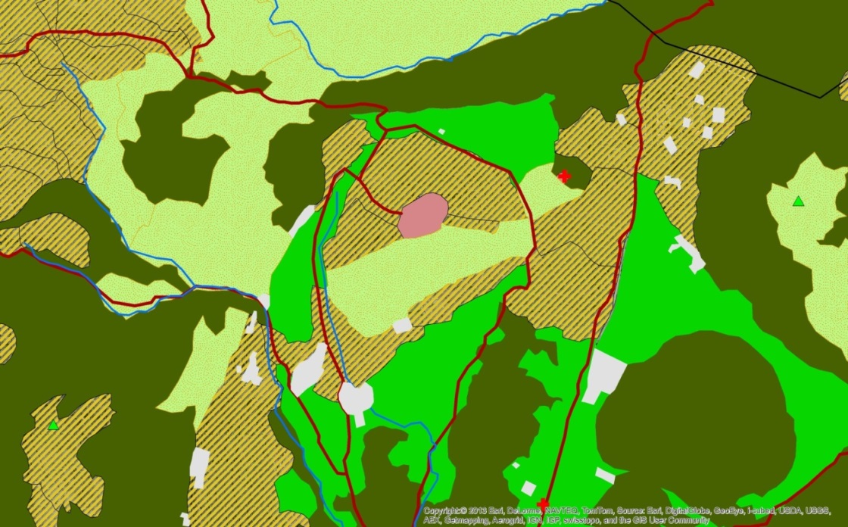
Fig. 8. N-LINK HLC, Ambrifi.

4.1.1. Professional development and skills
The Fellow, Dr Sabrina Pietrobono, has fully achieved the planned programme of work outlined in Annex 1 to the Grant Agreement. She has maintained a consistently high level of criticism toward herself and her performance and has succeeded in working independently. Dr Pietrobono has ensured her work programme has been kept under constant review in relation to emerging results.
In accordance with to the N-LINK project plan, the Fellow has attended GIS courses and improved her knowledge of theoretical archaeology. As planned, an effective way to improve her knowledge of both archaeological theory and British medieval archaeology has been attendance at the research seminars of the host School, including weekly Research Seminars (in Archaeology and History) and participation in seminars of the Landscapes Research Strand and MedLAB Research Forum (both of which are coordinated by the supervisor, Prof. Sam Turner). She has developed an effective knowledge of good practices in GIS, and a strong working knowledge of British medieval archaeology.
In addition, the Fellow has been supported in her GIS work by the Archeomatica group (in Rome), and has established a current collaboration with Archeomatica – mediaGEO group, supported and directed by Dr. M. Fasolo.
This project has increased the researcher’s portfolio of individual competence and skills and enhanced her potential for career development. She established a personal development career plan according to the requirements of the N-LINK project, and has participated in a range of career development activities run by Newcastle University’s Staff Development Unit (SDU), including: Career Bites - CVs and Cover Letters; 4 Steps to Independence; Chairing Power Meetings; Academic Writing; Influential Communications; The Essentials of Project Management; Writing to Persuade; Managing Successful Research Project; Dealing with Difficult People; and participated in a number of SDU e-learning courses (Knowledge Bank Office 2010, Appraisal and performance management, Effective writing, Listening, Meetings, Negotiation, PDR, Persuading and influencing, Presentations, questioning, Stress at work, Time management).
In addition, the Fellow has also participated in seminars and meetings at other Universities, for instance:
1. University of Oxford, Life-long learning course: 8-10 February 2013. Early Medieval defended communities across Europe: Fortified Settlements of the Eighth to Tenth Centuries AD.
2. University of Leeds, 1-4 July 2013. International Medieval Congress (IMC), especially the 4th of July: 'Defended Communities': Fortified Settlements of the 8th-10th Centuries - Origins, Forms, and Functions, I-III.
3. University of Nottingham, 20 - 22 September 2013. “The Archaeology of the Norman Conquest”. Centre for Advanced Studies, University Park Campus.
The Fellow has also attended the Cyprus Marie Curie Action meeting, on 5th – 6th of November 2012 and other important meeting, as in Cork in 2012.
The Fellow has demonstrated an impressive level of self-management by solving several problems on her own and, when necessary, by seeking appropriate individuals to provide assistance and asking for help. In this respect, she has obtained an in-depth knowledge of British academia and the significant cultural differences between working as a scholar in British and Italian contexts. As underlined in the mid-term report, the Fellow experienced some significant problems during the central part of the project. However, the Fellow was able to find a way to obtain the appropriate support in order to resolve difficult communication issues with other staff.
The process of undertaking the project has been very demanding for the participants. It has been a new experience not only for the Fellow but also for the host School, but the Fellow has succeeded in developing a balanced timetable and produced good results for her project. The experience has proved the reality of her independent thinking and her effective potential. The fellow has been successfully reintegrated into the scientific field.

4.2. Dissemination activities
Plans for effective dissemination have been executed at three levels: local, national and international.
In accordance with the project design, the fellow started dissemination activities for local high school students in England and UK: in England, she organised a cycle of 5 classes (“Fascinated by food”) collaborating with a group of other Marie Curie researchers from Newcastle University, during the course of the British Science Festival in Newcastle, from 7th to 12th September 2013; in Italy, she organised 5 meetings with schools and associations of teachers of the Province of Frosinone, Viterbo and Caserta (Associazione AEDE e Movimento Federalista Europeo di Frosinone; Liceo Classico di Viterbo; Liceo Classico e Liceo Psicopedagico di Frosinone; Liceo Classico di Vairano Patenora), from the 5th to the 8th of April 2014.
In May 2014, she taught on ‘Byzantine influences in the Norman Kingdom of Sicily: royal landscapes and architectures’ for the MA in Early Medieval and Byzantine Archaeology, Newcastle University.

Presentation of papers
2012. University of Leeds, International Medieval Congress, on 12th July 2012. The persistence of medieval boundaries in the landscape of Central Italy [Paper No: 1608-b].

2013. 7 November. “Nouz non intrâmes en la terre pour issirent si légement”. Comparing landscapes between Northern England and Southern Italy: the N-LINK project. Newcastle University. MedLAB research seminar.

2014. 30 May, Sora. La "seconda vita" delle epigrafi: casi studio per la ricostruzione dei paesaggi storici nella Valle Latina" in Proceedings of the 10 conference on “Le epigrafi della Val Comino”, directed by H. Solin. Associazione Genesi. (To be published in 2015).

2014. 4-6 June, Rome. Poster (with S. Turner): Paesaggi a confronto: il Progetto N-Link ed il castello di Ambrifi (Lenola, LT). XI Incontro di Studi Lazio e Sabina, Accademia Olandese – Complesso del Vittoriano – British School at Rome. Soprintendenza ai Beni Archeologici del Lazio. (To be published in 2015).

2014. 17-20 September . ‘Comparing landscapes between Northern England and Southern Italy: the N-LINK project’. Accepted proposal for the LAC3 2014 (3rd International Landscape Archaeology Conference), Rome (with following publication).

Publications
2013. Pietrobono, S. and Turner, S. Comparing methods in European context: Historic Landscape Characterisation and new perspectives for research in Italy. Archeologia Postmedievale 14, 2010 (2013).
2014. (accepted, in press) Casale, Villa or Castello? Gallinaro and the Normans in the Medieval Val Comino. Medieval Settlement Research 29.

Further scientific publications
2014. Single-authored monograph. The fellow is working on a book titled Landscapes and Identities of Norman Kingdoms, which will be submitted to the publisher by the end of the summer (This is an additional output to the work planned in the original N-Link project proposal (and Annex 1)).
2014. The fellow is organising a session at the (peer-reviewed) Leeds International Medieval Congress 2014, Europe’s leading medieval conference (9 July) on Norman Landscapes: session titled “Landscapes and Norman Empire: A New Comparative Approach in European Context“. The session (n.1103) includes D. Petts (Durham University) and A. McClain (University of York). The fellow’s paper is titled : 'moult nous seront loing à retorner là dont nouz venîmes': the landscapes of the Norman frontiers in England and Italy. This paper will be submitted to the international peer-reviewed journal Medieval Archaeology by September 2014.
2015. The fellow has been invited to submit a paper to Temporis Signa, University of Rome La Sapienza’s Journal of Medieval Studies by February 2015.

4.2.3. Exploitation of the results
Historical research is clearly different from archaeological research: they can be related but it is often impossible to match the different points of view without extensive training to develop the necessary interdisciplinary skills. With the European Landscape Convention (2000) now ratified in most European countries, it has become hugely important to have trained researchers with passion and new ideas that could contribute to the development of future strategies for managing our common landscape by implementing interdisciplinary tools in archaeology and history. The Fellow has become one of this new generation of researchers: she is currently carrying out further research in the Durham archive that will lead to new research applications and insights.
Landscape change related to factors such as increasing urban population and industrialised agriculture means that multidisciplinary and interdisciplinary strategies are now required to investigate and understand historic landscape evolution. ‘N-LINK’ paves the way for a new interdisciplinary and multidisciplinary approach for the study of landscape archaeology, providing an effective tool to inform for landscape management and for research/innovation: “to present coherent and reliable interpretations about the processes that have shaped the cultural landscape and the periods when these changes took place” (Turner, 2010). The project has successfully contacted and involved stakeholders, particularly the Italian Soprintendenza ai Beni Archeologici del Lazio (thanks to Soprintendente Elena Calandra, and Drs Michaela Angle, Giovanna Rita Bellini, Carlo Molle, Nuccia Ghini and the staff of the Soprintendenza ai Beni Archeologici del Lazio); and Italian municipalities (specifically the sindaci and staff of the technical offices of Rocca d’Evandro, S. Apollinare, S. Ambrogio sul Garigliano, Sant’Andrea del Garigliano, and Lenola). The project has benefitted from coinciding with the recent process of professional recognition of archaeologists in Italy, which means new techniques are finding a more receptive audience.
The cutting-edge historical and archaeological research implemented in ‘N-LINK’ helps to enhance and to develop pan-European networks, yet conserve a local flavour and promote local landscape character and regional identity. In this digital society, the project has demonstrated that moving forward with a fresh interpretation of data opens up an appreciation of the present in the light of the past. Therefore, this project has been able to respond positively to the necessity of learning more about two landscapes and the social necessity of strengthening awareness of the value of local territories in areas that suffer high levels of socio-economic deprivation in their national context, Northumberland, County Durham, the provinces of Frosinone and of Caserta. Collaboration with local, national and international associations (for instance Associazione S. C. Monti Ausoni) will disseminate this new awareness at the local level.
Developing new ideas at the European level in the Humanities is crucial to increasing the attractiveness of Europe for researchers, proving that the EU is a real laboratory with shared awareness and care for its own history. If we can accept that all the physical elements of a landscape can be appreciated as material objects with a range of different but possible values for people in the past and present – whether they are buildings, ruins, earthworks, trees, rivers, hedges, plants, etc, then an ‘archaeological’ approach can give us a good framework for facilitating debate about the landscape and its value today (Pietrobono and Turner 2013). This project has continued the development of a new method applicable in Europe or indeed in other parts of the world which need to protect their landscape and develop environmental policies for effective sustainable growth.
The EU promotes the conscience of shared European Landscapes (Fairclough, 2010), in order to understand and appreciate their values, by means of projects like Cost, Action A27 (‘Landmarks’), “Understanding pre-industrial structures in rural and mining landscapes” (Bartels et al., 2008, 11). Through N-LINK, the fellow is promoting the importance of the common European landscape in both British and Italian communities. The results of the project can contribute to regional strategies for managing the historic landscape in UK and Italy: the fellow is sharing the final results of N-LINK with the appropriate public bodies in each country: in Italy with the “Soprintendenze”, and other regional services of MIUR (Ministry of Education, University and Research); in England through contacts with each county Historic Environment Record (HER) and English Heritage’s National Monument Register (a national database of historic assets).

Bibliography
Alcock, S. E.; Cherry, S. F., 2004. Side-by-side survey: comparative regional studies in the Mediterranean World. Oxford: Oxbow books, 2004.
Arthur, P., 2010. 'Edilizia residenziale di età medievale nell'Italia meridionale: alcune evidenze archeologiche'. In P. Galetti (ed), Edilizia residenziale tra IX-X secolo. Storia e archeologia. Firenze: All'insegna del Giglio, 31-58.
Bartels, C., Bloemers, T., van Londen, H., Orejas, A., Ruiz del Árbol, M., 2008. Introduction, Landmarks – Profiling Europe’s Historic Landscapes, Coast and the Action 27, Veröffentlichungen aus dem Deutschen Bergbau- Museum Bochum, 158, 11-18.
Bresc, H. 2012. Palermo al tempo dei Normanni. Palermo: Dario Flaccovio editore.
Britnell, R. 2004. 'Fields, Farms and Sun-Division in a Moorland Region, 1100-1400'. The Agricultural History Review. Vol. 52, No. 1, 20-37.
Cherubini, G., 2006. 'Popoli, etnie e territorio alla vigilia della conquista. Il mezzogiorno continentale'. In Licinio, R., Violante, F., 2006. I caratteri originali della conquista normanna. Diversita’ ed identita’ nel Mezzogiorno (1030-1130). Bari: Edizioni Dedalo, 67-86.
Creighton, O. H., 2004. 'The rich man in his castle, the poor man at his gate: castle baileys and settlement patterns in Norman England', in Flambard Hericher, A.M., Ettel, P., McNeill, T., (dir.) 2004. Château Gaillard 21: Etudes de castellologie médiévale: La Basse cour; Actes du colloque international de Maynooth (Irlande), 23-30 août 2002. Caen: Publications du CRAHM, 25-36.
Creighton, O. H., 2005. 'Castles and castle-building in town and country', in Giles, K., Dyer, Ch. (eds.), 2005. Town and Country in the Middle Ages: Contrasts, Contacts and Interconnections, 1100–1500, The Society for Medieval Archaeology, Monograph 22, Leeds: Maney, 275-292.
Crow, J. Turner, S. Vionis, A. K., 2011. 'Characterizing the historic landscapes of Naxos', Journal of Mediterranean Archaeology 24(1), 111-137.
Cuteri, F. 2003. I Normanni in finibus Calabriae. Soveria Mannelli (Catanzaro): Rubbettino.Cuteri, F. 2008. 'Motte e villaggi abbandonati in Calabria. Ricerche archeologiche a Motta San Demetrio, Rocca Angitola e Mileto Vecchia'. In G. Lena (a cura di), Ricerche archeologiche e storiche in Calabria. Modelli e prospettive, Atti del convegno di studi in onore di Giovanni Azzimmaturo (Cosenza, 24 marzo 2007), Cosenza: editoriale progetto 2000, 2008, 173-192.
D’Onofrio, M., 1994 (ed). I Normanni popolo d’Europa, MXXX – MCC. Venezia: Marsilio.Drell, J.H. 1999. Cultural syncretism and ethnic identity: The Norman ‘conquest’ of Southern Italy and Sicily. Journal of Medieval History, 25 (3), 187-202.
Fairclough, G., 2010. 'Crossing Frontiers: towards a common European Landscape'. Futuropa. For a new vision of landscape and Territory, (2), 4-5.
Fasolo, M. 2013. Tyndaris e il suo territorio I, Introduzione alla carta archeologica del territorio di Tindari. Roma: MediaGEO.
Faulkner, Th., Berry, H., Gregory J., (eds), 2010. Northern Landscapes: Representations and Realities of North-East England (Regions and Regionalism in History), Woodbridge: The Boydell Press. Fernie, E. C. 2002. The architecture of Norman England. Oxford: Oxford University Press.
Flambard Héricher, A.-M. 2013. La fin d’un châteaud’origine normande en Calabre. Collection de l'École française de Rome 421. l'École française de Rome.
Higham N.J, Ryan M. J., 2010. The Landscape Archaeology of Anglo Saxon England, Woodbridge: The Boydell Press.
Jamison, E. (ed.), 1972. Catalogus Baronum, Fonti per la Storia d'Italia 101. Roma: Istituto storico per il Medioevo.
Licinio, R. 2010. Castelli medievali. Puglia e Basilicata: di Normanni a Federico II e Carlo I d’Angio’. Caratteri mobili: Bari.
Molinari, A. 2010. Paesaggi rurali e formazioni sociali nella Sicilia Islamica, Normanna e Sveva (secoli X-XIII). In «Archeologia Medievale», 37, 229-245.
Petts, D., Turner, S. (eds), 2011. Early Medieval Northumbria: Kingdoms and Communities 450-1100. Studies in the Early Middle Ages 24, Brepols: Turnhout.
Pietrobono, S. 2006. Carta Archeologica Medievale – Frosinone. Forma Italiae Medii Aevi, F.159 – I. Firenze: All’Insegna del Giglio.
Pietrobono, S. ‘Casale, Villa o Castello? Gallinaro and the Normans in the Medieval Val Comino’. Medieval Settlement Research 29. Forthcoming.
Pietrobono, S. and Turner, S. 2013. ‘Comparing methods in European context: Historic Landscape Characterisation and new perspectives for research in Italy’. Archeologia Postmedievale 14 (2010), 111-133.
Quilici, L. and Quilici Gigli, S. (a cura di) 2012. Carta Archeologica e Ricerche in Campania 6. Roma: L’Erma di Bretschneider.
Rollason, D.W. 2000. Symeon of Durham. Libellus de exordio atque procursu istius hoc est Dunelmensis ecclesie (Church of Durham). Oxford Medieval Texts. Oxford: Oxford University Press.Rollason, D. W. 2003. Northumbria 500-1100: Creation and Destruction of a Kingdom. Cambridge: Cambridge University Press.
Stagno, A. 2009. Archeologia rurale. Uno statuto debole. In Volpe G. (a cura di), Atti del “V Congresso nazionale di archeologia medievale Foggia 1 - 3 ottobre 2009”, All’Insegna del Giglio, Firenze, 20-25.
Sommella, P. 2009. Esperienze documentali sul territorio dagli anni ’80 ad oggi. Alcune considerazioni. Archeologia e Calcolatori. 20, 2009, 47-59.
Turner, S., 2010. 'Historic Landscape Characterisation: an introduction to methods and applications for historical research'. Territori i Societat: el paisatge historic 5, 17-39.
Turner, S., Fairclough, G.J., 2007. 'Common Culture: the Archaeology of Landscape Character in Europe'. In Hicks, D., McAtackney, L., Fairclough, G.J., (ed.), 2007. Envisioning Landscape: Situations and Standpoints in Archaeology and Heritage, Walnut Creek, CA: Left Coast Press, 120-145.
Turner, S., S. Semple and A. Turner, 2013. Wearmouth and Jarrow. Northumbrian monasteries in an historic landscape. Hatfield: University of Hertfordshire Press.
Collins, S. 2014. Tyne and Wear Historic Landscape Characterisation Final Report. http://www.ncl.ac.uk/mccordcentre/research/researchreports/McCord_Centre_Report_2014.1.pdf
Valenti, M. 2012. 'Per un approccio neo processualista al dato archeologico'. In Redi Fabio, Forgione Alfonso (a cura di), VI Congresso Nazionale di Archeologia Medievale, L'Aquila, 12-16 settembre 2012, Firenze 2012, 8-11.

5. The address of the project public website, if applicable as well as relevant contact details.
In accordance with the project plan, the Fellow has established a project blog as a vehicle to provide updates for stakeholders. In addition, she uses social media including LinkedIn, Facebook, Google+ and Academia to disseminate information about the project. The blog is linked from this page: http://www.ncl.ac.uk/historical/research/project/4853 (or at http://n-link.blogspot.co.uk).

