


COLL-CT-2006-030300

COMFOR

Collective work science approach to solving common problems of occupational health and performance in European forest operations SMEs

Instrument: Collective Research Project

Thematic Priority: Specific activities covering a wider field of research

FINAL ACTIVITY REPORT

Period covered: from 01.06.2006 to 31.05.2009 Date of preparation: 15.08.2009

Start date of project: 01.06.2006 Duration: 36 Month

Project coordinator name: Dr. Edgar Kastenholz

Project coordinator
organisation name: European Network of Forest Entrepreneurs

Revision [final]


Collective Research to overcome common problems of occupational health and performance in European forest operations SMEs

Final Activity Report

Abstract

COMFOR aimed at developing an innovative knowledge transfer concept for SMEs in forest operations. This was achieved by providing seven tools and methods which will have a long term effect on health and performance, and which are tested, approved and acknowledged by contractors themselves. The concept was the result of continuous development work on the “Tools”, based on repeated testing and evaluation by the partner SMEs, resulting in a focused user-friendly educative package. The development work was based on research activities carried out by the partner Universities. Results of empirical studies, which started at the beginning of the project, are available in reports which contribute to the scientific knowledge about SMEs in forest operations.

The COMFOR tools and methods have already found their way into the forestry contracting sector due to extensive dissemination and training activities in the final period of COMFOR. Training concepts and packages were individually designed for the respective conditions in each of the ten participating countries. There has been widespread acceptance of the tools and they are already being considered for incorporation into a number of contractor training and certification schemes in the participating countries. A variety of multipliers for future implementation was mobilised and trained by the COMFOR team. This will ensure that the results of three year extensive co-operation between 21 partners from 10 countries will reach the target group SMEs in forest operations, and will contribute to their health and performance through improved economic viability.

1. Project Execution

The objectives: knowledge transfer for improved health and performance

The objective of COMFOR was to develop an innovative knowledge transfer concept for SMEs in forest operations. While current ergonomic research provides answers for healthier working practices which also improve performance there are still difficulties in putting science into practice for these businesses, who face practical and financial barriers to change their way of working, and who are not in a position to undertake research and development themselves.

The pan-European problem of poor occupational health and economic performance called for a collective solution. COMFOR transformed science into practice by researching and developing means and measures which will enable and encourage SMEs to adopt ergonomically sound working practices. COMFOR has trained the national Forestry Contracting Associations in these methods of knowledge transfer, thus mobilising the results of the research to a wide body of forestry contractors in Europe.

The COMFOR Consortium

COMFOR has gathered a consortium of 21 partners which was directed by ten forest entrepreneurs (SMEs), who provided research demands, tested and piloted the solutions and who were assisted by their National Entrepreneur Associations.

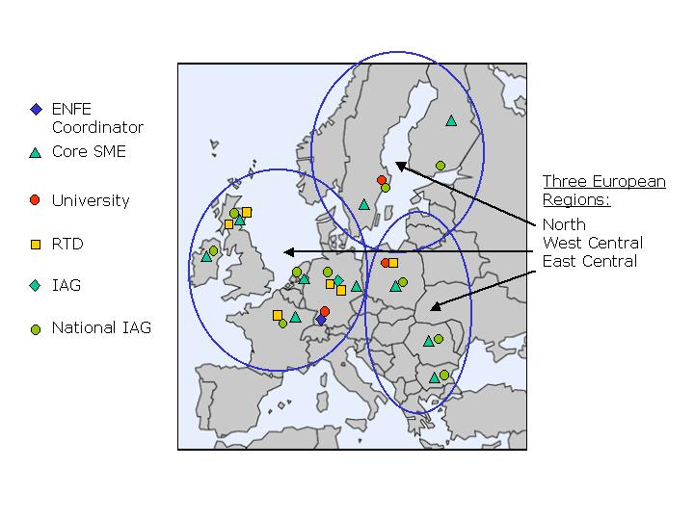
Figure 1: COMFOR works in three regions:
North, West Central and East Central Europe

Three universities with proven track records in ergonomics & economics, learning and knowledge transfer, and the implications of regional structural change undertook the basic research.

Six applied Research, Training and Development Organisations (RTDs) from across North, West Central and East Central Europe ensured that the results of this project are fit for purpose in their practical application to forest operations businesses. ENFE representing National Forestry Contracting Associations and QfF in Germany, a social partnership, disseminated the results and trained the National Associations in the use of the knowledge transfer packages, thus mobilising the results of the research to a wide body of businesses.

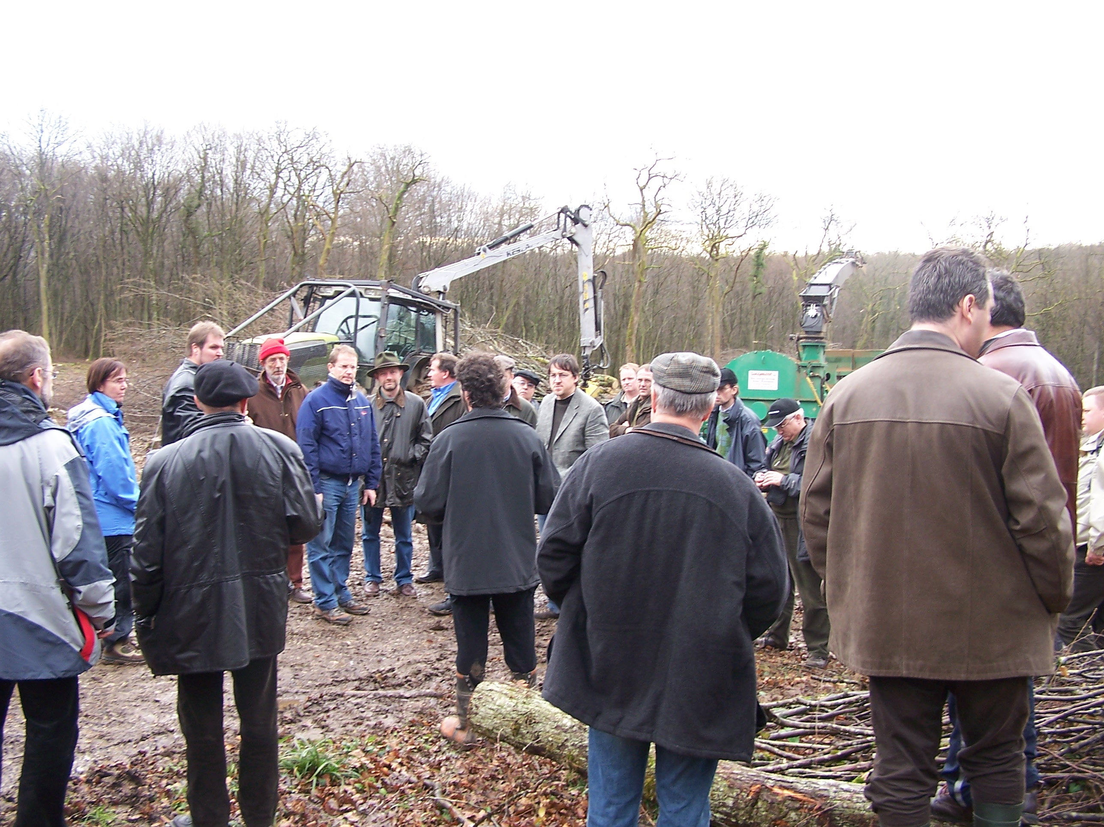
Six consortium meetings were held to manage and organise the work and the co-operation between the 21 partners. To highlight the applied research approach all consortium meetings were structured to ensure the integration of the Core SME Group by organizing, as part of the consortium meetings, a visit to the forest operations of the contractor based in the host country. Meetings were held in the Netherlands, France, Romania, Finland, Scotland, and Germany. This was proven as being appreciated by all partners, because it allowed insight in the specific working conditions in the respective country.

Figure 2: COMFOR partners at a field trip to operations
of its French SME partner Sundgaubois

The co-ordination of the project progress was facilitated by a Management Team which consisted of the technical work package leaders Barrie Hudson (WP1 empirical studies), Folke Bohlin (WP2 research), Ewa Lidén (WP3 design of tool packages), Maryse Bigot (WP4 training), and the project co-ordinator Edgar Kastenholz (WP5 management). This team co-operated during the whole duration closely particularly with monthly telephone conferences, email communication and ad hoc meetings when found necessary to facilitate proper management.
Case studies and regional reports form the empirical basis for knowledge transfer

The first year of the project was dedicated to investigate SMEs´ enterprise and work environment in case studies with the ten partner SMEs, accompanied by establishing the current stage of development and frame conditions for the workforce in forest operations in ten European countries. To this end the six applied RTDs in the consortium carried out an inquiry of the frame conditions for forest operations in the ten countries by desk research and data collection with various stakeholders, and they undertook in depth interviews with all SME partners. The empirical work was based on an inquiry guideline which was developed with input from all RTD partners.

This first phase of data collection was completed after 12 months of the project, and detailed empirical data from all 10 countries and all 10 core SMEs were available for the Universities for their first analysis. The three universities used the data to undertake the basic research:
- Research into how business management of forestry SMEs can best be developed to allow for the economic effects of ergonomic improvements and investment. (Swedish University of Agricultural Sciences)
- Research into business management and ergonomic investment (Swedish University of Agricultural Sciences)
- Pedagogic research into the most effective learning styles for forest operations SMEs in the three European regions which will encourage the uptake of good ergonomic practice (University of Freiburg)
- Research into SME learning styles (University of Freiburg)
- Research into how the structural change to mechanised harvesting affects the take up of ergonomic good practice in the three European regions by explaining the effects of structural change on SMEs. (Warsaw Agricultural University).
First interim results were presented to partners at the 3rd consortium meeting held in June 2007. Discussion papers and presentations to the consortium were delivered, outlining theoretical background and methodological assumptions guiding their research activities.

A longitudinal study to develop a methodology for measuring the health and economic benefits of ergonomic investment across the 10 Core SMEs was started by the Swedish University of Agricultural Sciences, developing a cost/benefit calculation tool. These have been included in the subsequent field work carried out with the SMEs, where the applicability of the proposed modes of calculations was tested. Feedback was collected from a number of SMEs for further development of the cost/benefit analysis procedures.

The empirical case studies with the ten COMFOR SMEs provided in depth information about three issues, where the scientific state of the arts lacked deeper insight. This gap has been closed with three scientific papers which have been edited and will be published in scientific series:
- The report “ergonomic and economic efficiency in mechanised forestry” provides a contribution to the long standing challenge how to estimate cost of ill health and how to economically justify investment in health protection and organisational improvement in enterprises. A method is provided how to monitor long term health related effects in enterprises. The instrument for estimating cost of ill health and benefit of ergonomic measures became part of the COMFOR tool package.
- The report “Impact of structural change on health and performance including an explanative model” provides a broad overview of structural data in the ten participating countries and brings them in relation to overall socio-economic parameters such as employment and economic situations in European regions. This report provides particular insight in the economic frame conditions in the Eastern European countries, where the general economic development is still a restriction to enterprise development in forestry SMEs. This again has a considerable impact on the implementation of the COMFOR results, which is quite easy for example in the Nordic countries, but which is difficult in the Eastern countries where the process of technical development in forest operations has not happened with the momentum expected when COMFOR was planned.
- The report “Optimum educative techniques” offers fruitful insight into the current state of understanding and practice in the field of competence development and knowledge transfer in the forestry operations sector, especially with regard to occupational safety and health. It reflects approaches on learning, education and knowledge transfer. It describes the learning conditions of forestry contractors in three different regions (Northern Europe, West Central Europe, East Central Europe), and it provides conclusive recommendations regarding factors influencing “successful” knowledge transfer.
These reports are available on the COMFOR website.

Customised training packages respect national conditions

Based on the results achieved in the first 12 months, Ewa Lidén (delo) started the process of designing the educative packages for improving performance and occupational health situation for SMEs and micro businesses in forest operations.

Ergonomic and work organisation best practice was known and available in various publications before COMFOR started. The aim was to process this knowledge into a form and into procedures which meet SMEs´ demands and perceptions, and which is adapted to their learning cultures. The design of these tools was the continuous development work of three years. In the third COMFOR year the tools were tested, evaluated, and continuously amended in co-operation with the research team and the COMFOR SME partners.

The final result is the Educational Package 'The Tools'. These are the training packages with instruments to improve health and performance, including the methodology for monitoring long term effectiveness. It is a system of educative packages which are connected to each other via a method for continuous development, the so called 'The Process'. In total seven packages are available, it is to be noted that the development of these seven packages, as a result of continuous iteration in the working process, exceeds the initial expectations in the description of works, which proposed only three knowledge transfer packages.

The figure below illustrates the set of tools and the process how they build upon each other and how they are linked. It is recommended that all the tools are used in a development process in an enterprise, but it must also be noted that they can also be applied individually.

Each of the seven tools and the process are accompanied by explanation and instruction material, which enables a contractor to use the tools without further assistance by a trainer or consultant. However, it has been shown in the COMFOR process, that even if the aim was to reduce complexity as far as possible, for many contractors it will be useful to have professional support in the application of this “process”. This led to the demand of training for trainers which was the subject of extensive training activities.
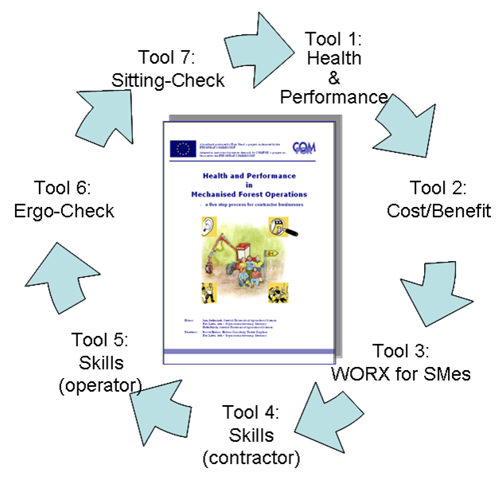

Figure 3: The COMFOR system of educational packages

The tools are available on the internet at www.enfe.net/comfor.htm in all national languages and are ready for use by National Contractor Associations and their member contractors.

Training multipliers and SMEs to enable effective exploitation of the Tools

It was observed at an early point in the COMFOR progress that direct training of a considerable number of contractors would be far beyond the possibilities and resources of COMFOR. Therefore, it was decided to work with organisations which already are active in training or consulting processes with contractors. These organisations were trained in the use and application of the tools.

The planning and scheduling of the training in the ten countries was carried out stepwise under leadership of the Institute Technologique FCBA (partner 7) and with input from the six applied researchers, and the ENFE members, the National Contractor Associations. The work included the following steps:

  - The design of a generic structure for a training syllabus by partner 7 to enable a consistent approach towards the training activities.
  - The preparation of a training plan for each country where the target groups, the training content and a schedule was outlined. This generated training packages which were customised for the specific national conditions in the respective country.
  - Training based on the structures and recommendations provided in the COMFOR training modules.

A handbook “Training activities – recommendations for the trainers” a useful aid for further training to apply the COMFOR tools in practice has been prepared. This is a generic instrument to support future users in preparing efficient training programs and sessions.

As mentioned above it was observed at an early point in the COMFOR progress that direct training of a considerable number of contractors would be far beyond the possibilities and resources of COMFOR. One of the most important experiences in working with contractors is that they can not always be called in for workshops or seminars, because they always will give the highest priority to keeping their business running. The difficulty to reach the target group forestry contractors was reflected already at the very beginning of COMFOR, it is a core result of the research activities in COMFOR, and as such it has been reported in various reporting stages throughout the project duration. They have to be addressed with knowledge and innovative methods like the COMFOR results, when they are already at a training site, or when they feel the need for training. Therefore, it was decided to work with organisations which already are active in training or consulting processes with contractors.

An inquiry among the SMEs and the applied researchers in COMFOR showed that there is a number of such “multipliers” in every country which have the credibility and the capacities to implement enterprise development concepts. These multipliers were addressed as the major target group for training by the COMFOR consortium.

With the availability of the tools and the recommendations for trainers on the internet and with the maintenance of these documents by ENFE the continuous use and further training of multipliers is ensured. A huge benefit of the consortium is that particularly the applied RTDs have taken a leading role for the future in the application of the tools. They have shown a keen interest in using the results to the widest possible extent in their own training and consulting activities. With this they will support the National Contractor Associations in their goal to improve the health and performance of their membership.
Already by the end of the project a considerable implementation of the results has been carried out, this visible uptake is a major result for COMFOR. However, the biggest part of implementation requires future activities. The acknowledgement by many experts, which have been trained, or informed about the tools, ensures that in due time the COMFOR results will reach a wide range of forestry contractors in Europe.

2. Dissemination and use of the results

COMFOR has finally led to the two exploitable results which are described in the following sections. These two products are clearly framed as a set of documents and methods which are already being used, and will continue to be used, in practice.

2.1 Educational Package “The Tools”

The educational Package “The Tools” are the seven training packages to improve health and performance, including a methodology for monitoring long term effectiveness. It is a system of educative packages which are connected to each other via a method for continuous development, the 'The Process'. In total seven packages have been developed and customized, which means they have been adapted through a continuous development process over the three years of COMFOR into tools which correspond to the needs of SMEs in forest operations and are user-friendly in their application.

Each of the seven tools and the process are accompanied by explanation and instruction material, which enables a contractor to use the tools without further instruction by a trainer or consultant. However, it has shown in the COMFOR process, that even if the aim was to reduce complexity as far as possible, for many contractors it will be useful to have professional support in the application of this “process”. The system is described in detail in the report “Tested and proved knowledge transfer packages” (D3 of the COMFOR deliveries).

All the tools have been translated into the participating country languages. They are available and possible to download at the COMFOR website www.enfe.net/comfor.htm.

The exploitation of the tools will mainly be the role of the National Contractor Associations (i.e. ENFE members). The implementation has already started during the project and further exploitation activities will immediately follow after the project end. Since exploitation aims at an outreach to as many contractors as possible, the applied RTDs in the consortium play a specific role in the exploitation. They are in all cases the leading multiplier and will use the tools in their enterprise development activities. Further, they also have, beside their research activities, a development branch, which enables them to carry out consultancy towards enterprises (this was, by the way, one of the reasons why they were chosen as partners in COMFOR).

The COMFOR tools will generally be provided royalty free to SMEs in forest operations. The main channel for dissemination is the COMFOR website, where they are free for download. This serves the intention that COMFOR wants to achieve the widest possible dissemination of the results, and thereby improve health and performance in forest operations, rather than gaining profit by selling the tools. It is the intention of ENFE, QfF and their respective membership to provide services to their membership SMEs, to support them in their economic development and viability. Therefore, the project products are accessible and affordable for SMEs and micro enterprises without economic barriers.

There is a considerable difference in the ways the tools will be exploited in the ten countries and in other countries in Europe. Initial reaction to the tools has been extremely favourable in all ten countries participating in the project. It is worth picking just three examples of potential future exploitation, in Finland the COMFOR results have been taken up by one of the major forestry insurers who are contributing to their development and dissemination to a wide section of the forestry contracting sector. In the Netherlands the tools will be incorporated into an existing contractor certification scheme. In the UK, the tools, in whole or in part, are to be incorporated into the existing machine operator certification scheme during the current review process. During the project the activities were focused on performing the tasks according to the work plan in the ten countries where COMFOR partners were based. Of course, it is intended to exploit the COMFOR results as wide in Europe as possible. Therefore COMFOR will be promoted to all ENFE member organizations.

Like any investment in health and safety, the impact of the application of COMFOR results can not be measured on a short term basis. The general impact is that contractors, who use the COMFOR results, become aware of health problems in their enterprise, achieve awareness of the economic impact of health problems and the benefit of investment in ergonomics and work organisation. Further to this, COMFOR contributes to a continuous development of their enterprise, which on a long term will lead to economic benefits. The feedback from the partner enterprises and others involved in COMFOR trainings clearly supports these expectations.

2.2 Recommendations for trainers

The process of designing training programs in the ten countries where the COMFOR project operated has lead to exploitable results in the form of a handbook titled “Training activities – recommendations for the trainers”

This is a generic tool to support the owners of the knowledge and their partners in implementing the tools to prepare efficient training programs and sessions. This handbook contains:
- the general format of a training session. Special instructions are given to handle the principal steps of the training sessions:
- Step 1: Introduction of the session (How to present and start the training session)
- Step 2: Delivery of the core of the training,
- Step 3: Evaluation of the training session.
- the special approach and content regarding the Process and the different Tools. “Identity cards” are elaborated for the process and for the 7 tools to help COMFOR trainers to deliver training on these different materials. An identity card is a description of the tool with recommendations for the transfer activity:
  - Field of application (+ type of data necessary for application)
  - COMFOR feed back : some motivating arguments from the piloting period
  - Type of tool : monitoring tool, calculation tool or work book
  - Documents: handbook, excel file, pdf file…
  - Frequency of application
  - Concerned persons
  - Directions for use
  - Recommendations for the training (when training a group or when coaching a contractor).

- a template of two documents to use during the training sessions:
- a participants list template (see appendix 4)
- a trainee’s satisfaction inquiry sheet template, a so called happy sheet, (see appendix 5)

The recommendations for trainers were used during the course of the training phase in COMFOR, to design their respective training activities. Since the recommendations have been proven to be effective to facilitate training, they are now provided free of charge for download on the COMFOR website.

2.3 Main scientific results

The research results of the three universities have resulted in three research reports, which are already available as COMFOR reports, and also are being published in university publication series to become accessible for a wider scientific audience.

The three reports are:
- Ergonomic and economic efficiency in mechanised forestry
- Impact of structural change on health and performance including an explanative model
- Optimum educative techniques

COMFOR results have been published in a variety of articles and were presented in ten papers in scientific conferences. A world wide scientific community on forest operations and work science was addressed with two invited papers at the 3rd Forest Engineering Conference held in October 1-4, 2007 in Mont Tremblant, Quebec. Oral and poster presentations were given on various occasions, for example in the General Assemblies of the Contractors Associations in all ten countries.
The participation in a panel discussion at the KWF fair in 2008, one of the most important forestry shows in Europe, addressed a broad audience of professional and scientists. A number of international seminars and meetings has been used to inform about COMFOR and its progress with poster and power-point presentations.
An overview on publications is available and will be further updated on the COMFOR website.
More and updated information is available at:

www.enfe.net/comfor.htm

Coordinator contact details:

ENFE - European Network of Forest Entrepreneurs e.V.
Secretariat General

Rütteberg 10, D-79294 Sölden, Germany
www.enfe.net - secretariat@enfe.net

Contact Person:

Dr. Edgar Kastenholz
ENFE Secretary General

