


Project no. : 030806
Project acronym: ILDAS
Project title: In-flight Lightning Damage Assessment System

Instrument: STREP
Thematic Priority: Aeronautics

FINAL PUBLISHABLE INFORMATION
– ADAPTED FROM FINAL REPORT

After completing the analysis of the A320 ground test and the helicopter ground test, the Final Review was held at 28 July 2009, at EADS_IW, Toulouse. The meeting was attended by most partners and two members of the Advisory Board.
It could be concluded that the results were very positive, meaning that the ILDAS project objectives were fully met.

A brief description of the ILDAS Research project can be found on the public website hosted by NLR. This website will be kept active for at least one year after the project end date.

The web URL is:
http://ildas.nlr.nl

The end results of the ILDAS research project are the deliverables as defined in the Deliverables List.
These documents are not publishable, but the overall end result of ILDAS have been described in a Paper that was compiled for the International Conference on Lightning and static Electricity, held in Pittsfield, MA, USA, from 15 to 17 September 2009.

Paper Reference details:
In-flight Lightning Damage Assessment System (ILDAS) - Results of the Concept Prototype tests - Rob Zwemmer, Michiel Bardet, Alte de Boer, John Hardwick, Keith Hawkins, Daniel Morgan, Mathieu Latorre, Nicolas Marchand, Jeremy Ramos, Ivan Revel, Wolfgang Tauber.

The ILDAS Paper was presented in three consecutive 30 minutes presentations by Rob Zwemmer (NLR), Dan Brown (Cobham) and Ivan Revel (EADS-IW).

The ILDAS Team received the ICOLSE 2009 Best Paper Award for their paper; from in total 44 papers the paper was regarded the best one! This is surely recognition of our effort we performed in the ILDAS project as a team.


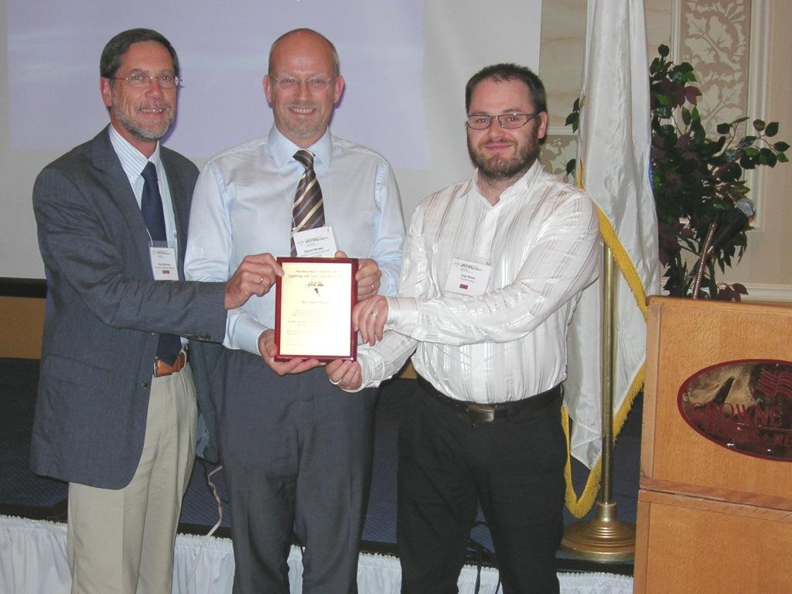

ILDAS Concluding Paper

The text in the Appendix is the ILDAS paper In-flight Lightning Damage Assessment System (ILDAS) - Results of the Concept Prototype tests - .

APPENDIX: ILDAS paper In-flight Lightning Damage Assessment System (ILDAS) - Results of the Concept Prototype tests – , Paper presented at the ICOLSE 2009, Pittsfield, MA,USA, 15-17 September 2009 Paper AAA-1A,B,C

ICOLSE 2009, Pittsfield, MA,USA, 15-17 September 2009 Paper AAA-1A,B,C

In-flight Lightning Damage Assessment System (ILDAS)
Results of the Concept Prototype tests

Rob Zwemmer, Michiel Bardet, Alte de Boer
National Aerospace Laboratory NLR, Amsterdam, The Netherlands

John Hardwick, Keith Hawkins, Daniel Morgan
Cobham Technical Services, Lightning Testing and Consultancy, Abingdon, United Kingdom

Mathieu Latorre
Nexio, Toulouse, France

Nicolas Marchand
Groupe Socius, Labarthe-Inard, France

Jeremy Ramos
Airbus France, Toulouse, France

Ivan Revel
EADS Innovation Works, Toulouse, France

Wolfgang Tauber
Eurocopter Deutschland, Ottobrunn, Germany

Abstract

The In-flight Lightning Strike Damage Assessment System ILDAS was a research project within the scope of Aeronautics Research of the 6th Framework Programme of the European Commission.

The first objective of the ILDAS research project was to develop and validate a concept prototype of an ILDAS, capable of in-flight measurement of the parameters of lightning strikes. Such a system would give in due course better knowledge of these parameters that could be used to improve aircraft lighting protection. Based on the reconstructed attachment points and amplitudes of the in-flight lightning strike in real time, the second objective was to enable the development of tailored and efficient maintenance inspection procedures that must be applied after a recorded strike.

In order to achieve these objectives, it was necessary to develop a measurement system concept prototype. ILDAS uses advanced sensor techniques that enables characterization of lightning strike parameters from the measured electric fields on, and the current flowing in the aircraft skin. For the purpose of measured data interpretation, the development and implementation of an innovative Inverse Method, based on a numerical simulation of the lightning current propagation, have been performed. Finally a database concept has been realised, enabling subsequent exploitation.

The validation of the various types of sensors and the entire ILDAS Concept Prototype system has been done. The validation comprised simulated lightning tests on a bespoke rig fitted with the system in the UK and its installation and ground testing on an Airbus A320 in France. Characterisation of current flow patterns from simulated strikes to a helicopter has been done in Germany.

After reviewing the project objectives, this paper describes the ILDAS concept prototype, including the different types of sensors. The key results of the rig test, A320 ground test and helicopter test campaigns are presented. The analysis of the data from the A320 tests using a specially developed EM tool kit is reviewed. After the ILDAS research project, a further industrialisation phase will be needed before it can actually fly on a test aircraft.

In conclusion, the principle of an in-flight lightning strike measurement system has been successfully validated. All the subsystems performed in an acceptable way. It was possible to measure aircraft skin currents resulting from a simulated strike. The measurements were of a sufficient quality to enable the determination of the entry/exit scenarios as well as the reconstruction of the injected current, After some necessary improvements to the prototype, it is likely that real lightning measurements will be performed within two or three years by fitting on a test aircraft during icing trials. The analysis of these data will benefit the industrial and scientific lightning community, improving the knowledge of the phenomenon and possibly leading to better-tailored lightning protection.

Project Description

Project Objectives
The In-flight Lightning Strike Damage Assessment System ILDAS was a research project within the scope of Aeronautics Research of the 6th Framework Programme of the European Commission. The project started in October 2006 and was completed in July 2009. The project was a joint effort of twelve European companies, see Figure 1. Details of the project were earlier described in reference 1.

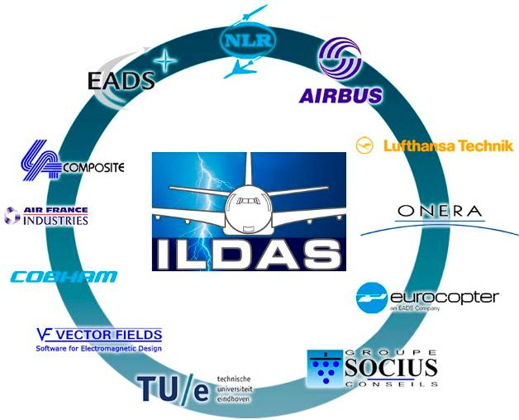
Figure 1. ILDAS Partners

The first objective of the ILDAS research project was to develop and validate a concept prototype of an ILDAS, capable of in-flight measurement of the parameters of lightning strikes. Such a system would give in due course better knowledge of these parameters that could be used to improve aircraft lightning protection. Based on the reconstructed attachment points and amplitudes of the in-flight lightning strike in real time, the second objective was to enable the development of tailored and efficient maintenance inspection procedures that must be applied after a recorded strike.

In order to achieve these high-level objectives, it was necessary to develop an innovative and efficient measurement concept, build a Concept Prototype and validate its potential as a system for in-flight measurement of lightning strikes to aircraft. ILDAS uses advanced smart sensor techniques which enable characterization of lightning strike parameters and current flowing through the aircraft skin during an in-flight lightning strike. For the purpose of measured data interpretation, development and implementation of an Inverse Method, based on a numerical simulation of the lightning current distribution, has been performed within the project. Finally a database concept has been defined dedicated to the measured currents and reconstructed lightning strike data, enabling subsequent exploitation.

Project scope and further exploitation
The project was primarily focussed on Airbus fixed-wing aircraft. Adaptation to helicopters, which is of particular interest given the use of composite materials on them, is also considered. In the limited time frame of the project, flight tests were not planned. Ground tests have been performed on a Test Rig, on an Airbus A320 and on an EC135 helicopter.

The aircraft part of the ILDAS Concept Prototype is neither strictly a prototype in the sense that it can be used for certification purposes nor does it represent a pre-production prototype. Within the scope of the project, the Concept Prototype was necessary to validate the system concept during ground tests. Throughout the development of the system, certification aspects have been taken into account as much as possible to ease later industrialization and certification of the system after the end of the ILDAS project.

As shown in Figure 2, a number of lightning sensor assemblies have been developed, strategically located on the aircraft, which were able to measure the H field, both for low and high frequency spectra. Acquisition and Processing subsystems are applied to reconstruct the original lightning strike phenomenon and to determine the attachment locations.

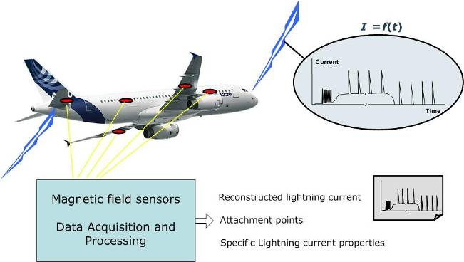
Figure 2. Lightning Characterization on the aircraft

ILDAS Concept Prototype

System description
Figure 3 shows the block diagram of the ILDAS on-board and ground subsystems, comprising the distributed Sensor Assemblies which each consist of several sensors and a local electronics unit, the Data Accumulation and Data Storage Unit (DADS), the Ground Support Equipment (GSE) and the EM Toolkit analysis software.

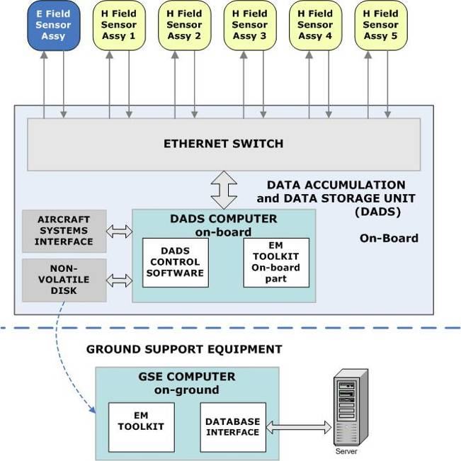
Figure 3. ILDAS System concept

The DADS, developed by the National Aerospace Laboratory NLR, consists of a computer with control software, a non-volatile disk for the strike data, a fibre-optical Ethernet switch, a provision for highly accurate time synchronisation of the sensor assemblies over Ethernet, and distribution of electrical power to the sensor assemblies. The DADS interfaces with one E-field sensor assembly and 5 H-field sensor assemblies. The DADS features a memory card slot that is used for transfer of captured data to the ground-based part of ILDAS. A range of parameters such as geographical location and landing gear deployment state are collected from various aircraft systems over ARINC 429 buses, while BIT (Built-In Tests) results and the near-real-time strike report are provided to other aircraft systems.

A number of Sensor Assemblies will be located throughout the aircraft, making the system vulnerable for signal disturbance due to EMI, especially during the lightning event. The Sensor Assemblies therefore are coupled to the DADS using fibre-optic cables. Only the power supply to the Sensor Assemblies is provided by copper through an uninterruptable power source.

The trigger for simultaneous data acquisition of all Sensor Assemblies is provided by the E-field Sensor Assembly. The multicast circuit in the DADS will distribute the trigger command synchronously to all Sensor Assemblies. During a strike a ring buffer memory in each Sensor Assembly will be filled with measurement data. After the strike, this data will be transmitted to the DADS over an optical Ethernet link. This process requires several minutes. The DADS computer assembles the measurement data for each strike into a strike data package. Meta data such as strike time, aircraft location and state, etc is appended. The strike data package is transferred to a non-volatile memory for transfer to the GSE.

Dedicated EM toolkit software has been developed by EADS-IW, both for on-board and on-ground application. The on-board part is able to roughly identify the possible locations of initial entry and exit attachment points (lightning scenario) and the severity of the lightning strike and delivers a near-real-time strike report.

The Ground Support Equipment mainly consists of a computer hosting applications developed by Socius for data analysis by the EM Toolkit, a Database Interface and for visualisation of the raw and reconstructed waveforms. The Database Interface will allow storage of lightning strike data on a Server running in a protected web-based environment. The on-ground part of the EM toolkit is able to reconstruct, from the sensors raw data, the different components of the lightning channel current waveform.

Sensors
A number of sensors have been developed for ILDAS by the Technical University of Eindhoven and by ONERA, in order to evaluate possible sensor configurations capable of correctly measuring the lightning current. Details were published in references 3, 4 and 5.
A specific H-field sensor has been developed capable of measuring both the high-frequency (HF) lightning strike signals as well as the associated low-frequency (LF) signals that characterize continuing current. Another specific sensor is a window sensor, which can possibly replace externally mounted fuselage sensors. Furthermore a method for measuring the E-field behind a window has been evaluated in order to verify if it can replace an external fuselage E-field sensor. Several methods for determination of the continuing current were developed and evaluated.

The following Table 1 and Figure 4 show the sensor types.

Table 1. Sensor types
Sensor Type | Phenomena | Principle
HF sensor | Burst, Stroke | H-field, coil
HF window | Burst, Stroke | H-field, coil
LF coil | Continuing current | H-field, coil
Shunt voltage | Continuing current | Voltage over section of fuselage
Window E-field | E-field for trigger | E field, ½ capacitor

The sensors form part of a sensor assembly, generally consisting of one HF sensor, one LF sensor and a sensor electronics unit.

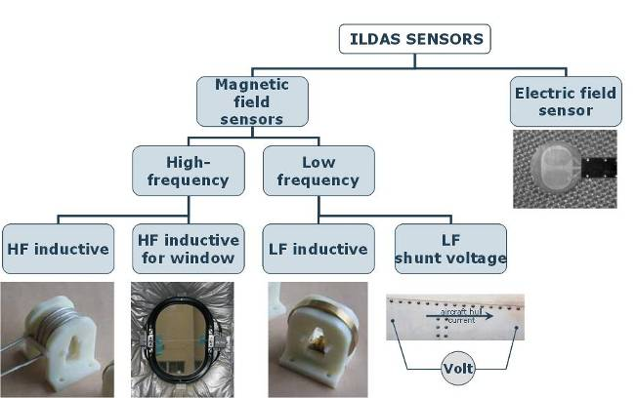
Figure 4. ILDAS Sensors Overview

Sensor Assembly electronics unit
Figure 5 shows the block diagram of the H-field sensor assembly electronic unit, developed by NLR. Signals from the high-frequency inductive sensor (coil or window sensor) are connected to the electronic unit through co-axial connections. The signal is split (the split is done externally for practical reasons), and then fed to two different integrators, each with its own time constant. This provides two signal processing channels with different gains. The outputs of the integrators enter analogue signal processing stages, consisting of - for each of the two channels - a low-pass anti-alias filter, a driver and level shifting circuit, and a high-speed Analogue-to-Digital Converter (ADC). The two-channel approach is taken to allow a large dynamic range to be measured, which was required to be at least 83 dB. The gain of the two channels is 26 dB apart. The frequency range is 100 Hz to 10 MHz.

Low-frequency magnetic fields (up to 100 Hz) are captured either by an inductive sensor, or by shunt voltage measurement. In the case of an inductive sensor, the signal is fed to a third integrator. It is then sent to an analogue signal processing and ADC stage. If the low-frequency current components are measured with a shunt voltage sensor, the differential shunt voltage is connected to an input EMI filter that replaces the third integrator.

Digital signal processing for the three measurement channels takes place in a field-programmable gate array (FPGA), programmed by EADS-IW. Measurement data is continually written in a 1.3 second ring buffer memory, until a strike to the aircraft occurs. Buffer writing is then stopped in such a way that the buffer contains 0.2 seconds of data before the trigger and 1.1 seconds thereafter. If two lightning strikes happen quickly after one-another and one ring buffer memory is still occupied with data from the first strike, data will be written to a second ring buffer. Sensor assemblies are polled periodically by the central DADS computer for the availability of data. If buffers are found to be full, their strike data – 192 MiB per sensor assembly per strike – will be downloaded to the DADS through a fibre-optic Ethernet network.

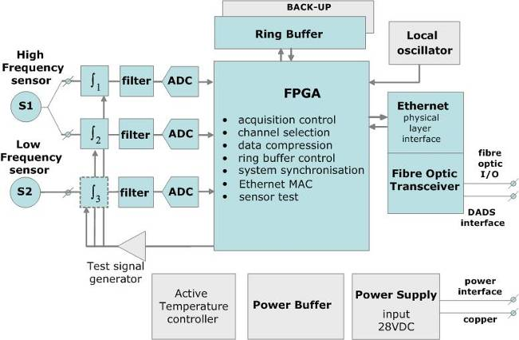
Figure 5. Block diagram of the H-field sensor assembly

In order to enable verification of correct operation of the sensor assembly, some built-in test circuits are present. The H sensor assembly has three sensor channel test circuits, one for each HF channel and one for the LF channel. The sensor test circuits are under digital control by the FPGA. The 28 VDC power that is applied to the sensor assembly by the DADS is filtered when it enters the electronics unit. Conversion takes place to the required internal supply voltages. Active temperature control is designed to prevent the electronics from becoming colder than -40 °C in case it is placed outside the temperature-controlled area of the aircraft.

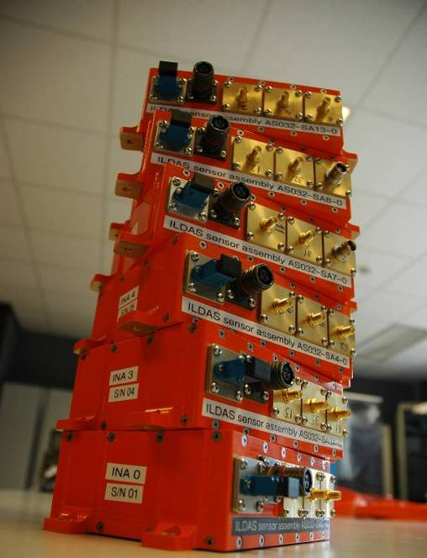
Figure 6. The ILDAS Sensor Assembly electronic units

EM Toolkit for lightning analysis
In the frame of the ILDAS project, numerical methods have been proposed both for recovering the localization of initial lightning attachment points (lightning scenario) and for the reconstruction of the return stroke current waveform, starting from the magnetic field components measured with different sensors on the structure.

First, the principle of the localization method is to extract parameters from measured signals (relative polarities, ratio and ranking of maximum amplitude of H-field over all sensors) and to compare them with those numerically predicted for different scenario in order to identify the best fit. These profiles have been obtained using 3D numerical simulations with Finite Difference method in the time domain (EADS software ASERIS-FD). The lightning scenario identification method should be as robust as possible with regard to any disturbance such as noise, variability of attachment location on a given zone or the lightning sweeping process. In addition, installed on-board the aircraft, it needs to give an instantaneous result as it will provide a near real time strike report to maintenance teams. We illustrate below a scheme of the zones that we attempt to discriminate with the ILDAS system.
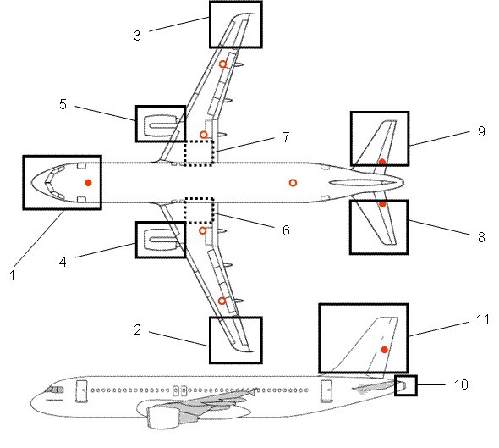
Figure 7. Initial attachment areas discriminated by the system

Once the attachment scenario is identified, the objective is to determine the lightning current waveform from H-field measurements and using different numerical methods: direct methods relying on transfer functions in frequency domain and applied on each sensor independently, and iterative inverse methods based on cost function minimization in time domain and possibly applied on a set of sensors at the same time. Both methods are based on preliminary FDTD simulations to build an aircraft database consisting respectively of transfer functions (H(f)/G(f) with Gaussian injections, G(t)) and pulse responses (H(t) with Dirac injections, δ(t)).

A lightning flash comprises a contiguous series of current pulses. Prior to an in-flight strike, the aircraft is also subjected to a varying electric field. The current pulses comprise a burst of short sharp pulses during the lightning channel attachment (~100 ms) to the aircraft followed by a series of return strokes or recoil streamers (each ~100 µs) and some continuing current (~1 s). Because all of these components have significantly different properties, it is necessary to split the full lightning event in individual waveforms associated with the components listed above. This split is achieved by analysing both E field and H field shapes and amplitudes.

Concerning strokes, they are analysed individually and independently from the rest of the lightning strike. The reconstruction method is applied on a time window centred on the stroke, with a duration of 1 ms.

Ground Tests results
Measurement aspects of the components described in the previous section have been considered during the ILDAS concept development and the performance has been verified during laboratory tests (section 3.1) and tests on a test rig at the Cobham Lightning Laboratory in the UK (section 3.2). A further set of tests to an A320 aircraft at the Airbus site in Toulouse was made with an ILDAS sensor set and DADS system installed to study an actual installation of the system (section 3.3). While the main sensor set was designed around a largely aluminium alloy transport aircraft, there is interest in composites and rotor craft too so the current density characteristics arising from strikes to a composite helicopter were measured during some tests at Eurocopter in Donauwörth (section 3.4)

Laboratory verification
A verification of the system was performed to confirm the system’s measurement and data handling performance and to provide initial calibration values for the measurement chain. For each sensor, the effective area was determined, for each integrator the time constant was measured. For the electronics unit the band pass frequency of both the LF and HF channels was verified to be 160 mHz to 10 MHz, while the amplitude dynamic range was determined to be 96 dB when using the twin HF measurement channels. Download of 192 MiB of data from a single sensor assembly to the DADS took about twenty seconds.

Integration Rig tests
An overview of the test rig is shown below. It comprises a rectangular box made of aluminium alloy sheet. The side walls are curved to give a similar radius as an A320 fuselage. Four window apertures were included in one side wall with size and spacing similar to the A320 windows.

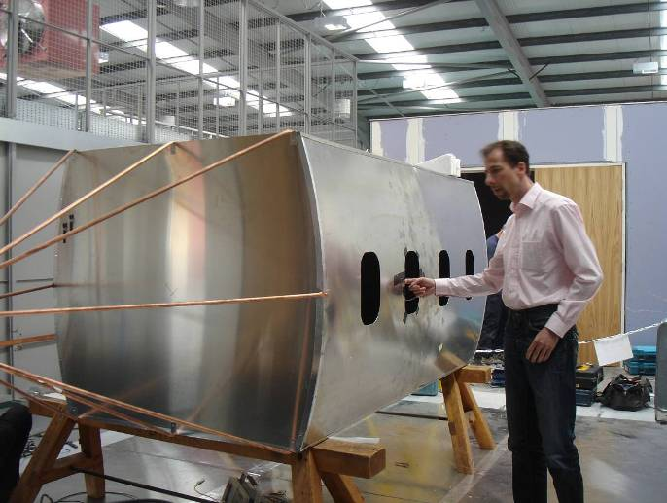
Figure 8. Overview of the Cobham test rig

The lower surface is flat to allow ILDAS “flap track fairing” sensors to be attached. The ends of the rig are terminated by copper tubing brought to a point. The flat ends of the box structure are closed off with aluminium alloy sheet. The current is returned to the generator by a ground plane placed underneath the rig. Consequently the current densities were higher in the lower half of the rig. The test rig allowed the electric field sensor, surface current density, shunt and window sensors to be tested.

A variety of Cobham Lightning laboratory generators was used so the sensors’ responses to the magnetic fields associated with reduced component A pulses anticipated for the A320 (<3 kA) test and the complete set of transients expected in flight to be checked. The tests also allowed functional verification of the ILDAS system in a lightning test environment as well as calibration and background signals of the sensors to be assessed.

The current distribution on the test rig was measured with a Cobham bespoke surface current probe and is shown in the figure below.

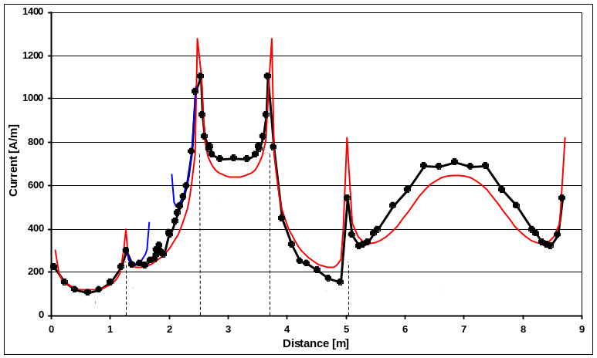
Figure 9. Measured (black and blue (window edge)) and predicted (red) current density variation around a section through the rig. The data has been normalized to an injected current of 2 kA
The distribution is governed by the inductive paths available. In 2D the distribution is exactly analogous to an electrostatic charge distribution so the current density is larger where the go and return conductors are closest and the current has a tendency to bunch at the corners of the cylinder’s square cross section. The 2D inductive sharing model (the Cobham INDCAL programme, reference 2) gives a good representation of the current distribution on the rig.

The nominal gains of the ILDAS sensors were sometimes found to differ from the calibrated Cobham probes up to 2 dB but generally this could be explained by the details of the magnetic field pattern around the test rig. For example the up/down asymmetric current flow means that the flux entering and leaving the window aperture is also asymmetric leading to low measurement values for the window sensor. Such an effect would also be anticipated in the A320 tests where a ground plane is used as a return conductor too. In flight the distribution should be more up/down symmetric.

The following figures show some examples of the results obtained. Figure 10 below shows that the ILDAS sensor measures the same shape current density as the calibrated Cobham probe when corrected for any error in the nominal gain. This is the current density associated with a reduced return stroke component A waveform test.

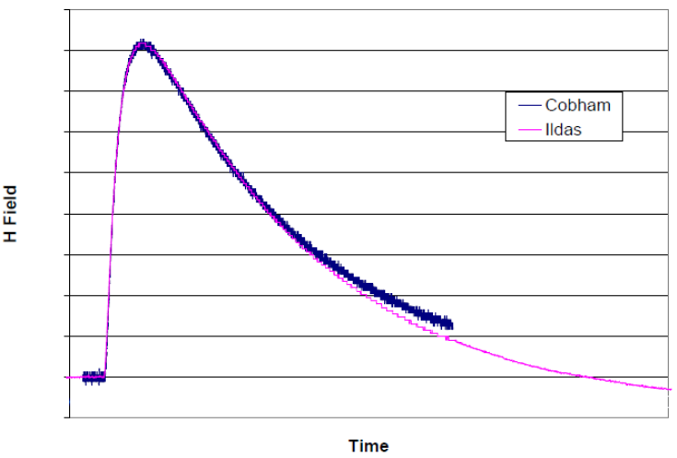
Figure 10. Comparison between current density waveforms from ILDAS (purple) and Cobham (blue) sensors

Continuing currents were measured with both magnetic field coils and a current shunt. Fortuitously, fault drop outs in the current supplied by a battery set during testing illustrated some features of the two methods of measurement. The coil has a fall off in the low frequency response because of the integrator poor response in this region but measures the sharp excursions well (figure 11). The shunt measures the low frequency behaviour well but because of inductive voltage drops has overshoots on the sharp excursions (figure 12).
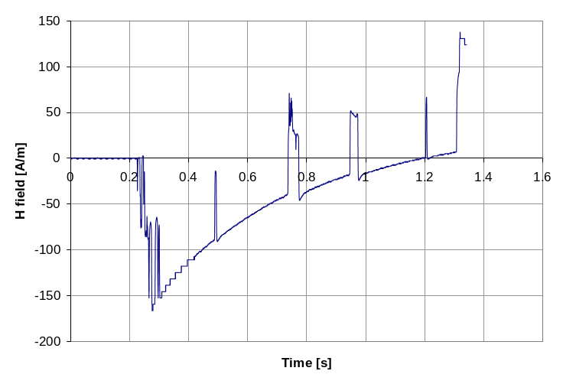
Figure 11. H Field (proportional to continuing current) from LF inductive sensor
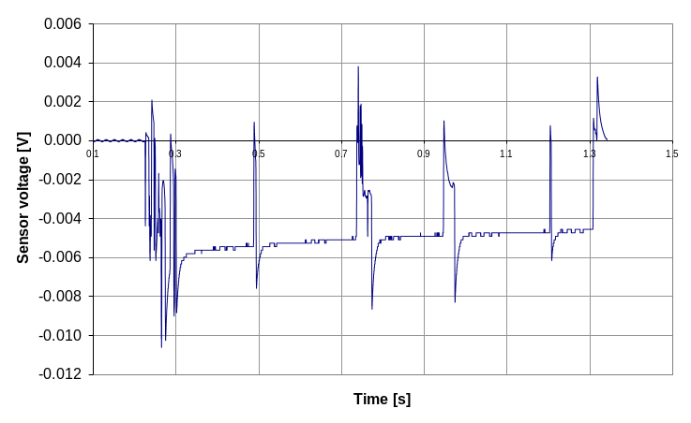
Figure 12. Voltage (proportional to continuing current) from shunt voltage sensor
These basic measurements allowed us to proceed to the A320 tests with confidence. In addition, the electric field sensor response, the ability to capture all the strokes and pulses within multiple wave trains and the performance at high current densities of the coil sensors were all checked to verify the ILDAS concept for in flight events.

A320 tests
The primary objective of the A320 test was to measure current densities (derived from the magnetic field derivative probes) at several points on the airframe and to record them with the ILDAS system. Data were obtained for different combinations of attachment and exit points. Current densities were then used to reconstruct the injected current and attachment scenarios as described in section 4 using the EM toolkit.

Secondary objectives were to try out other sensors that would be part of the overall sensor suite (E field and shunt sensors). These would allow a characterization of the complete lightning flash when installed in a flying aircraft but during the test itself were not used in the reconstruction as no pre trigger pulses or continuing current were injected. Nevertheless tests of the E field sensor were undertaken and the interoperability of the ILDAS system with the Aircraft communications was checked out.

For the A320, the testing required a scaled down (up to 3 kA) version of the initial return stroke component A. The component A is a double exponential current of peak amplitude 200 kA with rise time of 6.4 µs and time to half height of 69 µs.

Given the large size of the A320 airframe the only practical return conductor was a large ground plane. This was constructed from wire netting in the form of a cross that was placed under the fuselage and wings. The whole assembly was isolated from the ground by sheets of polythene.

The generator used comprised a 12.5 µF capacitor that can be charged to 15 kV. Such a capacitor has been used previously for General Aviation aircraft tests where the combined aircraft return conductor inductance has been a few µH. With an internal load resistor of 4 Ω this gives a critically damped waveform that has the same shape as component A and such a waveform was achieved in the test rig tests.

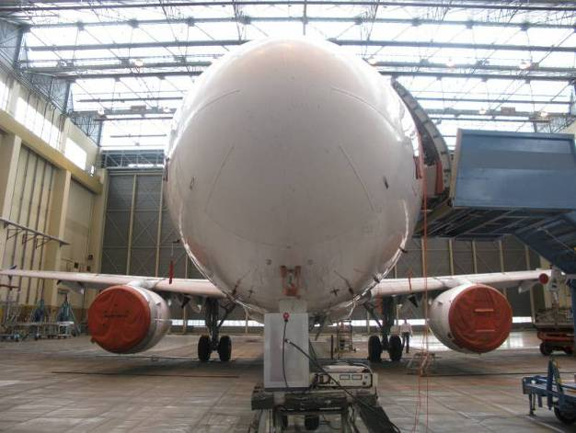
Figure 13. A320 rolled onto wire netting ground plane with small generator situated below the nose

The A320 aircraft and the ground plane assembly had an inductance of up to 25 µH for some attachment scenarios giving waveforms of rise time up to 25 µs. However this did not present any problems for either the sensor sensitivity (dependent on dI/dt) or reconstruction algorithms. The current was measured with a commercial current transformer. A trigger pulse was derived from this signal and fanned out as a trigger for the ILDAS system.

Twelve attachment/return points were used during the test: nose, port and starboard engine; horizontal stabiliser tips, wing tips, landing gear, vertical stabiliser and the tail cone, and measurements were made for 18 different combinations. These scenarios had look-up table data in the search algorithm described in section 4; these are noted in the table below.

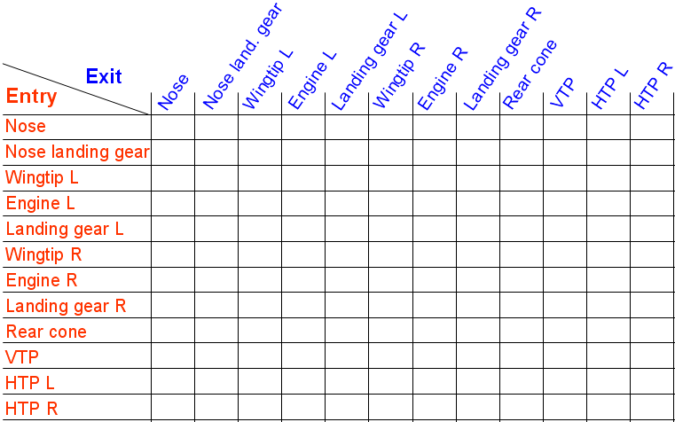
Figure 14. Table of attachment scenarios

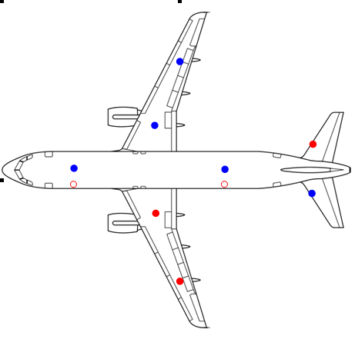
Figure 15. Sensor set on A320. Red ILDAS sensors, blue Cobham sensors
H02
H03
H04
H05
H06
H01
H07
H08
H13
H12
ILDAS sensors
Cobham sensors

The airframe was equipped with the ILDAS sensor set. The approximate positions of the sensors are indicated in the figure above.

Of the ILDAS sensors, three current density probes were available. A pair of these was fitted under the port wing to measure current flow along the wing axis; these allow distinction between engine and wing tip strikes. The wing coils were fitted near the front part of the flap track fairing where in practice there would be sufficient empty space to install such coils.

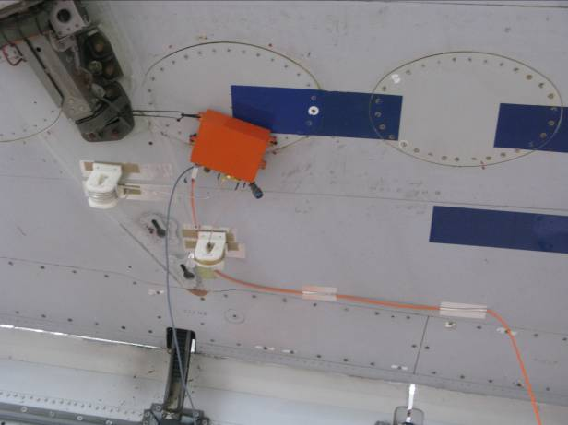
Figure 16. Inboard port wing sensor coils and electronics unit

Another was fitted to the leading edge part of the starboard horizontal stabilizer to measure current flowing along the leading edge of the stabilizer. All these sensors measure surface currents from integrating signals from both high and low frequency band width coils. As well these surface current probes, two window sensors at fore and aft fuselage locations were installed. As discussed in the test rig tests, the proximity of the ground plane in the A320 trial is expected to give some up/ down asymmetry of current density so there would be some correction required or some deviation in the reconstructed current would be expected particularly for the forward window sensor where the fuselage is quite close to the ground plane. All signals were transmitted to the data acquisition system by fibre-optic links mounted locally to the coils together with battery packs.

In order to obtain full coverage of the current densities over the entire airframe, as well as the set of 5 ILDAS probes a complementary set of Cobham probes was installed on the opposite sides of the aircraft. These are small coils as were used to map the current distribution on the test rig. They were linked to remote digitizers. Three of these probes were complementary to the ILDAS wing and stabilizer probes. Another two were installed on the top forward fuselage and the lower aft fuselage giving a back up for the two window sensors and also measured the up/down asymmetry due to the ground plane (H02 (lower) factor 4 greater than H01 (top); see figure 15) for nose to tail strikes. The primary purpose of the complete probe set was for identifying off line the attachment locations; the data were provided to the analysis team without prior knowledge of the attachment scenario. Only the ILDAS probes were used in the reconstruction of the injected current.

The tests were performed over a two week period in June 2009. In total 86 shots had recorded data for ILDAS and Cobham sensors. The following figure illustrates typical results obtained with the sensor set. This plot shows the current densities obtained for the wing tip to wing tip attachment with current densities measured by the Cobham and ILDAS probes giving a similar current density with a similar shape to the injected waveform. These tests also allowed the polarity of the sensors to be checked or corrected that was essential for the correct functioning of the look up table algorithm.
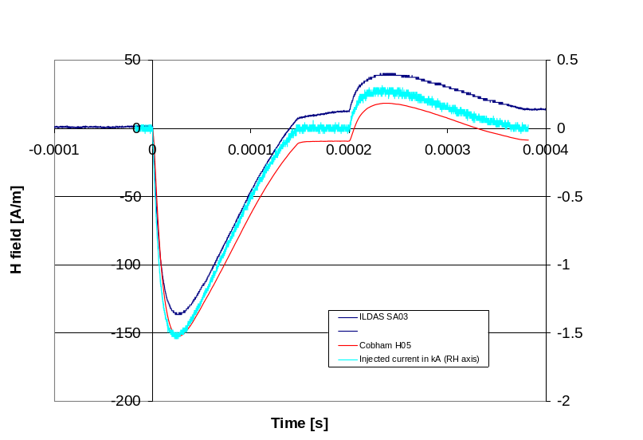
Figure 17. ILDAS H03 and Cobham H05 comparison with injected current

Helicopter tests
The primary objective of the helicopter tests was to validate theoretical results from modellers and to prove the applicability of the ILDAS measurement test set-up. Further objectives were to investigate the possibility to derive entry and exit points of a lightning strike with the help of the selected number of sensors and their locations as well as to confirm the applied lightning protection design.

The tested helicopter was a serial one of the type EC 135. The helicopter was placed in a hangar on a ferro-concrete floor (electrically more or less conductive). To guarantee the isolation a plastic foil was put between helicopter and ground. The design of the return line depended on the applied scenario. As a basis return line two copper plates (600 mm width, about 10m long, 0,6 mm thick) placed symmetrically in parallel all along the right and left side of the helicopter as well as two copper stripes lateral to these lines were used. The injection of the lightning strike was achieved by connecting a lightning generator between the respective selected entry point and the return line. At the exit point of the helicopter the return line was short circuited. The whole test set-up is illustrated in Figure 18. The injected transients were the A-waveform (amplitude about 1,6 kV) and H-waveform (amplitude about 300 A).
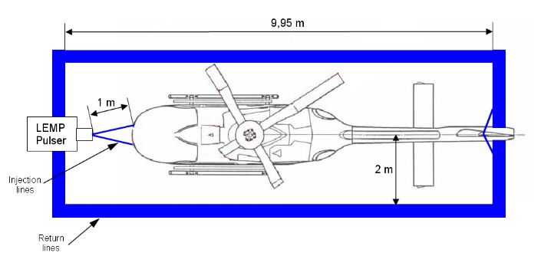
3
7
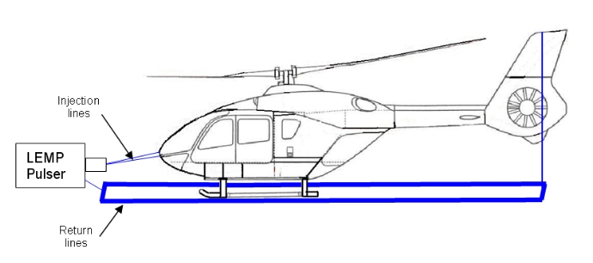

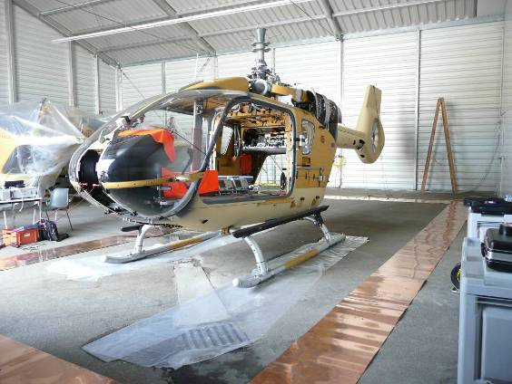
Figure 18. Example of test set-up (nose – tail configuration)

Four lightning scenarios representing the most probable ones were chosen:
► nose - tail configuration
► landing gear - tail configuration
► main rotor - tail configuration
► main rotor - landing gear configuration
For each of the scenarios six surface current measurement sensors were mounted according to Figure 19. The output of such a sensor is a voltage level which has to be corrected to get the surface currents in A/m.
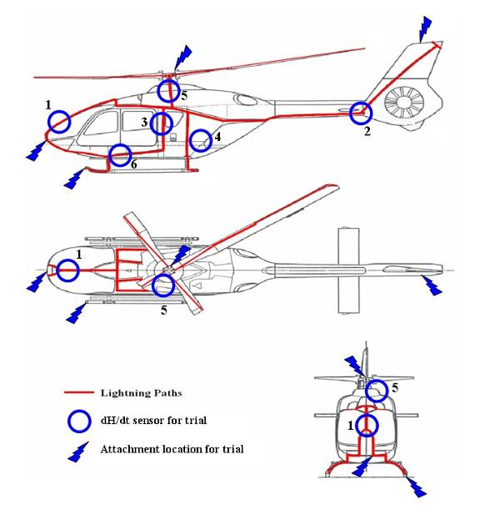
Figure 19. Sensor locations on the EC135

One representative result for the landing gear – tail scenario is shown on Figure 20. It is evident that the tail sensor measures the highest surface current density. From the injection point the current is split mainly in direction of the lightning paths on the right and left side of the structure and the front window (level slightly less). Measurements of currents on cable bundles routed in parallel to the lightning paths showed that cable bundles function also as lightning paths. The relatively low level of the sensor mounted on the rear part of the structure (sensor 4) is due to the large surface area that the sensor was put on (low current density). In summary it can be confirmed that all results are plausible and explainable. The measurements also allowed the theoretical results to be validated (see Figure 21).

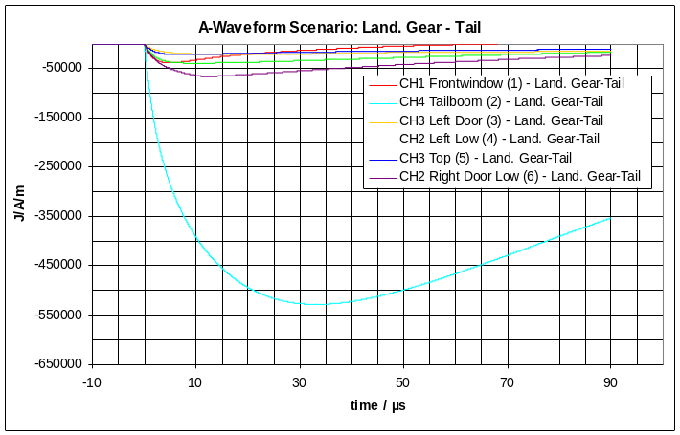
Figure 20. Measurement results for A-waveform for the landing gear – tail configuration

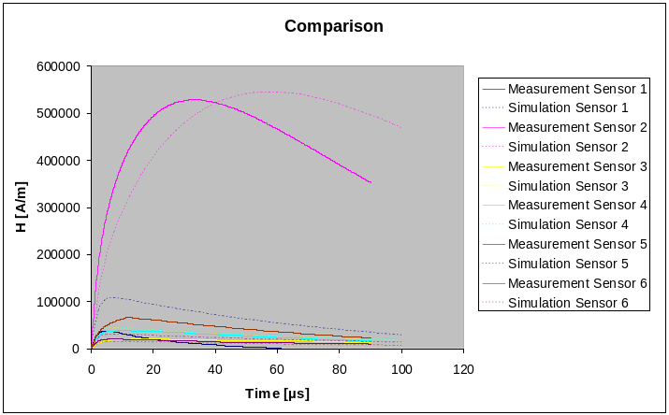
Figure 21. Comparison of theoretical results and measurements for the landing gear – tail configuration.

The overall results can be summarised as following:
- The results are plausible with respect to the measured surface currents
- Currents on cable looms are significant
- As the direction of the surface current is measured, it is possible to derive entry and exit points of a lightning strike
- To do this, a number of five sensors is sufficient
- To a large extent the theoretical results could be validated by the measurements

EM Toolkit results
The results obtained with the numerical EM toolkit for the determination of the attachment scenario (entry/exit points) and the reconstruction of injected currents from H field measurements during the A320 trials are presented in this section. We report in the next table a summary of results obtained with numerical methods in term of scenario identification and best reconstruction accuracy.

Table 2. Summary of results obtained with numerical methods. Half: only one point correctly identified; No: no scenario identified
(HTP/VTP: horizontal/vertical tailplane, LG: landing gear)
Test scenario | Identified?
Nose – left engine | YES
Nose – left wingtip | YES
Nose – right HTP | YES
Nose – left LG | YES
Left Wingtip – left LG | YES
Left wingtip – left engine | YES
Left wingtip – right HTP | YES
Left wingtip – right engine | NO
Left wingtip – right LG | YES
Left wingtip – right wingtip | YES
Left wingtip – left HTP | YES
Left engine – right HTP | YES
Left engine – left LG. | YES
Left HTP – right HTP | YES
VTP – right HTP | Half
VTP – nose | Half
Tail cone – nose | YES
Tail cone – right HTP | YES

For most cases (15 out of 18) the correct attachment scenario has been predicted by the numerical method. The method failed in cases where H field reported by several sensors had similar amplitudes leading to a ranking sensitive to discrepancies between tests and models. For left wingtip – right engine case, the method was unable to distinguish between several scenarios, as a consequence of a lack of refinement in the scenario profiles pre-established. One of the most satisfactory result is the capability of the method to discriminate between engine and landing gear attachment points.

These results prove that the approach consisting in characterizing a lightning scenario by a max H field ranking and polarities is quite efficient.

Concerning the current reconstruction, we applied the transfer function method to all sensors for each scenario and obtained a wide range of accuracy. Unlike expected, the current predicted from H field measurement with sensors located out of the main current path is quite satisfactory provided that the sensor is not too far from the main excited area.

Thus we present on the figure below the results obtained for a left wing tip – right wing tip attachment scenario, consisting in the injected current and the current reconstruction from H03 (in board flap track fairing of left wing) and H03 (aft fuselage window).

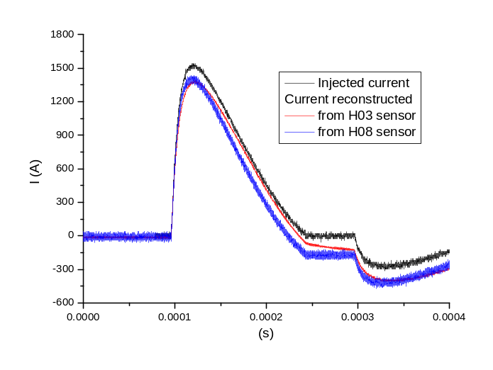
Figure 22. Left wing tip – right wing tip attachment scenario.

The overall waveform is correctly reconstructed with an accuracy on the maximum current, the rise time and the width of 10% and of 20% on the action integral (main pulse). The shift from zero at 250 µs compared to the injected current is due to the absence of spectral data below 100 Hz in the waveform from the HF probe used for the reconstruction.
We report below the results obtained for a nose – left engine scenario :

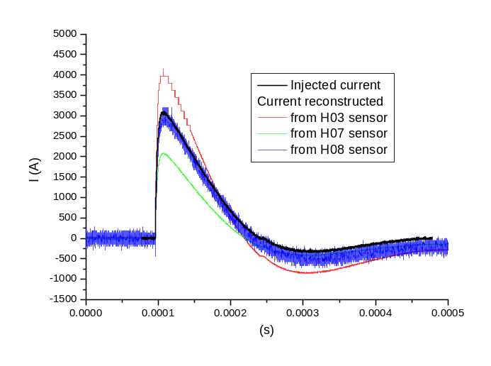
Figure 23. Nose – left engine gear attachment scenario.

All over the scenarios tested, the minimum accuracy reached is of 30%, what is quite satisfactory considered all the possible causes of discrepancies (differences in exact injection locations, sensors locations and orientations, insufficient meshing accuracy on sensors located in the leading edge of HTP). The difficult point remaining is now to define reliable criteria that allow selecting the most relevant reconstructed current.

Further Exploitation
While the concept prototype has been successfully demonstrated during the A320 ground test campaign, there is still some work required in order to make the ILDAS system able to measure real lightning strikes in flight condition.

A number of adaptations and improvements will have to be done. Environmental qualification of the device and its elements will be necessary to make sure that shocks, vibrations, acceleration, humidity, temperature and pressure variations will not impair the good behavior of the system. Some of the sub-systems will probably have to go through a redesign phase, for instance to reduce their dimensions so that they can fit most appropriately at the selected locations, in particular below the flap track fairings. The interfacing with a number of aircraft systems will also have to be implemented and verified. It is not expected that the installation of fiber optics and power supply cables will be a problem given the fact that the current target for ILDAS first flight is a test aircraft (such as the A320 MSN1) where existing paths can be re-used.

A preliminary economical viability study showed that the payback period for an ILDAS system used on airliners would be at least 15 years. This is too long compared to the 1 to 3 year period that is considered acceptable by airlines and MROs (Maintenance, Repair and Overhaul). Therefore at this stage, it is foreseen that ILDAS will continue to be developed primarily as a flight test equipment. Its possible commercial adaptation –and associated industrialization- will be re-evaluated once a final prototype is ready, which could be as soon as 2011 or 2012.

Indeed, it is the intent of Airbus to try and use the ILDAS system for the flight test campaign of the all-composite A350 XWB. The icing campaign in particular would be a very good occasion to measure a significant number of lightning strikes, which would greatly contribute to the constitution of the lightning strike database.

Concluding remarks
The ILDAS project was an ambitious research programme aiming at validating the principle of an in-flight lightning strike measurement system. From that perspective, we can state that the project main objectives have been reached. Not only has the ILDAS system been specified and developed but its performance was verified during both a rig test campaign and an A320 ground test campaign.

All the subsystems, comprising the DADS, the sensor assemblies and the GSE, performed in an acceptable way. It was possible to measure current flow arising from a simulated lightning strike on a real aircraft in a configuration quite close to what it would look like in a real flight. In addition, the measurements were of a sufficient quality to enable the determination of the entry/exit scenarios as well as the reconstruction of the injected current, thanks to the numerical tools developed. Measurements done on helicopters also produced interesting results, in particular regarding the paths followed by lightning currents.

With this strike measurement concept validated, and with the necessary improvements to make ILDAS flyable, it is likely that real lightning measurements will be performed within two or three years. The opportunity of using the ILDAS system during an icing test campaign could lead to record several dozens of strikes, which would be the starting point of the database constitution. The analysis of these data will certainly benefit to the industrial and scientific lightning community, improving the knowledge of the phenomenon and possibly leading to even better-tailored aircraft designs.

References

[Ref 1] S Alestra, I Revel, V Srithammavanh, M Bardet, R Zwemmer, D Brown, N Marchand, J Ramos, V Stelmashuk; Developing an in-flight lightning strike damage assessment system. ICOLSE Paris, 2007.

[Ref 2] C J Hardwick, S J Haigh, B J C Burrows; A filamentary method for calculating induced voltages within resistive structures in either the time or frequency domains. ICOLSE. Oklahoma, 1988.

[Ref 3] V. Stelmashuk, A. P. J. van Deursen; Sensors for lightning measurements on aircraft. IEEE Sensors, 2008.

[Ref 4] V. Stelmashuk, A. P. J. van Deursen, R. Zwemmer; Sensor development for the ILDAS project. EMC Workshop 2007.

[Ref 5] V. Stelmashuk, A. P. J. van Deursen; Sensors for in-flight lightning detection on passenger aircraft. ESA workshop on Aerospace EMC 2009.

Acknowledgements
The work presented is partly funded by the European Commission under contract FP6-030806. This support is gratefully acknowledged by the ILDAS Partners.

We would like to thank the members of the ILDAS advisory board (chairman J.P. Moreau of Dassault Aviation) for their advice during the project.

We would like to take the opportunity to thank the following people and organizations who have contributed to the project:
Matt Webster of Airbus UK, Chris Jones of BAE Systems (use of Nimrod aircraft in 2007 for test of window sensor), Dan Brown, Alex Meakins and Nic Terzino of Cobham Lightning, Jean-François Boissin, Dominique Lemaire, Laurent Saissi, Thomas Boisson, Franck Flourens of Airbus France.

And finally we would like to express our sincere recognition to Michel Crokaert who was at the origin of the definition of the ILDAS project.

Contacts
Rob Zwemmer zwemmer@nlr.nl
Michiel Bardet bardet@nlr.nl
Alte de Boer adeboer@nlr.nl
John Hardwick john.hardwick@cobham.com
Mathieu Latorre mathieu.latorre@nexio.fr
Nicolas Marchand nicolas.marchand@socius.fr
Jeremy Ramos Jeremy.ramos@airbus.com
Ivan Revel ivan.revel@eads.net
Wolfgang Tauber wolfgang.tauber2@eurocopter.com

