- A summary description of project context and objectives
Positron Emission Tomography (PET) is a powerful non-invasive, real-time imaging technology that can be used to identify and characterize human disease, but is currently limited by deficiencies in chemistry. While simple molecules such as fluorodeoxy-glucose (FDG) can be efficiently prepared, more complex, biomedically interesting molecules often cannot. The short half-life of ¹⁸F (110 min) dictates severe restrictions on the chemical synthesis of PET tracers. Fluoride introduction must occur at a late stage of the synthesis, ideally as the last step, to avoid unproductive decay of the ¹⁸F nucleus before injection into the body. Due to the limited functional group compatibility with conventional fluorination reactions employed today and the short half-life of 110 min, the synthesis of PET tracers is limited to a fairly small number of simple molecules. Reaction time is not the only constraint. The high specific-activity isotopes – thus low mass – dictate a need for unusually high chemical reaction rates and efficiencies, which are met by only a handful of methods. The Ritter group at Harvard has developed a unique technology based on the concept of late-stage fluorination as a tool to streamline the synthesis of complex fluorinated molecules using ¹⁹F. Late-stage fluorination has the potential of significantly increasing the number of ¹⁸F-PET agents and their radiochemical yield when translated into an appropriate methodology for the incorporation of radioactive fluorine, ¹⁸F, into organic molecules.
- Overall Project Aims - During this Fellowship we wish to develop and validate late-stage ¹⁸F-fluorination chemistry for the synthesis of PET tracers for molecular imaging. The new technology developed will be initially applied to the preparation ¹⁸F-fluorodeoxyestrone using late stage carbon-fluorine bond formation as an initial ‘proof-of-concept”. In a more advanced stage, the project will deal with the preparation of a new PET tracer for the Metabotropic Glutamate Receptor Subtype 5 (mGluR5) and the transfer of knowledge from Harvard to ETH Center for Radiopharmaceutical Sciences.

- A description of the main S&T results/foregrounds

First year. The focus of the project has been towards the development of a new methodology for late stage fluorination using ¹⁹F. It was found that compound 1, which is commercialized as PhenofluorTM could perform deoxyfluorination of several aliphatic alcohols under extremely mild conditions and with broad functional group compatibility (Table 1).
ªParent compound refers to the name of the natural product/pharmaceutical used as starting material or to the name of the natural product/pharmaceutical from which the starting material is derived. ^{b}Isolated yields. ^{c}No KF was used. ^{d}No EtN^{i}Pr₂ was used. ^{e}Deoxyfluorination with retention was observed.
Side reactions such as elimination and rearrangement via carbocation intermediates are usually observed in the preparation of aliphatic fluorides. We found that the use of reagent PhenofluorTM, substantially reduce or completely suppress these side reactions. Deoxyfluorination of aliphatic alcohols with reagent 1 can be carried out at room temperature, enabling fluorination of temperature-sensitive substrates. For example, for everolimus (see 21) or oligomycin A (see 23), fluorination was performed at room temperature to avoid decomposition (Table 1). Chiral secondary alcohols can typically be deoxyfluorinated with inversion without observed epimerization or elimination in most cases. In addition, secondary allylic alcohols were converted without notable formation of side products derived from S_{N}2’ pathways. Ketones and especially aldehydes are challenging substrates for deoxyfluorination reactions because they are often converted to the corresponding gem-difluorides, yet, reagent 1 can tolerate carbonyl functional groups (see e.g. 12, 19, 20). Complex molecules, such as several of those depicted in Table 1, frequently contain more than one carbinol. Typically, reagent 1 can discriminate between different carbinols and afford a single fluorinated analog in synthetically useful selectivity, for example 71% of the fluorinated oligomycin A analog 23 was isolated, despite the presence of five hydroxyl groups in oligomycin A. We have observed several trends that enable prediction of the fluorination site in the presence of several hydroxyl groups: 1) primary alcohols are selectively deoxyfluorinated in the presence of secondary and tertiary alcohols. 2) Secondary alcohols react significantly slower or not at all when they are β, β'-dibranched, unless the secondary alcohol is allylic. 3) Tertiary alcohols do not react, unless they are allylic. 4) Based on previous observations, hydroxyl groups engaged in hydrogen bonding are not reactive. For the substrates evaluated, these four guidelines were suitable to correctly predict reactivity and selectivity for deoxyfluorination.

Second year. The focus of the project has been towards the translation of the methodology developed in the first year from ¹⁹F to ¹⁸F (radioactive fluoride). In order to achieve this goal, the initially developed reagent 1 (PhenofluorTM) had to be modified. The initially developed reagent contains two ¹⁹F-fluorine atoms and transfers only one of them to the final product. When radiolabelling with ¹⁸F is performed, the limiting reagent is ¹⁸F⁻ . If a ¹⁸F-Phenofluor analogue is used, half of the initial ¹⁸F⁻ would be wasted, reducing the radiochemical yield. In order to face this challenge, it was decided to treat the alcohol with Phenofluor-type reagents and isolate the activated intermediate, therefore removing ¹⁹F-fluoride (Figure 1). The isolated intermediate would be subsequently treated with ¹⁸F-fluoride, yielding the labelled compound with high specific activity. The intermediate deriving from phenols and Phenofluor-type reagents have been prepared successfully. We synthesized several analogues of Phenofluor, trying to modulate the steric/electronic properties of the intermediates, in order to guarantee the successful identification of the radio-fluorination conditions (Figure 1). Investigation of the fluorination step has shown a strong dependence of the fluorination yield from the counter-anion. Intermediates bearing anions such as PF₆⁻, BF₄⁻, HF₂⁻, F⁻, OTf ⁻ have been prepared and their reactivity has shown that the counter-anion HF₂⁻ affords the best fluorination yield with ¹⁹F⁻. Unfortunately, when the intermediate with counterion [¹⁹F]-HF₂⁻ is treated with ¹⁸F⁻, incorporation of both fluorine isotopes is observed. Current efforts towards the radio-fluorination step are now under investigation within the Ritter group and involve the use of Lewis and Brønsted acid additives to improve the ¹⁸F-fluorination in the presence of inert counter-anions.
We also attempted the use of aliphatic alcohols as substrates, but in this case the activated intermediates could not be isolated because of their high reactivity and consequent decomposition to ¹⁹F-fluorinated products.
During the development of the analogues of Phenofluor, the gaseous reagent CF₃I was used. It was fortuitously observed that when gaseous CF₃I was condensed with the liquid reagent tetramethylethylenediamine (TMEDA), a solid complex with stoichiometry TMEDA•2CF₃I was formed. The complex was structurally characterized using single crystal X-ray analysis. This surprising finding was attributed to Hlogen Bonding between the Lewis basic TMEDA and the Lewis Acidic trifluoromethyl iodide. CF₃I is an extremely useful reagent for trifluoromethylation, but its utility is limited by its gaseous nature and the difficulties associated with its handling. Although this surprising and unexpected result was not directly related to the main goal of the fellowship, we reasoned that halogen bonded complexes of CF₃I could be very valuable reagents in synthesis. We therefore prepared the Halogen Bonded complexes of CF₃I with tetramethylguanidine (TMG) and dimethylsulfoxide (DMSO) and we have used them as trifluoromethylation reagents for several transformations (selected examples in Scheme 2). The reagents proved practical and in some cases also had an improved reactivity profile in comparison to gaseous CF₃I. Due to the high utility and uniqueness of the halogen bonded complexes, a patent application has been filled and a publication has been submitted to the Journal of the American Chemical Society.
We also studied the unusual bonding in the CF₃I adducts, using a combination of experimental techniques and DFT calculations (Figure 2). The Halogen Bonding was unambiguously established by measuring an interatomic N···I distance of 2.80 Å, which is smaller than the sum of the Van der Waals radii (3.53 Å) for N and I. DFT calculations successfully corroborated the experimentally determined N–I bond distance. With the validated DFT functionals, we calculated the bonding parameters in TMG•CF₃I and found a N···I bond length of 2.8 Å and an interaction energy corrected for basis set superposition error (BSSE) of 9–10 kcal∙mol⁻¹. Halogen bonding interactions are typically on the order of 1 to 10 kcal∙mol⁻¹, which puts the TMG•CF₃I halogen bond in the upper segment in terms of strength. The calculated strength of the halogen bond is consistent with the temperature and storage stability of TMG•CF₃I.
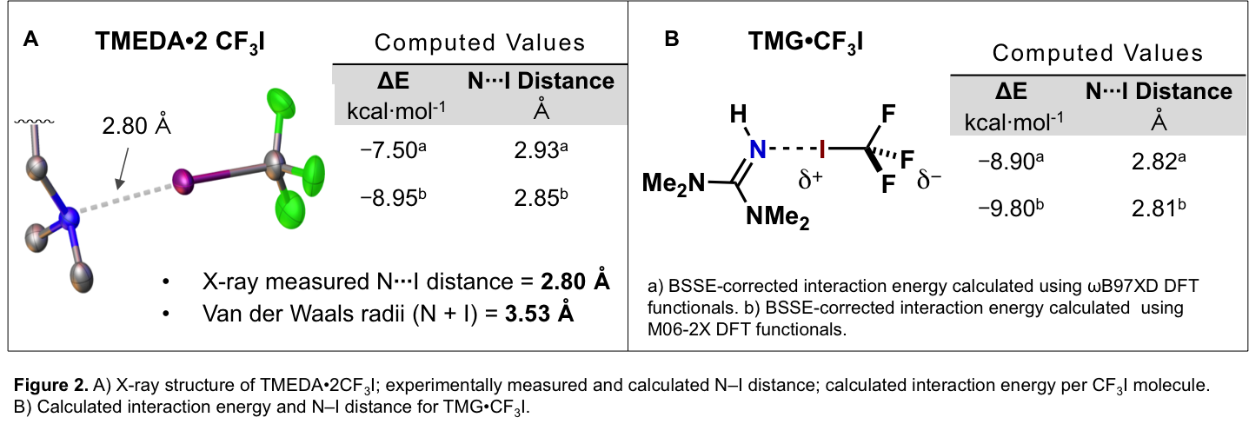

Third Year: During the third year, the experience in fluorination chemistry developed during the outgoing phase has been applied to the synthesis of new radio-fluorinated compounds and their efficacy as potential imaging tracers has been evaluated in vivo in mice. Three main sub-projects have been investigated:
Sub-project 1: ¹⁸F-imaging of tumor microenvironment targeting Fibroblast Activation Protein (FAP).

Milestones:

Developed precursor synthesis and ¹⁸F-radio-labeling of a selective FAP-inhibitor.
- Plasma stability studies.
- Animal Study with mice bearing FAP⁺ xenografts (SK-Mel187 xenografts).
- Blockade experiment with cold-reference.
- Biodistribution studies.

Results:
- Radio-synthesis of ‘hot’ FAP-inhibitor:

Scheme 2. Radiosynthesis of ¹⁸F-FAP inhibitor with nM IC₅₀ for FAP in vitro.

- Plasma Stability Sudies. the target compound was stable (no observed decomposition) for up to 2 hours in mouse, rat and human plasma, when incubated at 37 ºC.
- ¹⁸F-FAP PET/CT in Nu/Nu mice with SK-Mel-187 xenografts. Succesful tumor accumulation was observed as detailed in the following figure.

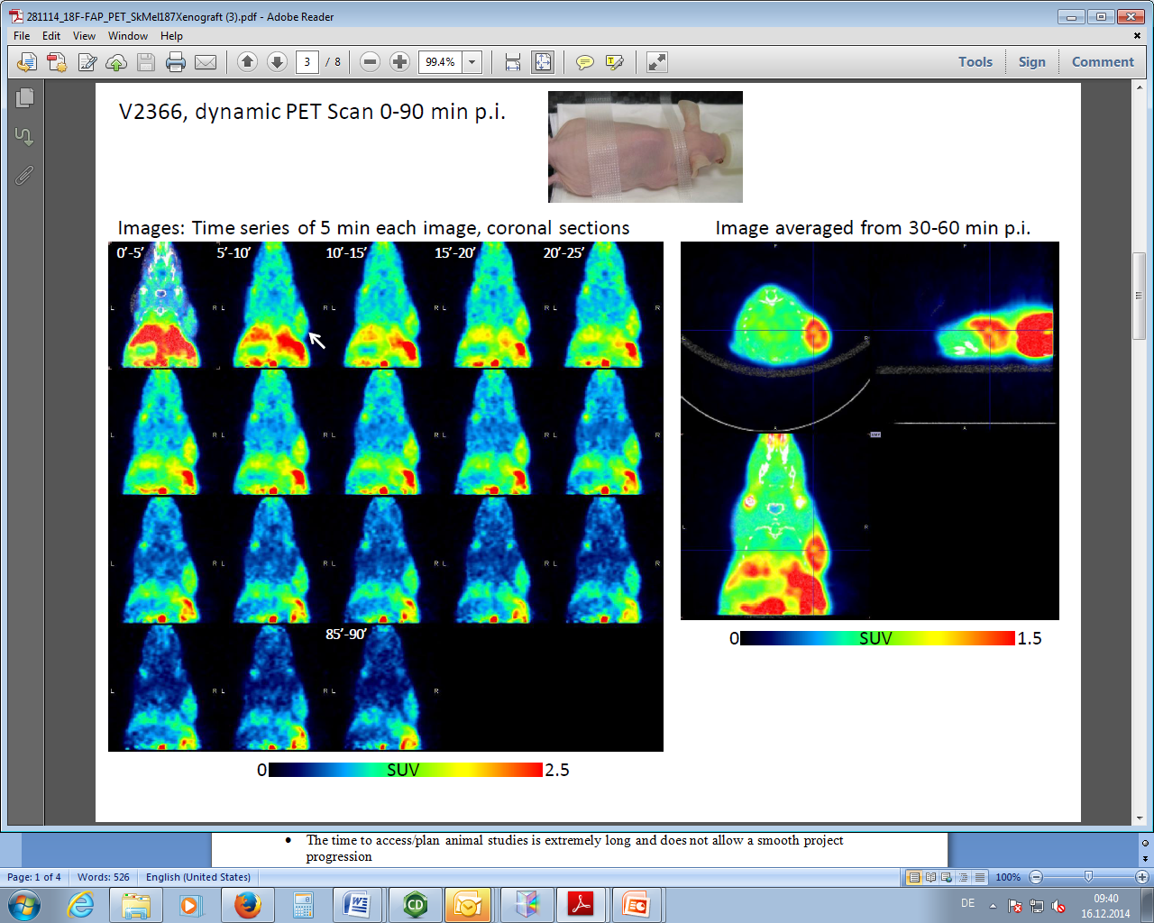
Figure 3. V2312, dynamic PET Scan 0-90 min p.i. images: averaged from 0-90 min.

- Blockade studies. Tumor uptake of the target compound could be blocked using a 1000-fold excess of the cold compound formulated in PEG-water 1:1 (Figure 2 and 3).

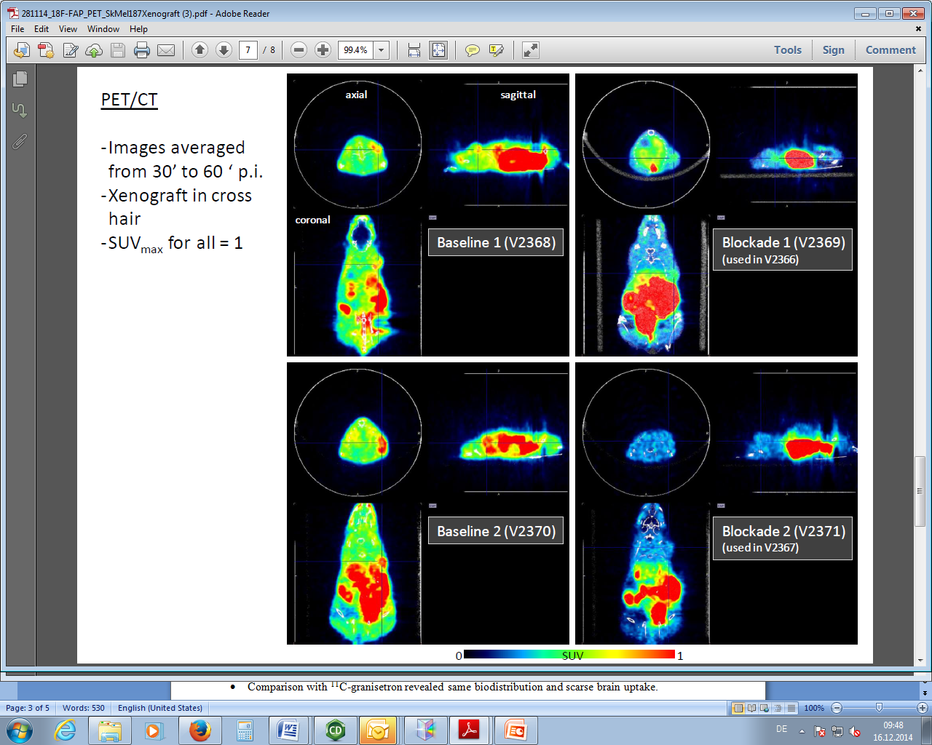
Figure 4. Dynamic PET/CT Scan averaged 30-60 min p.i. Xenograft in cross hair. SUV_{max} = 1.

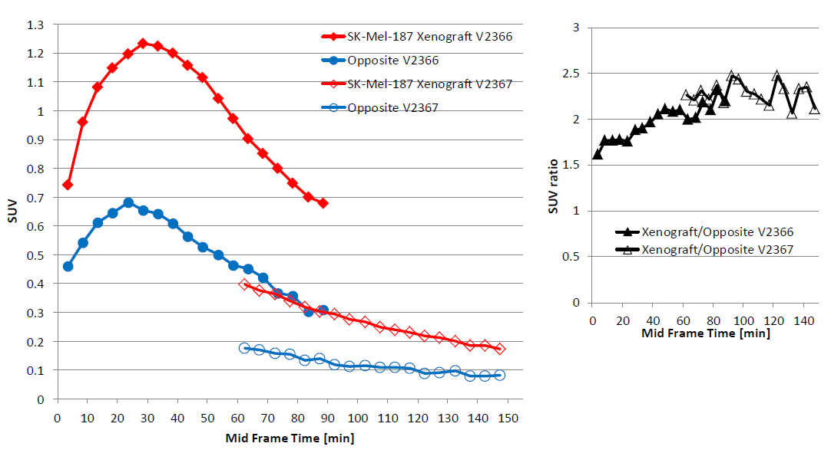
Figure 5. Time activity curves.
- Biodistribution studies. Biodistribution studies confirmed preferential tumor uptake compared to other tissues. When the biodistribution was performed in the presence of 1000-fold excess of cold reference, lower uptake was observed in tumor and also in other tissue samples (blood, muscle, etc). A plausible hypothesis for this phenomenon is that our compound is binds to albumin. When 1000-fold excess cold substrated is added, the whole albumin is saturated and lower uptake is observed in all tissues where albumin is usually uptaken.
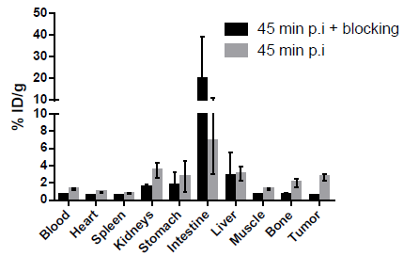
Figure 6. Biodistribution studies.

Sub-project 2 ¹⁸F-imaging 5HT₃ receptor.

Milestones:

Optimized protocol for radio-fluorination and purification.
- Conducted first animal study: no significant accumulation in expected brain region observed.

Comparison with ¹¹C-granisetron revealed same biodistribution and scarse brain uptake.

Results: Several iodonium salts were prepared according to Scheme 2. In all cases , radiofluorination was performed successfully, but in moderate yields (2-10%). Nevertheless, the amount produced was enough to study biodistribution in mice and to perform blockade experiments.
Scheme 3. a) Iodination of Palonosetron. b) and c): Synthesis of iodonium salts used in the radio-fluorination.
- Prepared 18F-palonosetron was injected in male Wistar rats. Significant uptake was only observed in the Pituitary gland.

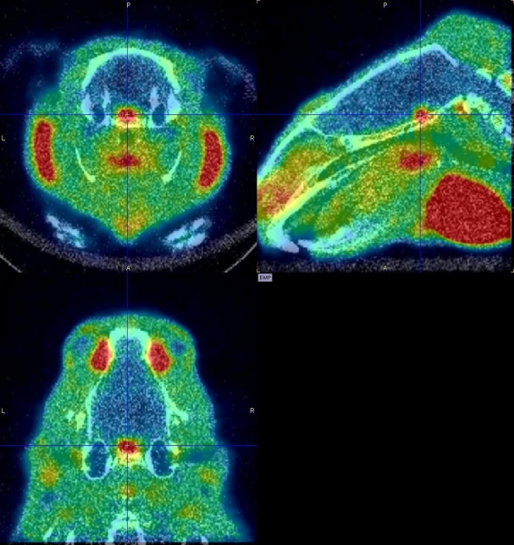
Figure 7. Left: PET/CT scan with 18F-palonosetron, PET image averaged from 0-60 min. Piturity gland is dominant in uptake.

Comparison between ¹⁸F-palonosetron and ¹¹C-granosetron showed that in both cases brain uptake is low (see, Figures 8 and 9).
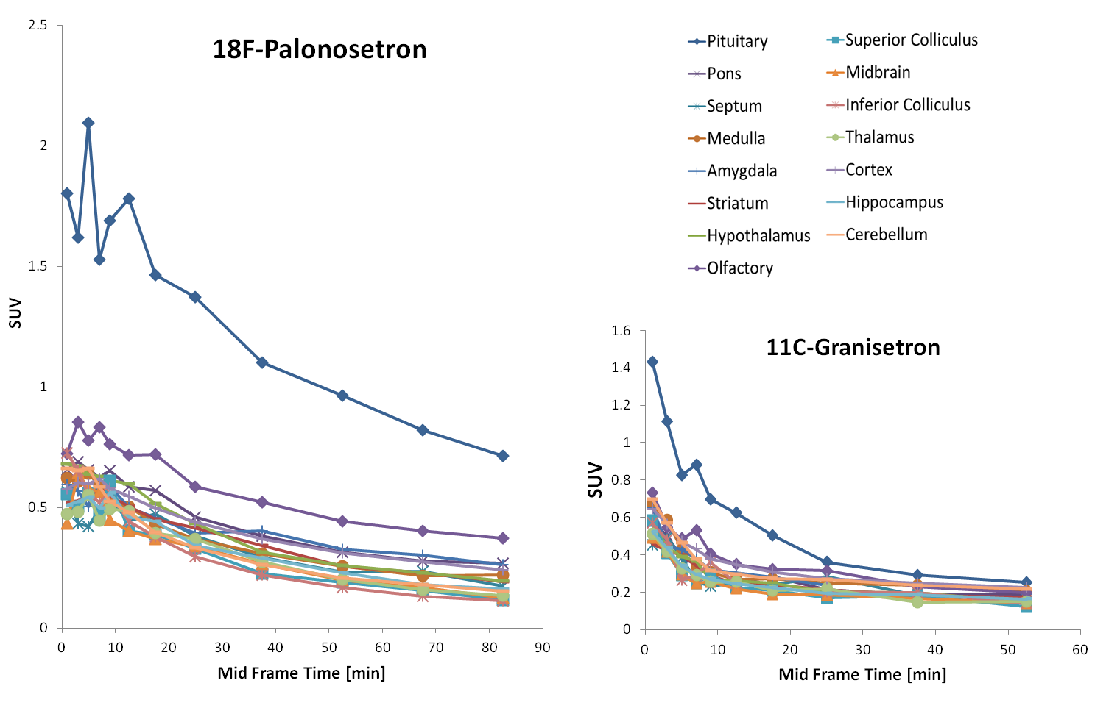
Figure 8. Comparison of ¹⁸F-palonosetron and ¹¹C-granisetron and their uptake in different brain regions.

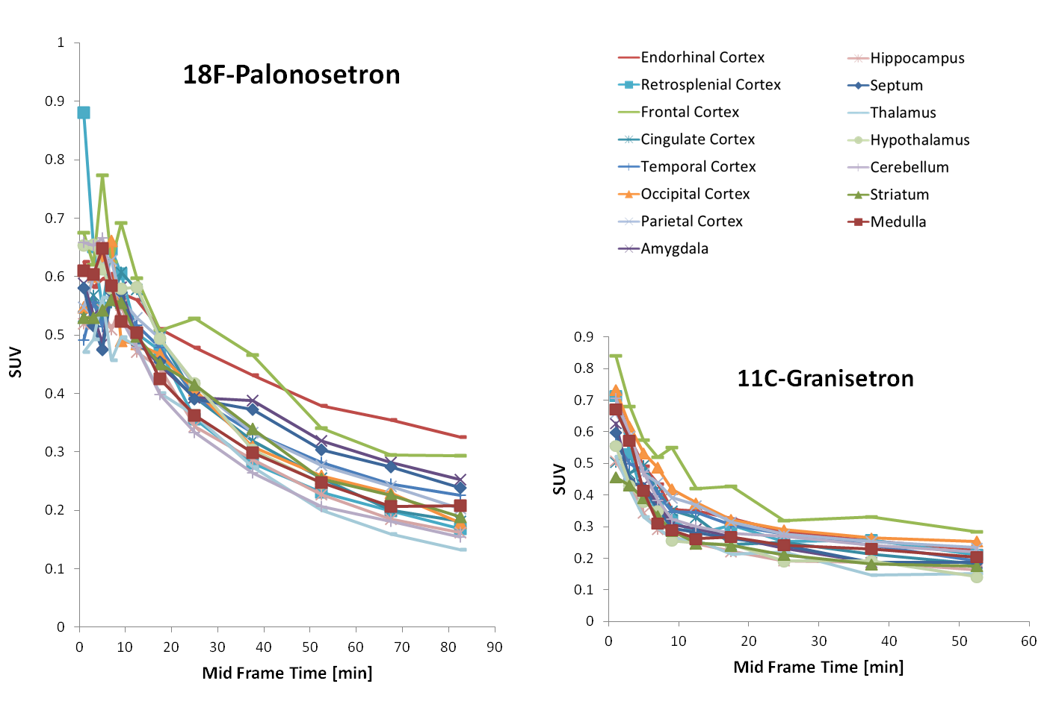
Figure 9. Comparison of ¹⁸F-palonosetron and ¹¹C-granisetron and their uptake in different brain regions (continued).

Conclusions: Despite being used as a commercial drug targeting 5-HT₃ receptor, it appears that ¹⁸F-palonosetron cannot be used to image the 5-HT₃ receptor in brain. Since 5-HT₃ receptors are distributed in other body parts, it might be of interest evalueting the compound doing a full-body scan and blockade experiments.

