**Publishable Summary of the MESMEC project**

The two-year Marie Curie MESMEC project (2013-2014, www.pml-meiofauna.org) aimed at assessing, understanding and predicting structure, diversity, function and importance of meiobenthos (small (32µm<1mm) invertebrate sediment dwelling organisms) in marine ecosystems in order to understand and predict better marine ecosystem dynamics and function in general. To achieve this: (1) long-term monitoring analyses were conducted to understand natural spatial and temporal meiobenthic patterns and variability, (2) in-situ, laboratory mesocosm, and microcosm experiments were conducted to assess impacts of environmental change (e.g. temperature, CO2, O2) on meiofauna diversity and function, (3) results were assessed for integration into coupled ecosystem models to develop the meiobenthic component as part of the benthic ecosystem, and (4) the role of the meiobenthic contribution to ecosystem function, goods and services were evaluated. Throughout the project, efficient communication and engagement with scientific, policy and general end-users was pursued using different media.

(1) Analyses of meiofauna samples from the Western Channel Observatory (WCO) off the coast of Plymouth, UK, indicated a close relationship between productivity at surface waters and meiobenthic biodiversity and functioning at times of seasonal phytoplankton blooms. This close coupling between the pelagic and (meio)benthic realms has implications for the development of ecosystem models and our ability to predict changes in biodiversity and ecosystem functioning under ongoing climate change. Bimonthly sampling of the benthos continues as part of the WCO Benthic Survey and as part of projects such as the Marine Ecosystems Research Programme and Shelf Seas Biogeochemistry project.

(2) Experiments investigating faunal interactions and effects of climate change and ocean acidification on meiobenthos were performed, often benefiting from larger-scale initiatives within other EU and UK national projects (e.g. UKOA, QICS, RISCS, etc.). Using multidisciplinary consortia allowed ecosystem integration and added value beyond the meiobenthic component. Results showed close but non-specific niche and habitat separation between macro-, and megafauna and the smaller meiofauna owing to competition for a common food resource. Ecosystem model developments should take this “energy equivalence” concept into account to ensure accurate representations of benthic interactions and ecosystem function. Ocean acidification scenarios as predicted for the end of the 21st Century will have relatively minor, but detectable impacts on meiobenthic abundance, community composition, diversity and function, particularly on nematodes and copepods, the two dominant metazoan meiobenthic taxa. Experiments indicated that there is a potential impact of point source CO2 leakage should this occur in the context of Carbon Capture and Storage in the seabed; since these will be associated with short- to medium term pH drops affecting the benthic ecosystem, after which recovery does occur. Natural variability and cyclical or unique environmental shifts as observed in natural coastal systems masks potential CO2 leakage scenarios, indicating the importance of naturally changing assemblages in the field being able to regulate ecosystem function. Short-term (two weeks) ocean acidification exposures led to acclimatization of the meiobenthos, which seemed able to cope with the changes within their physiological boundaries without high mortality or diversity or functional changes. Longer-term exposure (10 weeks), however, affected most if not all aspects of meiobenthic communities. Increased temperature affects meiobenthic communities, but also adds to the negative effects caused by ocean acidification, highlighting the need for integrating multiple stressors in experiments and parameterisations of modelling efforts. Results also indicated that climate change would affect meiobenthic respiration and its non-linear relationship with benthic densities. We have also established that the bacteria as a natural food source have an intricate relationship with free-living nematodes feeding on microbes involving complex chemical communication mechanisms that allow nematodes to react to potential food sources.

(3) Modelling results confirm the close relationship between bacteria and nematodes in benthic ecosystems, but the necessary complexity of interactions between benthic components needs careful development in the future to predict accurately the ecosystem changes that will occur under climate change conditions. Conceptual models of this integration have been developed (Fig. 1.1) but need empirical integration into existing ecosystem models.

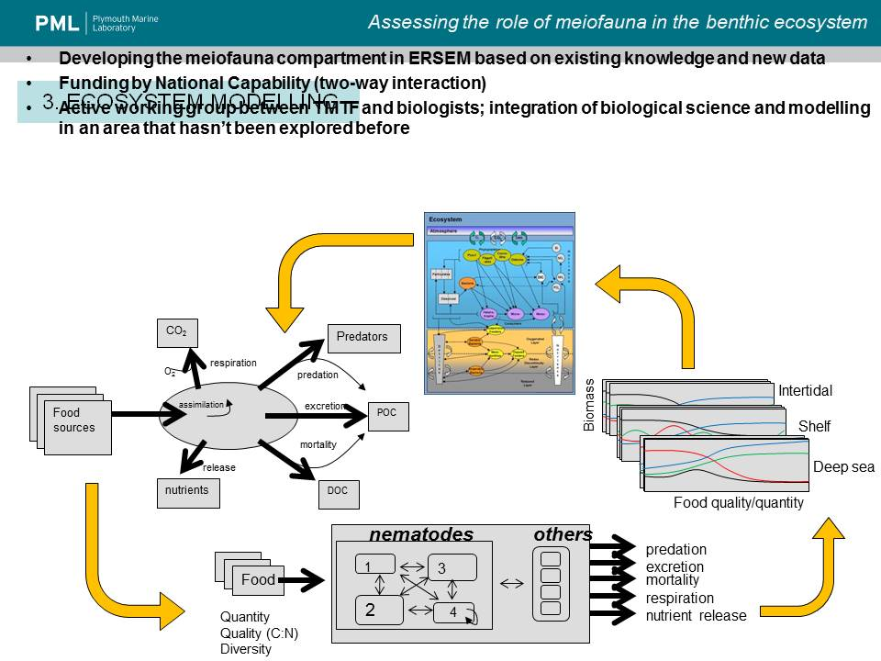

Fig. 1.1.

(4) We have not yet achieved satisfactory quantification of meiobenthic contributions to ecosystem good and services but a more accurate view of important processes and functions performed by meiobenthos was achieved and ideas on how to combine this information with existing ecosystem goods and services frameworks are taking shape.

(5) The project has had considerable impact via scientific interaction, communication and publications as well as social media outreach on different levels. Seventeen peer-reviewed publications and sixteen non-peer reviewed abstracts and contributions have been produced and several are in the pipeline. Efforts have been made to contribute to science-policy communication and interact with marine management as well as exchanging knowledge with the general public. Fourteen conferences, workshop and working meetings were attended with high impact and organisational involvement of the Researcher and a series of new national and international collaborations have been instigated or re-invigorated through the project.

The research training project and career development has resulted in a research fellow with increased international recognition, experience and diversification and expansion of research and complementary skills needed to attain professional maturity and excellence in Marine Science in Europe. The MESMEC project has supported the Researcher with attaining a postdoctoral continuation of his employment.