INCLUDED | EXCLUDED
All fortified centres >=2ha size. | All fortified centres <2ha size.
Non-fortified centres >=2ha size  described as important in published studies. | All sites described as ‘rural’ or ‘a village’, regardless of size.
Large necropolises explicitly linked with undiscovered (proto-) urban centres. | vici/pagi without urban characteristics, regardless of size.
All coloniae, municipia, fora, and those vici possessing indicators of urbanization, regardless of size. | All road-stations (e.g. mansiones/stationes), regardless of size.
Table 1. Criteria developed for defining the object of study

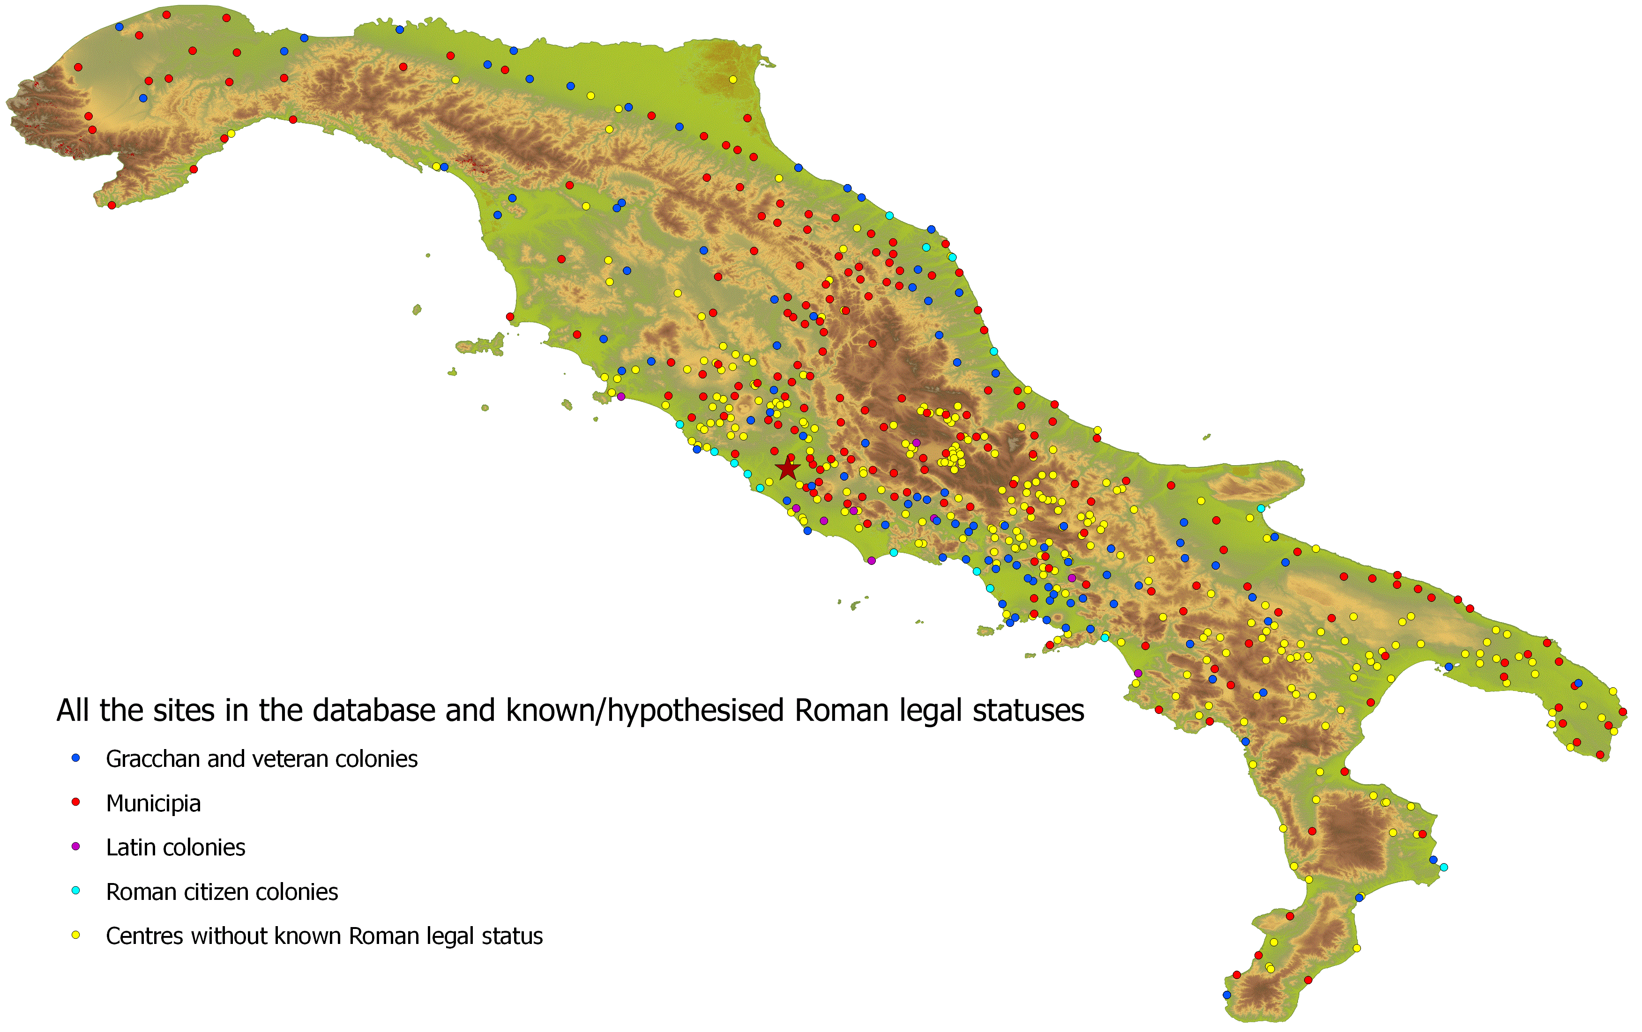
Figure 1. Example of GIS analysis. All the sites in the database and their known/hypothesised Roman legal statuses.

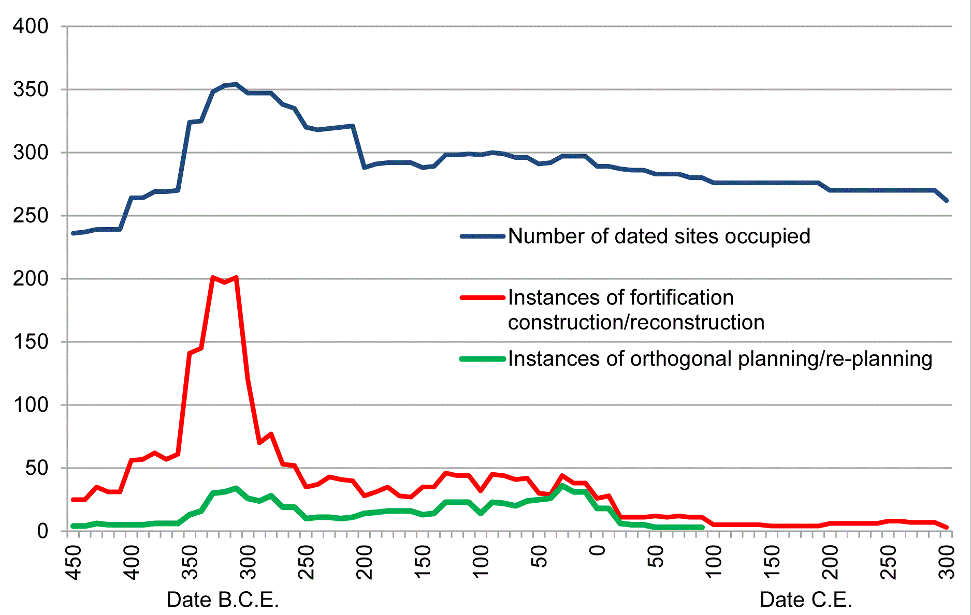
Figure 2. Example of a quantitative analysis. Chronological comparison of number of dated sites occupied, instances of fortification construction/reconstruction and instances of orthogonal town-planning.

