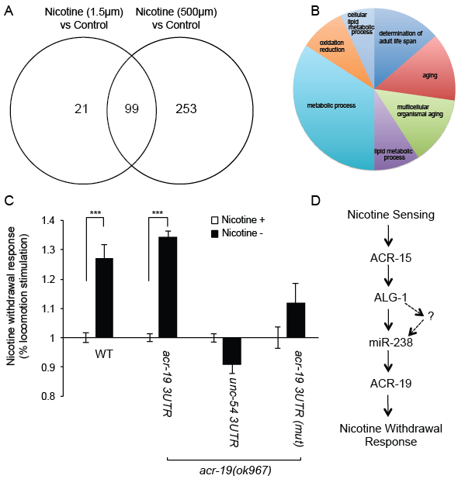

Figure 1. Panel A: number of genes differentially regulated after prolonged nicotine treatment (1.5 μM and 500 μM). Panel B: pie chart depicting the biological functions of differentially regulated genes. Panel C: transgenic acr-19(ok967) mutant worms carrying acr-19 with its native 3´UTR rescue the nicotine withdrawal response, whereas the mutant worms carrying the unc-54 3´UTR show no effect. A transgene containing the acr-19 gene with its 3´UTR harboring a mutation in the miR-238 binding site partially rescues the nicotine withdrawal response. Bars show average ± SEM (n>5). Panel D: schema of the model showing the nicotine-mediated regulation of the miRNA and the AChRs.

