# STARTPAGE

ANNEX 2: FINAL REPORT

Project n°: 301688

Project acronym: aj86rh5gym

“Driving innovation. Determinants of performance   
in the Formula One racing industry”

PIEF-GA-20111-301688

Period covered: from 15.07.2012 to 16.07.2014

Period number: year 1 and 2

Start date of project: 16.07.2012

Project beneficiary name: Dr Paolo Aversa

Project beneficiary organization name: Cass Business School, City University London

Date of preparation: August-September 2013

Date of submission (SESAM): 16.09.2014

Duration: 24 months

Version: 1.0

1. **FINAL PUBLISHABLE SUMMARY REPORT**

In its 24 months of development, the Marie Curie project “Driving innovation. Determinants of performance in the Formula One racing industry” successfully explored one of the most critical question in management theory and practice “what are the determinants of firm superior performance in competitive environments?”. The study was conducted in the field of Formula 1 racing, a highly technological setting where firm-level decisions related to technology, strategy, and team formation, are influenced by the yearly variation of the FIA’s regulation, which significantly impacts the firms’ possibility of gaining performance returns from their innovation efforts. The analyses were based on an extensive 30 year population-level database (in some cases this was extended to 60 years), whose results took shape in form of academic articles first, and later media release later.

The main results demonstrated that in environments where regulations change radically, firms whose technological innovation are incremental in nature will enjoy major performance returns compared to their competitors who opt for radical innovations. On the other hand, technological radical innovations will lead to better results when the regulatory environment remains stable or changes incrementally. Two fine-grained mechanisms underpinning these results have been explored. In fact when technological products undergo major architectural redesign, adding new modules or components might throw the transient product architecture off balance, thus dampening its performance and functionality (namely “architectural product complexity”). Also, when competition is fierce and time-constrained, managers might lack the necessary attention resource to solve the challenges connected to fitting these new components into an optimized and well-balanced product architecture (namely “time-based cognitive limitations”).

The research design mainly observed and compared three major type of variables: (1) detailed technological changes of all the racing cars; (2) interfirm mobility of the team members—including drivers— and related individual capabilities deployment; (3) impact of alliances and collaborations between racing teams and their suppliers/external partners. I leveraged a wide range of analytical methods, including both quantitative (multiple regressions; network analysis) and qualitative techniques (grounded theory, interviews and content analysis).

I succeeded in achieving all the goals I had formerly set for my project. First, I learned how to structure a large and relevant database to test theories and ideas. I developed the most extensive Formula One database for research purposes. Second, I enhanced my knowledge and practical skills with quantitative methods, especially the ones concerning longitudinal regressions, time series, and panel data. To accomplish this goal I participated several classes and training opportunities. Professor Charles Baden-Fuller’s renowned quantitative skills provided me with extraordinary guidance in this process. Third I refined my writing skills and my knowledge of academic English, which is the main language used in international management publications. Professor Charles Baden-Fuller’s skills helped me improving my writing skills.

Fourth, I completed my international research profile by combining different skills in theorizing, testing, and policymaking. I attended international industry conferences to gain a better understanding of the systematic challenges in the automotive industry where I established relations with important representatives of the automotive industry, which facilitated the diffusion of my suggestions for policy makers. Finally, the professional evolution derived from the Marie Curie Fellowship supported my independent research career internationally, which ended up with an appointment at Cass Business School in the role of Lecturer in Strategy.

To pursue these goals, significant work has been done in collaboration with industry experts (in order to gain data and timely insights on the specific dynamics), which allowed me to increase the practitioners’ general interest on the research outcomes of the study. Under the pivotal and meticulous supervision of the supervising scientist Prof. Charles Baden-Fuller, I have undergone a program of intense training that has helped me absorbing the research skills that were necessary to target top-management journals. At the moment, five working paper coming from this database are at different stages of preparation, and two of these are at an advanced stage of review process in two top-tier international management journals (i.e. I am currently incorporating constructive reviews to resubmit the working papers for the third round revision at *Organization Science* and *Industrial and Corporate Change*). Other papers from previous databases have also been improved thanks to the technicalities I gathered in my training program (for the complete list of publications and working papers please see the “2.1. Academic Dissemination” section in this document). Furthermore, I have turned the preliminary results of my study, and other related outcomes into articles for the press. This type of dissemination allowed me to start a collaboration with some international media. During my Marie Curie project I have in fact published six articles in the Financial Times, one in the Engineering and Technology management, and three in Linkiesta (in Italian). All of these are aimed at diffusing my research outcomes to a broader international audience. In addition, I have developed used social media (Cass [“Centive” website](http://www.cass.city.ac.uk/research-and-faculty/centres/centive/formula-1), my [personal blog](http://motorsportstrategy.wordpress.com/) and [twitter](https://twitter.com/aversapaolo)) to further amplify the scope of my research. During this time I have also widely engaged with the academic community. My papers were presented 12 times in 9 international peer-reviewed conferences, and additionally I have been invited to present my works in 13 brown bag seminars, for a total of 25 paper presentations and discussions.

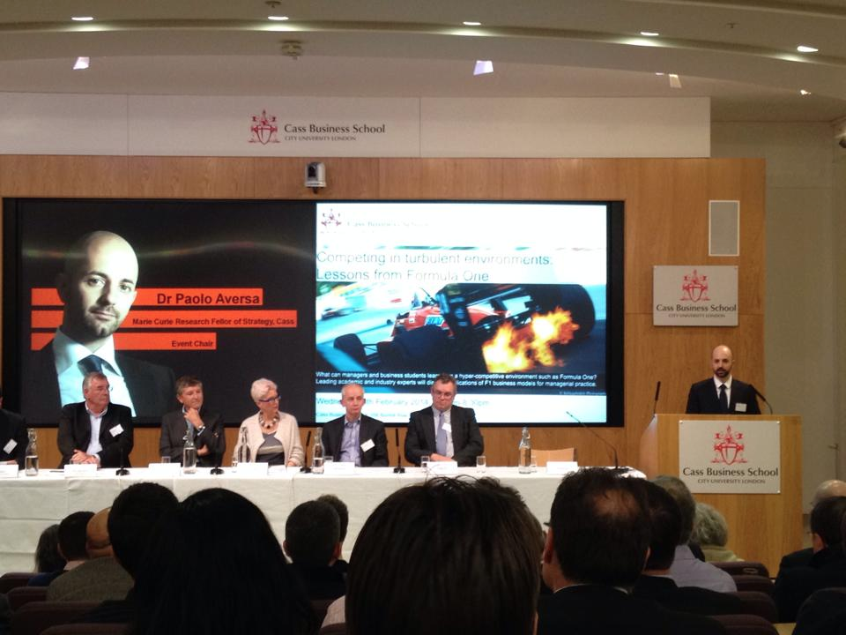

Figure 1: Opening of the Formula 1 Event at Cass Business School, 05/02/2014.

The international media has also demonstrated great interest for my academic contribution from the early release of my findings, as my research was cited more than 30 times in the news around the world (in USA, UK, Germany, Italy, France, Netherlands among others). This gave me increasing visibility within the industry and the media, and I am now considered one of the main academic experts in the Formula 1 industry, as far as business and strategy concern. As a result, I am often invited by international media such as BBC to comment on related topics in the automotive and motorsport sectors. I have already commented at BBC World News (tv channel broadcasted live in more than 200 countries), BBC Radio 4 and BBC Radio 5, as well as in the Italian national tv channel Rai 1. Finally, as planned in my proposal I organized a roundtable at Cass Business School, on the business of Formula 1 “Competing in Turbulent Environments. Lessons from Formula 1”. Formula 1 represents the cutting edge of the automotive industry, and its fast and fierce competitive environment is the perfect setting to derive managerial policies for other hypercompetitive industries. Accordingly, the event *“Competing in turbulent environments: lessons from Formula One”* discussed how racing can provide timely lessons not only to people working in motorsport, but also to managers and business students engaged in other fields. Six leading experts from academia and the industry were invited to participate, and several side activities were included (such as the possibility for the guests to try a racing simulator). Despite the unexpected London Tube strike, Cass auditorium was filled up as 230 guests came, including media, photographers and authorities (please see the event report in the “2.3. Industry dissemination” section for further details).

****All in all, my Marie Curie project exceeded all the proposed goals listed in the funded proposal, and allowed me to effectively prepare myself for an international career in management academia. Cass Business School, under the expert guidance of Professor Charles Baden-Fuller, represented the ideal environment to fully accomplish my initial objectives, as I found an outstanding research environment and an extremely professional faculty and staff. Finally, after interviewing in several top Universities in Europe, I happily accepted an offer as “Lecturer in Strategy” at Cass Business School, where I will continue my academic career by targeting excellence in research, education, and engagement with the industry.

**Date:** *August 25, 2014*

**Dr. Paolo Aversa:**

**Paolo.aversa.1@city.ac.uk**

# ENDPAGE

ANNEX 2: FINAL REPORT

Project n°: 301688

Project acronym: aj86rh5gym

“Driving innovation. Determinants of performance   
in the Formula One racing industry”

PIEF-GA-20111-301688

Period covered: from 15.07.2012 to 16.07.2014

Period number: year 1 and 2

Start date of project: 16.07.2012

Project beneficiary name: Dr Paolo Aversa

Project beneficiary organization name: Cass Business School, City University London

Date of preparation: August-September 2013

Date of submission (SESAM): 16.09.2014

Duration: 24 months

Version: 1.0