 | EUROPEAN COMMISSION  RESEARCH DIRECTORATE-GENERAL  Marie Curie Actions – Fellowships | EIF-OIF-IIF-IRG-ERG Final Activity and Management Report
Project n°: 301742
Project Acronym: RODATTN
Project Full Name: Mechanisms of attentional modulation of neural responses in visual cortex of mice
Marie Curie Actions
EIF-OIF-IIF-Final Activity and Management Report
Period covered: from 1/3/2012 to 1/3/2014
Period number: 1
Start date of project: 1/3/2012
Project coordinator name: Thomas Mrsic-Flogel
Project coordinator organisation name: University College London
Date of preparation: 15/3/14
Date of submission (SESAM): 12/3/14
Duration: 2 years
Version: 1
- Final publishable summary report
This section normally should not exceed 2 pages.

This is a comprehensive summary overview of results, conclusions and the socio-economic impacts of the project. The publishable report shall be formatted to be printed as a stand alone paper document. This report should address a wide audience, including the general public.

Please ensure that it:
- Is of suitable quality to enable direct publication by the Commission.
- Is comprehensive, and describes the work carried out to achieve the project's objectives; the main results, conclusions and their potential impact and use and any socio-economic impact of the project. Please mention any target groups such as policy makers or civil society for whom the research could be relevant.
- Includes where appropriate, diagrams or photographs and the project logo, illustrating and promoting the work of the project.
- Provides the address of the project Website (if applicable) as well as relevant contact details.

This project was aimed at understanding certain fundamental questions about how information is represented in the brain. In particular, we wanted to study how the visual cortex in mice is activated by specific visual stimuli, and critically, how does that activation change over the course of learning, that is, as the animal learns the relvance of one particular stimulus.

This is a very difficult question to address because it requires measuring the activity of the same population of neurons over many days, as an animal is awake and actively learning new associations. To perform such measurements we needed to first develop the tools for this. The solution was an elaborate one, which involved holding a mouse in place using an implant on its head, while it ran in a virtual-reality environment where it was given the illusion of running through a corridor as it ran on a wheel kept under its feet. We previously had to inject calcium sensitive dye into the brain of the mouse and then implant a small glass window on the brain to allow direct viewing of the brain surface. Then while the mouse was running in the virtual reality, we positioned a laser-scanning microscope on top of the mouse's head, and were able to observe the activity of neurons through the implanted window.
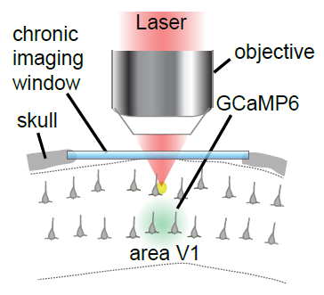
Figure 1. Schematic of imaging of neural activity through a chronically implanted cranial window
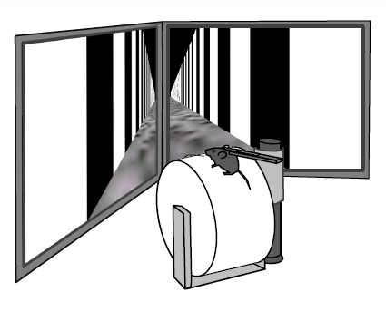
Figure 2: Schematic of a mouse running in virtual reality
Once we developed the ability to record from the same population of neurons over multiple days, we developed a simple behavioural task in which the mouse learns to associate one stimulus with a reward and another with absence of reward, and these stimuli were presented to them in the virtual reality. Mice learnt this task within a week, and as they were learning we recorded the activity of hundreds of neurons simultaneously.

We were able to complete an entire set of experiments and on analysing the data have found some very interesting results. Most strikingly, there is a large increase in the fraction of cells that represent the rewarded stimulus, and the population of neurons encode the information about the stimulus in a way such that as the animal learns the relevance of the stimulus, there a progressive enhancement in the amount of information encoded about the rewarded stimulus.

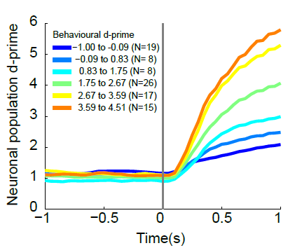

Figure 3. Neuronal population information about the rewarded stimulus increases as the animal learns the task over a few days

We expect to develop these findings further by studying other ways in which we can modulate the attentional context while presenting the same visual stimulus. For this we have made the mouse learn to switch attention from a visual task to an olfactory task while we imaged its brain. We expect to analyse that data soon. The results of that experiment will be crucial in understanding the nature in which the brain switches attention from one modality to another.

These results and the expected results together throw light on some of the most important questions about how the brain works, such as the neural dynamics underlying memory and attention. This has been possible by bringing together some of the most cutting edge technologies together and will allow us to further our understanding of the nature of brain function and disease.

- Use and dissemination of foreground
Section A (public) – Dissemination measures
This section should describe the dissemination measures, including any scientific publications relating to foreground and specify any applications for patents etc. Its content will be made available in the public domain thus demonstrating the added-value and positive impact of the project on the European Community.

    - Dissemination activities

We presented this work in the following places
- 4th European visual cortex meeting 2013, Croatia (talk)
- Bench to bedside meeting 2014, Unversity of Basel, Basel Switzerland (talk)
- Seminar in IISER, India (talk)
- COSYNE meeting 2014, Salt Lake City, Utah (poster presentation)
- FENS meeting 2014, Milan, Italy (poster presentation).

We have not yet published this work, but have a manuscript in preparation. This will be submitted for peer review in a top quality journal in the coming months

    - Publications (peer reviewed)

The list of scientific publications (see article II.12 of the grant agreement) starting with the most important ones, should specify:
  - publication name,
  - date and page in order to be able to identify it (see proposed template).

list of scientific (peer reviewed) publications, starting with the most important ones
NO. | Title | Main author | Title of the periodical or the series | Number, date or frequency | Publisher | Place of publication | Year of publication | Relevant pages
1 | None so far
2
3

With regard to scientific publications published before or after the final report, such details/references and an abstract of the publication must be provided to the Commission at the latest two months following publication. Furthermore, an electronic copy of the published version or the final manuscript accepted for publication shall also be provided to the Commission at the same time for the purpose of publication by the Commission if this does not infringe any rights of third parties.
Section B (confidential) - EXPLOITABLE FOREGROUND AND PLANS FOR EXPLOITATION

This section should specify the exploitable foreground and provide the plans for exploitation. It will be kept confidential and will be treated as such by the Commission.

The applications for patents, trademarks, registered designs, etc. shall be listed according to the template provided hereafter.

The list should, specify at least one unique identifier e.g. European Patent application reference. If applicable, contributions to standards should be specified.

Table B1: List of applications for patents, trademarks, registered designs, etc.
Type of IP Rights: Patents, Trademarks,  Registered designs, Utility models, etc. | Application reference(s)  (e.g. EP123456) | Subject or title of application | Applicant(s) (as on the application)
na

Please complete the table hereafter:

Table B2: Overview table with exploitable foreground

Exploitable Foreground  (description) | Exploitable product(s) or measure(s) | Sector(s) of application | Timetable, commercial use | Patents or other IPR exploitation (licences) | Owner & Other Beneficiary(s) involved
na

In addition to the table, please provide a text to explain the exploitable foreground
[One text box per row in table B2]
Open space (2 pages maximum) composed as following:

- Its purpose
- How the foreground might be exploited, when and by whom
- IPR exploitable measures taken or intended
- Further research necessary, if any
- Potential/expected impact (quantify where possible)

- Scientist in charge questionnaire
RESEARCH TRAINING ASSESSMENT:

What is the size of the hosting research group? | 10 persons

How many researchers have you supervised, within the past 10 years? Of which funded by:
EC/Marie Curie actions | 3
EC Other Funding | 3
University fellowships | 2
National public bodies | 5
Industry | 0
Other | 2
Other, please specify: | EMBO, Humboldt Foundation

How many researchers have you supervised within this project? | 1
Corresponding to how many person months? | 24

Number of publications resulting directly from the research project:
Recruited researcher(s) and yourself | 0 (in preparation)
Recruited researcher(s) alone | 0 (in preparation)
Recruited researcher(s) with authors other  than yourself | 0 (in preparation)

Participation of the recruited researcher(s) at conferences (number):
Passive | 0
Active | 4
How do you rate the overall success of the research training? | Very poor  Poor  Fair  Good  Very good

General assessment:

RESEARCHERS ASSESSMENT:

Rate the overall level of the recruited researcher(s) integration in the research team and the
host organisation with regards to:
participation in meetings/seminars | Very good
discussions of results and project-related  topics | Very good
co-operation with other team members | Very good
co-operation with other researchers of the  host institution | Very good

Rate the overall performance of the recruited researcher(s) with regard to:
originality of fellow(s) approach towards research (initiative/independent thinking) | Very good
capacity to develop new skills and to benefit  from training | Very good
productivity (research  results/publications/international conference  attendance) | Very good
communication skills | Very good
group leader skills (collaboration with other  groups/project management) | Very good
training and/or teaching skills | Very good
Please comment:

RESEARCH TRAINING OUTCOMES:

Has this project provided additional links with other research groups or institutions? | yes
If yes, indicate the number of contacts in each case
Universities | 1
Research Centres | 1
Industry/private companies
Others
If Other, please specify:

Rate the importance of the following outcomes of the research training
results of the research | Very good
number of publications | na
development of research | Very good
establishment of international collaborations | Very good
transfer of knowledge/technology | Very good
training of researcher | Very good
further academic qualifications (PhD, habilitation etc.) for fellows | none
Please comment:

YOUR OPINION ABOUT THE MARIE CURIE ACTIONS:

Do you have any other comments or suggestions of how to improve the concerned Marie Curie actions? None. Excellent support!

Did you have previous knowledge of the Marie  Curie actions? | yes

If yes, what sort of image do you think that the  Marie Curie actions have among the scientific community in your research area? | Enhances the scientific quality of the individual, and contributes to the scientific community locally and internationally.

Attachments:

Date:  Signature Scientist in Charge: | Date:  Signature Researcher:

