Figure 1: Comparison of the Casimir Polder-Potential as a function of distance for different surfaces
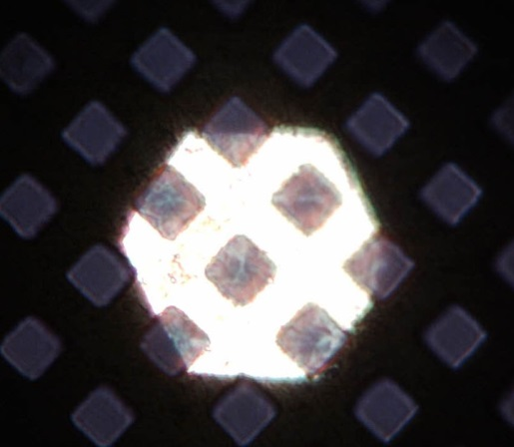

Figure 2: Optical microscope picture of a free-standing graphene membrane on a TEM grid

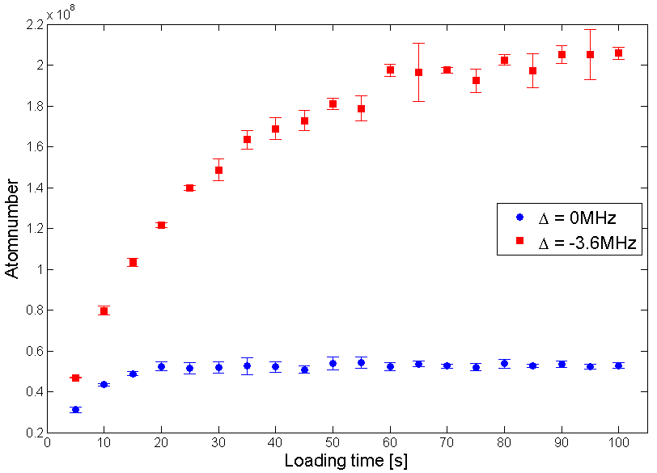
a) b)
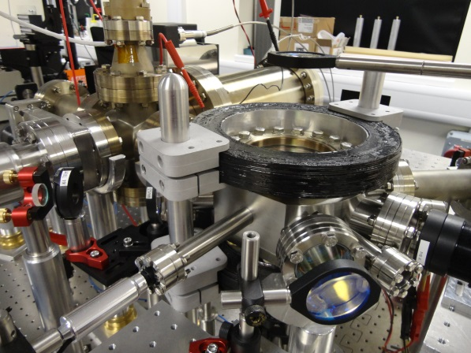

Figure 3: Left (a): Experimental apparatus to form the Dual Colour MOT, Right (b): Loading rate comparing dual colour with single colour operation.
