**Figure 1** – Projected timeline (green arrow indicates current date)

**Figure 2** – Average blood glucose measurements during progression of type 1 diabetes in NOD mice from two different suppliers. (n=10 per supplier)



**Figure 3** – Incidence curves during progression of type 1 diabetes in NOD mice from two different suppliers. (n=10 per supplier)



**Figure 4** – Diabetes incidence curve for NOD mice at the Jackson Laboratories. Circles represent males (n=20); squares represent females (n=16). From: Curr Protoc Immunol. 2001 May;Chapter 15:Unit 15.9. The NOD mouse: a model for insulin-dependent diabetes mellitus. Leiter EH. The Jackson Laboratory, Bar Harbor, Maine, USA.

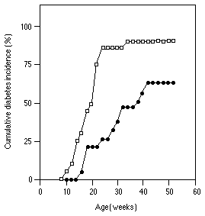

**Figure 5** – Comparison of diabetes incidence as a variable of housing conditions.



**Figure 6** – Dithizone-stained pure handpicked pancreatic islets after isolation from two mice (which were also included in Figure 5).

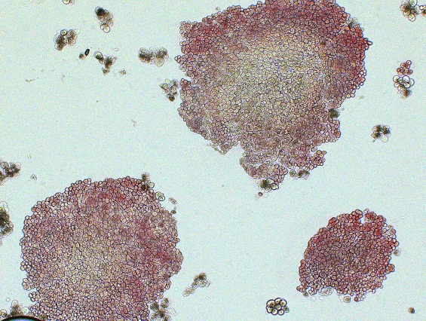

**Figure 7** – Flow cytometry on infiltrating leukocytes from isolated pancreatic islets from 5 24 week-old NODShiLTj mice. Top row is population from mesenteric lymph nodes for comparison.

C:\Users\Ken Coppieters\Desktop\Flow islets.tif

C:\Users\Ken Coppieters\Desktop\Series016_z04.tifC:\Users\Ken Coppieters\Desktop\Image005.tif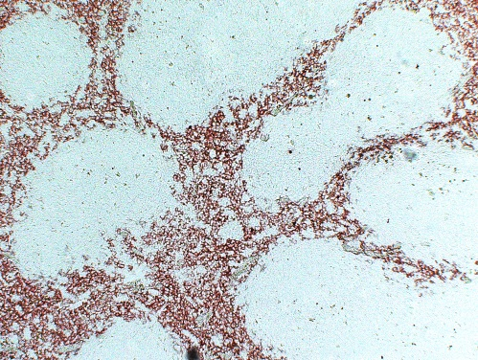**Figure 8** – Immunohistochemical and immunofluorescent analysis of macrophage infiltration on frozen sections. From left to right: F4/80 optimization on spleen sections; F4/80 staining (green) in conjunction with insulin staining (red) on representative frozen section from non-diabetic mouse from Figure 2-3; Whole-mount staining of an isolated pancreatic islet from a non-diabetic mouse from Figure 5 (F4/80 staining in red, insulin in green/yellow).