New inter-scale techniques for damage analysis of novel composite architectures
In a race for efficiency and functionality modern composite become increasingly complicated. At present, the design of fibrous architectures is often tailored to a specific application and optimised for a particular aspect of composite performance. As a result, fibres are organised in complex curved interlaced trajectories and patterns. Every single fibre tow in such architecture may have its own individual path. This level of sophistication becomes typical for the entire suite of composite manufacturing processes ranging from laminated geometries obtained by automatic fibre deposition to intrinsically complex net-shaped textile preforms.
The essential material properties such as stiffness, toughness, strength depend on the interaction of composite constituents at the local scale of fibre bundles. To understand and predict deformation and damage processes the internal structures of these materials need to be examined with a high resolution. This implies high computational cost of analysis since fine geometrical features (characteristic sizes of mm and sub-mm) need to be taken into account at the component scale. Thus, the new manufacturing trend creates a fundamental need for simple and rational design tools that would allow a fast but comprehensive assessment of the composite performance at the structural and component scales.
Modelling approach
The conventional multi-scale techniques address the challenge of high-resolution – low computational cost by establishing a hierarchy of problems at the component and structural levels. The problem at lower level is set for a local representative volume element. This project developed a strategy where the separation of scales is applied to the composites lacking a characteristic representative element through space and scale separation of considered architecture.
It was demonstrated that a complex interaction of unit cells in an arbitrarily nested textile laminate can be successfully replicated by the analysis of a single unit cell repeat. The key to an adequate estimation of deformation characteristics is the well-designed conditions set on its boundaries and imitating the interaction of the considered volume with its neighbours. The feasibility of generalising this concept was then tested in application to more complicated architectures and loading cases.
Test cases
The applicability and limitations of the proposed modelling concept were tested in a large cases of the parametrical tests problem reproducing features such as in-plane and out-of plane waviness, ply crimp, ply symmetry, material properties, etc. These test cases were aimed at comparing the results of decomposition approach with the trusted reference solutions obtained at a realistic computational cost. The presented test cases allowed to explore the applicability of the approach beyond the conventional textile architecture and assess the predictive capacity for modelling tow-steered, non-crimp, and patterned composites.
Numerical tools developed within the project
A library of new numerical tools was developed within the project. In particular they enabled generating the realistic geometrical models of patterned textile reinforcement with imposed features such as thickness variation, distortions, ply curvature and take into account features which are ignored in conventional model but are essential for understanding consolidation mechanisms and fine peculiarities of the load flow in textile composites (such as lateral yarn interaction and side yarn crimp).
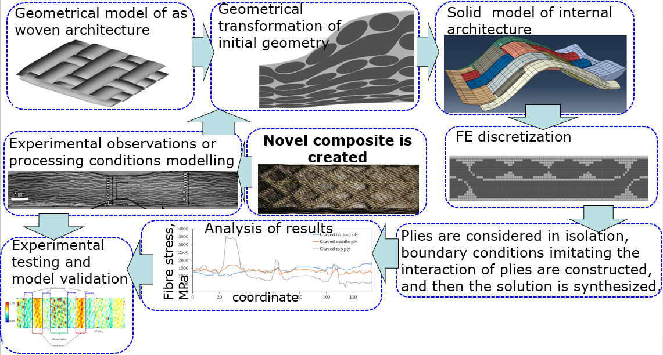
Figure 1. A scheme of data flow in the numerical simulation of novel architectures
The logistics of data flow between the defragmented elements of the architecture also demanded novel numerical algorithms. This included the transformation of vector field into nodal boundary conditions, tools for post-processing and superposition of 3D displacement fields, tools for meshing complex architectures, and post-processing algorithms.
Novel architectures
The particular attention of InterCom was devoted to the characterisation and analysis of real composite architectures obtained using both the conventional and innovative manufacturing methods. In particular three characteristic case studies were examined in details:
- Laminated composites obtained by tow steering. Steered architecture are characteristic for high in-plane curvature of tow paths, ply thickness variation, resin rich zones, etc.
- Woven architectures patterned through Liquid Resin Print. They feature yarn crimp, superposition of textile and print induced patters, fibre volume fraction variation.
- Composites with graded dissimilar matrices and complex distribution of additives applied to redistribute the load around the stress concentration sites.
An experimental testing programme was conducted for these material systems with the focus on the deformation and damage accumulation mechanisms at the tow/yarn scales.
Application of the decomposition approach to model damage
The high resolution assessment of stress distribution allowed modelling damage accumulation and failure. Damage in composites may violate the translational symmetry of even initially periodic structures and hence, the analysis of non-periodic structures becomes particularly relevant in the context of damage modelling. The suggested approach is not constrained by the requirements of a representative volume and hence there is a larger freedom in selecting the volume of considerations at the structural scale. It enables simpler and more efficient modelling of deformation in damaged material. This was demonstrated for layered textile composites prone to failure through delaminations.
Further work and synergy with the parallel projects
The InterCom project created a densely cross-linked cluster of studies leading to the experimentally proven, verified multi-scale concept. A number of approaches and techniques developed within InterCom expanded the capabilities of numerical analysis and the design of novel composites which has been developed by the PI and collaborators in a number of parallel projects. These structures allow creating patterned graded and functionalised composites by means of Liquid Resin Print method. The tools developed within InterCom will be further exploited and applied to design and manufacture materials at the yarn scale.
Project management
InterCom project has facilitated and helped the reintegration of the PI in the new institution. It made a pronounced contribution in establishing a new research niche and allowed to build on the research work initiated previously.
Academic projects which have been conducted in parallel to InterCom include:
EPSRC Grant: “New generation of manufacturing technologies: liquid print of composite matrices”, 2015-2017, PI
EPSRC Centre for Innovative Manufacturing in Composites Feasibility study: “Dimensionally stable textile preforms for use in liquid resin infusion manufacture”, 2013-2014, PI
EPSRC Pump Priming study to facilitate interaction with Sir Henry Royce Institute: Gradient reinforcements and matrices for resilient feature-insensitive composites, 2016, PI
Engineering Faculty Pump Priming Fund Novel patterned composites with revolutionary loading of functionalising additives by 3D printing, 2015-2016, PI
EPSRC Centre for Innovative Manufacturing in Composites: “Defect Generation Mechanisms in Thick and Variable Thickness Composite Parts - Understanding, Predicting and Mitigation” (DefGen), 2013-2016, CoI.
InterCom facilitated creating a research group. Currently 3 PhD students have been supervised (one of them was funded by the InterCom projects) and 4 PhD students co-supervised. There are also 2 master project students, several research assistants on fixed term or casual staff contracts. InterCom project enabled a series of experimental and modelling intern projects, which often served as a pre-cursor for the follow-on funded projects. Overall, these activities formed a solid ground for further development of the research on the interface between the multi-scale modelling and the innovative manufacturing.

