PEOPLE
MARIE CURIE ACTIONS

Intra-European Fellowships (IEF)
Call: FP7-PEOPLE-IEF-2012

Final report

“Active actin-microtubule crosstalk in reconstituted systems”

Acronym: CytoskeletonCoupling

Name of the fellow : Florian Huber
Email : f.huber@amolf.nl
Fax : +31-20-754-7224

Final publishable summary report
The actin and microtubule (MT) cytoskeletons are key structural components that allow and coordinate rapid and sometimes drastic changes in cellular morphology, such as polarization, migration and cytokinesis. Up until now much attention has been focused on the independent functions and characteristics of these two elements; yet, the cooperative functioning of actin and microtubules (MTs) is increasingly regarded as a central element for many cellular key processes including cell division, cell migration, and adhesion. Several specific actin-MT linker molecules have been discovered, but a detailed understanding of their effects on actin-MT co-organization remains elusive.

For a more profound and quantitative understanding of actin-MT crosstalk we developed a simple yet realistic reconstituted model system. MTs are grown from either stabilized seeds or centrosomes in the presence (or absence) of actin networks. To account for the diversity of cytoskeleton architectures we confront dynamic MTs with single actin filaments, loose actin networks, or rigid bundles. Coupling between the two cytoskeleton components is introduced in form of transient binding of growing MT plus ends to actin filaments using a actin-MT linker (termed TipAct) that is similar in functionality to the protein MACF.

We find that the presence of an actin-MT linker allows growing microtubules to steer actin bundle formation and to transport actin filaments. In return, existing actin bundles can reliably capture and guide growing microtubules. Facing a wide spectrum of different geometrical and mechanical settings, the same dynamic actin-MT cross-linker thus can result in a rich repertoire of co-organizational effects, independent of biochemical regulation. In particular we found, that dynamic MTs can actively restructure surrounding actin networks if TipAct is present (see figure).

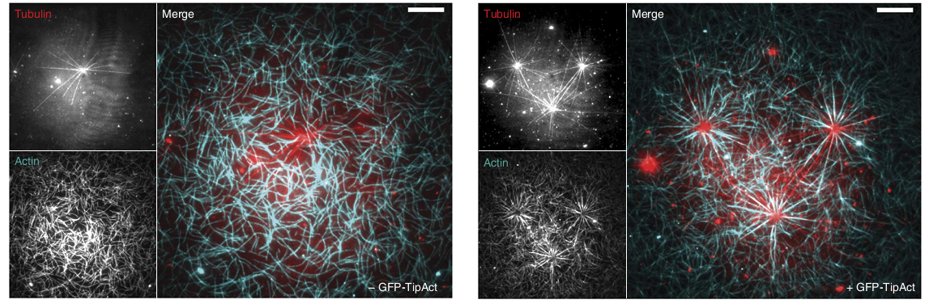
Figure 1 Dynamic microtubules (red) grow from purified centrosomes that were attached to a glass cover slip. The centrosomes were embedded in an entangled network of actin filaments (cyan). Left panel: In the absence of actin-MT linkers the actin network was not noticeably affected by the presence of growing MTs. Right panel: In the presence of actin-MT linkers (termed TipAct), however, radial bundles formed within 15-30minutes around the centrosomes, following the tracks of dynamically growing MTs. Scale bar is 5µm.
During the course of this project we further realized that the very fundamental behavior of MTs in the presence but also the absence of obstacles is still far from being understood on a mechanistic level. To uncouple the MT dynamics from further protein interactions we focused on data that was obtained from individual growing MTs in the presence and absence of rigid micro-fabricated barriers. Using fluorescence microscopy techniques such as TIRF, we are able to follow the dynamics of individual growing microtubules. We further studied the effect of addition of EB3 (end-binding protein 3), an essential microtubule-related protein known to bind to growing microtubule ends. This data was complemented by a stochastic computer simulation to be able to map the observed MT behavior to intrinsic random decay processes.

We find that a strongly reduced stochastic description of the MT tip is sufficient to qualitatively and quantitatively explain a diverse collection of data on growing MTs under different conditions (with and without EB), in the presence or absence of rigid obstacles. This will allow us to propose a novel description of the MT tip which is entirely based on a random hydrolysis of the tubulin dimers in conjunction with a high volatility of the foremost tubulin dimers.

Finally, an additional experimental system was developed to probe the effect of dynamically treadmilling Arp2/3-based actin networks on MT dynamics. This system is able to mimic the interaction of dynamic MTs with the lamellipodial actin network in migrating cells as well as in neuronal growth cones. First results indicate that MTs are surprisingly sensitive to the presence of dense actin meshworks.

In summary, the results obtained deliver a deeper understanding of MT growth dynamics as well as the interplay between dynamic MTs and actin networks. Both processes are key to a wide range of essential cellular processes. In addition to novel insights in these processes, we expect that our results will be used as a basis to further explore cytoskeleton self-regulation. First, the in vitro experimental assays carried out can be extended by the use of additional core ingredients such as molecular motors or cross-linking proteins. And second, our simulation not only leads to further predictions that are to be tested, but –due to its simplicity- can also easily be incorporated into more complex settings of larger scale cytoskeleton simulations.

