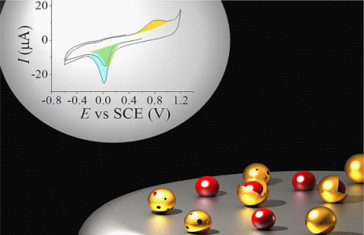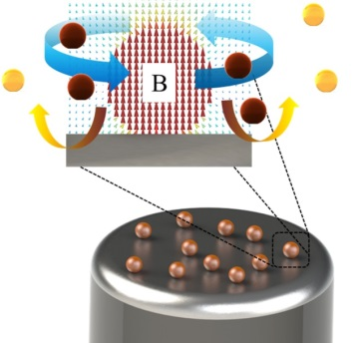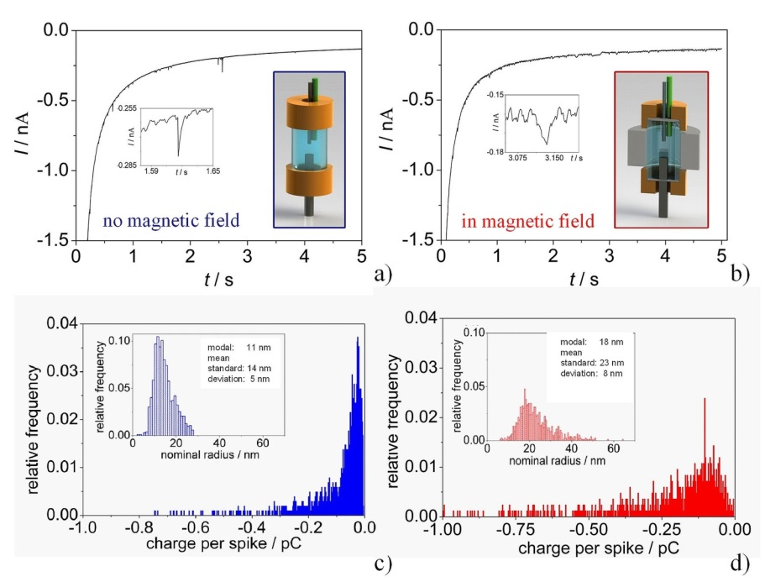
a) b)
magnetic
nanoparticle
c)
Figure 1: Nano-impact experiments reveal the magnetic field-induced agglomeration of colloidal magnetic nanoparticles, b) magnetically-switchable enhanced mass transport at magnetite nanoparticle modified electrodes, c) analysing the quality of shells of core-shell nanoparticles by cyclical voltammetry.

