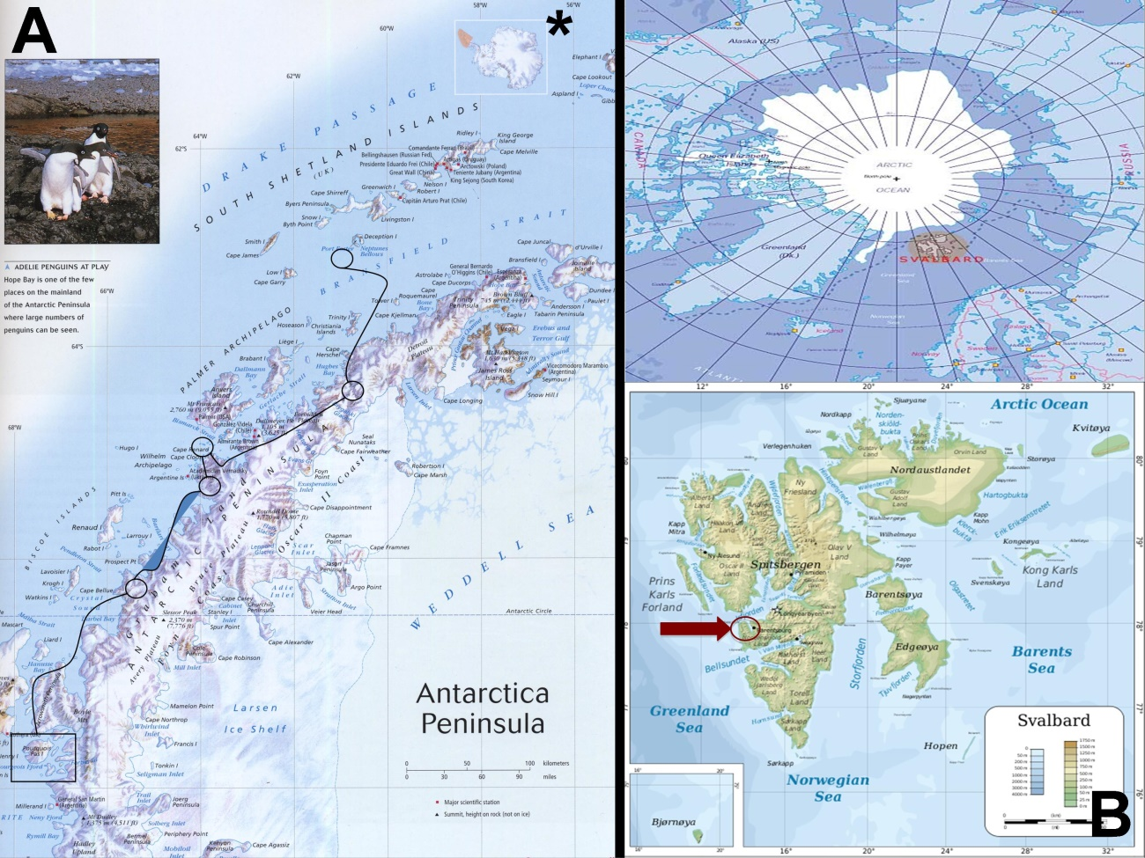
Localization of the sites from which samples analyzed as part of the research project originated. Left (A); Antarctic sampling sites were located along a latitudinal gradient in the Antarctic Peninsula. Right (B); Arctic samples originated from several lakes at the Svalvard archipelago.

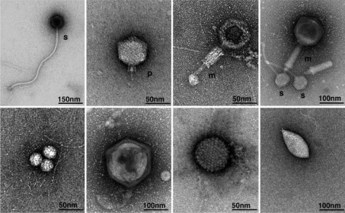
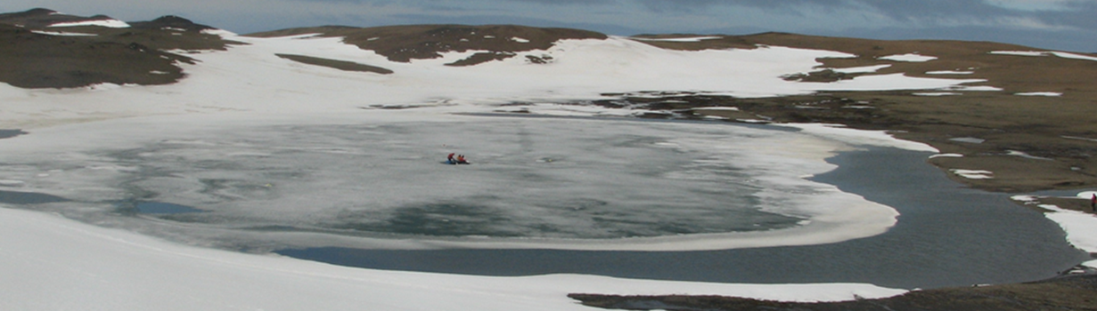

Top: Photograph depicting scientist sampling Lake Limnopolar (Antarctic Peninsula).
Bottom: Micrographs of several viral morphologies observed for this lake.

