A new step in career development: Building bridges between academia and industry
This can be achieved with the help of Marie S.-Curie Actions. Alina M. Balu was enjoying her experience working in top industry with an IEF MSC Fellowship hosted by an SME in Netherlands. Avantium BV is a leading renewable chemical company selected by the Cleantech Group as European Cleantech Company of the decade.
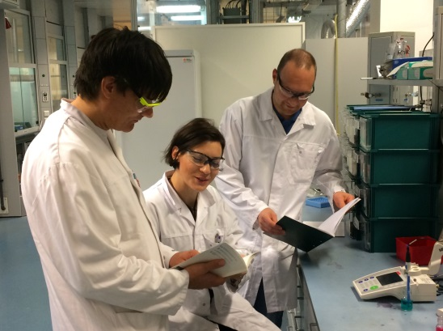 New Chemistry team members with Marie Curie fellow© Avantium
Since its foundation in 2000, Avantium has identified and developed sustainable alternatives for the cost effective production of biobased fuels, chemicals and materials. In response to the global increase in the use of biofuels as substitute transportation fuels (as urgently needed due to finite fossile reserves and increased GHG emissions) advanced chemical, biochemical and thermochemical biofuels production routes are being promoted. Research and development in this field is also carried out at Avantium and is aimed at improving the quality and environmental impact of biofuels and biochemicals production, as well as the overall efficiency and output of biorefinery production plants.

Many researchers from Avantium are very aware of these issues, and the New Chemistries group that was recently created (20 people and continuously growing) is focusing their efforts towards sustainable solutions for this important challenges. We are a multidisciplinary and international team working in closely related but complementary fields of research to catalyze the biobased future.

I was awarded an IEF-grant (under Marie S.-Curie Actions) to work at Avantium in the project YXY FS (“Producing YXY fuels from carbohydrates”). The conversion of carbohydrate-rich feedstocks, e.g. glucose and fructose, in the key intermediates hydroxymethylfurfural (HMF) and its ethers and in levulinic acid (LevA) and its ester methyl levulinate (MeL), is well established by YXY Technology Platform and currently being scaled-up by Avantium.
Avantium built an YXY Pilot Plant (operating 24/7) in Geleen and announced the on-stream coming of the commercial plant for the production of large amounts of furanics and levulinics by 2017/2018. This will enable for first time access to large volume of levulinics at competitive prices. However, the further derivatization into new bio-based fuels is not well understood because the molecules behave very different chemical characteristics from the fossil-based produced fuels. Therefore the chemistry and optimal conversion of especially LevA ester produced in high volume and with high purity (MeL) needs further research. The extensive knowledge I have gained over the past years, during my postgraduate studies and during the postdoc in Biorefineries group (Aalto, Finland) working on Green Chemistry methodologies in the different areas mainly materials science and heterogeneous catalysis has very useful to achieve a better understanding and therefore try to improve the economics of the process.
In the YXY FS project, we aimed at developing novel multifunctional catalysts for specific transformations of MeL into higher valuable chemicals and fuels. The designed catalytic materials including carbonaceous nanomaterials have been tested under various reaction conditions (concentration, space velocity etc) on chemical conversion of LevA and MeL to valuable compounds including gamma-valerolactone and pentanoic acid under both conventional heating and microwave irradiation. After establishing the optimal catalyst and process conditions, testing real feeds originating from the YXY Pilot Plant process has been the main aim of the project. In order to make this project successful, I work closely in an interdisciplinary working environment and collaborate with exciting groups of biomass specialists, organic chemists, chemical engineers as well as fuel specialists, both at Avantium and in collaboration with various networks including the cooperation under the COST Action Framework (I am currently MC for NL for FP1306 COST Action) and with the specific working group members of WG2 I am leading on “Hemicelluloses side streams valorization”. This Action provides also opportunities for researchers to exchange information on recent developments in R&D through networking, meetings and/or workshops.
In view of these findings and important developments, the project can advance the scientific knowledge in the field of aqueous processing and biomass valorization, being highly promising for future research and commercial endeavours from Avantium as a company.

Websites: Company website: www.avantium.com, Twitter: @Avantium
YXY FS project: http://cordis.europa.eu/projects/rcn/108320_en.html

References:
1. A.M. Balu, N. van der Puil, N. Kemeling, J.C. van der Waal, E. de Jong, Insights in technical and economical aspects for sustainable production of methyl levulinate towards its commercialization. 247th ACS National Meeting and Exposition, March 16-20, 2014, Dallas, Texas, Chemistry and Materials for Energy, Oral presentation. http://presentations.acs.org/common/presentation-detail.aspx/Spring2014/ENVR/ENVR019a/15168
2. A.M. Balu, G. van Klink, A. Sijpkes, N. Kemeling, J.C. van der Waal, E. de Jong, Levulinics: Novel sustainable building blocks for renewable formulations. MSCA event at Euro Science Open Forum (ESOF2014 Conference), Copenhagen, 19-20th June, 2014, Poster presentation.
3. Lange, J.P., Price, R., Ayoub, P.M., Louis, J., Petrus, L., Clarke, L., Gosselink. H. Valeric biofuels: A platform of cellulosic transportation fuels. Angew. Chem. Int. Ed. 2010, 49, 1 – 6
4. Gruter, G.J., de Jong, E. Novel biofuel options from carbohydrates. Biofuels Technol., 2009, 1, 11-17.

