- Publishable summary
A summary description of the project objectives:
This project proposed to: a) understand why the junction position is close to cathode in most light-emitting electrochemical cells (LECs); b) incorporate protein into light-emitting devices. In addition, the project also aimed to train the researcher (Dr. F. Gao) to be an independent scientist.
A description of the work performed since the beginning of the project:
We prepared light-emitting electrochemical cells using several different emissive polymers, and tried to understand the reasons why the light emission is usually close to the cathode.
We incorporated protein into light-emitting devices.
We investigated charge generation mechanisms of organic photovoltaics.
Dr. Gao attended a range of academic conferences, teaching/supervision courses, leadership training courses, and submitted independent grant applications.
A description of the main results achieved so far:
1, By investigating a range of different emissive polymers, we concluded that emission position of LECs heavily depends on electron-negative elements in the emissive polymer. For example, for poly[2-methoxy-5-(2-ethylhexyloxy)-1,4-phenylenevinylene] (MEH-PPV), which contains electron negative oxygen, the emission position is close to the cathode. In contrast, for poly(9,9-di-n-dodecylfluorenyl-2,7-diyl) (PFO), which contains only carbon and hydrogen, the emission position is in the middle.
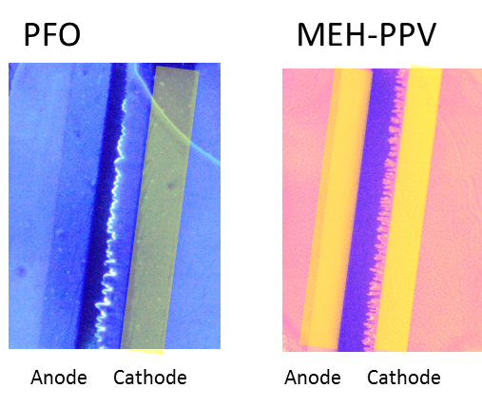

2, We successfully prepared a novel light-emitting device, where the emission is confined in a very thin layer of emissive fibrils. The fibrils are proteins with emissive metal complexes inside. The main emission is obviously from the emissive fibrils.

3, We employed straightforward temperature-dependent open-circuit voltage measurements to tackle a complicated and fundamental issue in organic photovoltaics, i.e. charge generation. We observed a decrease of open-circuit voltage at low temperature. This behavior is rationalized in terms of reduced charge separation at low temperature.
The impact:
1, The result on the factors affecting emission position of LECs helps to understand the key problem that limits the lifetime of OLECs, i.e. the close-to-cathode emission junction. A better understanding of the key factors affecting the junction position could help to control the junction position at the centre, and hence improve the device lifetime.
2, Incorporating biological materials in light-emitting devices to improve the device performance is a novel approach, which is facile and compatible with large-area printing methods.
3, By measuring the open-circuit voltages at different temperatures and comparing different donor:acceptor systems, we set up a consistent description, which does not contradict previously reported experimental observations. Therefore, we are a step closer to understanding an important issue (i.e. charge generation) in organic solar cells.

