The “Risky Decision-Making (RDM): opening the human black box” project aimed to answer the following research and operational question: “How can we gather and study real-world data on decision-making (DM) in risky situations?”. The project studied decision-making (DM) in real situations (“naturalistic decision-making”) to better understand the processes and competences mobilized by novices and professionals in risky situations. This knowledge is essential to training personnel and designing procedures and equipment supporting robust, sound and efficient decisions.
Following the airplanes blackboxes’ example, the primary objective was to design a “cognitive black box” for individuals: that is to say a kit for collecting and analysing the DM processes of workers involved in hazardous contexts and high pressure situations by investigating the potential of the Subjective Evidence Based Ethnography (SEBE) (Lahlou, Le Bellu, & Boesen-Mariani, 2015; Lahlou, 2011), a naturalistic approach using first-person perspective (FPP) video ethnography to collect and study the flow of activity during real-life practice in the field. The SEBE framework involves two points of data collection: 1) video recording using a subjective camera (subcam: see Figure 1) of the participant’s own action; 2) a replay interview (RIW) in which the participant(s) and researcher view the subcam footage and analyse the participant’s own behaviour (see Figure 2).

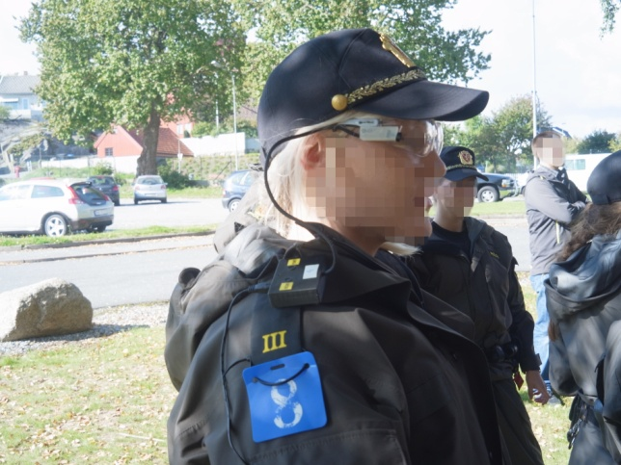 | 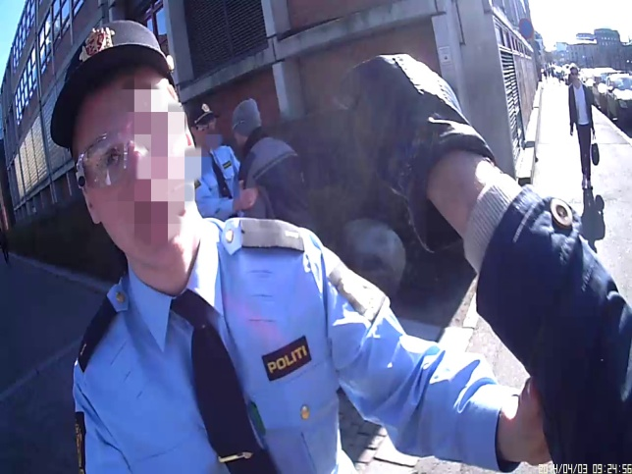
Figure 1: A police student wearing the subcam (left); First-person perspective from the perspective of an actor playing member of the public in a case (right).
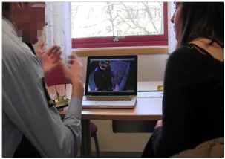
Figure 2: Each volunteer participant is equipped with a subcam before starting the simulation (left picture); then debriefed during a RIW session (right picture).

Two kinds of contexts were investigated within two different organisations:
- Policing decisions, with the Norwegian Police University College (PHS). In this context, the studied situations were realistic simulations completed by novice (last-year students becoming professionals) and expert police officers in pairs at PHS training camps.
- Operational activities involving decisions on gaz terminals during real work activities completed by operators within the French gaz industry Engie.
The corpus of data collected is both qualitative and quantitative: FPP footages of the cases, video and audio recordings of the interviews, timeline forms, informed consent forms, survey forms. Table 1 reports the data collected: this represents 700 GB of data. In total, in 2 years:
- we organised and conducted 7 campaigns of data collection;
- 141 participants agreed to participate in this project (Mage=29,2, Range 19 - 62 years-old, 26% women, 74% male);
- and video recordings of 110 cases involving risky decision-making across policing and operations on gas terminals (203 total FPP video recordings) were collected.

Setting | Profession | Organisation | Collection campaign | Data Collected | Participants | Data collected
Training context: realistic case-based training | Policing | Training camps of the Norwegian Police University College | 1 | 8 policing scenario across 1 operative case | 8 first-year police students | Case videos  54 GB
 |  |  | 2 | 46 policing scenario; 3 operative cases (Active shooter, Intoxicated man, Public stabbing) | 32 final-year police students | Case videos  192 GB
 |  |  | 3 | 30 policing cases across 1 operative case (Intoxicated man) | 52 final-year police students  6 expert police officers | Case videos  198 GB
 |  |  | 4 | 18 policing cases across 1 operative case (Intoxicated man) | 36 expert police officers (becoming certified instructors) | Case videos  206 GB
 |  |  | 5 | DM Factors study: 36 surveys |  | 1260 answers: 35 questions per form incl. 17 open answers
Real work setting | Gaz industry | Engie  (French Gaz company) | 6 (subcam footages) | 8 real operational cases on gaz terminals | 7 operators | Case videos  50 GB
 |  |  | 7 (replay interviews)
Total |  |  | 7 campaigns | 110 decisional cases | 141 participants | 700 GB  + 1260 answers (surveys)
Table 1: corpus of data collected in the RDM project.

SEBE is a paradigm for action-research. It allows addressing and proposing changes at three levels: the research level, the individual level, and the organisational level. The 4 main findings arising from this project indicate that:
- SEBE can be implemented in large scale qualitative intervention for collecting and investigating NDM in risky situations (Le Bellu & Lahlou, in prep.).
The first objective of the study was to evaluate if SEBE could feasibly be implemented to study NDM. Our qualitative design was implemented to collect and analyse a large scale of real and contextualised data as it occurs in situ (see Table 1). The development of a qualitative video-based method based on the principles of SEBE for studying NDM offers an innovative framework better connected to real events and settings than current methods, by actually recording human DM in situ, and thus addressing limitations of current techniques: naturalistic capture of the actual sequences of actions, recording of the context, post-hoc interviews based on video tracks straight from the participant’s perspective (FPP), and limitations of reconstructed memories. Not only does SEBE help track the chain of exact actions and decisions while they occur, but it also contributes to improve training by providing material for analyses and reflective debriefings (see next points 2, 3 and 4 of results).

- SEBE enables in-depth study of situated and distributed cognitive processes that occur when professionals make joint-decisions during their work activity (Le Bellu, Lahlou, Phelps, & Aandal, submitted)
The implementation of SEBE from design to analysis allows enhancing our understanding of DM processes during risky situations involving decision-making. We showed it enables: a) to effectively return participants to the original context via FPP video. This provides access to cognitive experiences in a different way compared to previous research and, b) to examine how joint decision-making actually occurs, here in professional contexts involving risky situations.
SEBE enables to measure significant times for making decisions and to identify key-moments, processes and triggering cues. This allows detailing situated and distributed cognitive processes and to map and compare the different strategies used by the workers: see (Le Bellu, Lahlou, Phelps, & Aandal, submitted) for an example of detailed analysis.

- SEBE improves the development of learning and self-reflection of the participants (Phelps, Strype, Le Bellu, Lahlou, & Aandal, 2016).
We examined if our intervention may have led to increased learning outcomes for the participants using SEBE. The participants in the SEBE intervention self-reported learning more about decision-making, communication and coping with stress, and could recall more learning outcomes and areas of improvement regarding communication and decision-making during the scenario to a greater degree than the comparison group (Phelps et al., 2016). All signs point to this being beneficial for having deep feedback on performances as the SEBE method offers valuable room for self-learning and reflection, specifically upon the ability to: a) analyse one’s own action in detail and in retrospect; b) gain awareness of one’s own tendencies, reflexes, and limitations; c) develop a better understanding of one’s partner or team’s view of the situation, and compare it with what one’s thoughts; and d) analyse the way teams communicate and deal with time pressure and stress.

- The material collected through the application of the SEBE method enables to provide training material for the organisations.
The field studies we conducted show that the SEBE procedure is applicable in professional training or industry without major difficulty as long as the management supports the initiative (Le Bellu, Lahlou, Phelps, & Aandal, submitted). Professional instructors and personnel in charge of designing the educational methods and materials in training centres and in companies could be interested by making this systematic, innovative, and psychological video-based protocol part of their toolbox. Material obtained through the SEBE method can be used for designing training material (e.g. assessment scheme, databases of cases…);

The SEBE method can contribute to help organizations to better understand the causes of accidents and failures, and to design methods for prevention, through capturing and collecting data on situations deemed as risky. Future research should address more real-life situations in various domains, compare simulation and real-life settings and extend the database of cases.
The project will boost Europe’s competitiveness via the long-term benefits that could emerge for all decision-makers in academic or industrial institutions interested to apply the method and, more precisely, for all heavy-industries or risky/stressful situations in which decision-making can leads to negative impact (human death, financial loss, reputation, political impact, human relations, etc.). All institutions and organisations are concerned, at various levels of decision: operational, tactical (e.g. project management) or strategic (e.g. board committees).

The RDM project is presented:
- on the website of the SEBE research group:

http://sebe-lab.org/sebe/projects/risky_decision_making/

- in Horizon magazine, the Research and Innovation Magazine of the European Union where an article entitled Human 'black box’ provides insight into decision-making features and promoted the research of Dr Le Bellu on the RDM project:

http://horizon-magazine.eu/article/human-black-box-provides-insight-decision-making_en.html

Contact details: Dr. Sophie Le Bellu (S.le-bellu@lse.ac.uk; sophie.lebellu@gmail.com) and Prof. Saadi Lahlou (S.lahlou@lse.ac.uk).

