1. Final PUBLISHABLE SUMMARY

Ultrafast light pulses offer the fascinating opportunity to study system dynamics at ultrashort time scales. Trains of ultrafast light pulses also feature a broad frequency comb structure that has been exploited in a range of applications, e.g. for high precision metrology. These characteristics have made ultrafast optics with coherent control techniques a flourishing field over the last decades. A rich toolbox has been developed to generate shorter pulses with engineered temporal and spectral properties. Likewise, exploiting the quantum features of light has enabled remarkable progress for the experimental exploration of fundamental physics and has been central for the establishment of the fields of quantum information and quantum metrology.

In this project, we have combined these fields, quantum control and femtosecond, continuous variable quantum optics, for the purpose of both designing and analyzing multimode, nonclassical structures. More specifically, the objective was to use a synchronously pumped optical parametric oscillator to generate, detect and engineer multimode states of light. To that aim, time/frequency mode dependent detection system had to be developed.

We have realized a scalable and on-demand way to generate versatile multipartite quantum networks within one single beam. A 76MHz train of 150fs optical pulses centered at 795nm is used to synchronously pump an optical parametric oscillator (OPO) below threshold, generating 16-modes co-propagating multi-mode squeezing. Frequency resolved homodyne detection, where the local oscillator pulse is shaped at will, is employed to characterize the multipartite entanglement (see Fig. 1) and a novel method is presented that allows to verify multimode entanglement in any partition. Starting from a 10-partition in the frequency domain, we demonstrate entanglement with respect to all 115974 possible K-partitions. This highly entangled source can be turned into any type of quantum network benefiting from the versatility of the measurement process. This procedure turns the source into a quantum network simulator, allowing in our case to generate up to 12 mode cluster states and testing 5-players secret sharing.

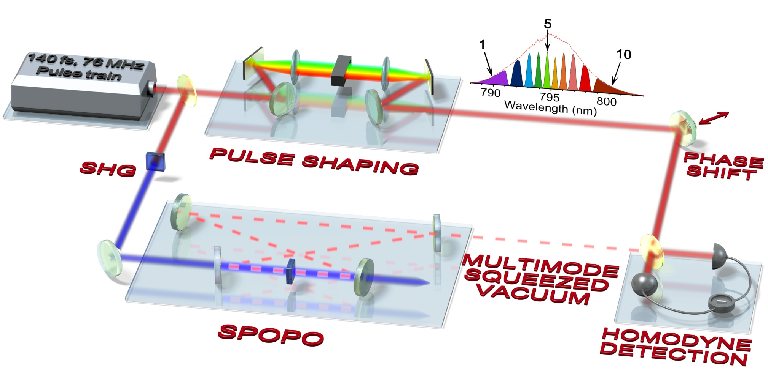

Fig 1: Multimode squeezing source with pulse shaped homodyne detection.

The unprecedented versatility and multimode character of this source make it a very promising candidate for measurement based quantum computing. We thus did develop a multimode detection system allowing for the simultaneous detection of 16 frequency bands and real time measurement of the covariance matrix. We have proved that, using computer post-processing, it is a very serious candidate for novel approach to quantum information processing

MBQC

Fig. 2: Multimode homodyne detection and computer based post-processing for measurement based quantum information.

Using these quantum tools, we also demonstrate that due to their extreme sensitivity they could be used both for quantum and classical metrology purposes. In particular, we did demonstrate how to extract the modal content of a classical ultrafast laser, testing for the first time amplitude and phase frequency resolved correlations and using it for the extraction of laser dynamics. Finally, the very same tools have been utilized for the improvement of frequency metrology beyond the vacuum noise limit.

Ferrini, G., Roslund, J., Arzani, F., Cai, Y., Fabre, C., & Treps, N. (2015). Optimization of networks for measurement-based quantum computation.*Physical Review A*, *91*(3), 032314.

Gerke, S., Sperling, J., Vogel, W., Cai, Y., Roslund, J., Treps, N., & Fabre, C. (2015). Full Multipartite Entanglement of Frequency-Comb Gaussian States.*Physical review letters*, *114*(5), 050501.

Schmeissner, R., Roslund, J., Fabre, C., & Treps, N. (2014). Spectral Noise Correlations of an Ultrafast Frequency Comb. *Physical review letters*, *113*(26), 263906.

Roslund, J., De Araujo, R. M., Jiang, S., Fabre, C., & Treps, N. (2014). Wavelength-multiplexed quantum networks with ultrafast frequency combs.*Nature Photonics*, *8*(2), 109-112.

de Araújo, R. M., Roslund, J., Cai, Y., Ferrini, G., Fabre, C., & Treps, N. (2014). Full characterization of a highly multimode entangled state embedded in an optical frequency comb using pulse shaping. *Physical Review A*, *89*(5), 053828.